SEPTEMBER, 2020

# DBMS PROJECT PROPOSAL

**< Medical Equipment’s Management Website>**

**Project Manager:**

Tayyaba Sana

**Project Team:**

* Bisma Ali 181370150

**Submission Date:**

End of semester

## Document Information

|  |  |
| --- | --- |
| **Category** | **Information** |
| Customer | Surgical Supply Shops |
| Project | **Medical Equipment’s Management Website** |
| Document | Project proposal |
| Document Version | 1.0 |
| Author(s) | Tayyaba Sana, Fakhar Lodhi, Qaiser S Durrani |
| Approver(s) | Qaiser S Durrani |
| Issue Date | Sep,2020 |

Table of Contents

DBMS PROJECT PROPOSAL 0

Document Information 1

1. Introduction 2

2. Project Stakeholders List 2

3. Specific Requirements 2

4. Learning Outcomes 3

5. Practical Applications 3

6. Supporting Information 4

7. Entity Relationship Diagram (ERD): 6

8. Relational Mapping: 7

### 1. Introduction

The aim of this project is the development of a sample centralized relational Medical equipment store application. This application has to store products information. This project is used mainly to maintain the details of products such as categories and subcategories. This medical shop management website is so design as to ease the work load of medical equipment shop holders.

This documentation describes the development of this project and it includes:

* Architecture (Schemas and ERD)
* Implementation approach (The structure of the database)
* Functionality design (The goal of the program)
* GUI (User level display)

### 2. Project Stakeholders List

This website is for the automation of Medical Equipment It maintains two level of users:

* Administrator level
* User level

### 3. Specific Requirements

It describes the function and non-functional requirements. Modeling requirements, diagrams and Users information. The following are the list conventions and synonyms used in the documents project Administrator, Client, MySQL (used to perform CRUD operations on database). This project team decided to implement the core functionality first and later to attach additional functions.

**3.1 FRs**

* User can view the price and available products.
* User can buy the available products and give feedback.
* Product details (Category, Subcategory, and description).
* Add, delete and update Product information by admin panel.
* Administrator has all the records of the orders.
* Administrator can check sales record, i.e. profit loss statement.

**3.2 NFRs**

* 24/7 Activity
* Speedy Operations

### 4. Learning Outcomes

Understand the various manager roles in an information system and how describe the various process of project management activities. Understand how to develop a successful project. Know the factors affecting in a project.

We understand the basics and concepts of database systems (HTML, CSS, SQL, JavaScript, PHP). Design, implement and evaluates a computer-based system, process, components, or program to meet desired needs.

* An ability to do current techniques, skills and tools necessary for computing practice.
* Ability to analyze, design, and implement a small database system.
* A knowhow about advance database concepts.
* Learning about E-commerce related concepts.

### 5. Practical Applications

The main goal of the application is to maintain the record of products information details. **User Documentation:** this project will include a user manual. The user manual includes complete overview of the product, configuration of the tool used (MySQL server or others), technical details, contact information which will includes email address and phone number**. It’s applicable on Store or product display websites.**

* Planned approach towards working,
* Accuracy
* Reliability
* Immediate retrieval of information
* Easy to operate

### 6. Supporting Information

**Modules**

* **Admin:** 
  1. **Admin Login:**
* Admin need to login by providing the login credentials to access the below given admin modules.
  1. **Product Entry:**
* Admin can enter details about new medicine products details.
  1. **View Product Entry:**
* Admin can view details about the product.
  1. **Categories Entry:**
* Admin can enter details about new category.
  1. **E-Commerce Stats:**
* Admin can view all the stats like loss profit and sales.
* **User:** 
  1. **View Products:**
* The products are arranged and can be viewed in categories.
  1. **Buy Product:**
* User can buy different products
  1. **User Login/Signup:**
* User need to Login/Signup to buy products
  1. **User Feedback:**
* User can give feedback to all the orders w.r.t products.

**Project Implementation Technology**

The Project is loaded in Sublime Text Editor. We use Sublime Text Editor for coding of the project. Create and maintain all databases into MySQL Server, in that we create tables, write queries for storing data or record of project.

The Main Technologies we use are:

* PHP
* HTML
* Bootstrap
* CSS
* JavaScript
* MySQL

**Hardware Requirement:**

* i3 Processor Based Computer or higher
* Memory: 1 GB RAM
* Hard Drive: 50 GB
* Monitor
* Internet Connection

**Software Requirement:**

* Windows 7 or higher
* Visual studio 2010.
* MySQL Server (Xampp in our case)

**ADVANTAGES**

* User can view details of the equipment without going anywhere.
* It is convenient for users as this system provides accurate cost and description of the system.
* The website is used for e-shopping.
* User can view different categories of product of different companies at a single place.
* User can order the product from website.

**Disadvantages:**

* The user cannot view the product in person.
* There is no human interaction.
* There can be fraud and security problems.

**Related Famous Website:**

* **Loops Sports**:

It is a website that displays Sports Products w.r.t. its categories, user can buy the products and leave a review.

Link: https://www.loopssprorts.com

### 7. Entity Relationship Diagram (ERD):

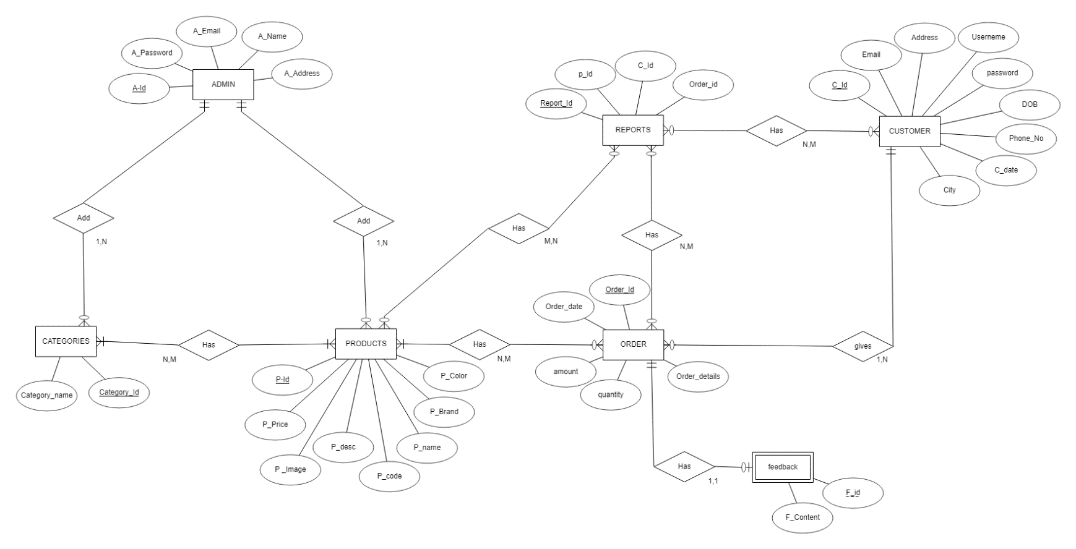

### 8. Relational Mapping:

