Flask

Flask is a popular web framework for building web applications with Python. It’s a microframework that provides the basic tools for creating web applications and is designed to be easy to use and extend.

Interesting Facts about Flask
- Microframework: Flask is lightweight and minimal. It gives developers flexibility instead of forcing a fixed structure like Django.
- Built on Werkzeug & Jinja2: flask build with two powerful library
  - Werkzeug handles requests and responses.
  - Jinja2 is used for dynamic HTML templates.making it easy to build web pages with variables and loops.
- Simple Routing: URLs are mapped to Python functions using decorators, which makes routing easy and readable.
- No Built-in ORM: Flask doesn’t force an ORM. You can use SQLAlchemy, raw SQL, or any database tool you prefer.
- Great for APIs: Flask is widely used for RESTful APIs, microservices, and backend services.
- Built-in Development Server: Comes with a simple server for local testing (not for production).

Advantages of Flask
- Flask is a lightweight backend framework with minimal dependencies.
- Flask is easy to learn because its simple and intuitive API makes it easy to learn and use for beginners.
- Flask is a flexible Framework because it allows you to customize and extend the framework to suit your needs easily.
- Flask can be used with any database like:- SQL and NoSQL and with any Frontend Technology such as React or Angular.
- Flask is great for small to medium projects that do not require the complexity of a large framework.
- Flask Documentation

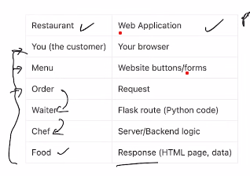
Request / Response cycle
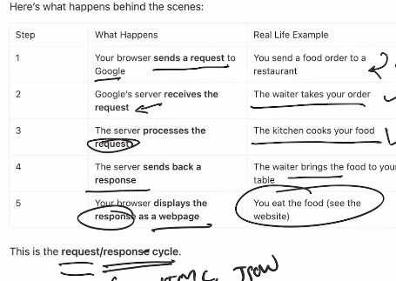

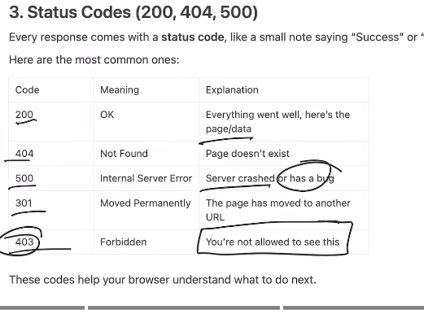
201 Created → Resource successfully created
401 Unauthorized → Authentication required or failed

• Browser:
A browser is a software used to access and view websites.
👉 Examples: Chrome, Firefox, Edge, Safari.
• URL (Uniform Resource Locator):
A URL is the address of a website on the internet.
👉 Example: https://www.google.com
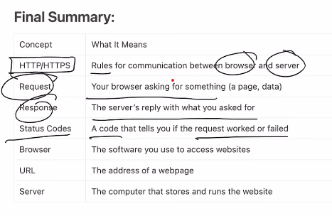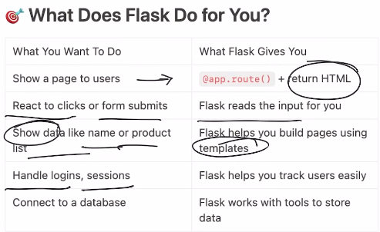R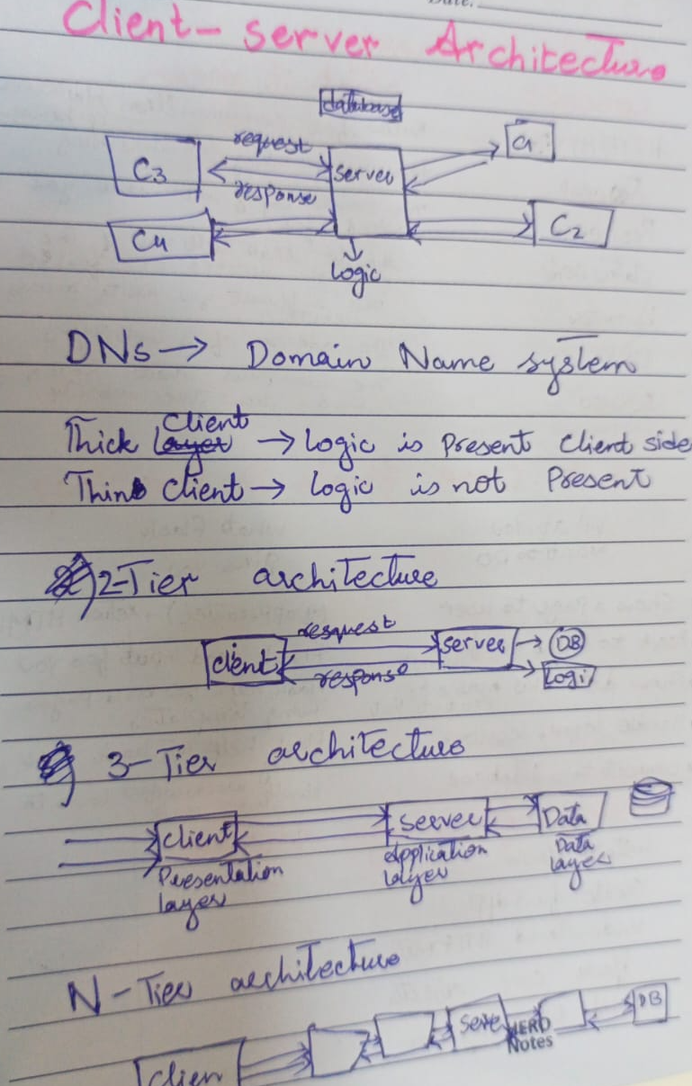

http method
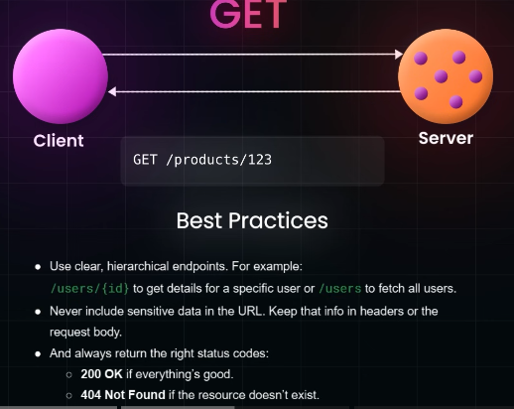

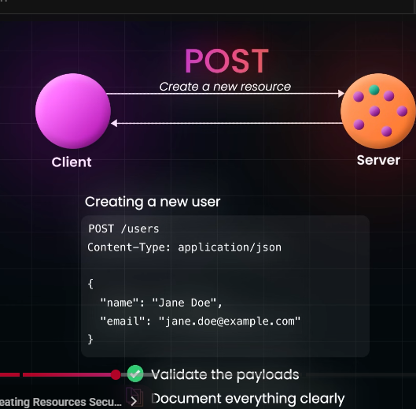

1. GET
- Purpose: Retrieve data from the server.
- Idempotent: Yes (calling it multiple times has the same effect).
- Body: Usually no body; parameters are in the URL.
- Example: Fetch a user profile
GET /users/123

2. POST
- Purpose: Send data to the server to create a new resource.
- Idempotent: No (multiple calls may create multiple resources).
- Body: Contains data to create (e.g., JSON).
- Example: Create a new user
POST /users
Body: { "name": "Bismah", "email": "b@example.com" }

3. PUT
- Purpose: Update or replace a resource completely.
- Idempotent: Yes (same data sent multiple times gives same result).
- Body: Full representation of the resource.
- Example: Update user completely
PUT /users/123
Body: { "name": "Bismah Rehman", "email": "b@example.com" }

4. PATCH
- Purpose: Partially update a resource.
- Idempotent: Usually yes (but depends on implementation).
- Body: Only the fields to update.
- Example: Update user email only
PATCH /users/123
Body: { "email": "bismah@example.com" }

5. DELETE
- Purpose: Remove a resource from the server.
- Idempotent: Yes (deleting a non-existent resource still results in the same state).
- Example: Delete a user
DELETE /users/123

Json Data Format
JSON (JavaScript Object Notation) is a lightweight data format used to store and exchange data between client and server.

1. Structure
JSON is made of key-value pairs and supports objects and arrays.
Object
- Enclosed in { }
- Contains key-value pairs
{
"name": "Bismah",
"age": 24,
"isStudent": true
}
Array
- Enclosed in [ ]
- Can contain objects, strings, numbers, etc.
{
"students": [
{"name": "Ali", "age": 22},
{"name": "Sara", "age": 23}
]
}

2. Data Types
- String: "text"
- Number: 123, 12.5
- Boolean: true / false
- Null: null
- Object: { "key": "value" }
- Array: [value1, value2]

3. Rules
- Keys must be strings in double quotes.
- Values can be any valid JSON type.
- No comments allowed.
- Data is human-readable and machine-parsable.

Stateless communication vs Stateless communication
- Stateless communication: Every request is independent. The server doesn’t remember anything from before.
  - Example: HTTP GET on a website — the server treats each request like it’s the first time.
- Stateful communication: The server remembers previous interactions with the client.
  - Example: Online banking session — you log in once, and the server remembers you until you log out.
Basically, stateless = no memory, stateful = keeps memory.
Understanding HTTP protocol and how web APIs work
1. HTTP Protocol (the language of the web):
- HTTP = Hypertext Transfer Protocol.
- It’s how your browser talks to a web server.
- You send a request, the server sends a response.
- Requests and responses have:
  - URL/endpoint: where you want to go.
  - Method: what you want to do (GET, POST, PUT, DELETE).
  - Headers: extra info like your identity or data type.
  - Body: data you send (mostly with POST/PUT).
Common HTTP methods:
- GET → “Give me this info.”
- POST → “Here’s new info, save it.”
- PUT/PATCH → “Update this info.”
- DELETE → “Remove this info.”
2. Web APIs (Application Programming Interface over the web):
- APIs are like menus at a restaurant: you request something, the server serves it.
- Web APIs use HTTP to let programs talk to each other.
- Example: your weather app calls api.weather.com/today?city=Karachi → server responds with weather data in JSON.
3. JSON (most common data format):
- JavaScript Object Notation, looks like:
{
"city": "Karachi",
"temperature": "28°C",
"condition": "Sunny"
}
4. How it works step by step:
- Your app/browser sends an HTTP request to a URL.
- Server receives request, does processing.
- Server sends back an HTTP response (status code + data).
- Your app reads the response and shows it to the user.
5. Status codes (quick cheat):
- 200 → OK
- 404 → Not found
- 500 → Server error
- 401 → Unauthorized

REST API design principles
Stateless – Each request must contain all info the server needs; no session stored on server.
Client-Server Separation – The client handles UI, the server handles data & logic.
Uniform Interface – Use standard HTTP methods:
- GET → read
- POST → create
- PUT → update/replace
- PATCH → update/modify
- DELETE → remove
Resource-Based – Everything is a resource (user, product) with a URL, e.g., /users/123.
Use HTTP Status Codes – Communicate results clearly:
- 200 → OK
- 201 → Created
- 400 → Bad Request
- 401 → Unauthorized
- 404 → Not Found
- 500 → Server Error
• Versioning – Include version in URL or headers: /api/v1/users.
Stateless Caching – Responses should indicate if they can be cached to reduce server load.
Consistent Naming – Use plural nouns for endpoints (/users, /products) and lowercase with hyphens.
HATEOAS (Optional) – Include links in responses so clients can navigate API easily.
Security – Use HTTPS, authentication (token, OAuth), and validate inputs.

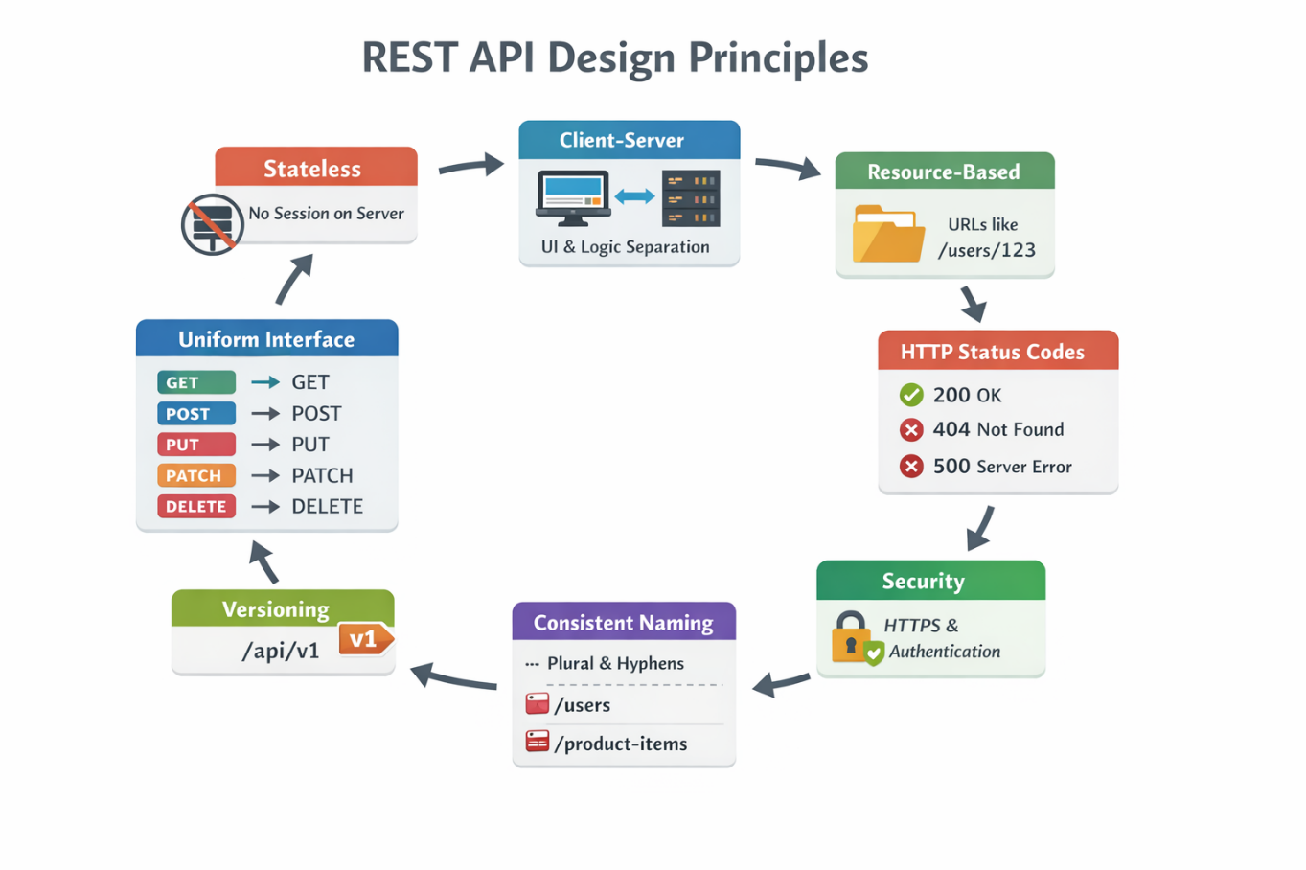
- App Instance – Your Flask app (Flask(__name__))
- Routes – Map URLs to functions using @app.route()
- Request – Get incoming data (request.json, headers, args)
- Response – Send JSON, HTML, or status codes (return jsonify(...), 200)
- Blueprints – Split routes into reusable modules
- Error Handling – Handle errors with @app.errorhandler()
