**EMPLOYEE REGISTRATION PROJECT-DOCUMENTATION**

The Employee Registration Project is a web application designed to facilitate the registration of employees within an organization. The project utilizes Spring Boot for backend development, JSP for frontend, and REST APIs for communication between the two.

The project is available at <localhost:8080/login> and h2-console is available at <http://localhost:8080/h2-console>

**Technologies Used**

* Spring Boot for back end development
* Java Server Pages(JSP) with CSS styling for frontend
* RESTful APIs
* Java In memory database-H2

**Communication Flow**

* User interacts with JSP based registration form
* JSP sends Restful requests to spring boot back end
* Spring boot process the request and interacts with the database
* Responses are sent to jsp for rendering

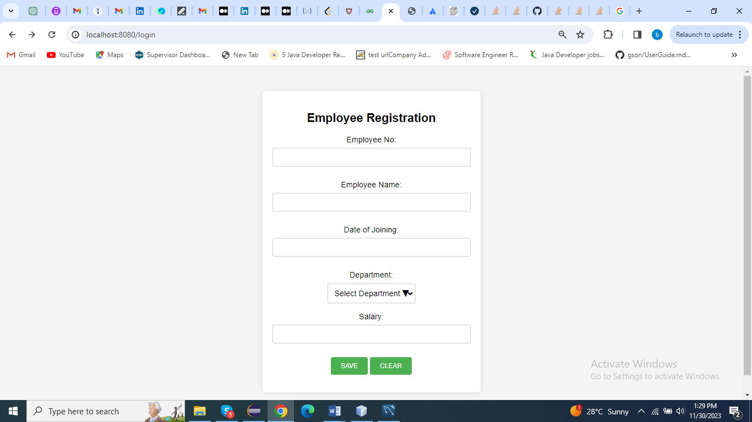

H2 Database

Repository

Controller

Service

**Setup and Installation**

Registration-form/

|-- src/

| |-- main/

| |-- java/

| |-- com.employee.registrationform/

| |-- Advice/

| |-- controller/

| |-- service/

| |-- repository/

| |-- Entity/

| |-- Exception

| |-- resources/

| |-- application.properties

| |-- data.sql

| |-- webapp/

| |-- WEB-INF/

| |-- jsp/

| |-- registration.jsp

| |-- success.jsp

|-- pom.xml

**Dependencies**

* Spring Boot Starter web
* Spring Boot Starter Data JPA
* Spring Boot DevTools
* Swagger
* Spring Boot Starter Validation
* Tomcat Embed Jasper(for JSP)
* H2(for h2 in memory database)
* Jstl (jsp)

**Data base Design**

Tables

* Employee

Columns:id,employee_no,employee_name,date_of_joining,department,salary

* Department

Columns:id,code,departmentName

**Rest API Documentation**

Project is configured with Swagger dependency,So all documentations of rest Apis and options to test the rest Apis are available at <http://localhost:8080/swagger-ui.html>.