复现官网(logux.org)的server.ts、client.ts:
实验流水：
- 不修改任何代码，找出为什么报错。
报错的原因是不能用node client.ts，因为node只能解析js
路线1:
用vite框架下的react框架
路线2：不行
把ts改成js

2、1中路线1的实验
Json内不能写注释
- 熟悉vite
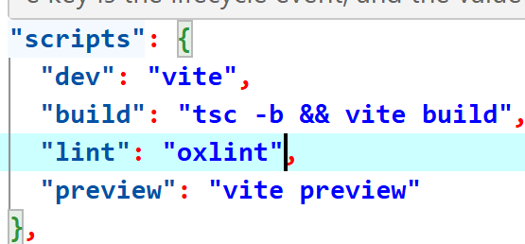
Npm run dev:运行热更新vite服务器
Npm run build:建立一个静态文件夹dist
Npm run lint:检查代码风格
Npm run preview：预览成果,在build之后运行。

- 复现https://github.com/logux/examples/tree/main
在client根目录下执行npm i --save-dev @types/node时，报错：
npm warn deprecated inflight@1.0.6: This module is not supported, and leaks memory. Do not use it. Check out lru-cache if you want a good and tested way to coalesce async requests by a key value, which is much more comprehensive and powerful.
npm warn deprecated glob@7.2.3: Old versions of glob are not supported, and contain widely publicized security vulnerabilities, which have been fixed in the current version. Please update. Support for old versions may be purchased (at exorbitant rates) by contacting i@izs.me
npm warn deprecated rimraf@3.0.2: Rimraf versions prior to v4 are no longer supported

added 247 packages, and audited 248 packages in 60s

39 packages are looking for funding
run `npm fund` for details

5 vulnerabilities (1 low, 3 moderate, 1 high)

To address all issues (including breaking changes), run:
npm audit fix --force

Run `npm audit` for details.
npm warn allow-scripts 1 package has install scripts not yet covered by allowScripts:
npm warn allow-scripts esbuild@0.18.20 (postinstall: node install.js)
npm warn allow-scripts
npm warn allow-scripts Run `npm approve-scripts --allow-scripts-pending` to review, or `npm approve-scripts <pkg>` to allow.
原因：这个项目是pnpm管理的。
3、复现这个项目https://github.com/logux/examples/首先要安装pnpm，然后用pnpm 安装vite然后再然后。我做这个复现是为了学习如何搭建客户端/服务端——都需要写什么东西。

总结：
创建logux客户端流程：（有问题）
npm create vite@latest
把client.ts文件放在vite项目文件夹下的src文件夹内
在client根目录下执行npm i --save-dev @types/node
打开tsconfig.app.json，在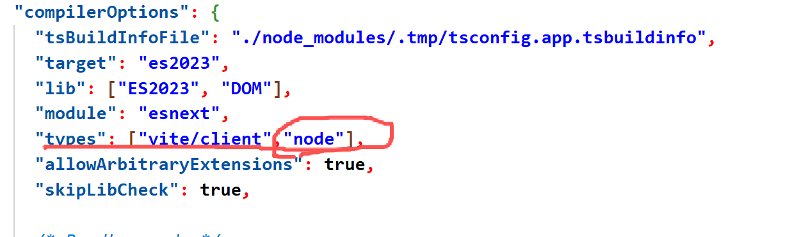加入“node”，
npm run build
Npm run preview
打开浏览器，监听主机指定端口
创建logux服务端流程：
用node test以及logux.org中的配置文件

