Iterative Deeping Depth-First Search 출제 100%

Complete? Yes

Optimal? 일반적으로 Yes (path const is a no)

Time? (d+1)b^0 +db^1 + … + 2b^\*(d-1) + 1b^d = O(b^d)

Space? O(bd)

Breadth-First Search (BFS)Properties

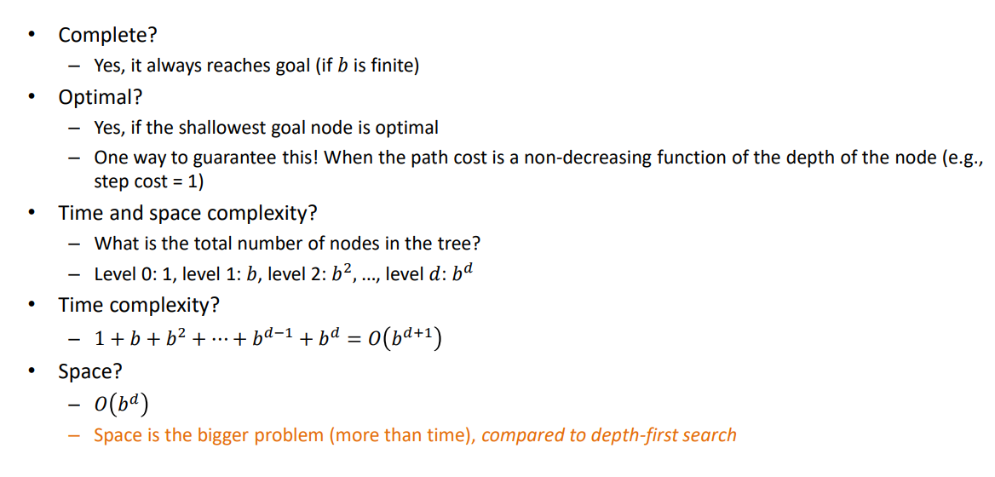

Uniform Cost Search

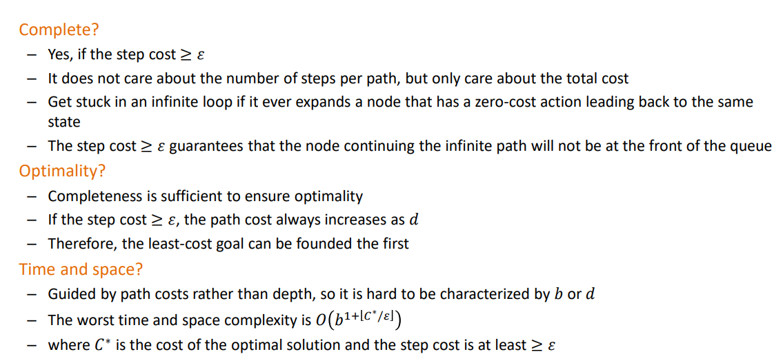

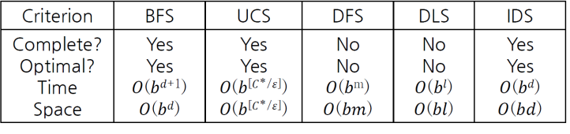전부 설명 가능이여야 함 \*\*\*\*\*

