TRIBHUVAN UNIVERSITY
Faculty of Humanities and Social Sciences
[College name]
[College address]
[College / university logo]
A PROJECT REPORT ON
AI CAREER PREDICTION SYSTEM WITH INTEGRATED JOB PORTAL
Submitted to
Department of Computer Application
In partial fulfilment of the requirements for the degree of
Bachelor of Computer Applications (BCA)
Submitted by:
[Student name 1] (Roll No.: [..], TU Reg. No.: [..])
[Student name 2, if any] (Roll No.: [..], TU Reg. No.: [..])
Under the supervision of:
[Supervisor name and designation]
[Month, Year]
CERTIFICATE
This is to certify that the project report entitled “AI Career Prediction System with Integrated Job Portal” has been prepared and submitted by [Student name(s)], Roll No. [..], in partial fulfilment of the requirements for the degree of Bachelor of Computer Applications (BCA) of Tribhuvan University, at [College name]. The work has been carried out under my supervision and, to the best of my knowledge, is an original work of the student(s) and has not been submitted elsewhere for any degree.
…………………………………………
[Supervisor name]
Supervisor, [Designation, College name]
…………………………………………
[Name]
Head of Department / Program Coordinator, [College name]
Date: [..]
SUPERVISOR’S RECOMMENDATION
I hereby recommend that the project report entitled “AI Career Prediction System with Integrated Job Portal”, prepared under my supervision by [Student name(s)], be accepted as partial fulfilment of the requirements for the degree of Bachelor of Computer Applications (BCA). To the best of my knowledge the report follows the prescribed format and the work is satisfactory. I therefore recommend it for evaluation.
…………………………………………
[Supervisor name]
Supervisor, [Designation, College name]
Date: [..]
INTERNAL AND EXTERNAL EXAMINERS’ APPROVAL LETTER
We certify that we have read this project report and, in our opinion, it is satisfactory in scope and quality as a project report for the degree of Bachelor of Computer Applications (BCA). The project report entitled “AI Career Prediction System with Integrated Job Portal” submitted by [Student name(s)] is hereby approved.
…………………………………………
[Name]
Internal Examiner
…………………………………………
[Name]
External Examiner
…………………………………………
[Name]
Head of Department / Program Coordinator
Date: [..]

ACKNOWLEDGEMENT
We would like to express our sincere gratitude to our project supervisor, [Supervisor name], for his/her continuous guidance, valuable suggestions and encouragement throughout the development of this project. His/her feedback helped us to improve both the system and this report.
We are also thankful to [Head of Department / Program Coordinator] and to all the teachers of [College name] for the knowledge and the facilities that made this work possible. We thank our friends for their ideas, testing and support during the project.
Finally, we thank our families for their patience and constant support.
[Student name(s)]

ABSTRACT
Choosing a career and finding a suitable job are difficult for students and fresh graduates because they rarely have an objective view of how their skills compare with what employers need, while employers receive many unstructured resumes that are slow to screen. This project, the AI Career Prediction System with Integrated Job Portal, addresses both sides of the problem.
A job seeker uploads a PDF resume. The system extracts the text, finds the skills and named entities with spaCy and pattern matching, predicts a suitable career using a hybrid of rule-based mapping and a TF-IDF with Logistic Regression classifier, calculates a resume score and the missing skills, and recommends jobs, courses and interview questions. When a job description is supplied, TF-IDF cosine similarity gives a match percentage. In the job-portal part, verified employers post vacancies that are published after administrator moderation; job seekers search and apply, and every application receives an automatic match score so that employers see applicants ranked by suitability and can update their status.
The system has three services: a React 19 frontend, a Laravel 12 REST API with JWT authentication and an SQLite database, and a FastAPI service for NLP and machine learning. It was developed with an iterative incremental method and tested with unit and system test cases. The current version is limited by a small skill database and a small, partly noisy training set, which are addressed in the future recommendations.
Keywords: career prediction, resume parsing, TF-IDF, natural language processing, job portal, Laravel, FastAPI, React.
TABLE OF CONTENTS
ACKNOWLEDGEMENT iv
ABSTRACT v
LIST OF ABBREVIATIONS viii
LIST OF FIGURES ix
LIST OF TABLES x
CHAPTER 1: INTRODUCTION 1
1.1 Introduction 1
1.2 Problem Statement 1
1.3 Objectives 2
1.4 Scope and Limitation 2
1.4.1 Scope 2
1.4.2 Limitations 3
1.5 Development Methodology 3
1.6 Report Organization 4
CHAPTER 2: BACKGROUND STUDY AND LITERATURE REVIEW 5
2.1 Background Study 5
2.1.1 Text Extraction from PDF Resumes 5
2.1.2 Named Entity Recognition with spaCy 5
2.1.3 Skill Extraction by Pattern Matching 5
2.1.4 TF-IDF and Cosine Similarity 5
2.1.5 Logistic Regression for Career Classification 6
2.1.6 Hybrid Rule-based and Machine Learning Prediction 6
2.1.7 Skill-gap Analysis and Resume Score 6
2.1.8 Job Portals, Applicant Tracking and Moderation 6
2.1.9 Three-service Architecture, REST and JWT 7
2.2 Literature Review 7
2.2.1 Existing Job Portals 7
2.2.2 Resume Analysers 7
2.2.3 Research on Resume Parsing and Matching 7
2.2.4 Comparison and Research Gap 8
CHAPTER 3: SYSTEM ANALYSIS AND DESIGN 9
3.1 System Analysis 9
3.1.1 Requirement Analysis 9
3.1.2 Feasibility Analysis 14
3.1.3 Object Modelling using Class and Object Diagrams 16
3.1.4 Dynamic Modelling using State and Sequence Diagrams 18
3.1.5 Process Modelling using Activity Diagrams 22
3.2 System Design 24
3.2.1 Architectural and Database Design 24
3.2.2 Refinement of Class, Object, State, Sequence and Activity Diagrams 27
3.2.3 Component Diagram 32
3.2.4 Deployment Diagram
33
3.3 Algorithm Details 34
CHAPTER 4: IMPLEMENTATION AND TESTING 36
4.1 Implementation 36
4.1.1 Tools Used 36
4.1.2 Implementation Details of Modules 36
4.2 Testing 39
4.2.1 Test Cases for Unit Testing 39
4.2.2 Test Cases for System Testing 40
4.3 Result Analysis 41
CHAPTER 5: CONCLUSION AND FUTURE RECOMMENDATIONS 43
5.1 Conclusion 43
5.2 Future Recommendations 43
5.2.1 Machine Learning and Language Processing 43
5.2.2 Security and Reliability 43
5.2.3 Engineering and Scalability 44
5.2.4 New Features 44
REFERENCES 45
BIBLIOGRAPHY 47
APPENDIX A: SCREENSHOTS 48
APPENDIX B: SOURCE CODE 52

LIST OF ABBREVIATIONS
Abbreviation | Full form
AI | Artificial Intelligence
API | Application Programming Interface
ATS | Applicant Tracking System
BCA | Bachelor of Computer Applications
CASE | Computer-Aided Software Engineering
CI/CD | Continuous Integration / Continuous Delivery
CSV | Comma-Separated Values
FK | Foreign Key
HTTP(S) | Hypertext Transfer Protocol (Secure)
IEEE | Institute of Electrical and Electronics Engineers
JSON | JavaScript Object Notation
JWT | JSON Web Token
ML | Machine Learning
NER | Named Entity Recognition
NLP | Natural Language Processing
ORM | Object-Relational Mapping
PDF | Portable Document Format
PK | Primary Key
REST | Representational State Transfer
RSS | Really Simple Syndication
SBERT | Sentence-BERT
SPA | Single-Page Application
SQL | Structured Query Language
TF-IDF | Term Frequency – Inverse Document Frequency
UI | User Interface
UML | Unified Modeling Language

LIST OF FIGURES
Figure 1.1: Iterative and incremental development model used in the project 4
Figure 3.1: Use case diagram of the system 11
Figure 3.2: Gantt chart of the project schedule 15
Figure 3.3: Class diagram (analysis level) 17
Figure 3.4: Object diagram with sample data 18
Figure 3.5: State diagram of an application 19
Figure 3.6: State diagram of a job posting 20
Figure 3.7: Sequence diagram of resume upload and analysis 21
Figure 3.8: Sequence diagram of job posting, application and ranking 22
Figure 3.9: Activity diagram of resume analysis 23
Figure 3.10: Activity diagram of job posting and application 24
Figure 3.11: System architecture 25
Figure 3.12: Database schema (relational) 26
Figure 3.13: Refined class diagram of the domain layer 28
Figure 3.14: Class diagram of the controller and service layer 28
Figure 3.15: Refined state diagram of resume processing 29
Figure 3.16: Refined sequence diagram of resume analysis 30
Figure 3.17: Refined sequence diagram of applying and ranking applicants 31
Figure 3.18: Refined activity diagram of the AI analysis pipeline 32
Figure 3.19: Component diagram 33
Figure 3.20: Deployment diagram 34
Figure A.1: Registration and login page 48
Figure A.2: Job seeker dashboard 48
Figure A.3: Resume upload and analysis result 49
Figure A.4: Skill gaps and recommendations 49
Figure A.5: Job search and saved jobs 49
Figure A.6: Job details and apply form 50
Figure A.7: My applications 50
Figure A.8: Employer job posting form 50
Figure A.9: Employer applicants ranked by match 51
Figure A.10: Admin moderation panel 51

LIST OF TABLES
Table 2.1: Comparison of the proposed system with existing approaches 8
Table 3.1: Functional requirements 9
Table 3.2: Use case description: Register and log in 12
Table 3.3: Use case description: Upload and analyse resume 12
Table 3.4: Use case description: Search and save jobs 12
Table 3.5: Use case description: Apply for a job 13
Table 3.6: Use case description: Post a job 13
Table 3.7: Use case description: Review applicants 13
Table 3.8: Non-functional requirements 14
Table 3.9: Estimated cost of the project (NPR) 15
Table 3.10: Project phases and duration 16
Table 3.11: Data dictionary of users and company_profiles 26
Table 3.12: Data dictionary of resumes and job_listings 27
Table 3.13: Data dictionary of applications and saved_jobs 27
Table 4.1: Tools and technologies used 36
Table 4.2: Main REST endpoints 38
Table 4.3: Unit test cases 39
Table 4.4: System test cases 40
Table 4.5: Summary of implemented features 41
Table 4.6: Evaluation of the ML career classifier 41

CHAPTER 1: INTRODUCTION

1.1 Introduction
Choosing a career and finding a suitable job are difficult steps for students and fresh graduates. Most of them can list the subjects they studied, but very few can say objectively which skills the job market expects, which of those skills they already have, and which ones are missing. At the same time, employers receive many resumes in different layouts and spend a lot of time reading them one by one. Both sides of the hiring process therefore lose time because resumes are unstructured documents that a computer does not understand by default.
The AI Career Prediction System with Integrated Job Portal is a web-based platform built to reduce this gap. A job seeker uploads a resume in PDF format. The system reads the text, finds the person’s skills and other details, predicts a suitable career path, calculates a resume score, lists the skills that are still missing for that career, and recommends jobs, courses and interview questions. When the job seeker also pastes a job description, the system tells how closely the resume matches that particular job.
The platform is also a job portal. Employers can create a company profile and post vacancies on the site by themselves; an administrator reviews each posting before it becomes visible. Job seekers search the published vacancies and apply using an analysed resume. Every application automatically receives a match percentage, so the employer sees applicants ranked from the most to the least suitable and can move each one through a hiring status such as shortlisted, interview or selected.
Technically, the system is built as three cooperating services: a React frontend for the user interface, a Laravel REST API that handles authentication, file storage, PDF text extraction and the database, and a FastAPI service that performs the natural language processing and machine learning work. Keeping the AI work in its own service lets each part be developed, tested and replaced independently.

1.2 Problem Statement
The following problems motivated this project:
- Unknown skill gaps. Students rarely receive a clear, data-based comparison between their current skills and the skills required for a target career.
- Slow manual screening. Employers, especially small companies, read every resume manually, which is slow and inconsistent when many candidates apply.
- Guidance and hiring are separated. Career-guidance tools and job boards are usually different products, so a candidate must move between several sites to understand a career, prepare for it and apply.
- Lack of feedback on resumes. Candidates seldom learn why a resume is weak for a given job, so they cannot improve it.
- Need for a simple local posting system. Small organisations need an easy way to publish vacancies and receive applications without paying for a large commercial recruiting tool.

1.3 Objectives
The general objective of this project is to develop a web-based platform that combines AI-supported career guidance with a job portal. The specific objectives are:
- To extract text, skills and basic entities (name, e-mail, organisations) from PDF resumes.
- To predict a suitable career path by combining a rule-based method and a machine learning classifier.
- To calculate a resume score, a job-match percentage and the list of missing skills, and to recommend jobs, courses and interview questions.
- To provide a secure job portal in which employers post vacancies, an administrator moderates them, and job seekers apply.
- To rank the applicants of every vacancy automatically by their match with the job requirements.
- To present results through a dashboard with charts and to store the analysis history of each user.

1.4 Scope and Limitation

1.4.1 Scope
- Three user roles are supported: job seeker, employer and administrator, each with role-based access.
- Job seekers can upload PDF resumes of up to 2 MB, view analysis results, search and save jobs, apply for jobs and track their applications.
- Employers can manage a company profile, post, edit and close vacancies, and review ranked applicants.
- Administrators can approve employers and job postings, manage users and refresh imported job listings from external feeds.
- The system runs as a web application and is accessed through a modern browser.

1.4.2 Limitations
- Only text-based PDF resumes are supported; scanned images are not read because no OCR is used.
- The skill database currently contains a small fixed list of 18 skills, so skills outside this list are not detected.
- The rule-based predictor knows only four careers, and the machine learning model is trained on a small dataset of about 200 samples.
- Match scores are based on word statistics (TF-IDF), not on the deeper meaning of sentences, so synonyms may be missed.
- The AI results are advisory; they support, but do not replace, a human decision by the candidate or the recruiter.
- Password reset and e-mail verification, in-app messaging, video interviews and online payment are outside the current scope.
- Imported job feeds depend on external websites, and the Adzuna feed needs an API key.

1.5 Development Methodology
The project was developed with the iterative and incremental model. Instead of building the whole system in one long pass, the work was divided into five increments. Each increment went through requirement analysis, design, implementation, testing and review, and produced a working version that the next increment built upon (Figure 1.1). This approach suits a project where the AI part and the web part must be tested early and where new requirements, such as the job portal, appear after the first version is running [1].
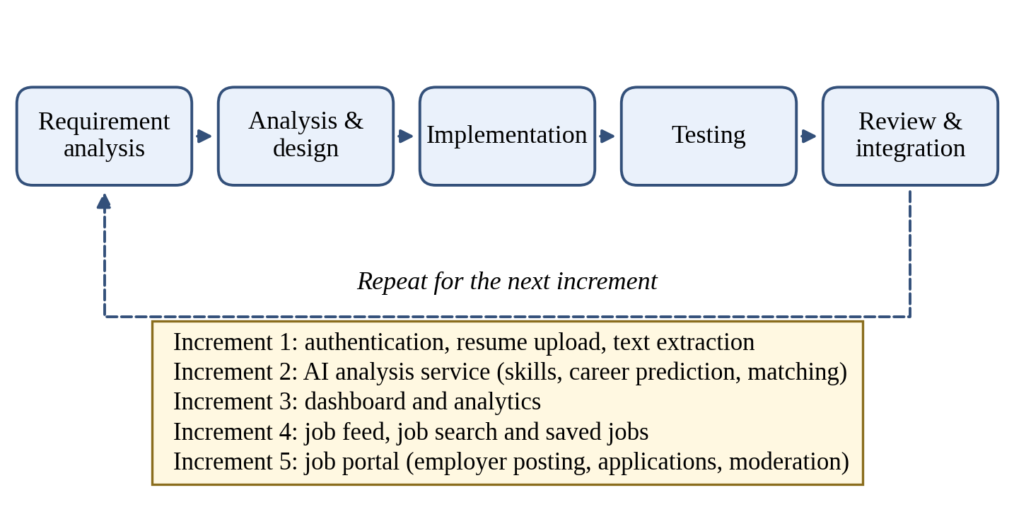
Figure 1.1: Iterative and incremental development model used in the project
The first increment delivered authentication, resume upload and PDF text extraction. The second added the FastAPI analysis service for skills, career prediction and matching. The third produced the dashboard and analytics. The fourth added job feeds, job search and saved jobs. The fifth turned the system into a job portal by adding employers, job posting, moderation, applications and applicant ranking.

1.6 Report Organization
This report contains five chapters. Chapter 1 introduces the project, the problem, objectives, scope and methodology. Chapter 2 explains the background concepts and reviews similar systems and research. Chapter 3 presents the system analysis and design, including requirements, feasibility, UML models, database design and algorithms. Chapter 4 describes the tools, the implementation of each module, the test cases and the analysis of results. Chapter 5 gives the conclusion and future recommendations. References and appendices with screenshots and source code follow the last chapter.

CHAPTER 2: BACKGROUND STUDY AND LITERATURE REVIEW

2.1 Background Study
This section explains only those concepts that are directly used in the project and shows how each one appears in the system.

2.1.1 Text Extraction from PDF Resumes
A PDF stores characters with their positions on a page, not as a logical stream of paragraphs. The Laravel service therefore calls the pdftotext tool of the Poppler library [2] through the spatie/pdf-to-text package [3] to convert an uploaded resume into plain text. This works for resumes created in word processors, but a scanned resume contains only pictures of text and returns little or nothing. For that reason the system checks the extracted text and shows an error when it is empty.

2.1.2 Named Entity Recognition with spaCy
Named entity recognition (NER) labels parts of a sentence as persons, organisations, places and so on. The AI service uses a pre-trained spaCy pipeline [4] to pick the candidate’s name and the organisations mentioned in the resume, while regular expressions find e-mail addresses. These details are used to summarise the resume and to make the analysis output easier to read.

2.1.3 Skill Extraction by Pattern Matching
Skills are the most important signal in a resume. The system keeps a SKILLS_DATABASE and searches the resume text for each skill with a regular expression that requires word boundaries. Word boundaries prevent false matches, for example finding “java” inside “javascript”. Pattern matching is fast and fully explainable, but it can only find skills that exist in the database, which is why expanding the skill list is the first future improvement.

2.1.4 TF-IDF and Cosine Similarity
Term Frequency–Inverse Document Frequency (TF-IDF) converts text into numbers by giving a high weight to words that are frequent in one document but rare across all documents [5], [6]. Two documents are then compared by the angle between their weight vectors. With the scikit-learn implementation [7], the similarity between a resume vector A and a job-description vector B is:
similarity(A, B) = (A · B) / (‖A‖ × ‖B‖)
The value lies between 0 and 1; multiplied by 100 it becomes the job match percentage shown to the user and stored with every application.

2.1.5 Logistic Regression for Career Classification
Logistic regression is a supervised classifier that learns, from labelled examples, how strongly each word pattern points to each class [8]. In this project the training file careers.csv contains short skill descriptions labelled with a career. The TF-IDF vectoriser turns each description into numbers and the logistic regression model learns to predict the career label of a new resume. It is a good fit for a small dataset because it trains quickly, needs little tuning and gives class probabilities.

2.1.6 Hybrid Rule-based and Machine Learning Prediction
A rule-based predictor maps a set of required skills to a career (for example, a career is suggested when enough of its required skills are found). Its answers are easy to explain but limited to the careers written in the rules. A machine learning predictor can generalise to wording it has not seen, but its quality depends on the training data. The system runs both, which allows one to act as a cross-check of the other and keeps every result explainable.

2.1.7 Skill-gap Analysis and Resume Score
Once a target career is known, the skills extracted from the resume are compared with the skills that career requires. The difference gives the missing skills, and the share of required skills that are present gives the resume score:
Resume score (%) = (matched required skills / total required skills) × 100
Missing skills = required skills − skills found in the resume
Missing skills are also used to select courses and to generate suggestions on how to improve the resume.

2.1.8 Job Portals, Applicant Tracking and Moderation
A job portal has two kinds of users with opposite goals: employers who publish vacancies and candidates who apply to them. A basic applicant tracking flow moves every application through defined stages (submitted, under review, shortlisted, interview, selected or rejected). Because anyone can create a vacancy, a moderation step in which an administrator approves employers and postings protects candidates from fake or low-quality listings. Access is controlled by roles so that a job seeker cannot open employer or administrator functions.

2.1.9 Three-service Architecture, REST and JWT
The system follows a client–server design in which the browser talks to a REST API [9] and the API talks to a separate AI service. Laravel [10] is used for the business logic and the database, FastAPI [11] for the Python machine learning code, and React [12] for the interface. Users are authenticated with JSON Web Tokens (JWT) [13]: after login the server returns a signed token that the browser sends with each request, so the API does not need to keep a session for every user.

2.2 Literature Review

2.2.1 Existing Job Portals
Large platforms such as LinkedIn [14] and Indeed [15] let employers publish vacancies and candidates search and apply, and they offer profile-based job suggestions. In Nepal, Merojob [16] is a well-known portal where employers post vacancies and candidates submit applications. These portals are strong at connecting the two sides, but their main function is listing and applying; a student who wants to know which skills to learn for a chosen career gets limited direct guidance from them.

2.2.2 Resume Analysers
Tools such as Jobscan [17] compare a resume with a job description and report how well the keywords match, so that candidates can adjust their resume. This is the same idea as the match percentage used in this project. Such tools, however, focus on one resume and one job posting and are not themselves a hiring portal in which the employer receives ranked applicants.

2.2.3 Research on Resume Parsing and Matching
Bhatia et al. [18] describe an end-to-end approach that parses resumes and finds candidates for a job description using BERT [19], showing that neural language models can capture meaning beyond exact keywords. Sentence-BERT [20] makes such comparison efficient by producing a fixed-size embedding for a whole sentence or document, so two texts can be compared with cosine similarity. These methods are more powerful than TF-IDF, but they need heavier models and more computing resources. TF-IDF was therefore chosen for the current version, with sentence embeddings kept as a planned upgrade.
Skill taxonomies such as ESCO [21] and O*NET [22] list thousands of standardised skills and occupations. They are the natural source for replacing the small hard-coded skill list of this project with a much larger and consistent vocabulary.

2.2.4 Comparison and Research Gap
Table 2.1: Comparison of the proposed system with existing approaches
Aspect | General job portals | Resume analysers | Proposed system
Employers post vacancies | Yes | No | Yes, with admin moderation
Resume upload and parsing | Profile based | Yes | Yes (PDF)
Skill-gap and career prediction | Limited | Limited | Yes (rule-based + ML)
Course and interview suggestions | Rarely | Rarely | Yes
Match score for each applicant | Varies | For one resume only | Yes, applicants ranked
Open, self-hosted and extensible | No | No | Yes

The review shows that job portals, resume analysers and career-guidance tools usually exist as separate products. The gap addressed by this project is a single, self-hostable platform that gives the candidate guidance and the employer ranked applicants from the same analysis engine.

CHAPTER 3: SYSTEM ANALYSIS AND DESIGN
This chapter analyses what the system must do, checks whether it can be built, and then models it using the Unified Modeling Language [23]. The analysis models describe the problem from the user’s point of view. The design models refine them into the classes, components and deployment structure that were actually implemented.

3.1 System Analysis
The system has three types of users. A job seeker uploads resumes, receives AI analysis, searches jobs and applies to them. An employer manages a company profile, posts vacancies and reviews applicants. An administrator approves employers and job postings, manages users and refreshes external job feeds.

3.1.1 Requirement Analysis

Functional Requirements
The functional requirements are listed in Table 3.1 and illustrated by the use case diagram in Figure 3.1.
Table 3.1: Functional requirements
ID | Module | Requirement
FR-01 | Authentication | The system shall allow a visitor to register as a job seeker or an employer using a name, e-mail and password (at least 8 characters, one uppercase letter and one number).
FR-02 | Authentication | The system shall allow users to log in with e-mail and password, receive a JWT token, and log out.
FR-03 | Authorization | The system shall restrict every feature according to the role of the user (job seeker, employer or admin).
FR-04 | Resume analysis | The system shall accept one PDF resume of at most 2 MB with an optional job description.
FR-05 | Resume analysis | The system shall extract text from the PDF and report a clear error if no text can be read.
FR-06 | Resume analysis | The system shall extract the name, e-mail addresses, organisations and skills from the resume text.
FR-07 | Resume analysis | The system shall predict a suitable career using rule-based matching and a machine-learning classifier.
FR-08 | Resume analysis | The system shall calculate a resume score, the job match percentage and the list of missing skills.
FR-09 | Recommendation | The system shall recommend jobs, courses and interview questions and generate resume improvement suggestions.
FR-10 | History | The system shall store each analysis, let the user view past analyses and delete any of them.
FR-11 | Dashboard | The system shall show total analyses, average score, top career, latest analysis, a career distribution chart and a score history chart.
FR-12 | Jobs | The system shall let users search vacancies by keyword, including imported external listings.
FR-13 | Jobs | The system shall let job seekers save and unsave jobs and view saved jobs.
FR-14 | Jobs | The system shall let the admin refresh job listings from external sources (WeWorkRemotely, RemoteOK, Adzuna).
FR-15 | Employer | The system shall let an employer create and update a company profile.
FR-16 | Employer | The system shall let an employer post a job with title, description, required skills, location, job type, salary range and deadline.
FR-17 | Employer | The system shall let an employer edit or close own jobs and see the status of each posting.
FR-18 | Employer | The system shall show the applicants of an employer’s job ranked by match percentage and let the employer update each application status.
FR-19 | Application | The system shall let a job seeker apply to a published job with an analysed resume and an optional cover letter, only once per job.
FR-20 | Application | The system shall let a job seeker track the status of applications and withdraw an application.
FR-21 | Administration | The system shall let the admin approve or reject employer accounts and job postings.
FR-22 | Administration | The system shall let the admin view and manage users.

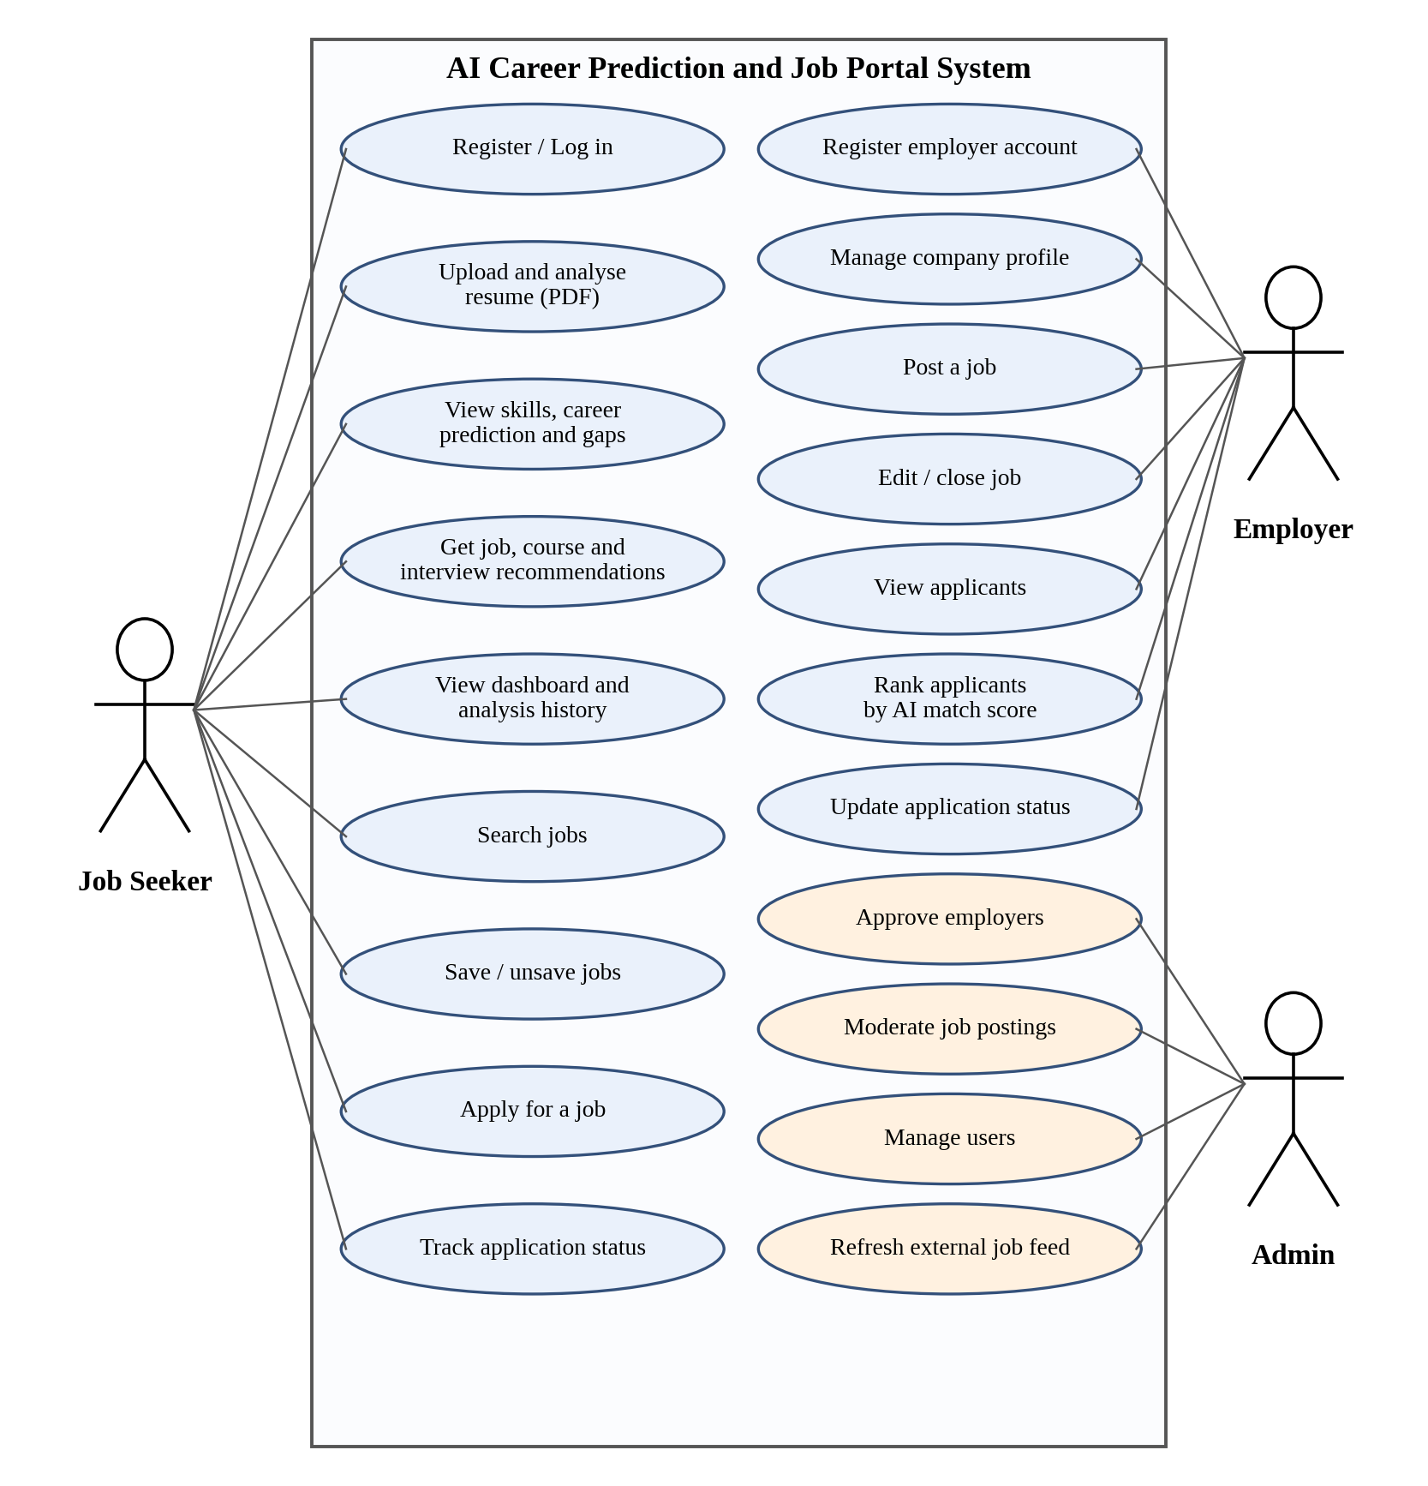
Figure 3.1: Use case diagram of the system
The most important use cases are described in Table 3.2 to Table 3.7.
Table 3.2: Use case description: Register and log in
Use case | Register and log in
Actor | Job seeker, employer
Precondition | The user is not logged in.
Main flow | 1. The user opens the registration page and enters name, e-mail, password and role.  2. The system validates the input and creates the account.  3. The user logs in and the system returns a JWT token.  4. The frontend stores the token and opens the dashboard for that role.
Alternative flow | If the e-mail already exists or the password is weak, the system shows a validation message. Wrong credentials give an “invalid login” message.
Postcondition | The user is authenticated and can use the features allowed for the role.

Table 3.3: Use case description: Upload and analyse resume
Use case | Upload and analyse resume
Actor | Job seeker
Precondition | The job seeker is logged in and has a PDF resume of at most 2 MB.
Main flow | 1. The user selects the PDF and optionally pastes a job description.  2. The frontend checks type and size and sends the file to the API.  3. The API stores the file, extracts the text and calls the AI service.  4. The AI service returns skills, career, score, missing skills and recommendations.  5. The API saves the analysis and the frontend displays it.
Alternative flow | If the file is invalid, no text can be extracted, or the AI service is unavailable, an error message is shown and nothing is saved.
Postcondition | A new analysis is stored in the history and counted on the dashboard.

Table 3.4: Use case description: Search and save jobs
Use case | Search and save jobs
Actor | Job seeker
Precondition | The job seeker is logged in.
Main flow | 1. The user enters a keyword in the job search.  2. The system returns matching published and imported jobs.  3. The user opens a job and saves it.
Alternative flow | If no job matches, the system shows an empty-result message.
Postcondition | The job appears in the user’s saved jobs.

Table 3.5: Use case description: Apply for a job
Use case | Apply for a job
Actor | Job seeker
Precondition | The job is published and open; the seeker has at least one analysed resume and has not applied before.
Main flow | 1. The user opens the job and selects “Apply”.  2. The user chooses a resume and writes an optional cover letter.  3. The system compares the resume with the job requirements and stores the match percentage and missing skills.  4. The application is created with the status “submitted”.
Alternative flow | If the job is closed or the seeker has already applied, the system rejects the request with a message.
Postcondition | The employer can see the application in the ranked applicant list.

Table 3.6: Use case description: Post a job
Use case | Post a job
Actor | Employer
Precondition | The employer account is approved and the employer is logged in.
Main flow | 1. The employer fills in the job form.  2. The system validates it and saves the job with the status “pending approval”.  3. After admin approval the job becomes “published”.
Alternative flow | If the admin rejects the job, the employer sees the remarks, edits the job and submits it again.
Postcondition | The published job is visible to job seekers until it is closed or the deadline passes.

Table 3.7: Use case description: Review applicants
Use case | Review applicants
Actor | Employer
Precondition | The employer has at least one published job with applications.
Main flow | 1. The employer opens a job and selects “Applicants”.  2. The system lists applicants ordered by match percentage.  3. The employer reads the skills summary and updates the status (under review, shortlisted, interview, selected or rejected).
Alternative flow | If the job has no applicants, an empty list is shown.
Postcondition | The job seeker sees the new status in “My applications”.

Non-functional Requirements
Table 3.8: Non-functional requirements
ID | Category | Requirement
NFR-01 | Performance | A normal resume analysis should be returned within about 10 seconds; pages other than analysis should load within 2 seconds on a normal connection.
NFR-02 | Security | Passwords are stored hashed, all protected routes require a valid JWT, uploaded resumes are stored in a private folder and inputs are validated on the server, following common OWASP guidance [24].
NFR-03 | Rate limiting | Upload and analysis requests are limited to 10 per minute per user to prevent abuse.
NFR-04 | Usability | The interface should be simple, responsive on mobile and desktop, and show clear messages for every error.
NFR-05 | Reliability | A failure in the AI service or in PDF extraction must not corrupt stored data; a failed analysis saves nothing.
NFR-06 | Maintainability | Frontend, API and AI service are separate modules that can be changed independently.
NFR-07 | Portability | The system runs on Windows, Linux and macOS with PHP, Node.js and Python installed.
NFR-08 | Privacy | A user can see and delete only his or her own resumes and analyses.

3.1.2 Feasibility Analysis

Technical Feasibility
All technologies used are mature and open source: React [12] with Vite [25], Laravel [10] with SQLite [26], and FastAPI [11] with scikit-learn [7] and spaCy [4]. Extensive documentation exists for each. The system runs on an ordinary laptop and needs no GPU because TF-IDF and logistic regression are lightweight. The project is therefore technically feasible.

Operational Feasibility
The system is operated through a web browser and needs no special training. Job seekers only upload a PDF, employers fill in a simple form, and administrators use a small moderation panel. It solves the real problems described in Chapter 1, so its users are likely to accept it. The project is operationally feasible.

Economic Feasibility
Because every tool is free and open source, the only costs are internet, documentation and optional hosting. Table 3.9 gives an estimate.
Table 3.9: Estimated cost of the project (NPR)
Item | Basis | Cost (NPR)
Software licences | Open-source tools only | 0
Internet | 4 months × 1,500 | 6,000
Printing and binding | Report copies | 5,000
Domain name (optional) | 1 year | 2,000
Demo hosting (optional) | 1 month | 6,000
Miscellaneous | Contingency | 3,000
Total |  | 22,000

The estimated cost is small compared with the benefit, so the project is economically feasible.

Schedule Feasibility
The work was planned over 16 weeks and divided into overlapping phases, as shown in Figure 3.2 and Table 3.10. The AI, API and frontend work overlapped, and the job-portal module was added as the last increment.
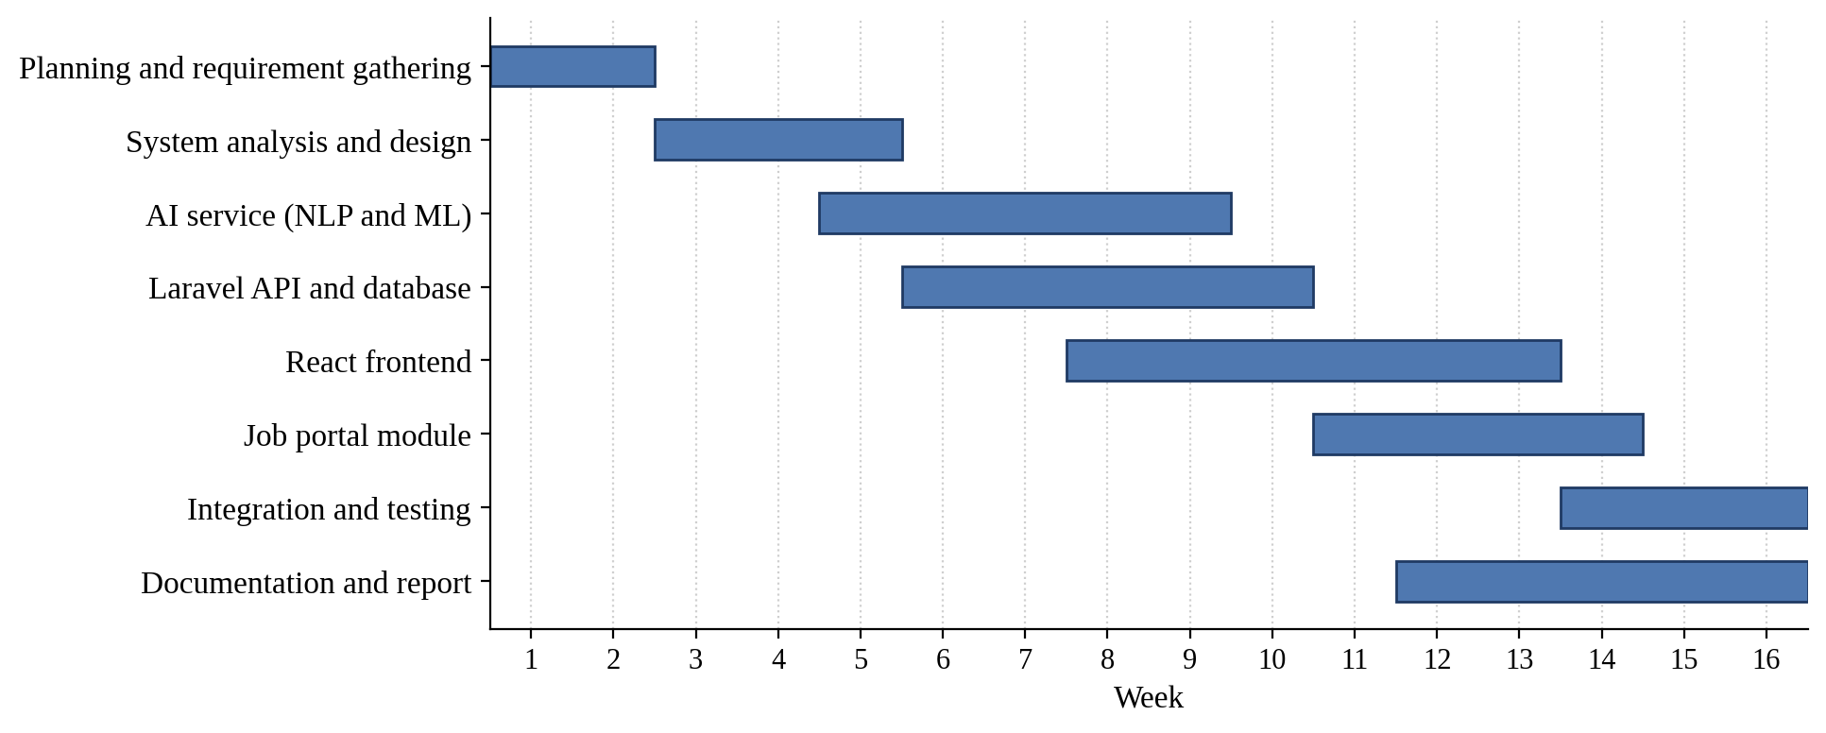
Figure 3.2: Gantt chart of the project schedule
Table 3.10: Project phases and duration
Phase | Main activities | Weeks
Planning | Problem study, requirement gathering, tool selection | 1–2
Analysis and design | Use cases, UML models, database design | 3–5
AI service | NER, skill extraction, career model, matching, recommendations | 5–9
Laravel API | Authentication, upload, PDF extraction, persistence, analytics | 6–10
React frontend | Pages, dashboard, charts, job search | 8–13
Job portal module | Employer profile, job posting, applications, moderation, ranking | 11–14
Integration and testing | Unit tests, system tests, bug fixing | 14–16
Documentation | Project report | 12–16

3.1.3 Object Modelling using Class and Object Diagrams
The analysis class diagram in Figure 3.3 shows the main business entities and their relationships. A user may own one company profile (only employers do), upload many resumes and submit many applications. A company posts many jobs, and each job receives many applications. Every application refers to exactly one resume, one job and one user. Saving a job is a many-to-many association between users and jobs.
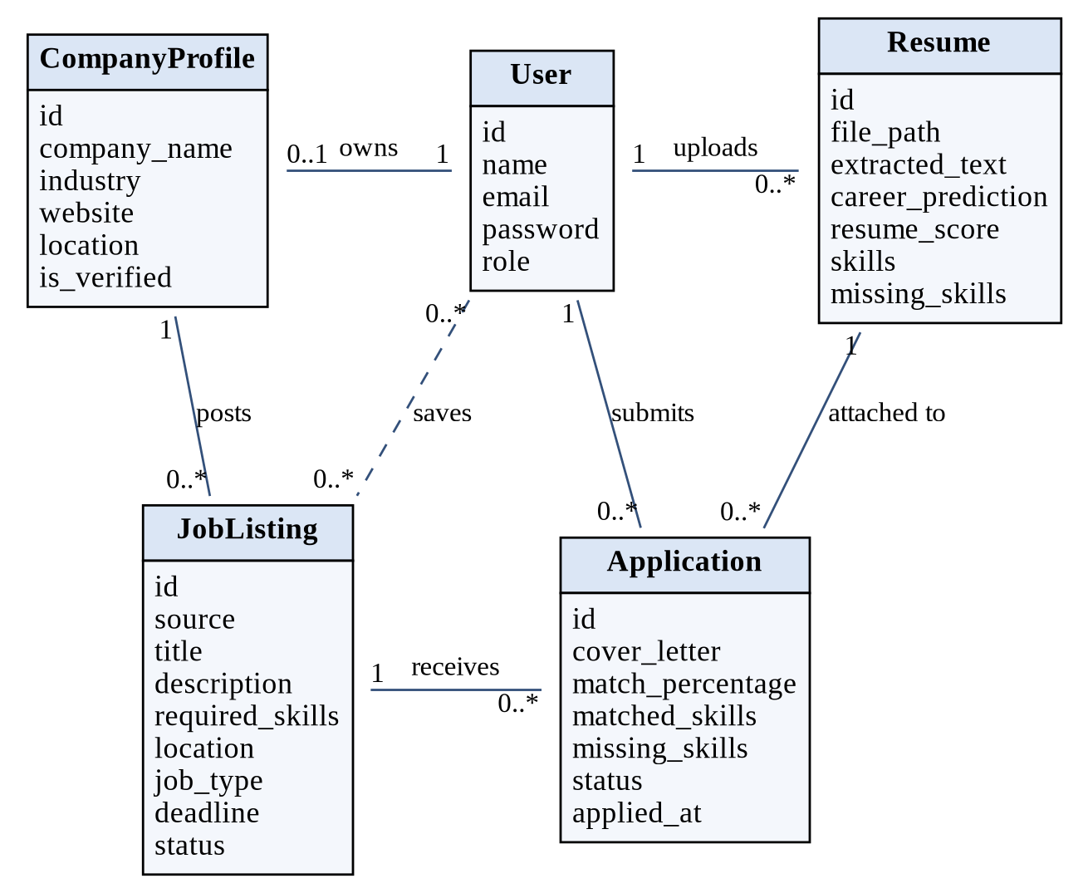
Figure 3.3: Class diagram (analysis level)
Figure 3.4 shows one sample state of the system as an object diagram: a job seeker with an analysed resume applies to a published job posted by a verified company.
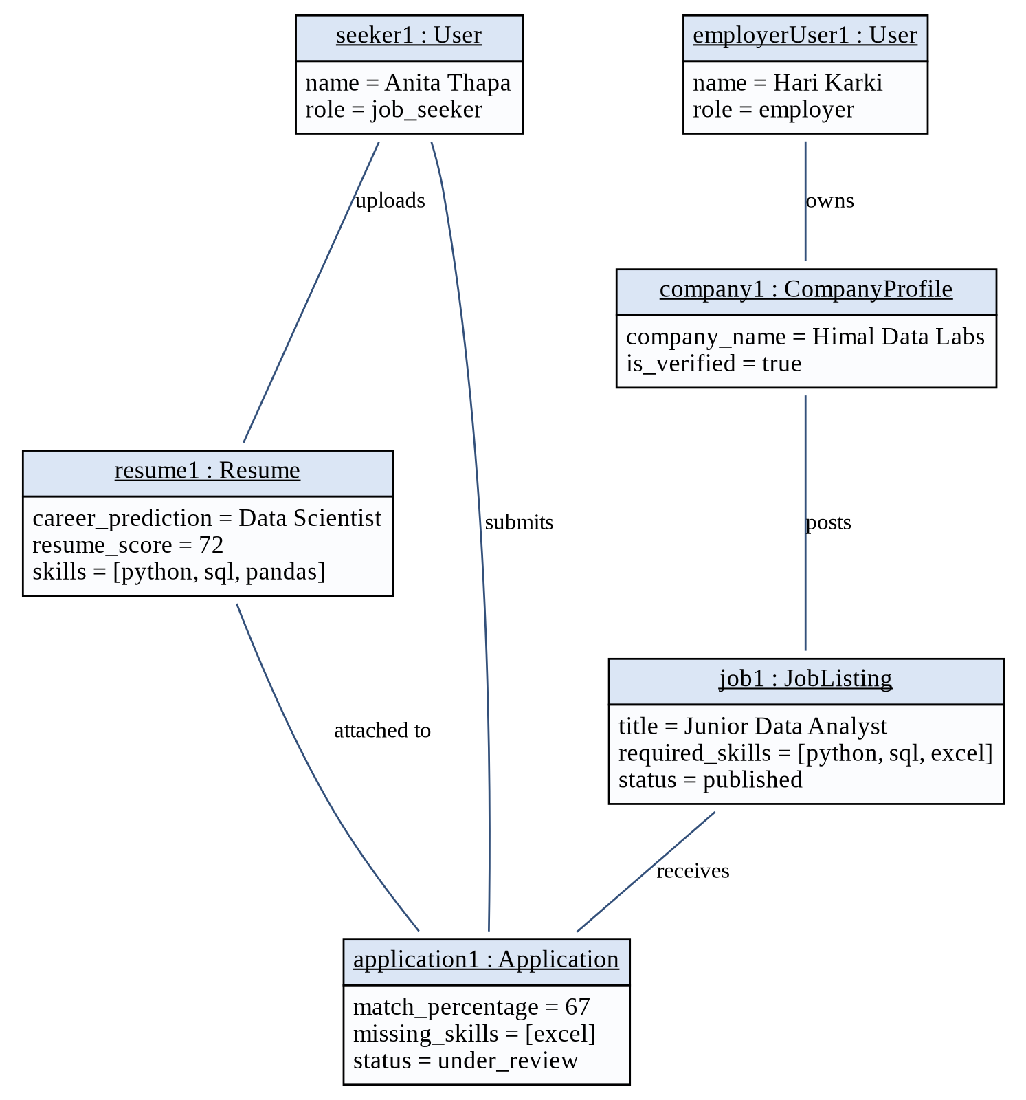
Figure 3.4: Object diagram with sample data

3.1.4 Dynamic Modelling using State and Sequence Diagrams
Two entities have a life cycle that changes with time. An application moves from “submitted” through review to a final decision (Figure 3.5). A job moves from draft to pending approval, published and finally closed or expired (Figure 3.6).
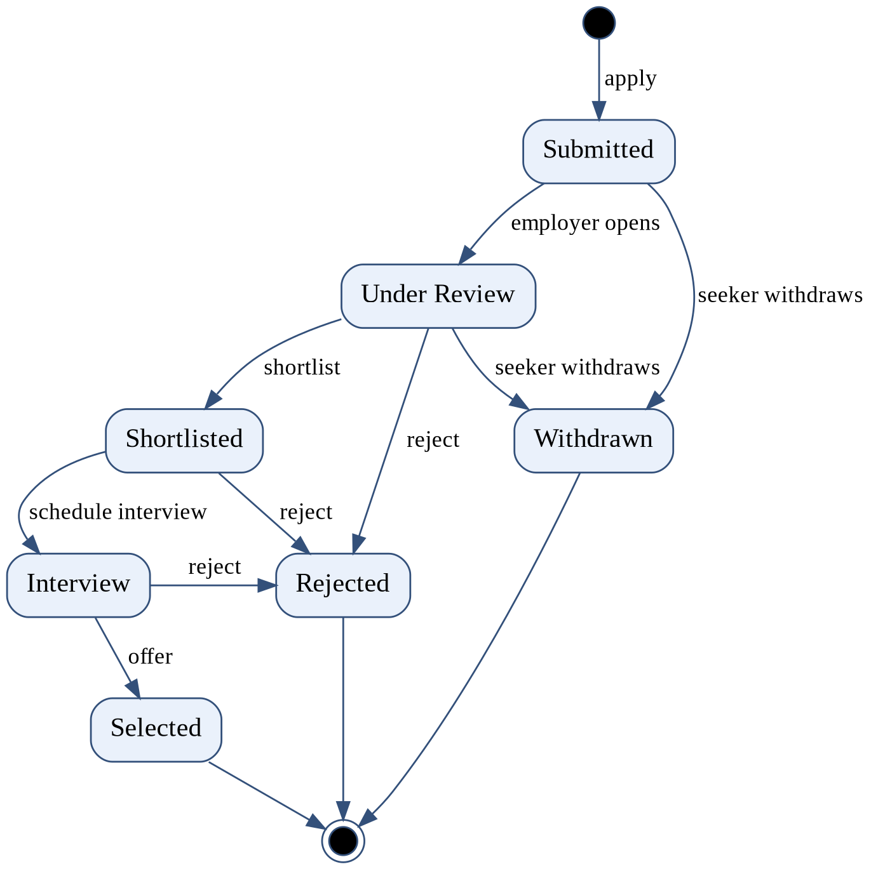
Figure 3.5: State diagram of an application
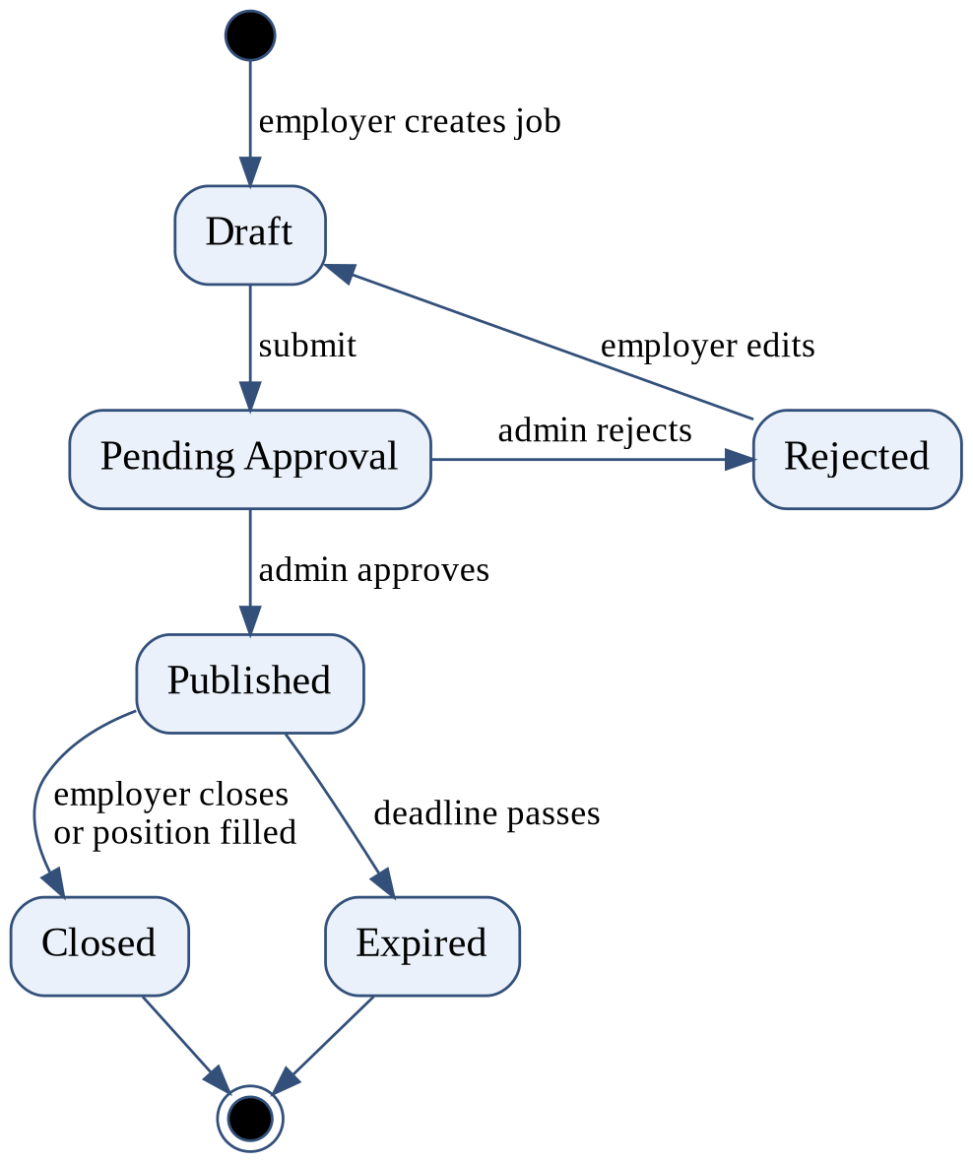
Figure 3.6: State diagram of a job posting
The interaction between the user, the frontend, the API, the AI service and the database during resume analysis is shown in Figure 3.7. The job-portal interaction, from posting to application, is shown in Figure 3.8.
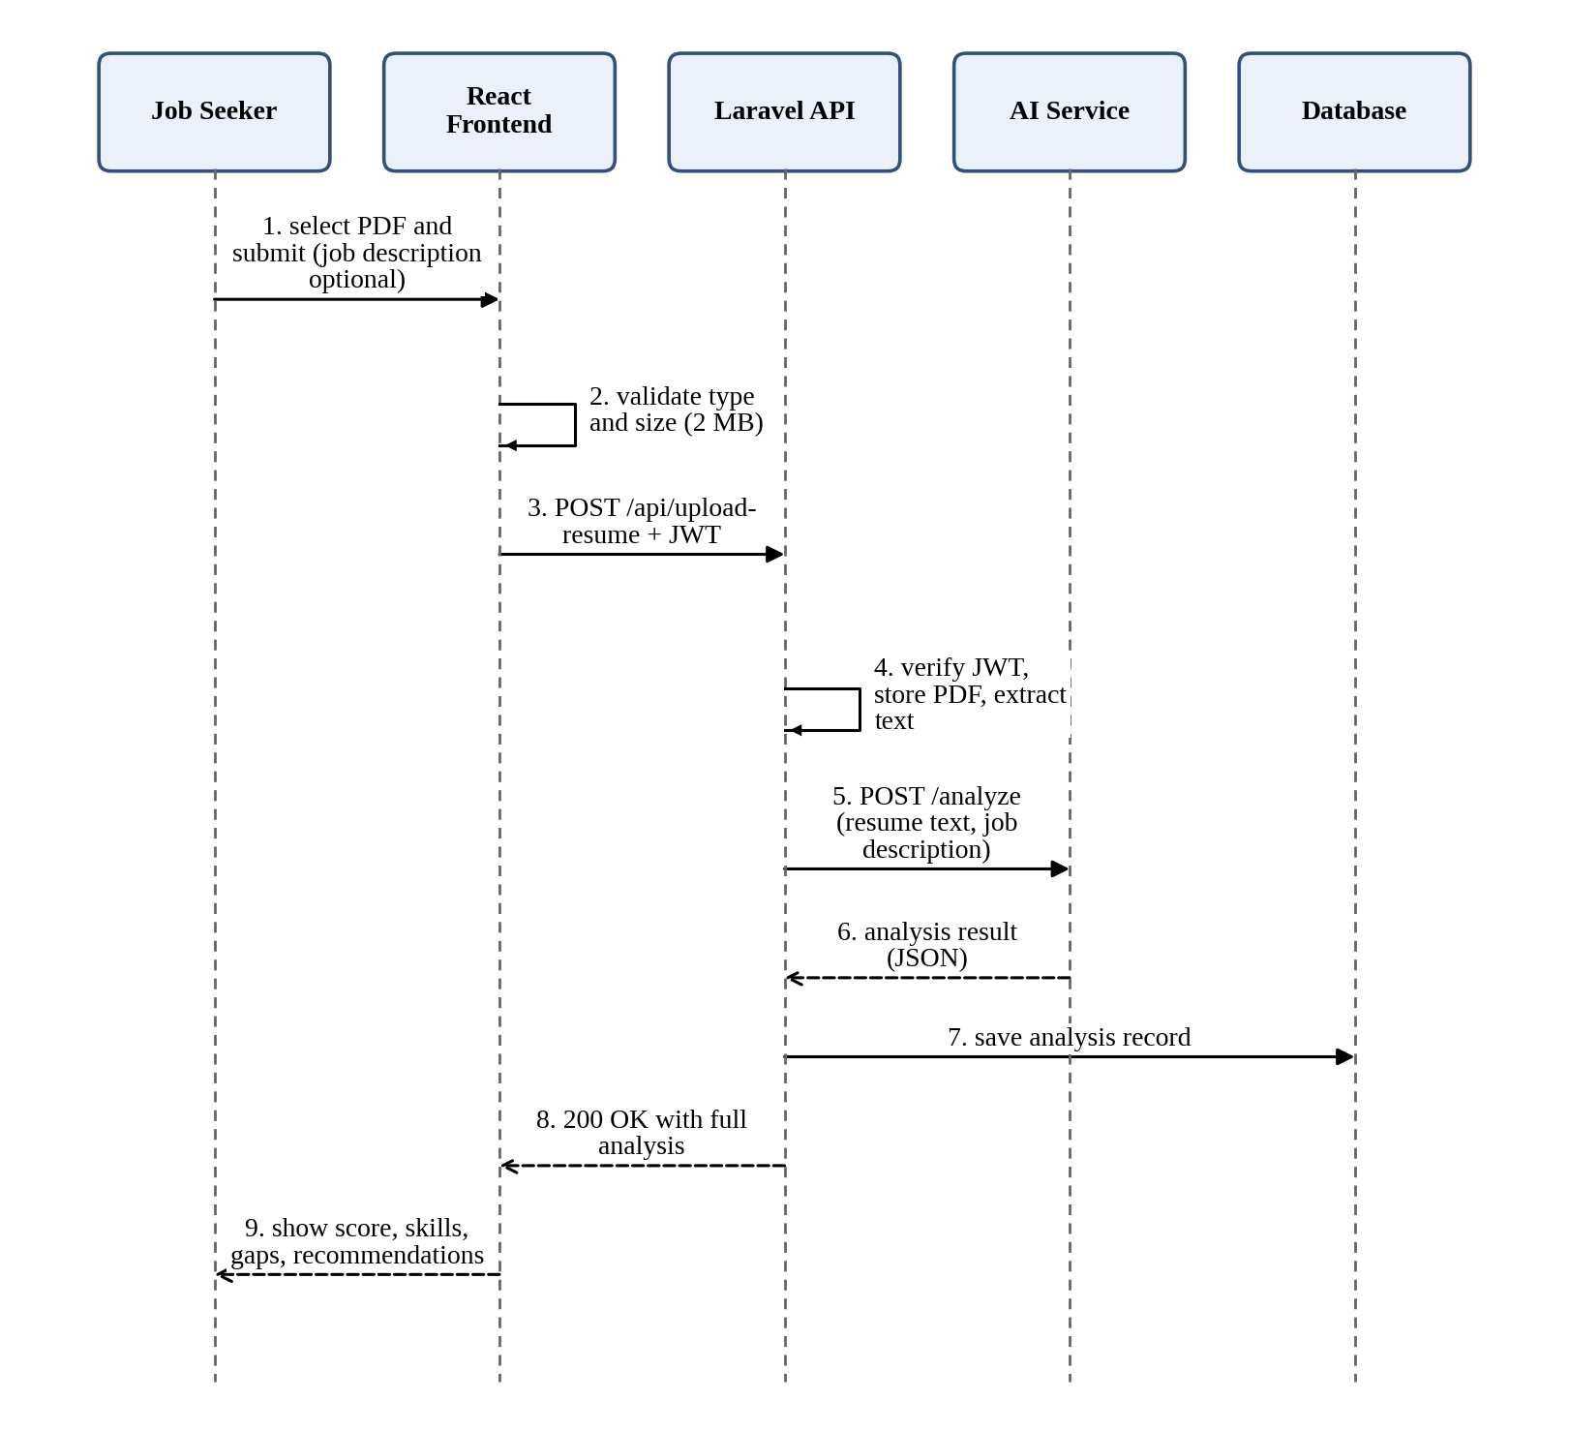
Figure 3.7: Sequence diagram of resume upload and analysis
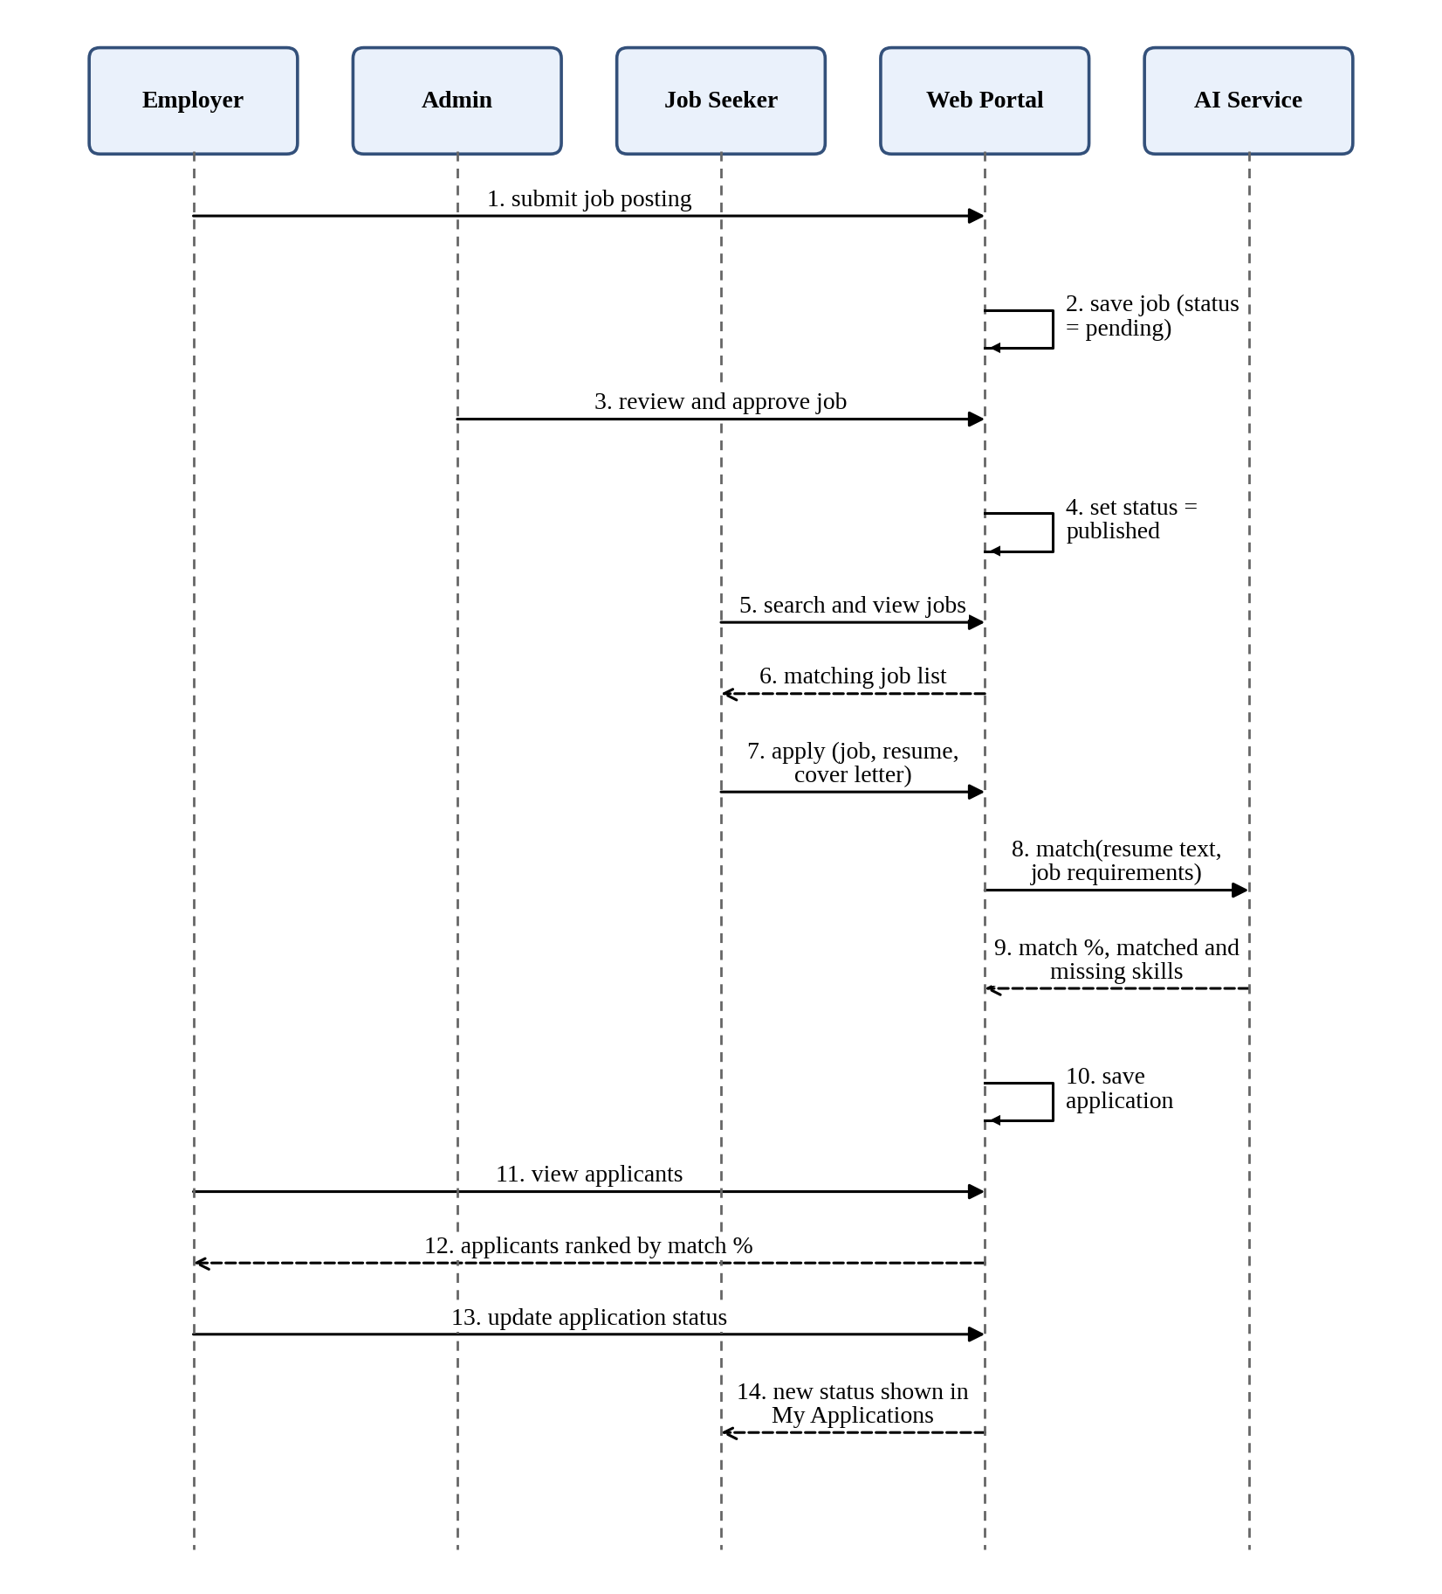
Figure 3.8: Sequence diagram of job posting, application and ranking

3.1.5 Process Modelling using Activity Diagrams
Figure 3.9 shows the activities of a job seeker analysing a resume, including the two error paths (invalid file and failed extraction). Figure 3.10 shows the job-posting and application process across the employer, admin, system and job seeker.
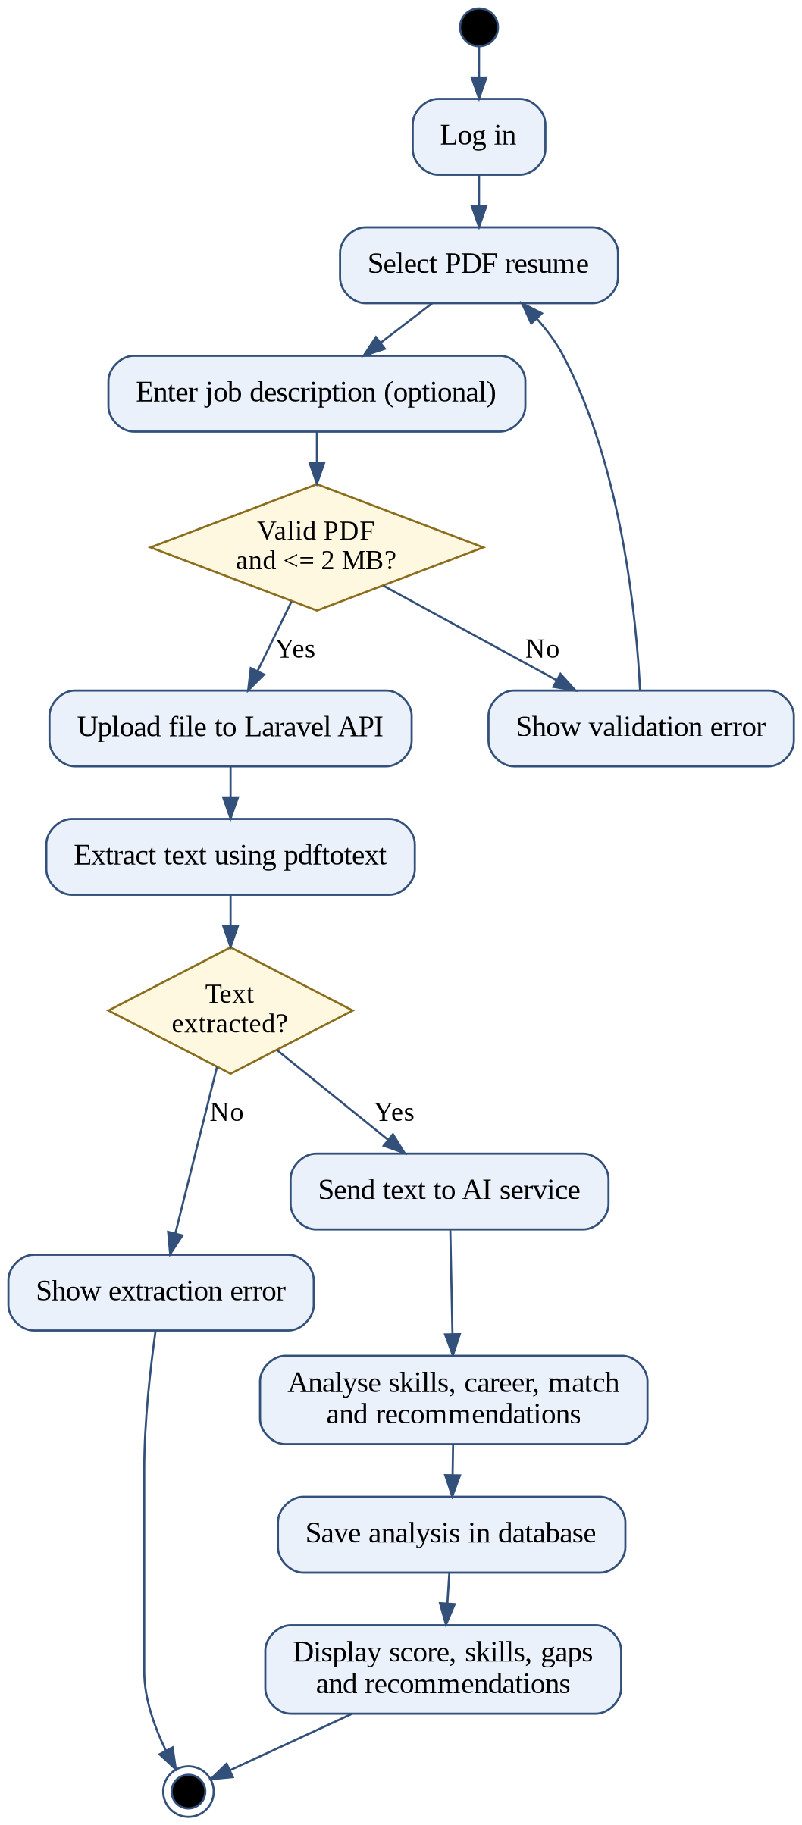
Figure 3.9: Activity diagram of resume analysis
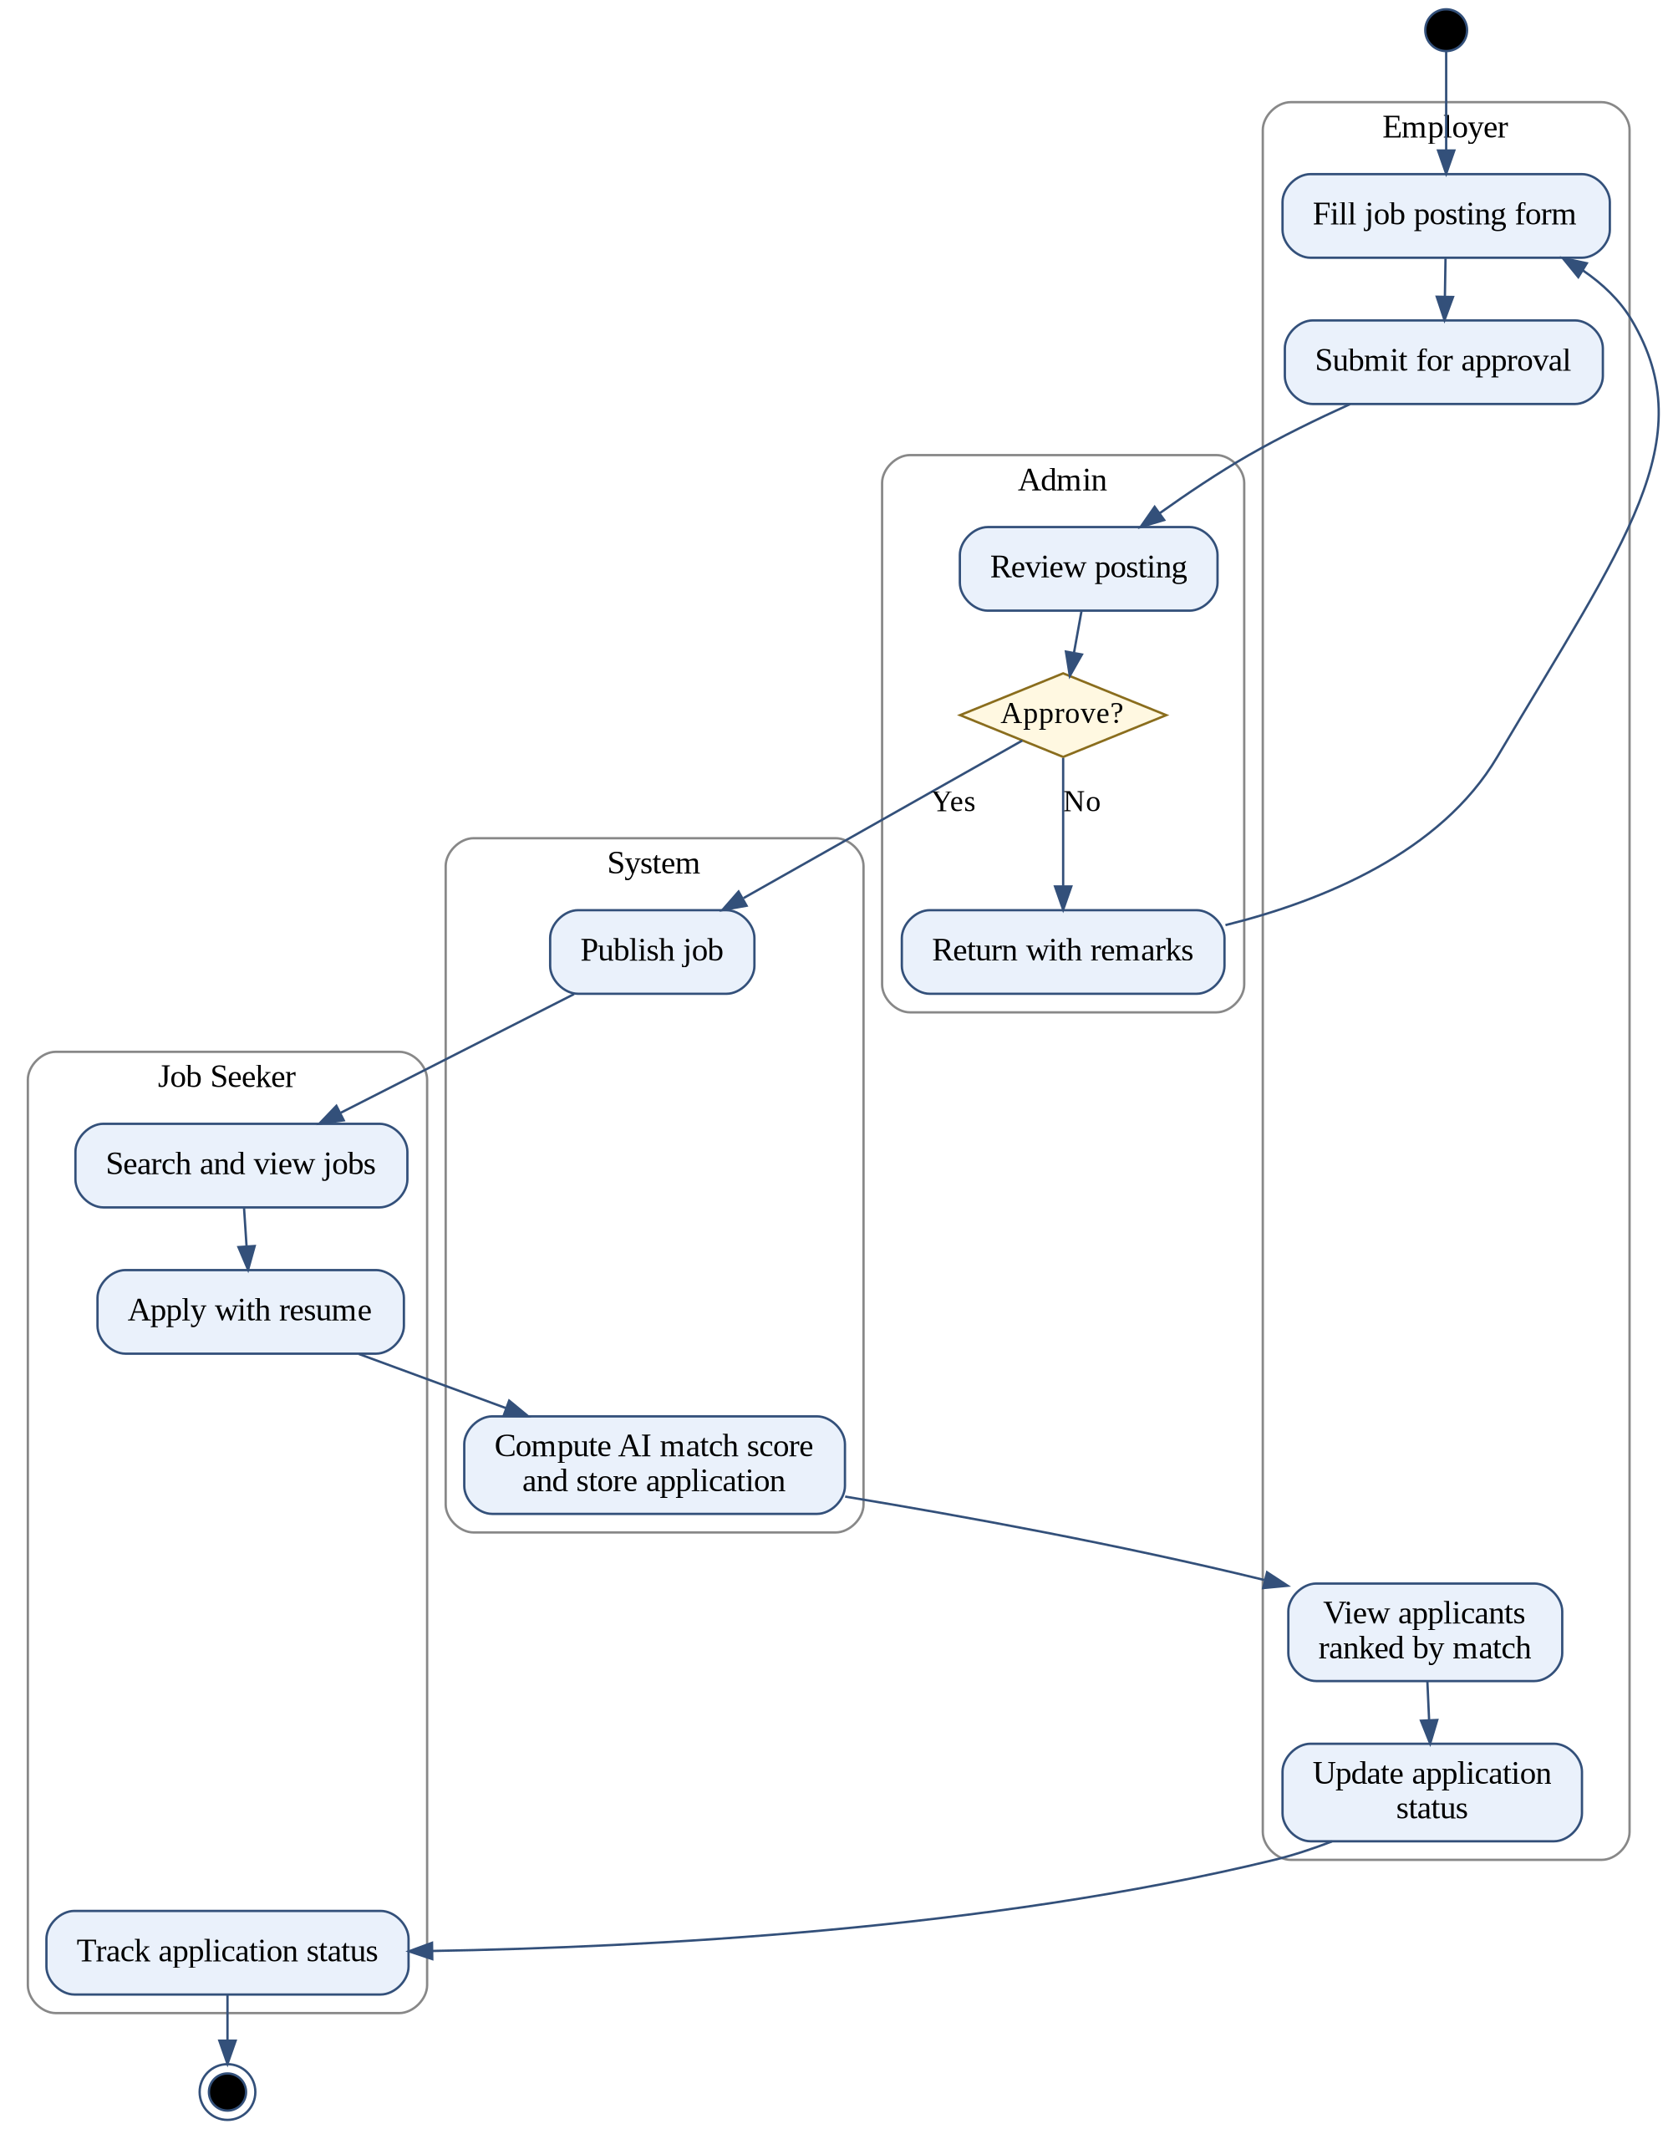
Figure 3.10: Activity diagram of job posting and application

3.2 System Design

3.2.1 Architectural and Database Design
The system follows a layered three-service architecture (Figure 3.11). The React frontend talks only to the Laravel API over HTTPS with a JWT. The API alone accesses the database and file storage and is the only caller of the AI service, which keeps the AI service unreachable for end users. External job sources are read by the AI service.
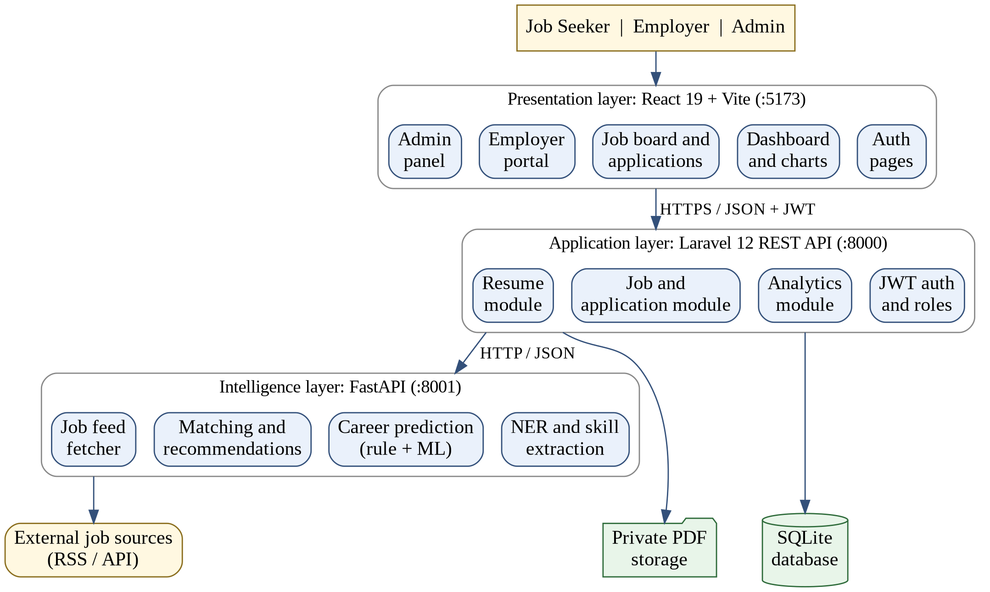
Figure 3.11: System architecture
The relational schema is shown in Figure 3.12 and the main tables are described in Table 3.11 to Table 3.13. Long list values such as skills are stored as JSON columns.
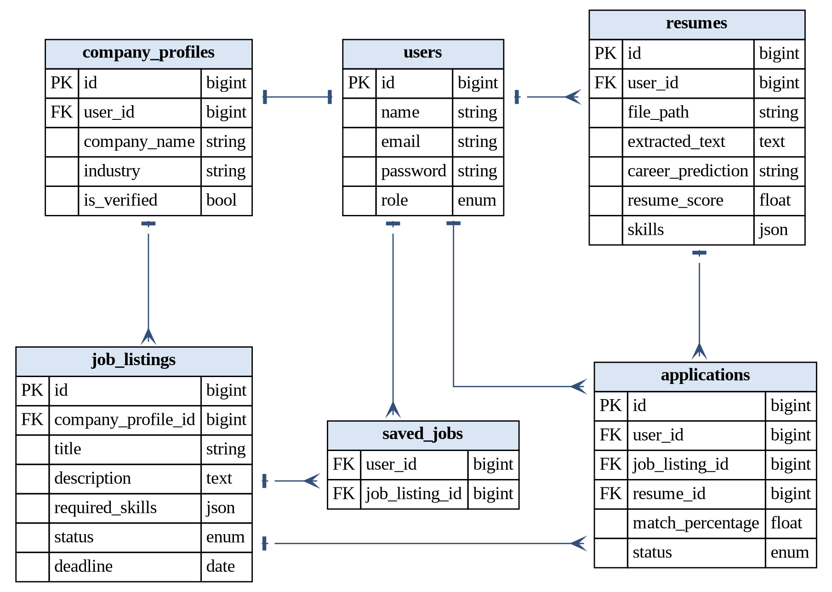
Figure 3.12: Database schema (relational)
Table 3.11: Data dictionary of users and company_profiles
Table | Field | Type | Description
users | id, name, email | bigint, string, string | Primary key, full name, unique e-mail
users | password, role | string, enum | Hashed password; job_seeker, employer or admin
company_profiles | user_id (FK) | bigint | Owner employer account
company_profiles | company_name, industry, website, location | string | Company details shown on jobs
company_profiles | is_verified | boolean | Set by admin after approval

Table 3.12: Data dictionary of resumes and job_listings
Table | Field | Type | Description
resumes | user_id (FK), file_path | bigint, string | Owner and private PDF location
resumes | extracted_text | text | Text produced by pdftotext
resumes | match_percentage, resume_score | float | Match with optional job description; skill coverage
resumes | career_prediction, skills, missing_skills | string, json, json | Analysis output
job_listings | source, external_id, url | string | Origin of imported jobs (internal for posted jobs)
job_listings | company_profile_id (FK) | bigint, nullable | Employer that posted the job
job_listings | title, description, required_skills | string, text, json | Vacancy content used for matching
job_listings | location, job_type, salary, deadline | string, date | Filter and display fields
job_listings | status, posted_at | enum, timestamp | draft, pending, published, closed, rejected

Table 3.13: Data dictionary of applications and saved_jobs
Table | Field | Type | Description
applications | user_id, job_listing_id, resume_id (FK) | bigint | Applicant, job and resume used; unique per user and job
applications | cover_letter | text | Optional message to the employer
applications | match_percentage, matched_skills, missing_skills | float, json | Computed by the AI service at application time
applications | status, applied_at | enum, timestamp | submitted to withdrawn (see state diagram)
saved_jobs | user_id, job_listing_id (FK) | bigint | Pivot table for saved jobs

3.2.2 Refinement of Class, Object, State, Sequence and Activity Diagrams
The analysis models were refined by adding data types, visibility and operations to the entity classes (Figure 3.13) and by adding the controllers and services that implement the use cases (Figure 3.14). The object diagram of Figure 3.4 needed no structural change: its attributes already follow the refined classes.
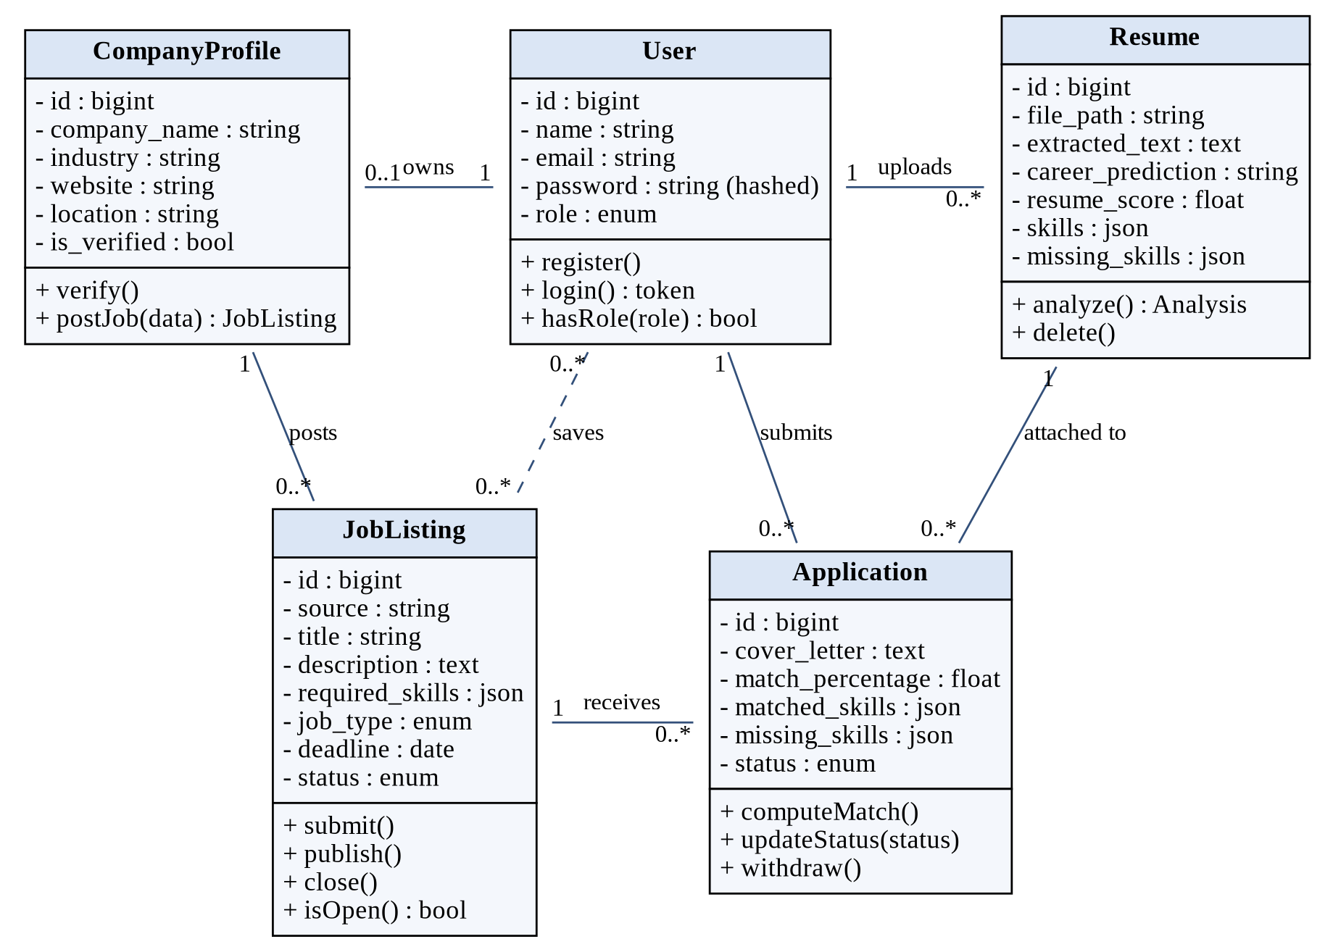
Figure 3.13: Refined class diagram of the domain layer
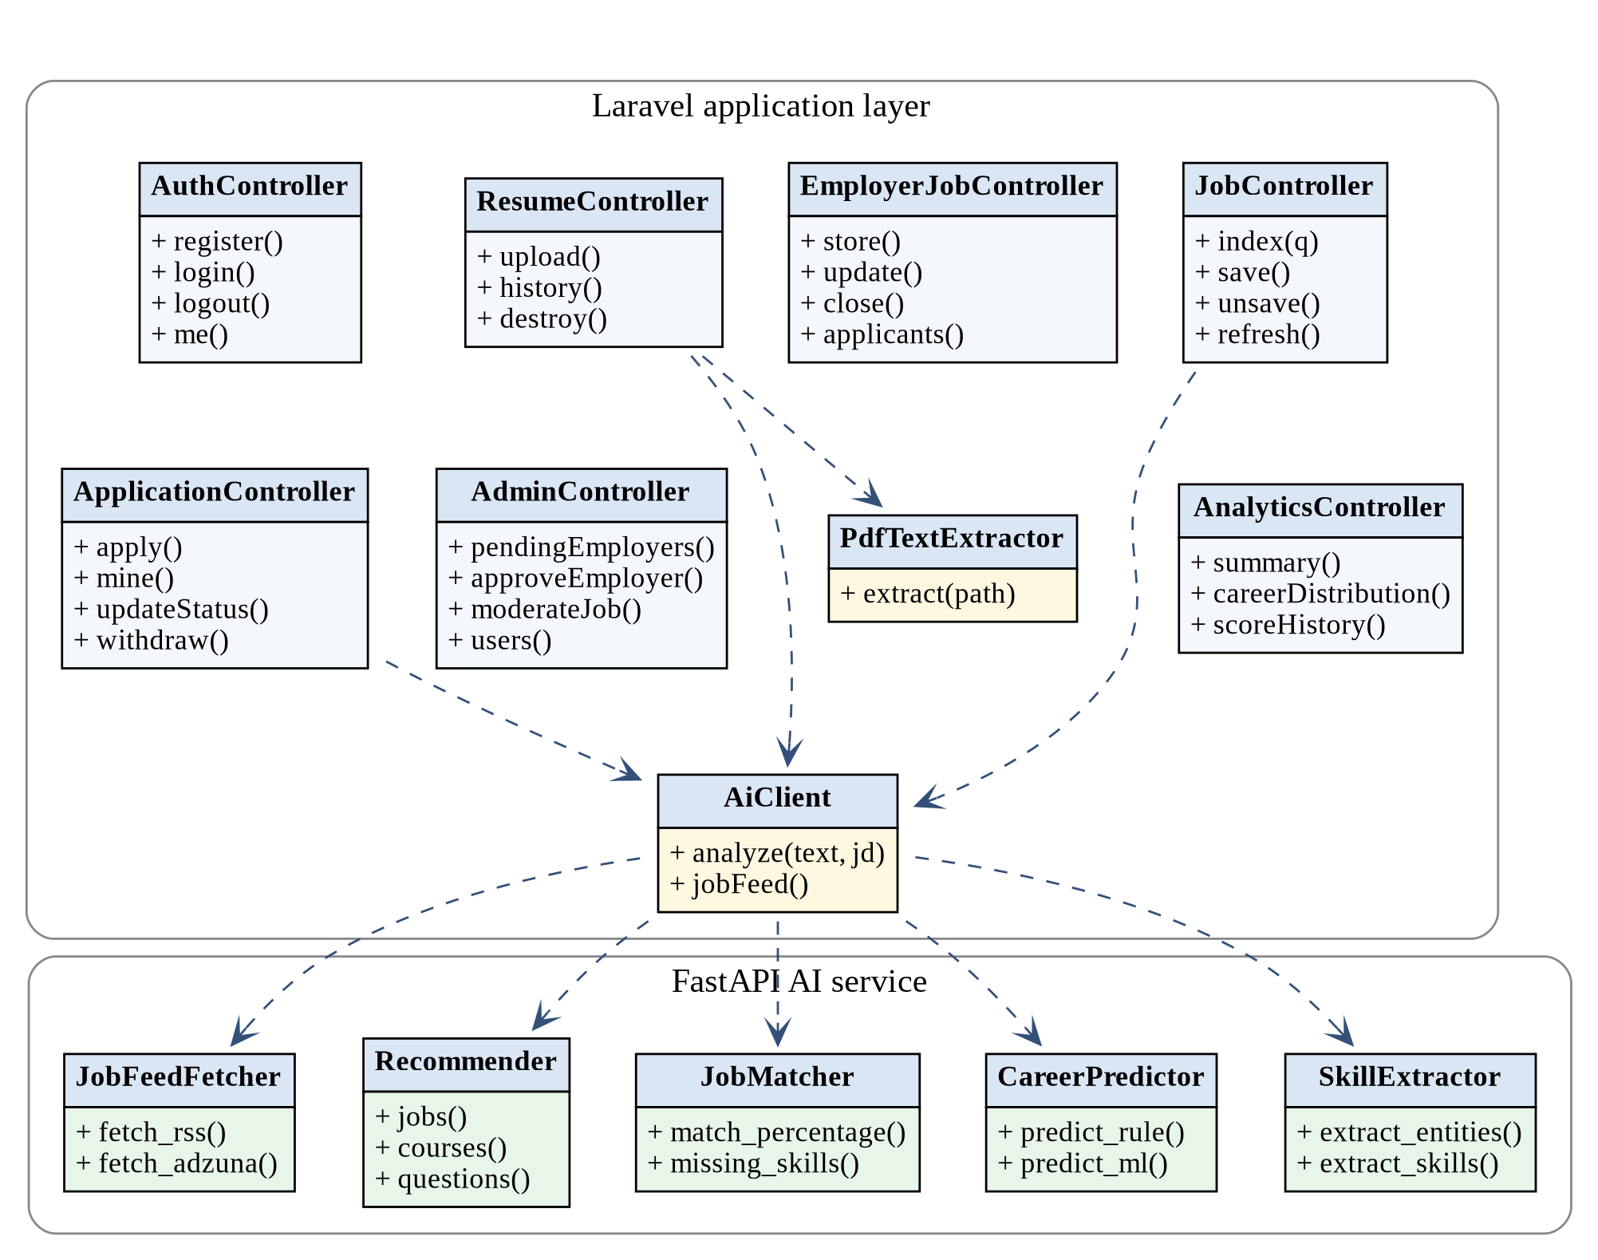
Figure 3.14: Class diagram of the controller and service layer
The application and job state machines of Figure 3.5 and Figure 3.6 are unchanged. A third state machine was added during design to describe the processing of one uploaded resume (Figure 3.15); it makes clear that a failed analysis is never saved.
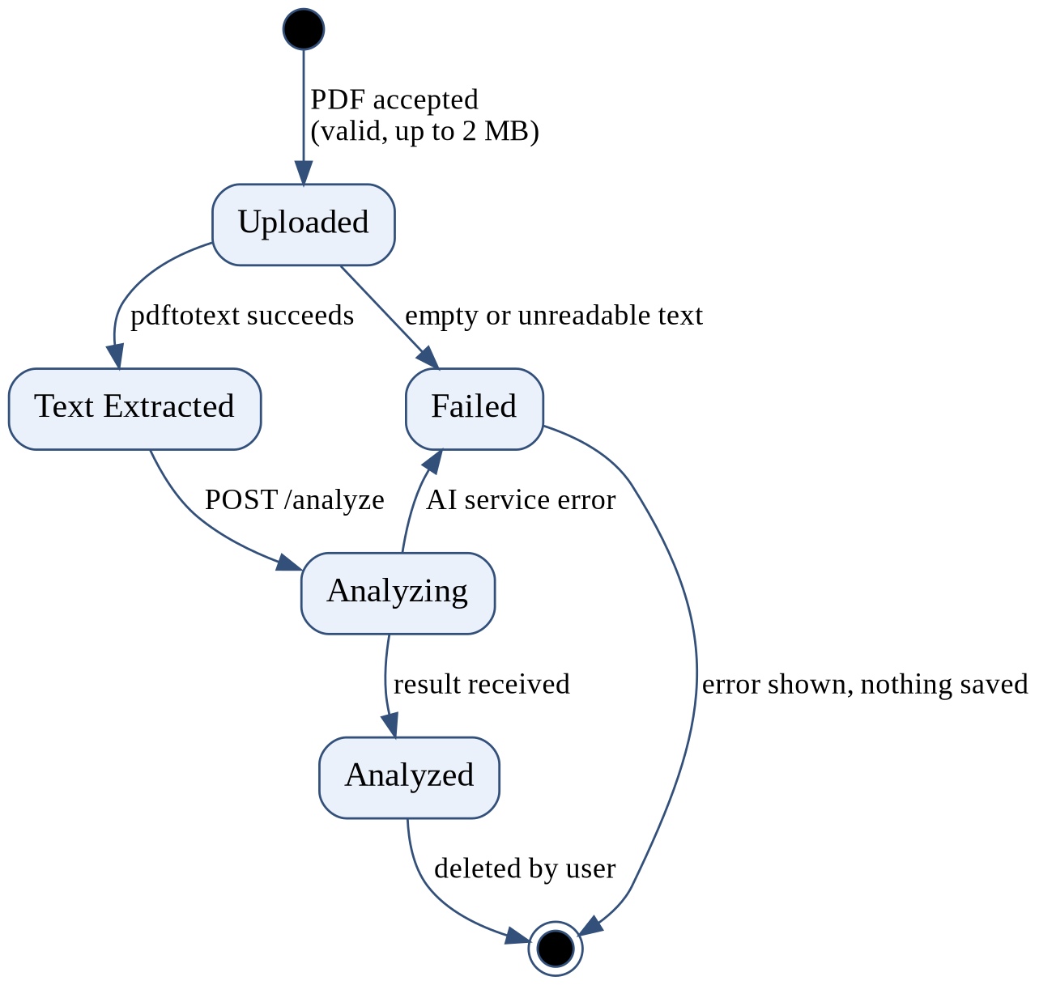
Figure 3.15: Refined state diagram of resume processing
The sequence diagrams were refined to show the actual classes and routes. Figure 3.16 shows the resume analysis inside the API and AI service, and Figure 3.17 shows how an application is created, ranked and updated.
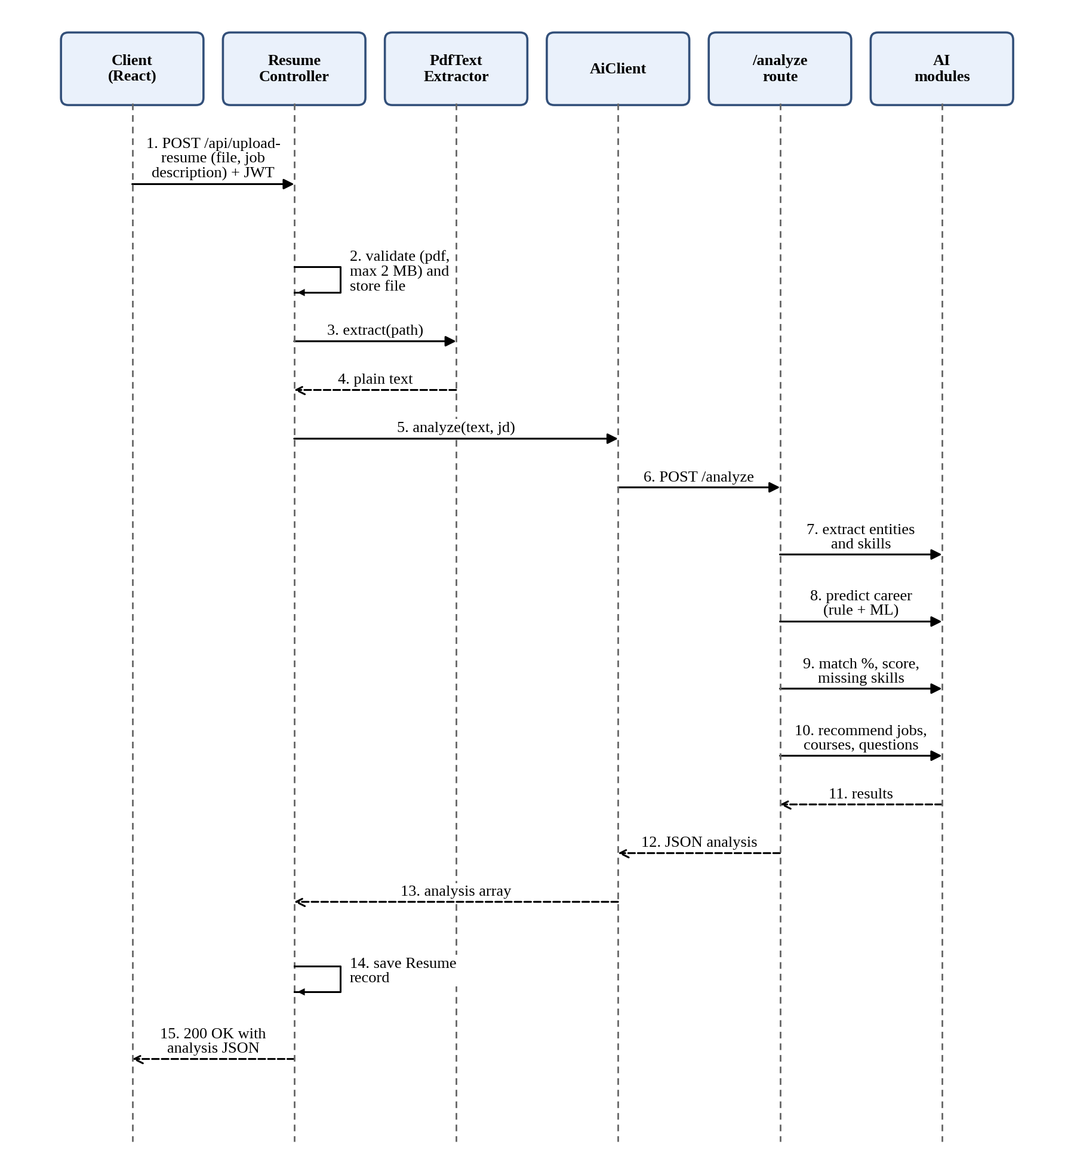
Figure 3.16: Refined sequence diagram of resume analysis
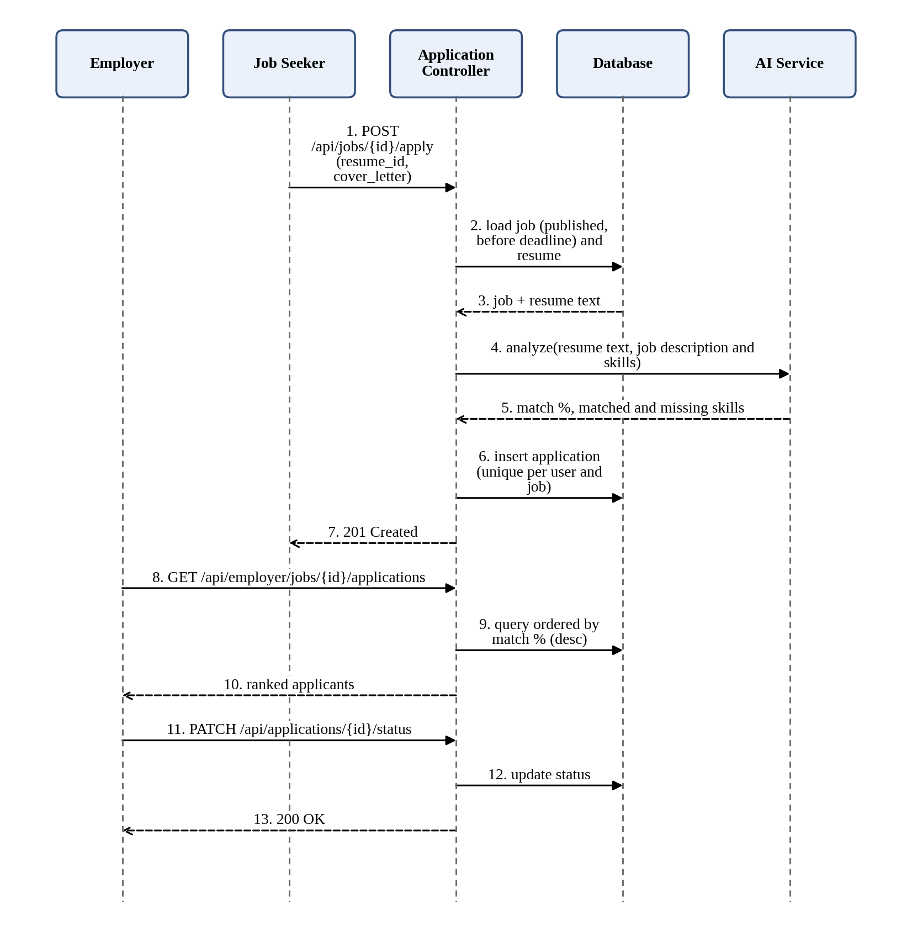
Figure 3.17: Refined sequence diagram of applying and ranking applicants
The activity inside the AI service was refined into the detailed pipeline of Figure 3.18, including the decision on whether a job description was supplied.
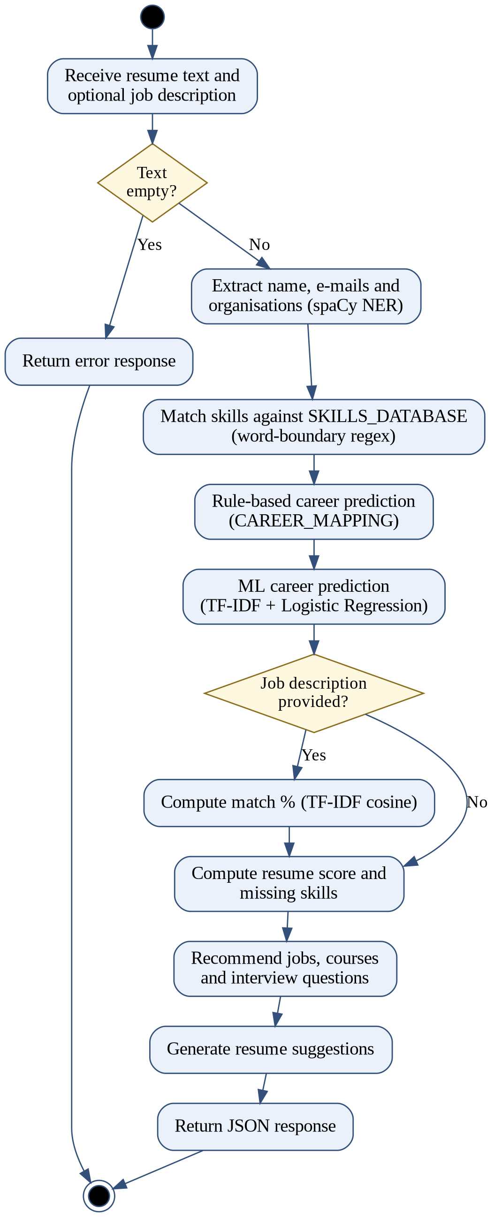
Figure 3.18: Refined activity diagram of the AI analysis pipeline

3.2.3 Component Diagram
Figure 3.19 shows the software components and their dependencies. Every request enters through the JWT and role middleware of the Laravel API, which dispatches it to a controller. Only the resume, application and job controllers use the AI client.
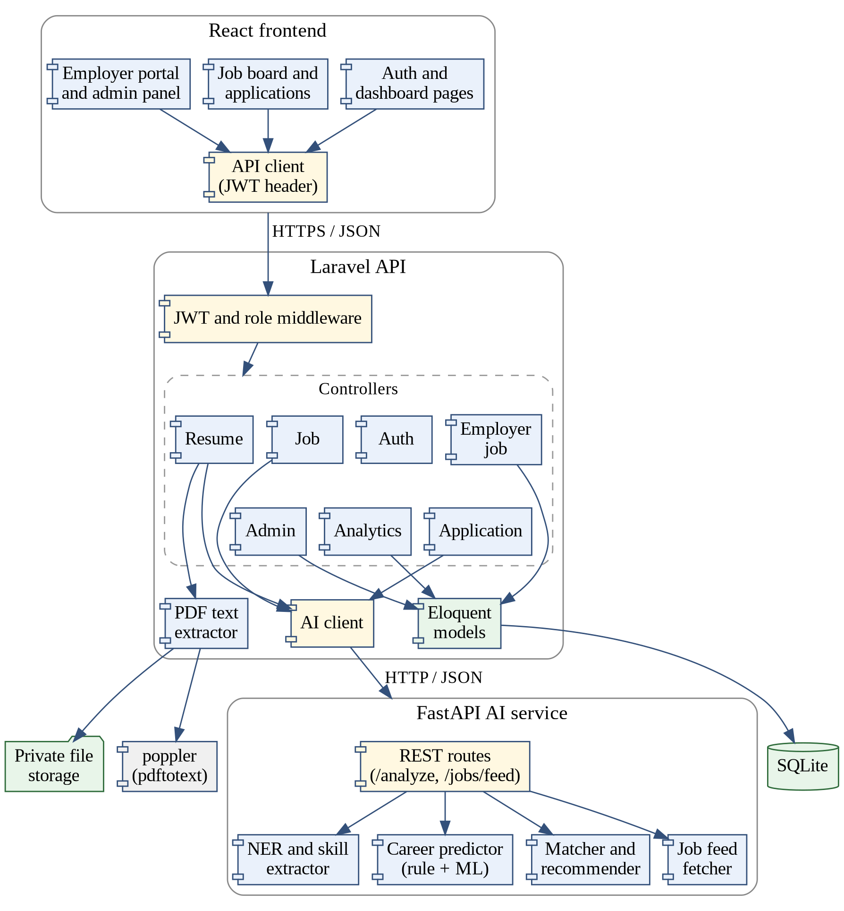
Figure 3.19: Component diagram

3.2.4 Deployment Diagram
Figure 3.20 shows the deployment. The three services run as separate processes on the ports 5173, 8000 and 8001, which can be on one server or on separate machines. The API reads and writes the SQLite database and the private resume folder, and the AI service reaches the external job sources over HTTPS.
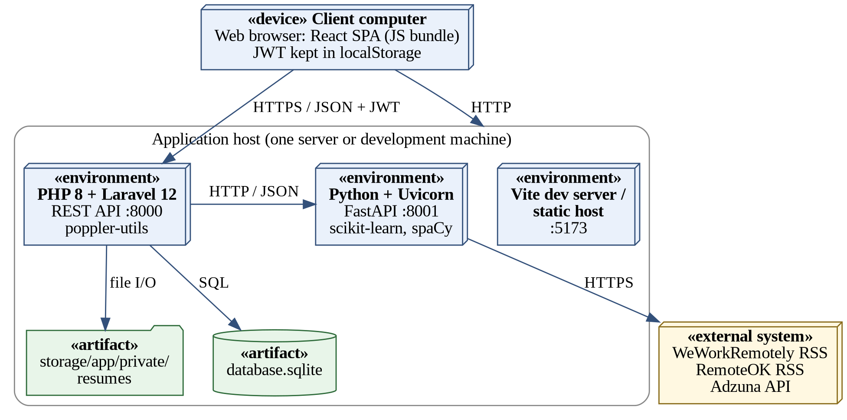
Figure 3.20: Deployment diagram

3.3 Algorithm Details

Algorithm 1: Skill extraction
- Convert the resume text to lower case.
- For every skill in SKILLS_DATABASE build a regular expression with word boundaries.
- If the expression matches the text, add the skill to the result set.
- Return the result set without duplicates.
Word boundaries prevent false matches, for example the skill “java” is not found inside “javascript”.

Algorithm 2: Rule-based career prediction
- For each career in CAREER_MAPPING count how many of its required skills are in the extracted skills.
- Divide the count by the number of required skills of that career.
- Return the career with the highest ratio; if all ratios are zero return “undetermined”.

Algorithm 3: Machine-learning career prediction
- Train: read careers.csv, convert each text sample to a TF-IDF vector and fit a Logistic Regression model with the career label.
- Predict: convert the resume text with the same vectorizer.
- Return the label with the highest predicted probability.

Algorithm 4: Job match percentage
The resume text and the job description are converted to TF-IDF vectors [6] and compared with cosine similarity:
match % = 100 × (A · B) / (‖A‖ × ‖B‖)
where A and B are the two vectors. In the job portal the “job description” is the vacancy description together with its required skills.

Algorithm 5: Resume score and missing skills
resume score = 100 × |resume skills ∩ required skills| / |required skills|
missing skills = required skills − resume skills

Algorithm 6: Job recommendation
- For every job in the job list compute the skill overlap with the resume, using the same ratio as the resume score.
- Sort the jobs by overlap in descending order.
- Return the top jobs together with the skills that are still missing.

Algorithm 7: Applicant ranking
- When a seeker applies, call the AI service with the resume text and the vacancy description and skills.
- Store match %, matched skills and missing skills in the application.
- When the employer opens the applicant list, sort by match % in descending order; applicants with equal match are ordered by earlier application time.

CHAPTER 4: IMPLEMENTATION AND TESTING

4.1 Implementation

4.1.1 Tools Used
Table 4.1 lists the tools, languages and platforms used to build the system.
Table 4.1: Tools and technologies used
Category | Tool / technology | Purpose
Frontend | React 19, Vite [25], Tailwind CSS [27], Recharts [28] | User interface, build tooling, styling and charts
Backend | PHP, Laravel 12 [10], tymon/jwt-auth [29] | REST API, routing, validation, JWT authentication
PDF processing | poppler pdftotext [2], spatie/pdf-to-text [3] | Extract text from uploaded PDF resumes
Database | SQLite [26], Eloquent ORM | Persistent storage of users, resumes, jobs and applications
AI service | Python, FastAPI [11], scikit-learn [7], spaCy [4] | NER, skill extraction, career prediction, matching, recommendations
Modelling (CASE) | Graphviz, Matplotlib | UML, database and schedule diagrams in this report
Data | careers.csv (200 samples) | Training data of the ML career classifier

4.1.2 Implementation Details of Modules

Authentication and Authorization Module
The AuthController provides register, login, logout and me. Registration validates that the password has at least 8 characters, one uppercase letter and one number. On login the API returns a JWT [13], which the React client keeps in localStorage and sends in the Authorization header of every request. Route groups use a role middleware so that employer routes reject job seekers and admin routes reject everybody else.

Resume Upload and Text Extraction Module
ResumeController@upload accepts a PDF of at most 2 MB (the frontend also checks the size), stores it in storage/app/private/resumes so it cannot be opened by URL, and extracts the text with pdftotext. The upload and analysis routes are rate limited to 10 requests per minute. If the extracted text is empty (for example a scanned image), the request is rejected before any AI call.

AI Analysis Module (FastAPI)
The /analyze route receives the resume text and an optional job description and returns one JSON object. Its steps follow Figure 3.18: spaCy NER extracts the name, e-mails and organisations; a regular-expression matcher finds skills from SKILLS_DATABASE; the career is predicted by rules and by the ML model; the match percentage, resume score and missing skills are calculated; and jobs, courses, interview questions and resume suggestions are generated from static databases (JOBS, COURSES, QUESTIONS).

Career Prediction Module
The rule-based part uses CAREER_MAPPING, which maps four careers to their required skills. The ML part uses a scikit-learn pipeline of TfidfVectorizer and LogisticRegression trained on careers.csv, so the model can name careers that the rules do not cover.

Dashboard and Analytics Module
The analytics routes return the total number of analyses, the average score, the most frequent career and the latest analysis, plus chart data: a career distribution for the pie chart and the last ten scores for the bar chart. The React dashboard draws them with Recharts.

Job Search and External Feed Module
JobController@index searches the local job_listings table by keyword. An admin can call the refresh route, which asks the AI service (/jobs/feed) to read the WeWorkRemotely and RemoteOK RSS feeds and, when API keys are configured, the Adzuna API. New jobs are stored with their source and external id so they are not duplicated. Job seekers save jobs through the saved_jobs pivot table.

Job Portal Module (Employer, Application and Moderation)
This module turns the system into a job portal. An employer creates a company profile, which the admin verifies. EmployerJobController lets the verified employer create, edit and close jobs; a new job is saved as “pending” and becomes “published” only after admin approval through AdminController@moderateJob. Job seekers see only published jobs whose deadline has not passed.
ApplicationController@apply checks that the job is open and that the user has not applied before, sends the resume text and the vacancy description with its required skills to the AI service, and stores the returned match percentage and skill lists with the application. applicants returns them sorted by match percentage, and updateStatus moves an application through the states shown in Figure 3.5.

Frontend Module
The React application is a single-page application with protected routes. The main screens are: login and registration, dashboard, resume upload and result, analysis history, job search and saved jobs, job details and apply, my applications, employer job manager and applicants list, and the admin moderation panel. Loading and error messages are shown for every API call.
The main API endpoints are summarised in Table 4.2.
Table 4.2: Main REST endpoints
Method and path | Role | Description
POST /api/register, /api/login | Public | Create account; obtain JWT
POST /api/logout, GET /api/me | Any user | End session; current user
POST /api/upload-resume | Seeker | Upload PDF, extract text, analyse, save
GET /api/resume/history | Seeker | List own past analyses
DELETE /api/resume/{id} | Seeker | Delete own analysis
GET /api/analytics, /career-distribution, /score-history | Seeker | Dashboard numbers and chart data
GET /api/jobs?q=keyword | Any user | Search published and imported jobs
POST /api/jobs/{id}/save | Seeker | Save or unsave a job
POST /api/jobs/refresh | Admin | Import jobs from external feeds
POST, PUT /api/employer/jobs, PATCH …/close | Employer | Create, edit, close own jobs
GET /api/employer/jobs/{id}/applications | Employer | Applicants ranked by match %
POST /api/jobs/{id}/apply | Seeker | Apply with a resume
GET /api/my-applications | Seeker | Own applications and status
PATCH /api/applications/{id}/status | Employer | Update application status
POST /api/admin/employers/{id}/approve | Admin | Verify an employer
POST /api/admin/jobs/{id}/approve, /reject | Admin | Moderate a job posting
POST /analyze, GET /jobs/feed (AI service) | API only | Resume analysis; external job feed

4.2 Testing
Testing was done at two levels. Unit tests check single functions and endpoints; system tests check complete user scenarios through the interface. The test cases are listed in Table 4.3 and Table 4.4. The Status column is filled in when each case is executed.

4.2.1 Test Cases for Unit Testing
Table 4.3: Unit test cases
ID | Unit / function | Input | Expected result | Status
UT-01 | Skill extraction | Text containing known skills | All known skills returned once each
UT-02 | Skill extraction (word boundary) | Text with “javascript” only | “java” is not returned
UT-03 | Entity extraction | Text with an e-mail address | The e-mail is extracted
UT-04 | Rule-based prediction | Skills of one mapped career | That career is returned
UT-05 | ML prediction | Sample resume text | A label from the trained classes
UT-06 | Match percentage | Identical texts; unrelated texts | About 100 %; a low value
UT-07 | Resume score | All required skills; none | 100; 0
UT-08 | Missing skills | Required minus resume skills | Exact set difference
UT-09 | Password validation | “password”; “Password1” | First rejected; second accepted
UT-10 | Login | Valid and invalid credentials | Token returned; 401 error
UT-11 | Upload validation | A .docx file; a PDF above 2 MB | Both rejected with a message
UT-12 | Rate limiting | 11 uploads in one minute | The 11th gets HTTP 429
UT-13 | Role middleware | Seeker calls an employer route | HTTP 403
UT-14 | Duplicate application | Apply twice to the same job | Second request rejected
UT-15 | Job status rule | Employer tries to publish directly | Not allowed; needs admin approval
UT-16 | Applicant ranking | Applications with different match % | Sorted in descending order

4.2.2 Test Cases for System Testing
Table 4.4: System test cases
ID | Scenario | Steps | Expected result | Status
ST-01 | Registration and login | Register, log in, open dashboard | Dashboard opens for the correct role
ST-02 | Analyse a resume | Upload a valid PDF without job description | Skills, career, score, gaps and recommendations shown
ST-03 | Analyse with job description | Upload a PDF and paste a description | Match percentage is shown
ST-04 | Unreadable PDF | Upload a scanned image PDF | Clear error; nothing saved
ST-05 | Dashboard and history | Analyse two resumes, open dashboard, delete one | Counts and charts update
ST-06 | Job search and save | Search a keyword, save a job | Job listed under saved jobs
ST-07 | External feed | Admin refreshes the feed | New jobs appear (network needed)
ST-08 | Employer approval | Register employer; admin approves | Employer can post jobs
ST-09 | Job posting and moderation | Employer posts; admin approves | Job becomes visible to seekers
ST-10 | Apply and rank | Two seekers apply to one job | Employer sees both, ranked by match %
ST-11 | Status tracking | Employer shortlists an applicant | Seeker sees the new status
ST-12 | Closed job | Employer closes the job | Job disappears from search; applying is blocked
ST-13 | AI service down | Stop the AI service, upload a resume | Friendly error; nothing saved
ST-14 | Access control | Open another user’s resume URL | Access denied
ST-15 | Expired token | Use the app after the token expires | User is sent to the login page
ST-16 | Responsive layout | Open main pages at mobile width | No broken layout

4.3 Result Analysis
The complete workflow of the system works end to end: a job seeker registers, uploads a PDF, and receives skills, a career prediction, a resume score, missing skills and recommendations; an employer posts a job, the admin approves it, seekers apply, and the employer sees applicants ranked by match percentage. Table 4.5 summarises the implemented features.
Table 4.5: Summary of implemented features
Feature | Result | Remark
JWT authentication with roles | Implemented | Seeker, employer and admin
PDF upload (2 MB) and text extraction | Implemented | Text-based PDFs only
Skill extraction | Implemented | 18 skills in the current database
Career prediction | Implemented | Rule-based (4 careers) and ML
Match %, resume score, missing skills | Implemented | TF-IDF cosine and skill coverage
Recommendations | Implemented | Static databases: 8 jobs, courses, questions
Dashboard analytics and history | Implemented | Pie and bar charts
External job feed | Implemented | Admin refresh; Adzuna needs keys
Employer job posting and moderation | Implemented | Admin approval before publishing
Applications and ranked applicants | Implemented | Match % stored per application
Rate limiting | Implemented | 10 requests per minute

The quality of the machine-learning classifier was also examined. Table 4.6 shows the evaluation table that is to be completed by running a train/test split (for example 80/20) with scikit-learn on the cleaned dataset.
Table 4.6: Evaluation of the ML career classifier
Metric | Value
Training samples | [fill in]
Test samples | [fill in]
Accuracy | [fill in] %
Weighted precision / recall / F1 | [fill in]

During the analysis of careers.csv, rows 105 to 201 were found to contain inconsistent labels; for example a text about HTML, CSS and JavaScript was labelled “AI Researcher”. Only the first part of the file is reliable. Many labels in the file also differ from the four careers of the rule-based mapping, so the two predictions can disagree. For this reason the ML output should be treated as advisory, and cleaning the dataset is the first item in the future work.
The main strengths are the clear separation of the three services, the explainable skill-gap output and the automatic ranking of applicants. The main weaknesses are the small skill vocabulary, the small and partly noisy training set, TF-IDF matching that cannot understand synonyms, and the missing password-reset and e-mail verification.

CHAPTER 5: CONCLUSION AND FUTURE RECOMMENDATIONS

5.1 Conclusion
This project developed the AI Career Prediction System with Integrated Job Portal. It analyses PDF resumes, predicts a suitable career, finds skill gaps and gives recommendations, and it lets employers post jobs, receive applications and see applicants ranked by an automatic match score. The system was built as three services (React, Laravel and FastAPI) using an iterative incremental method and was verified with unit and system test cases.
All objectives stated in Chapter 1 were addressed: the platform gives candidates objective feedback, saves employers screening time, and joins guidance and hiring in one place. The project also gave the team practical experience in NLP, machine learning, REST API design, authentication, and full-stack development. The present version is a working prototype; its accuracy and coverage depend on the size of the skill database and of the training data, which are the main areas to improve.

5.2 Future Recommendations

5.2.1 Machine Learning and Language Processing
- Clean and enlarge careers.csv, add a train/test split with accuracy and a confusion matrix, and align the ML careers with the rule-based careers.
- Expand the skill database from 18 to more than 200 skills using ESCO [21] or O*NET [22], and use spaCy’s phrase matcher or keyword extraction instead of plain regular expressions.
- Replace TF-IDF matching with sentence embeddings [20] so that synonyms are understood, and add skill proficiency levels.
- Add a fallback such as pdfplumber and OCR for scanned resumes.

5.2.2 Security and Reliability
- Protect the AI service with an API key or JWT validation, and add password reset and e-mail verification.
- Add structured logging, health checks that test the database and the AI service, and automated tests with a CI/CD pipeline.

5.2.3 Engineering and Scalability
- Containerise the three services with Docker, add Redis caching for AI responses and job feeds, and add pagination to history, jobs and analytics.
- Refresh external jobs on a schedule instead of manually, and move the frontend to TypeScript with tests and error boundaries.

5.2.4 New Features
- E-mail or in-app notifications for status changes, interview scheduling and messaging between employer and candidate.
- Resume versioning, export of the analysis as a PDF, and import from LinkedIn or GitHub.
- Career path visualisation, salary benchmarks, multi-language support, dark mode and a full admin dashboard.

REFERENCES
[1] I. Sommerville, Software Engineering, 10th ed. Harlow, U.K.: Pearson, 2016.
[2] “Poppler PDF rendering library.” freedesktop.org. [Online]. Available: https://poppler.freedesktop.org (accessed Sep. 20, 2026).
[3] Spatie, “spatie/pdf-to-text: Extract text from a PDF.” GitHub. [Online]. Available: https://github.com/spatie/pdf-to-text (accessed Sep. 20, 2026).
[4] “spaCy: Industrial-strength natural language processing in Python.” Explosion. [Online]. Available: https://spacy.io (accessed Sep. 20, 2026).
[5] K. Spärck Jones, “A statistical interpretation of term specificity and its application in retrieval,” J. Doc., vol. 28, no. 1, pp. 11–21, 1972.
[6] G. Salton and C. Buckley, “Term-weighting approaches in automatic text retrieval,” Inf. Process. Manag., vol. 24, no. 5, pp. 513–523, 1988.
[7] F. Pedregosa et al., “Scikit-learn: Machine learning in Python,” J. Mach. Learn. Res., vol. 12, pp. 2825–2830, Oct. 2011.
[8] D. W. Hosmer Jr., S. Lemeshow, and R. X. Sturdivant, Applied Logistic Regression, 3rd ed. Hoboken, NJ, USA: Wiley, 2013.
[9] R. T. Fielding, “Architectural styles and the design of network-based software architectures,” Ph.D. dissertation, Dept. Inf. Comput. Sci., Univ. California, Irvine, CA, USA, 2000.
[10] “Laravel documentation.” Laravel. [Online]. Available: https://laravel.com/docs (accessed Sep. 20, 2026).
[11] “FastAPI.” [Online]. Available: https://fastapi.tiangolo.com (accessed Sep. 20, 2026).
[12] “React documentation.” Meta Platforms. [Online]. Available: https://react.dev (accessed Sep. 20, 2026).
[13] M. Jones, J. Bradley, and N. Sakimura, “JSON Web Token (JWT),” Internet Eng. Task Force, RFC 7519, May 2015.
[14] “LinkedIn Jobs.” LinkedIn Corp. [Online]. Available: https://www.linkedin.com/jobs/ (accessed Sep. 20, 2026).
[15] “Indeed.” Indeed, Inc. [Online]. Available: https://www.indeed.com (accessed Sep. 20, 2026).
[16] “Merojob.” [Online]. Available: https://merojob.com (accessed Sep. 20, 2026).
[17] “Jobscan.” [Online]. Available: https://www.jobscan.co (accessed Sep. 20, 2026).
[18] V. Bhatia, P. Rawat, A. Kumar, and R. R. Shah, “End-to-end resume parsing and finding candidates for a job description using BERT,” arXiv:1910.03089, 2019.
[19] J. Devlin, M.-W. Chang, K. Lee, and K. Toutanova, “BERT: Pre-training of deep bidirectional transformers for language understanding,” in Proc. NAACL-HLT, Minneapolis, MN, USA, 2019, pp. 4171–4186.
[20] N. Reimers and I. Gurevych, “Sentence-BERT: Sentence embeddings using Siamese BERT-networks,” in Proc. Conf. Empirical Methods Natural Lang. Process. and 9th Int. Joint Conf. Natural Lang. Process. (EMNLP-IJCNLP), Hong Kong, China, 2019, pp. 3982–3992.
[21] European Commission, “ESCO: European skills, competences, qualifications and occupations.” [Online]. Available: https://esco.ec.europa.eu (accessed Sep. 20, 2026).
[22] National Center for O*NET Development, “O*NET OnLine.” [Online]. Available: https://www.onetonline.org (accessed Sep. 20, 2026).
[23] G. Booch, J. Rumbaugh, and I. Jacobson, The Unified Modeling Language User Guide, 2nd ed. Upper Saddle River, NJ, USA: Addison-Wesley, 2005.
[24] OWASP Foundation, “OWASP Top Ten.” [Online]. Available: https://owasp.org/www-project-top-ten/ (accessed Sep. 20, 2026).
[25] “Vite.” [Online]. Available: https://vite.dev (accessed Sep. 20, 2026).
[26] “SQLite documentation.” SQLite Consortium. [Online]. Available: https://www.sqlite.org/docs.html (accessed Sep. 20, 2026).
[27] “Tailwind CSS.” Tailwind Labs. [Online]. Available: https://tailwindcss.com (accessed Sep. 20, 2026).
[28] “Recharts.” [Online]. Available: https://recharts.org (accessed Sep. 20, 2026).
[29] “tymondesigns/jwt-auth: JSON Web Token authentication for Laravel and Lumen.” GitHub. [Online]. Available: https://github.com/tymondesigns/jwt-auth (accessed Sep. 20, 2026).

BIBLIOGRAPHY
[1] R. S. Pressman and B. R. Maxim, Software Engineering: A Practitioner’s Approach, 9th ed. New York, NY, USA: McGraw-Hill, 2019.
[2] A. Géron, Hands-On Machine Learning with Scikit-Learn, Keras, and TensorFlow, 2nd ed. Sebastopol, CA, USA: O’Reilly Media, 2019.
[3] D. Jurafsky and J. H. Martin, Speech and Language Processing, 3rd ed. draft, 2023. [Online]. Available: https://web.stanford.edu/~jurafsky/slp3/

APPENDIX A: SCREENSHOTS
This appendix contains screenshots of the main screens of the system. Replace each highlighted frame with the real screenshot.
[Insert screenshot: registration / login screen]
Figure A.1: Registration and login page
[Insert screenshot: dashboard with statistics and charts]
Figure A.2: Job seeker dashboard

[Insert screenshot: upload page and result with skills, score and career]
Figure A.3: Resume upload and analysis result
[Insert screenshot: missing skills, jobs, courses and interview questions]
Figure A.4: Skill gaps and recommendations
[Insert screenshot: job search results and saved jobs]
Figure A.5: Job search and saved jobs

[Insert screenshot: job details with the Apply form]
Figure A.6: Job details and apply form
[Insert screenshot: application list with status]
Figure A.7: My applications
[Insert screenshot: post a job form]
Figure A.8: Employer job posting form

[Insert screenshot: applicant list with match percentage and status buttons]
Figure A.9: Employer applicants ranked by match
[Insert screenshot: pending employers and job postings]
Figure A.10: Admin moderation panel

APPENDIX B: SOURCE CODE
Paste the important source code listings here (use a small monospaced font if the college allows). Suggested files:
- Laravel API: routes/api.php, AuthController, ResumeController, JobController, EmployerJobController, ApplicationController, AdminController, the models and migrations.
- FastAPI AI service: main.py (routes /analyze and /jobs/feed), the skill extraction, career prediction, matching and recommendation functions, and the model training script.
- React frontend: the API client, protected routes, the resume upload page, the dashboard, the job board, and the employer and admin pages.

