Software Requirements Specification (SRS)

Project Title: Web-Minner

Team Members: Biswajit kumar dandapat(AP22110010930)

Guide Name: Dr ChAnil Carie

Department: Computer Science and Engineering

Institution: SRM University – AP, Andhra Pradesh

Date: __________________________

# Document Control

| Version | Date | Authors |
| --- | --- | --- |
| 0.1 | YYYY-MM-DD | Biswajit Kumar Dandapat |
| 0.1 | YYYY-MM-DD | Team Member Names |

# Table of Contents

<<TOC will be auto-generated in Word>>

# 1. Introduction

## 1.1 Purpose

***Description:***

## 1.2 Scope

***Description:***

***1.3 Definitions, Acronyms, and Abbreviations***

***Description:***

***1.4 References***

***Description:***

***1.5 Overview***

***Description:***

*2. Overall Description*

***2.1 Product Perspective***

***Description:***

***2.2 Product Functions***

***Description:***

***2.3 User Classes and Characteristics***

***Description:***

***2.4 Operating Environment***

***Description:***

***2.5 Constraints***

***Description:***

***2.6 Assumptions and Dependencies***

***Description:***

***3. Specific Requirements***

***3.1 Functional Requirements***

***Description:***

***3.2 Non-functional Requirements***

***Description:***

***3.3 External Interface Requirements***

***Description:***

***3.3.1 User Interfaces***

***Description:***

***3.3.2 Hardware Interfaces***

***Description:***

***3.3.3 Software Interfaces***

***Description:***

***3.3.4 Communication Interfaces***

***Description:***

# 4. System Models & Diagrams

## 4.1 Use Case Diagram(s)

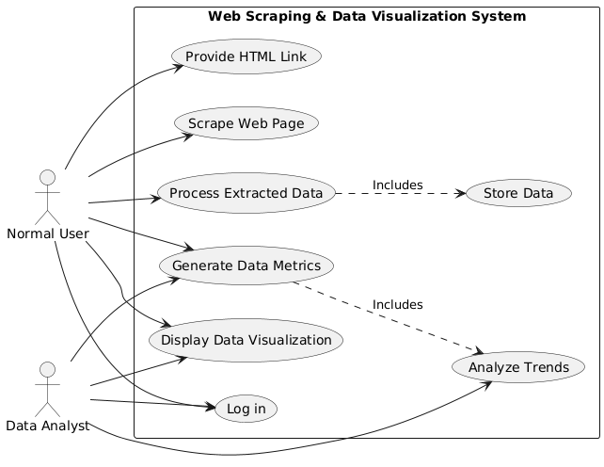

***Description:***

The system's core functionalities in the Web Scraping & Data Visualization System :-

**1. Normal User can:**

* Provide an HTML link for the web page to be scrapped.
* Trigger the scraping of the web page.
* Process the extracted data for further use.
* Generate data metrics from the scraped information.
* View the generated data visualization.
* Log in to access the system.

**2. Data Analyst can:**

* Generate data metrics from the scraped data.
* Visualize the data in a graphical format.
* Analyze trends based on the generated metrics.
* Log in to the system.

## 4.2 Use Case Descriptions

***Description:***

The use case diagram illustrates the interactions between two types of users, a Normal User (NU) and a Data Analyst (DA), and the key features of the web application. The system enables both users to input an HTML link for web scraping, process the data, and visualize the extracted product details.

### Key Points:

### 1. Normal User (NU):

### Provide HTML Link: Normal users input a valid HTML link for the system to scrape.

### Scrape Web Page: The system extracts relevant product details from the provided web page.

### Process Extracted Data: Data from the webpage is processed for visualization and metric generation.

### Generate Data Metrics: Metrics such as product prices, ratings, and other related data are generated.

### Display Data Visualization: The system displays graphs and charts for easier analysis.

### Log in: Users must log in to access the application. 2. **Data Analyst (DA):**

### Generate Data Metrics: Analysts can generate detailed data metrics for in-depth analysis.

### Display Data Visualization: Analysts can view the visual representation of the scraped data.

### Analyze Trends: Data analysts can analyze trends based on the extracted data.

### Log in: Data analysts also need to log in to use the system.

### 3. **Process Flow:**

### **The Process Extracted Data use case includes the Store Data process, ensuring that data is stored for further use.**

### Generate Data Metrics includes Analyze Trends, which allows for trend analysis based on the generated metrics.

### 

### 

### 4.3 Data Flow Diagrams (DFD)

### 

### Description: 4.4 Class Diagram ***Description:*** 4.5 Object Diagram ***Description:*** 4.6 Sequence Diagrams ***Description:***

### 4.7 Collaboration Diagrams ***Description:*** 4.8 Activity Diagrams ***Description:***4.9 State-Chart Diagrams ***Description:*** 4.10 Component Diagram ***Description:*** 4.11 Deployment Diagram ***Description:***5. Data Design Data Dictionary, Schema Definitions, ER Diagram

### ***Description:*** 6. Testing Plan Overview Functional Testing, Unit Testing, System Testing, Mention Tools ***Description:*** 7. Appendix Glossary, Sample UI Mockups, Sample Test Cases ***Description:***