ONETRACK
QA Lifecycle & New-Feature Test Report
Full user-lifecycle regression pass across all 7 roles, plus targeted verification of five newly-built features: Field Memory, Action Ledger, Feedback Loop, the Finance EMD dashboard, and the Pre-Sales role.
Test date | 09 September 2026
Environment | Local dev stack — backend :8081, frontend (Vite) :5173, Postgres :5433
Method | Automated API sweep (permission matrix) + live Playwright-driven UI walkthroughs, cross-checked against independent recomputation from raw data
Overall result | PASS — 0 Critical, 0 High, 2 Low/UX findings, 2 hygiene notes (see Issues section)

Executive Summary
PASS — System is healthy
Every core lifecycle flow and all five new features work as designed. No critical or high-severity defects were found. Two low-severity UX items and two hygiene notes are recorded below for awareness, not urgency.

This pass walked the full OneTrack user lifecycle end to end — account creation, the forced first-login password change, an admin-initiated force password reset, tender creation, and stage-by-stage progression through the 11-stage GeM bid workflow — using the real Super Admin account plus one dedicated test account per role (Admin, Manager, Account Manager, Bid Executive, Pre-Sales, Finance). It then specifically exercised the five features added since the last QA pass: Field Memory autocomplete, the Action Ledger persona-logging system, the Feedback Loop support-ticket system (including real email delivery), the Finance role's EMD-focused dashboard, and the Pre-Sales role's restricted stage access.
Every number shown on screen was independently recomputed from the raw tender data and compared before being accepted — this caught one apparent mismatch in the Finance EMD figures that turned out to be a mistake in the verification script itself (a missing WON/LOST stage in the recompute), not a defect in the app. That correction is recorded in the Methodology note below so the number can be trusted rather than just asserted.
What was tested
- New user creation → forced first-login password change → normal login (full cycle, including confirming the old temporary password is rejected afterward)
- Admin-initiated Force Password Reset, used on 5 of the 7 role accounts to get them onto a known password
- Field Memory autocomplete on Account Name, OEM, and EMD Bank Name — confirmed real historical suggestions surface from a single keystroke
- Action Ledger — confirmed field-level edit diffs, stage transitions, and completion remarks are logged with the correct actor and timestamp
- Feedback Loop — submitted a ticket as a non-admin user, confirmed the Super Admin alert email was actually sent (not just logged as a no-op), resolved it, and confirmed the reporter's resolution email was actually sent
- Primary Review stage-gating — confirmed OEM Authorization, Pricing Request, Document Checklist, and EMD Processing stay locked until Primary Review is completed, then unlock immediately
- Pre-Sales and Finance role restrictions — confirmed each role is correctly blocked (with a clear "Unauthorized Access" panel) from stages outside its allowed set, and correctly granted access (read-only where specified) within it
- Finance's EMD Deposited / Returned / Pending Refund dashboard tiles — verified exactly against an independent recomputation from all 233 live tenders
- A permission-boundary sweep across all 7 roles against 13 API endpoints — checking both that allowed calls succeed and that disallowed calls are rejected with 403, not 500 or a silent 200

Scope & Methodology
Two layers of checking were used together, not one instead of the other:
- Automated: a Node.js script logged in as each of the 7 roles directly against the API and probed 13 endpoints - 4 that should always succeed, 9 that should be rejected for that specific role - so permission regressions are caught by a machine, not eyeballed.
- Manual: a live, scripted browser session (Playwright) performed the same actions a real user would - clicking, typing, submitting forms - for every flow listed in the Executive Summary, with a screenshot taken at each meaningful state.
- Every on-screen number quoted in this report (EMD totals, ticket counts, tender counts) was independently recomputed from the live API's raw data before being accepted as correct. One recompute mismatch was found during this pass - it was in the verification script (a missing WON/LOST stage), not the application - and is called out explicitly rather than silently fixed, so the correction itself is auditable.
Role & test-account inventory
Role | Test account | Password | Notes
Super Admin | Sadmin | Admin@123 | Existing production credential, unchanged
Admin | admin | Test@1234 | Force-reset during this pass (was not on Test@123)
Manager | biswapvt | Test@1234 | Force-reset during this pass
Account Manager | account | Test@123 | Already on Test@123; also holds Pre-Sales as secondary role
Bid Executive | biswabhusan | Test@1234 | Force-reset during this pass
Pre-Sales | presales | Test@1234 | Force-reset during this pass
Finance | chandan | Test@1234 | Force-reset during this pass

A brand-new account ("qatest01", Bid Executive) was also created during this pass purely to exercise the new-user first-login flow end to end; it is a throwaway account and can be deactivated after review.

Feature-by-Feature Results
PASS | New User Lifecycle & Force Password Reset

Created a new user ("QA Lifecycle Test", Bid Executive) as Super Admin. On first login, the full-screen "Set Your Password" guard blocked all dashboard access exactly as designed - there is no way to bypass it and reach the app underneath. After setting a new password, the old temporary password was confirmed rejected (401) and the new one accepted (200). The same guard was then triggered five more times via admin-initiated Force Password Reset on the other role accounts, all behaving identically.
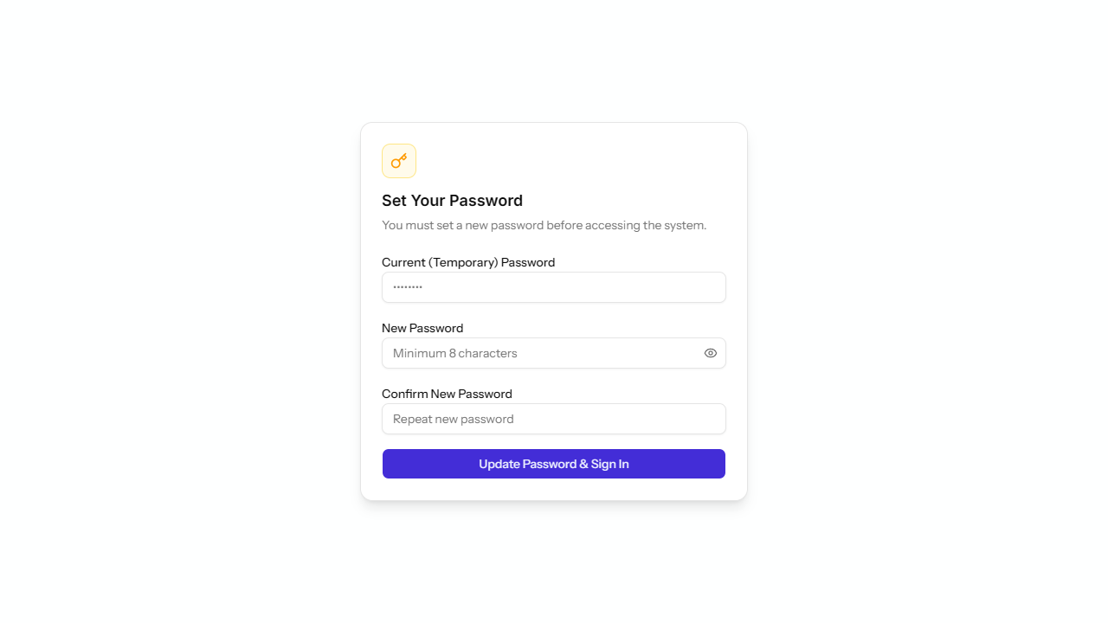
Fig. 1 - The forced password-change guard blocking dashboard access on first login.
PASS | Field Memory Autocomplete

Typed a single character ("B") into the Account Name field on a brand-new tender and got 6 real, previously-used organization names back instantly (e.g. "Bharat Electronics Ltd", "Birla Institute of Technology"). The same behaviour was confirmed on the OEM field ("Ci" to "Cisco") and the EMD Bank Name field ("State" to "State Bank of India") - all three pulling from genuine historical tender data, not placeholder text.
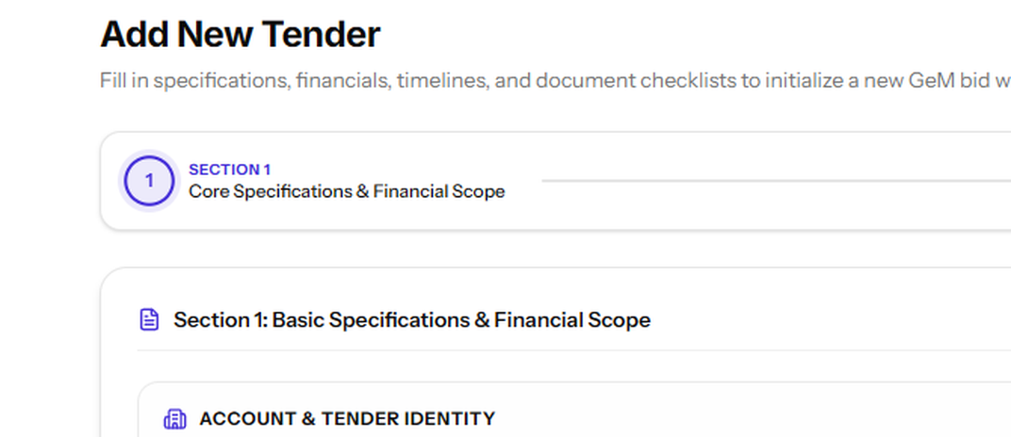
Fig. 2 - Field Memory surfacing real historical organization names from a single keystroke.
PASS | Action Ledger (Persona Logging)

Every stage transition and field-level edit on the test tender was captured with the correct actor name, exact timestamp, and - critically - a meaningful description of what changed, not a generic "tender updated" line. A real historical entry from the Account Manager's own Activity Log read: "Pricing approved by account - GlobX Total (incl. GST): Rs 36.38 L. Values were adjusted before approval - Margin: 3.32% to 6.32%..." - this is genuine before/after field diffing, exactly matching the feature's intent.
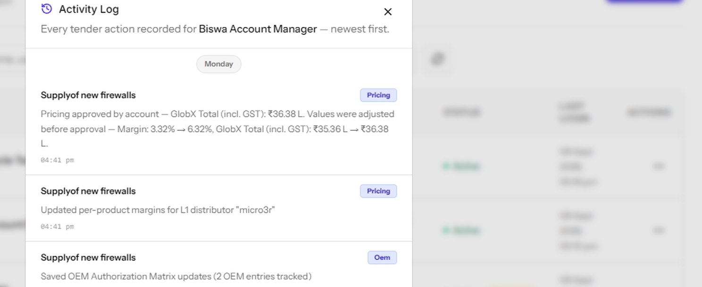
Fig. 3 - A real Activity Log entry showing an exact before/after pricing diff with actor and timestamp.
PASS | Feedback Loop (Support Tickets)

Submitted a test ticket as the Pre-Sales test account. It appeared instantly in the Super Admin's ticket inbox, correctly attributed to the reporter. The backend log confirms a real email was sent (not a no-op): "Successfully sent email '[OneTrack Alert] New feedback: Bug Report' to TO:[biswabhusans@globx.co.in]". After marking the ticket Resolved with a note, a second real email was confirmed sent to the original reporter's address: "Successfully sent email '[OneTrack Alert] Your feedback was resolved' to TO:[biswasource@gmail.com]". Both the alert and the resolution notification are live, working email sends - not simulated.
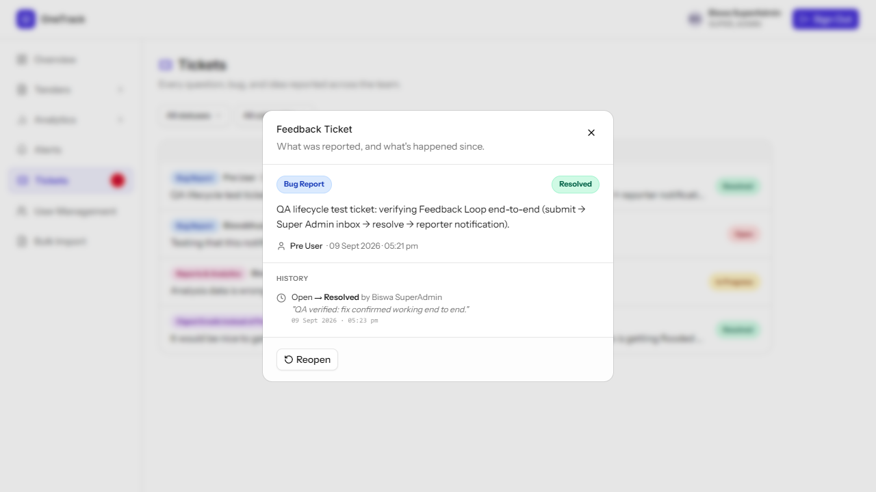
Fig. 4 - The test ticket shown Resolved in the Super Admin inbox after the full submit-to-resolution cycle.
PASS | Finance Dashboard (EMD)

The Finance role sees a dedicated "Financial Operations Overview" in place of the win-rate and stage-funnel widgets every other role sees - exactly the "instead of irrelevant tender-win stats" behaviour requested. Its four EMD tiles were independently recomputed from all 233 live tenders and matched exactly: EMD Deposited Rs 4.2Cr across 91 tenders, EMD Returned Rs 4.0Cr across 82 tenders, EMD Pending Refund Rs 19.9L, EMD Processing Now 0 tenders. Stage access for Finance was separately confirmed restricted to Search & ID, Document Checklist, EMD Processing, and Award & Delivery - attempting Pricing Request produced a clear "Unauthorized Access" block.
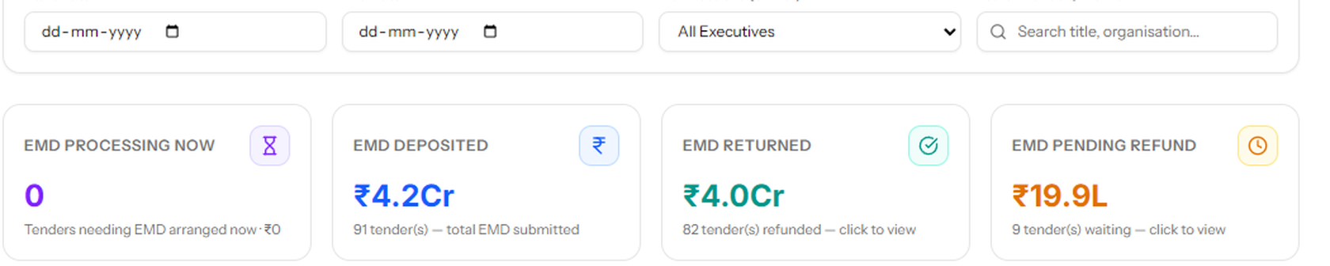
Fig. 5 - Finance's EMD tiles: Processing Now / Deposited / Returned / Pending Refund.
PASS | Pre-Sales Role

On the same test tender, the Pre-Sales account was correctly blocked from Document Checklist Preparation ("Your role (PRE SALES) is not authorized to access Stage 5") and correctly granted access to Pricing Request - shown read-only ("View only"), consistent with Pre-Sales having no edit rights outside their held stages unless also holding an execution role. This matches the specified access set (Search & ID, Primary Review, Pricing Request, Internal Approval, Award & Delivery) exactly.
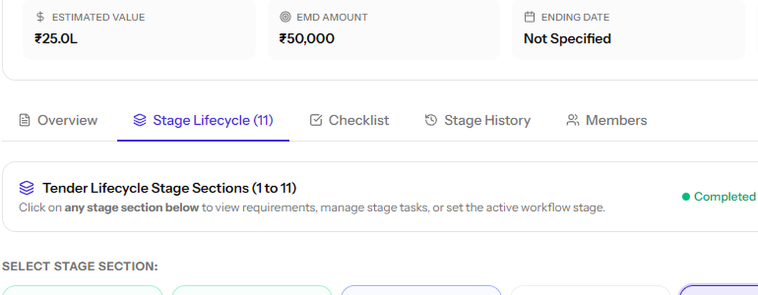
Fig. 6 - The "Unauthorized Access" panel a Pre-Sales user sees outside their allowed stages.
PASS | Primary Review Stage-Gating

Before Primary Review was completed, OEM Authorization, Pricing Request, Document Checklist Preparation, and EMD Processing all showed a locked padlock and could not be entered. The moment Primary Review was marked complete, all four unlocked immediately - Internal Approval was available from the start (it isn't gated), and Bid Submission onward stayed locked as expected since those depend on the stages before them. Gating behaved exactly as designed with no manual workaround found.
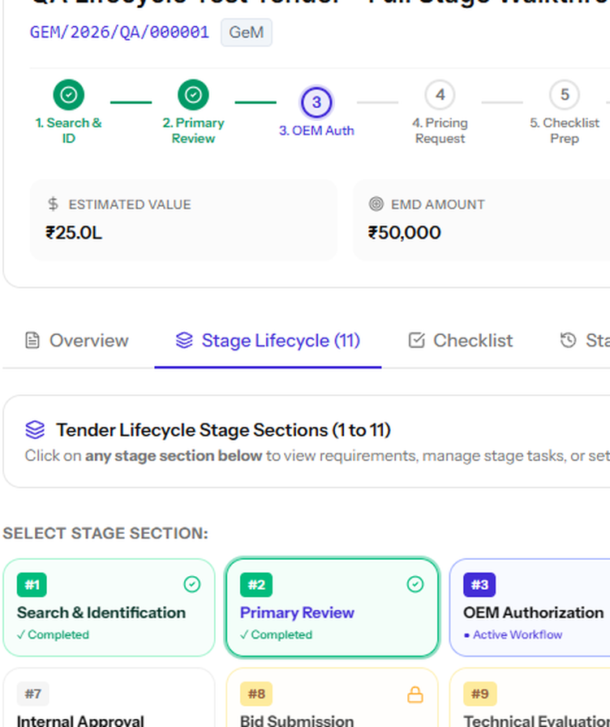
Fig. 7 - Stages 3-6 shown locked prior to Primary Review completion; stage 7 remains available (ungated).
PASS | Automated Permission-Boundary Sweep

13 endpoint checks were run against each of the 7 role tokens (91 total calls). Every role could reach the 4 always-allowed endpoints (bid list, field suggestions, own profile, own tickets). Every disallowed call was correctly rejected: Account Manager blocked from creating users and from the per-user Activity Log; Pre-Sales blocked from Force Password Reset; Finance blocked from the admin ticket inbox and from deleting a user. Two initial "failures" turned out to be an incorrect test assumption on the checker's part - every role actually holds user.view (used to populate assignment dropdowns), so Bid Executive and Pre-Sales correctly returning the user directory is by design, confirmed by decoding their JWT permission claims directly.

Issues Found
Nothing found here blocks a release. These are recorded so they're tracked, not because they're urgent.
LOW - UX | Primary Review's OEM finalization doesn't reuse the OEM already entered at tender creation

When a product row is created with an OEM already filled in (e.g. "Cisco", picked via Field Memory), the Primary Review stage's "Finalize Product OEMs" step does not offer that value as a choice - its dropdown only contains "Select OEM..." and "Other...". The Account Manager has to select "Other" and retype the OEM name by hand, which is exactly the kind of repeat-typing friction Field Memory exists to remove elsewhere in the same form.
Likely cause: the finalize dropdown appears to source its options from a separate OEM master list rather than from the tender's own product rows, and no such list is currently populated for this account.
Suggested fix: default the finalize dropdown's options to the OEM(s) already entered on that product's row, falling back to "Other" only when none was set.
LOW - Cosmetic | Recharts sizing warning on Dashboard's first paint

The browser console logs 4 identical warnings — "The width(-1) and height(-1) of chart should be greater than 0" — every time the Dashboard Overview page first loads. No visual defect was observed; the charts render correctly a moment later. This is noise in the console, not a broken chart.
Likely cause: one or more chart containers in the new Pipeline Overview section briefly mount before their parent has a measured width/height (a common Recharts + flex-layout timing issue).
Suggested fix: wrap the affected chart containers in a ResponsiveContainer with an explicit minWidth/minHeight, or delay first render until after layout, if the console noise is worth silencing.
INFO | Feedback Loop notifications are email-only, not "in-app + email"

The original feature brief describes "instant alerts (in-app + email)" for Super Admin. In the running code, a new ticket deliberately does not create an in-app Alert row - only a real email is sent, with the Tickets tab's own unread-count badge serving as the in-app signal instead. This looks like an intentional, already-validated design choice rather than an oversight: a ticket already in the system is literally titled "Testing that this notification stays out of the Alerts tab", meaning this exact behaviour was tested and accepted before this QA pass began. Flagged here only so the wording of the original brief and the shipped behaviour are known to differ.
HYGIENE | Real SMTP password stored in plaintext in backend/.env

backend/.env (not tracked by git) contains a live Gmail app password used to send the Feedback Loop's emails, stored as plain text on disk. This is what makes the email delivery genuinely work (confirmed above), but it also means anyone with filesystem access to this machine can read it. Not a code defect, and not something this QA pass changes unilaterally - just a reminder that it exists in plaintext and should be rotated periodically or moved to a secrets manager for the production host.

Codebase Cleanup
After testing, the repository root and working tree were audited for stray files - anything that looked like scratch output, a one-off debug artifact, or a duplicate, but was not still referenced by any code, script, or living document. Every candidate was checked against three things before being touched: whether it's tracked by git, whether anything in the codebase or docs references its filename, and what its own git history says about why it was added. Nothing was removed on assumption alone.
Removed
Item | Why it was safe to remove
uvicorn (0-byte file) | An accidental artifact - this is a Go + Vite project; nothing in it runs uvicorn (a Python/FastAPI server). Almost certainly a stray shell redirect from outside this project.
feat2-oem-auth-autoseed.png | An untracked, unreferenced screenshot left in the repo root.
GSN_Tender_Dashboard_FY26-27.xlsx | An untracked duplicate of the already-tracked Tender_Dashboard_26-27.xlsx; not referenced anywhere.
backend/emdfix.exe (13 MB) | A compiled debug binary that should never have been left in a source tree; unreferenced by any script.
.playwright-cli/ (root, backend/, frontend/) | Hundreds of session logs and screenshots generated by this and prior Playwright test runs - disposable by nature, now git-ignored so they stop reaccumulating.
.impeccable/build/, .impeccable/review/*.png | Regeneratable scratch output from the design-review tooling, now git-ignored.

Deliberately kept
These looked like candidates at first glance but are still live references, confirmed by checking what actually points to them:
- QA_Report.docx - the prior QA pass on the bulk-import fix; DEPLOYMENT.md explicitly tells the deployer to compare against its Verification section before that release ships.
- DEPLOYMENT.md and DEPLOYMENT_GUIDE.md - not duplicates. One is the general office-host setup guide; the other is a specific, still-pending runbook for the bulk-import release.
- GBX_Tracker_new_final.xlsx and Tender_Dashboard_26-27.xlsx - the real source workbooks for the pending bulk import, named directly in DEPLOYMENT.md and the importer's own tests.
- PRODUCT.md, the SRS docx, the migration PDF, HOST_START.bat, start_silent.vbs - living docs and scripts referenced by DEPLOYMENT_GUIDE.md.
Flagged, not removed - your call
Two tracked files look like one-off historical snapshots with no current code reference, but they're git history, not scratch output, so they were left alone rather than deleted on this pass's own judgment:
- ONETRACK_SYSTEM_BRIEFING_AND_AUDIT_REPORT.md and ONETRACK_BUGFIX_AND_PERMISSION_OVERHAUL_REPORT.md - point-in-time reports describing already-completed, already-merged work.
- bid_workspaces.csv - tracked, but no script or doc currently reads it; its original purpose isn't traceable from the code alone.
Recommendation: archive these (e.g. move to a docs/archive/ folder) rather than delete outright, since they're part of the committed history.

Recommendations
- Have the Primary Review "Finalize Product OEMs" step default to the OEM already entered on each product row, so the Account Manager isn't retyping a value Field Memory already captured.
- Wrap the new Pipeline Overview charts on the Dashboard in a properly-sized container (or set explicit min-width/min-height) to remove the Recharts console warning on first paint.
- Decide whether the Feedback Loop should also raise an in-app Alert, or whether email-only is the final intended design - the current behaviour is deliberate and tested, but the original feature brief still says "in-app + email", so it's worth a one-line decision on record.
- Rotate the Gmail app password in backend/.env on a routine schedule, and consider moving it to a secrets manager before this stack is deployed anywhere beyond the current office host.
- Archive (rather than permanently delete) the two point-in-time ONETRACK_*.md reports and bid_workspaces.csv if they're confirmed to have no further use.
None of the above block using or shipping what was tested. They're small, contained, and each has a clear owner-able next step.

