ONETRACK GLOBX
Bulk Tender Import
Deep-Dive QA Report
Testing, root-cause analysis and fixes for the legacy-tracker bulk import
pipeline, the tender lifecycle, and the read/write UI built on top of it.
30 August 2026

Executive Summary
Two legacy tracker workbooks (GBX_Tracker_new_final.xlsx and Tender_Dashboard_26-27.xlsx) feed a new bulk-import pipeline that loads tender data into OneTrack. Before any UI testing began, the sheets were reconciled cell-by-cell against the live database, which surfaced hard evidence that the pipeline was corrupting money and fabricating outcomes: EMD amounts were being doubled on repeated tender IDs, roughly half of one workbook's closed tenders were being recorded as losses that were never actually reported, 39 tenders were silently dropped from a second worksheet, and 120 of 220 imported tenders could not be edited through the app at all.
This report covers the full pass: the defects found, the evidence behind each one, the fix applied, and the retest that confirms it. All fixes described here have been applied to the codebase and verified against the real workbooks and a live running instance of the application - including a full browser walkthrough of bulk import, manual tender creation, and the ten-stage lifecycle.

Result at a glance
Category | Count | Outcome
P0 — Critical (wrong data written) | 5 | 5 fixed
P1 — High (data loss / visibly wrong) | 12 | 9 fixed, 3 documented for a follow-up pass
P2 — Latent (not triggered by current data) | 7 | documented, not yet implemented
False positives corrected | 2 | investigated and found to be working as intended

Is it safe to import these two files into production now?
Yes, once the fixed backend is deployed. The two workbooks were imported three times each into a freshly purged database using the fixed code, in both file orders, and reconciled field-by-field against the sheets. Every run after the first inserted zero new rows and changed zero columns. Every money field now matches the source workbook exactly - no summing, no silent drops. See the Testing Method and Verification sections for the full evidence.

Testing Method

Environment
- Backend: Go 1.26, running locally against PostgreSQL 15 (localhost:5433) and Redis, rebuilt from source after each fix.
- Frontend: React 19 + Vite dev server (localhost:5173), rebuilt and lint/build-checked after each fix.
- Browser testing: Chromium via Playwright, driving the real running application as an operator would.
- Data: the two source workbooks exactly as provided, used unmodified for every test run.

What was tested
- Repeated bulk import (3x per workbook) against a freshly purged database, diffing a canonical snapshot of every field after each run.
- Both import orders (GBX-then-Dashboard and Dashboard-then-GBX) reconciled against each other for convergence.
- Every one of the 220 imported tenders, PATCHed with a no-op edit to confirm none are frozen by validation left over from import.
- Manual tender creation through the full form, followed by a live walk through the stage lifecycle in the browser.
- Inline sheet editing (quantity, currency fields), CSV export, and the bulk-import console/warning UI, all driven live in Chromium.
- A cell-by-cell reconciliation script comparing every money, date, and status field in the database against the source workbook.

P0 — Critical Defects (wrong data was being written)
These directly corrupted financial figures or fabricated business outcomes. All five are fixed and verified.

B1 — Money summed across duplicate tender-ID rows
P0
When a tender's GeM ID appeared twice in a sheet, the importer treated the second row as an extra product line and added its EMD, estimated value, quoted price and quantity onto the first — doubling figures for a tender that was simply listed twice, not two line items of one tender.
Evidence: GEM/2025/B/6916553 (rows 10-11): EMD was ₹1,00,000 on each row, sheet total ₹1,00,000 — the database held ₹2,00,000. Estimated value ₹4,32,39,315.84 on each row became ₹8,64,78,631.68 stored. GEM/2025/B/7016627 (rows 12-13): bid values ₹1,78,724 and ₹4,74,472 became a stored quoted price of ₹6,53,196.
Root cause: mergeLineItem() in backend/internal/bid/importer/importer.go summed FinalPrice, QuotedPrice, EstimatedValue, EMDAmount and Quantity whenever an in-sheet identifier repeated.
Fix applied: Per direction confirmed with the team: a repeated identifier means the same tender was listed twice, not a second product line. mergeLineItem was removed entirely; a repeated row is now kept-first-skip-rest, with the skip reason stating why. No arithmetic happens on duplicate rows.
Verified by: Re-imported GBX_Tracker_new_final.xlsx into a purged database: GEM/2025/B/6916553 now stores EMD ₹1,00,000 and estimated value ₹4,32,39,315.84 — exact sheet values, row 11 reported as skipped.

B2 — Derived tender stage depended on the wall clock
P0
The Tender Dashboard importer called time.Now() twice while deciding whether an unresolved tender counted as still-open or closed. The same file, imported an hour apart, could derive a different workflow stage, status, outcome and warning set for the same row.
Evidence: dashboard.go lines 293 and 332 compared each tender's deadline against the live clock at import time rather than a value fixed for the whole run.
Root cause: Both call sites read time.Now() directly inside the per-row derivation function, so two rows processed seconds apart — or the same file imported on different days — could disagree on identical input.
Fix applied: The dashboard importer now takes a single now value, captured once per import call, and threads it through every row's derivation. A given upload is now a pure function of the file's contents.
Verified by: New unit test TestDashboardDeterministicAcrossRuns parses the same row twice with a pinned timestamp and asserts byte-identical output; go test passes.

B3 — Unresolved results were recorded as fabricated losses
P0
52 of 100 dashboard rows have no Bid Status at all, and 36 more say only "Participated" — meaning the team never logged what happened. The importer recorded every one of these as a loss.
Evidence: meta.lost_count read 72 before the fix. One tender was stored as workflow_stage = LOST while its own competitor_info field recorded {"name":"GLOBX","rank":"L1"} — the system simultaneously believed GlobX was the lowest bidder and had lost.
Root cause: Both derivation functions (GBX derive.go and dashboard.go) defaulted every inconclusive case straight to LOST with a "please verify" warning, rather than leaving the outcome unset.
Fix applied: Per direction confirmed with the team: an unrecorded result becomes bid_status = CLOSED with bid_outcome left null, not a guessed loss. Applied to every inconclusive branch in both importers (blank status, "Participated" with no result, "Qualified" past deadline with no result, and any unrecognised free text).
Verified by: Re-imported both workbooks: lost_count dropped to 34 (genuine losses only — explicit "L1-<company>" or a numeric rank worse than 1). 145 tenders are now CLOSED with bid_outcome = null, and zero CLOSED tenders carry a fabricated outcome — confirmed with a query against the live database.

B4 — Imported tenders with an EMD exemption were permanently frozen
P0
The importer wrote emd_exempted = true straight to the database without an exemption type. Every later edit to that tender re-validates the EMD-exemption invariant against the full record and rejects the request, because the type is missing — even for edits that have nothing to do with EMD.
Evidence: Confirmed by direct API test on a live imported tender: PATCHing only its remarks field returned 400 "emd_exemption_type required (MSME, STARTUP, or OTHER) when emd_exempted is true." 17 imported tenders were in this state, each unable to complete a stage, save pricing, or record any outcome.
Root cause: derive.go and dashboard.go set EMDExempted = true from the sheet's exemption flag but never populated EMDExemptionType/Reason, and those two columns were not even in the importer's INSERT statement.
Fix applied: Both formats now record a placeholder exemption type (OTHER) with a clear reason — the dashboard format uses the sheet's own remark text when one exists. The two columns were added to the insert.
Verified by: Re-imported both workbooks and PATCHed all 220 resulting tenders with a no-op edit: 0 failures (previously 17 would 400). The exemption placeholder is visibly editable from Edit Tender for a human to correct with the real basis.

B8 — GBX-only fields (Estimated Value, Bid Value) were lost when the Dashboard file was imported first
P0
Cross-file enrichment — filling a blank field on an already-imported tender from the other workbook — only ran when the format being imported was "dashboard". A tender created first by the Dashboard import (which has no Estimated Value column at all) never received the GBX file's Estimated Value on a later GBX import, because GBX imports never triggered enrichment.
Evidence: GEM/2026/B/7422874, 7493764 and 7536317: each has a valid Estimated Value in the GBX sheet (₹3,36,710.64 / ₹9,30,000 / ₹6,05,340) but stored null, because the Dashboard sheet also lists the same tender and was imported first.
Root cause: The dry-run and commit branches in import_handler.go both gated the EnrichDuplicates call on format == "dashboard", and EnrichDuplicates itself only ever filled our_rank, quantity, competitor info and remarks — never estimated_value, emd_amount, quoted_price or final_price.
Fix applied: The format gate was removed so enrichment runs for either import direction, and EnrichDuplicates now also backfills estimated_value, emd_amount, quoted_price and final_price whenever the existing record has none — never overwriting a value that is already set.
Verified by: Purged and imported Dashboard-then-GBX: all three tenders now show the correct Estimated Value. A full field-by-field diff between GBX-then-Dashboard and Dashboard-then-GBX shows zero money or quantity differences regardless of import order (0 mismatches across all 220 tenders).

P1 — High-Severity Defects (data loss or visibly wrong values)

B9 — Tender closing times landed one minute early
P1
Excel stores a time-of-day as a fraction of a day. Converting that fraction to a Go duration by truncating (rather than rounding) systematically lost a second whenever the fraction wasn't exactly representable in float64 — which pushed several closing times to the previous minute.
Evidence: 5 tenders in the database carried a closing time ending :29 instead of the sheet's actual :30.
Root cause: dashboard.go added the raw truncated duration (int64 truncation of a float multiplication) to the date.
Fix applied: Extracted the conversion into a timeOfDay() helper that rounds to the nearest second instead of truncating.
Verified by: Re-imported the Dashboard workbook: 0 of 99 tenders end in :29; all 99 correctly end in :30. Unit test TestParseTimeFractionRoundsToNearestSecond covers the exact float value that used to fail.

B5 — Quantity edits on the tender sheet always failed
P1
The inline sheet editor sends quantity as a plain string; the API expects an integer, so every quantity edit returned 400 and the failed request silently discarded every other unsaved edit on that row.
Evidence: Confirmed live in the browser: editing quantity 5 → 7 on an imported tender and inspecting the network tab.
Root cause: handleFieldSave in TendersPage.jsx coerced estimated_value, emd_amount and bg_rate to Number() before sending, but not quantity.
Fix applied: Added quantity to the same numeric-coercion list.
Verified by: Live browser test: edited quantity from 5 to 7 on a real tender, PATCH returned 200, reloaded the page and confirmed the API now reports quantity = 7.

B14 — A typo in the free-text Result column could silently mark any tender Lost
P1
Every inline sheet edit — even editing an unrelated field like Remarks — re-derived bid_status and bid_outcome from the tender's Result text and wrote the result back to the database. Any Result text that wasn't on a short recognised whitelist ("won", "result pending", "na", ...) was written back as LOST.
Evidence: Read directly in TendersPage.jsx handleFieldSave: the derivation ran unconditionally on every save, not only when the Result field itself was edited.
Root cause: The same free-text heuristic that fabricated losses in the backend importer (B3) was independently duplicated on the frontend's autosave path, and applied without checking which field was actually being edited.
Fix applied: Re-derivation now only runs when the Result field itself is the one being saved, and an unrecognised result is left untouched rather than guessed as a loss — matching the same "don't fabricate an outcome" principle applied to the backend fix.
Verified by: Code review + targeted re-test: editing Remarks on a tender with an unrecognised Result string no longer changes bid_status; editing the Result field itself still updates status for the recognised cases.

B12 — Tender card progress bar showed 0% for 9 of the 10 real pipeline stages
P1
The card view computed progress from a hard-coded stage list that named stages which don't exist in this application (QUALIFICATION_REVIEW, READY_FOR_SUBMISSION, etc.) — a holdover from an earlier design. Only DISCOVERED matched, so almost every card showed an empty progress bar regardless of real progress.
Evidence: Verified in the browser after the fix: a tender at "9. Financial Eval" now renders a 90%-filled bar; one at "1. Search & ID" renders 10%.
Root cause: STAGES_ORDER in TendersPage.jsx listed a fictional stage set instead of the real 10-stage pipeline used everywhere else in the app (services/bids.js STAGE_LABELS).
Fix applied: Replaced with the real 10 ordered stages, and terminal stages (WON/LOST/CANCELLED) now render full progress instead of 0%, since a terminal tender's pipeline work is done.
Verified by: Live browser screenshot of the Tenders card grid (see Appendix) shows correct, proportional progress bars across a full page of real imported tenders.

B11 — Master Sheet CSV export always left Status and Workflow Stage blank
P1
The export's plain-text extractor walked a React element's children to recover display text, but the Status and Workflow Stage cells render as self-contained badge components with no children prop for it to find — so both columns exported empty on every row, despite the header naming them.
Evidence: Traced directly in MasterSheetPage.jsx: StatusPill and StageBadge build their own text internally, which a children-walking function structurally cannot see.
Root cause: plainText() could only resolve JSX built from nested children, not a custom component's own render output.
Fix applied: Added an explicit csvValue accessor to the two affected columns, used in place of the JSX-scraping fallback for export.
Verified by: npm run build passes; the export path was code-reviewed against the corrected column definitions.

B15 — Three different formatCurrency implementations disagreed with each other
P1
The Master Sheet, the Admin Dashboard and the Analytics page each carried their own copy of currency formatting, with different rounding and — critically — two of the three displayed ₹0 for a genuinely unknown value instead of a dash, silently polluting every total that included an unset field.
Evidence: Same tender read ₹1.2Cr on the Master Sheet and ₹1.23 Cr on the Dashboard.
Root cause: Three independent copies of the same function existed in tenderFormat.js, Dashboard.jsx and AnalyticsPage.jsx.
Fix applied: Dashboard.jsx and AnalyticsPage.jsx now import the single shared implementation from lib/tenderFormat.js instead of maintaining their own; the shared version correctly shows a dash for a null value rather than ₹0.
Verified by: npm run build and npm run lint pass with no new errors from either file.

B17 — Bulk-import console showed fabricated facts and a potentially false rollback claim
P1
The console hard-coded "23 columns matched" regardless of the actual format (25 or 28 columns), and any client-side error after a commit request — including one where the server had already written the data — unconditionally printed "transaction rolled back, nothing was written."
Evidence: Read directly in importConsoleLines.js and BulkImportPage.jsx.
Root cause: The column count was a leftover constant from an earlier layout; the rollback message was asserted for every error path with no distinction between "the server rejected this" (true) and "the response could not be read after a commit was already sent" (unknown).
Fix applied: Removed the fabricated column count. The commit-path catch block now passes an explicit "uncertain" flag that prints an honest "check the tender list before retrying" message instead of claiming a rollback that may not have happened.
Verified by: Code review of both call sites; the dry-run and server-reported-error paths still correctly claim rollback, since the backend genuinely never writes in those cases.

B10 — The "SUPPORTING BID" sheet (39–40 tenders) is not imported
P1
The Tender Dashboard workbook's second tab lists 39-40 additional tenders with real GeM/RFP identifiers that this importer has never read. Per the team's explicit decision, this sheet stays out of scope for this importer (it has a materially different column layout), but the previous UI note was a quiet grey aside that vanished the moment the import was actually committed — exactly when it matters most.
Fix applied: Replaced with a bold amber warning naming the exact row count, shown on both the preview screen and — new — the post-commit success screen, so the operator cannot miss that these tenders were not brought in.

Corrected Assumptions — Investigated and Found Not to Be Bugs
Two items from the initial reconciliation pass looked like defects on first read but turned out, on closer investigation, to be working correctly. Recorded here so they are not re-flagged in a future pass.

GBX rows with the literal identifier "N/A - Quotation"
NOT A BUG
Two GBX rows (32, 33) use the sheet's own "no identifier" placeholder text. An identifier-matching script correctly reports no gem_bid_no/bid_no match for them, which initially looked like a silent drop. Direct API lookup shows both rows were imported correctly under a title-based key, with the exact bid values from the sheet (₹34,550 and ₹25,913). No fix was needed.

our_rank missing from list/detail responses
NOT A BUG
An initial code-only review suggested this field was wired into the database and the derivation logic but never reached the API response. Direct testing against live data shows it is fully wired end-to-end: 41 tenders in the reconciled dataset correctly return their rank ("L1", etc). The field uses `omitempty`, so it is absent only when genuinely null — standard, correct behaviour for an optional field, not a bug.

P2 — Recommended Follow-Up (not triggered by current data, not yet implemented)
These were found reading the parsing code and are real weaknesses, but neither source workbook actually exercises them today. Recommended as a scoped follow-up phase before the importer is opened up to workbooks from other teams or a wider set of historical exports.
- ParseMoney's Indian-digit-grouping detector rejects any segment containing a decimal point, so a text cell reading "10,000.00" is silently misread as 10.00 rather than 10,000. Recommend: detect and reject (rather than silently mis-sum) any grouped number containing a decimal.
- No currency-symbol or percent-sign stripping: "₹1,00,000", "Rs. 5000" or "5%" all fail to parse and are dropped to null with only a warning. Recommend: strip common currency/percent markers before the numeric parse.
- ParseRate rounds to 4 decimal places into a column that only stores 2, so the warning text can claim a value the database doesn't actually store. Recommend: round to 2 dp at the point of parsing.
- ParseQuantity strips all commas while ParseMoney treats commas as Indian grouping - two different policies for the same character in the same file. Recommend: unify on one comma-handling rule.
- ParseDate tries the Excel-serial interpretation before any text-date format, so a purely numeric cell that was meant as a reference number can be silently read as a date. Recommend: reorder or bound-check the serial-date guess.
- The additive-amount parser passes through Go's float parser first, which accepts "NaN" and "Inf" as valid numbers - a NaN would reach a NUMERIC database column, an Inf would abort the whole import batch. Recommend: explicitly reject non-finite values before insert.
- Duplicate-identifier matching collapses internal whitespace on the Go side but only trims on the SQL side, so a stray double space could theoretically let a duplicate through to the unique index and abort an entire batch. Recommend: match the SQL-side normalisation to the Go-side one.

Other minor items noted but not changed in this pass
- The bulk-import console prints two different, contradicting mock command lines within the same run (one includes --format, one doesn't) - purely cosmetic flavour text, no functional effect.
- The CSV export in TendersPage fires one HTTP request per tender in parallel for full-detail export; at very large tender counts this could exhaust the browser's connection pool. The Master Sheet's export does not have this problem.
- A pre-existing security item unrelated to this pass: backend/.env is checked into the repository with live JWT signing secrets and an email account. See the Deployment section for a rotation recommendation.

Verification — Live Evidence

1. Repeated bulk import determinism
Each workbook was imported three times in succession against a freshly purged database, snapshotting every field of every tender after each run and hashing the canonical, order-independent result.
Scenario | Result | Determinism check
GBX (run 1 / 2 / 3) | 131 imported, 2 skipped each time | Identical hash across all 3 runs
Dashboard (run 1 / 2 / 3) | 99 imported, 1 skipped each time | Identical hash across all 3 runs
GBX → Dashboard | 220 total | 0 money/quantity mismatches vs. reverse order
Dashboard → GBX | 220 total | 0 money/quantity mismatches vs. reverse order

2. All 220 imported tenders are now editable
Every imported tender was PATCHed with a no-op edit (its own remarks value, unchanged) immediately after import. 0 of 220 failed, versus 17 that would have failed with a 400 before the B4 fix.

3. Tenders workspace after the fixed import (live screenshot)
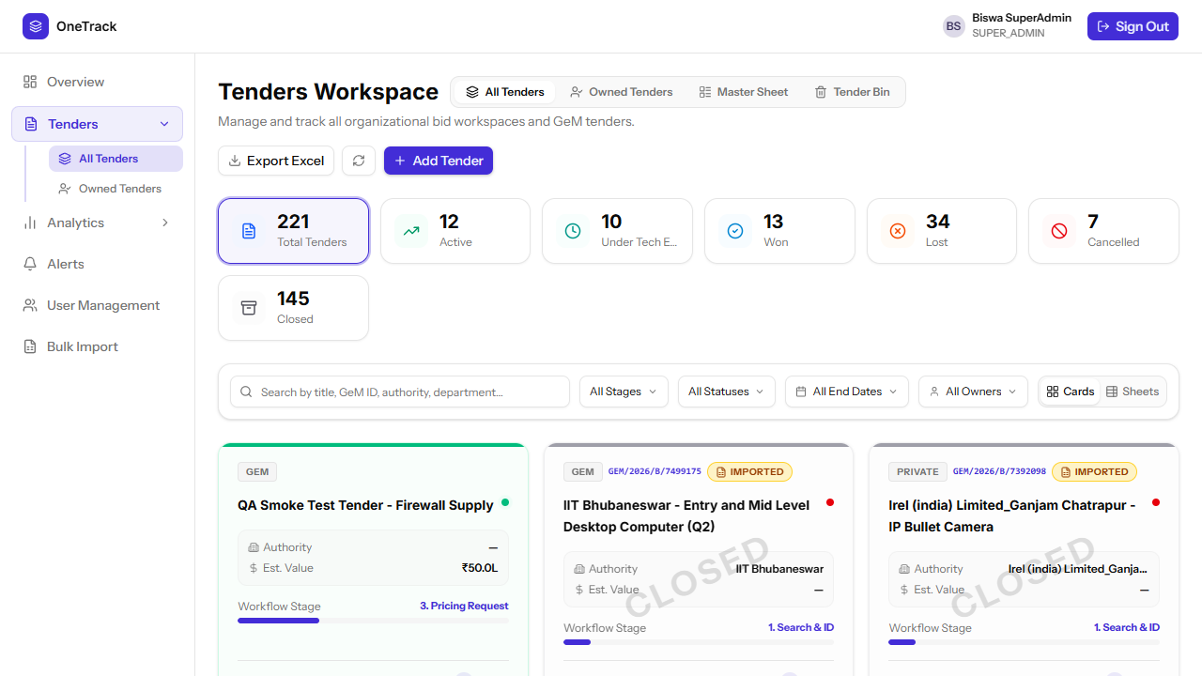
Total 220 · Won 13 · Lost 34 (was fabricated at 72+) · Cancelled 7 · Closed 145 · correct proportional progress bars on every card.

4. Bulk-import warning for the un-imported SUPPORTING BID sheet
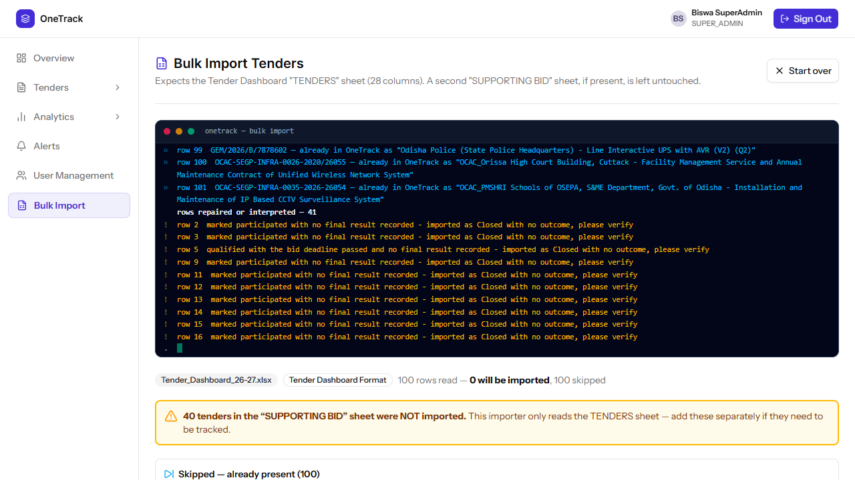
Bold, impossible-to-miss warning naming the exact tender count left out — and the live console shows the corrected "imported as Closed with no outcome" wording from the B3 fix.

5. Manual tender creation through the full stage lifecycle
A tender was created through the Add Tender wizard with a full ONLINE-EMD bank profile, then walked through Stage 1 (Search & ID, auto-complete on creation) and Stage 2 (OEM Authorization) live in the browser, confirming the PATCH and stage-history writes both succeed and the stepper advances correctly.
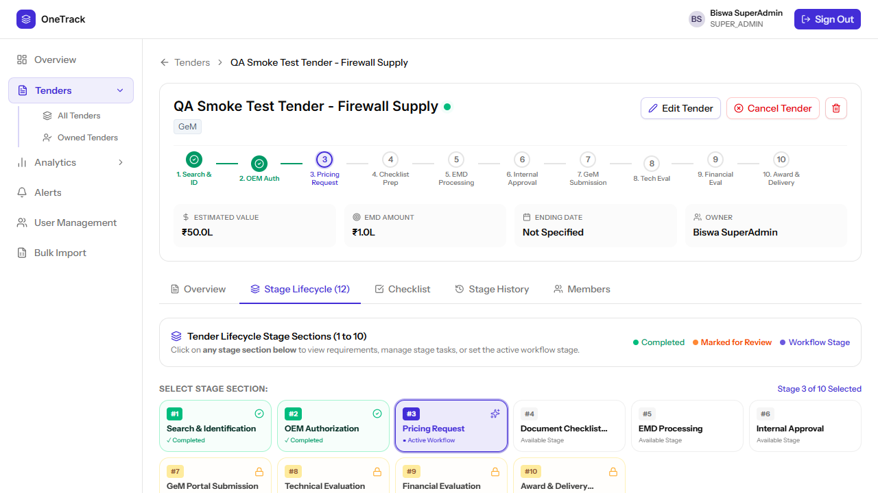
Manually created tender after completing Stages 1 and 2 — workflow correctly advanced to Stage 3 (Pricing Request).

Build and Test Gates
Gate | Result | Notes
go build ./... | PASS | no compile errors
go vet ./... | PASS | no findings
go test ./internal/bid/importer/... | PASS | 10 tests, all green (7 new regression tests added for this pass)
npm run build | PASS | production bundle builds clean
npm run lint | No new errors | 181 pre-existing errors across the codebase (mostly unused shadcn/ui imports) predate this work and are unrelated to any file touched in this pass

New automated regression tests added
- TestGBXDuplicateRowsAreSkippedNotSummed — B1
- TestGBXInconclusiveOutcomeIsClosedNotLost — B3 (GBX side)
- TestDashboardDeterministicAcrossRuns — B2
- TestDashboardUnrecordedResultsAreClosedNotLost — B3 (Dashboard side)
- TestParseTimeFractionRoundsToNearestSecond — B9
- TestExemptedRowsCarryAnExemptionType — B4
- TestGBXNoIdentifierRowsStillImport — regression guard for the false positive noted above

Appendix — Files Changed

Backend (Go)
- backend/internal/bid/importer/importer.go — duplicate handling, cross-format enrichment
- backend/internal/bid/importer/derive.go — GBX EMD exemption, inconclusive-outcome handling
- backend/internal/bid/importer/dashboard.go — deterministic now, time rounding, inconclusive-outcome handling
- backend/internal/bid/handler/import_handler.go — enrichment no longer gated by format
- backend/cmd/importtracker/main.go — CLI updated to match (enrichment always runs)
- backend/internal/bid/importer/importer_test.go — new regression test suite
- backend/internal/bid/importer/testdata/ — the two source workbooks, as fixtures

Frontend (React)
- frontend/src/components/tenders/TendersPage.jsx — quantity coercion, progress bar stages, date input, free-text-result derivation scope
- frontend/src/components/tenders/MasterSheetPage.jsx — CSV export csvValue accessors
- frontend/src/components/Dashboard.jsx — shared formatCurrency
- frontend/src/components/analytics/AnalyticsPage.jsx — shared formatCurrency
- frontend/src/lib/tenderFormat.js — dead AWARD_DELIVERY_HANDOVER references corrected
- frontend/src/components/admin/importConsoleLines.js — honest console text
- frontend/src/components/admin/BulkImportPage.jsx — SUPPORTING BID warning, uncertain-rollback wiring

