ONETRACK GLOBX
Database Design Document
Complete reference of every table, column and relationship in the OneTrack tender-management database, with an Entity Relationship Diagram and a full Database Diagram.
23 | 268 | 4 | 38
Tables | Columns | Schemas | Foreign keys

Database engine | PostgreSQL 15
Database name | onetrack
Schemas | auth · bid · feedback · public
Schema version | Migration 000048_pricing_suggestion_window (all 49 migrations applied)
Source | Read directly from the live database catalogue (information_schema / pg_catalog)

Contents
1. Table Overview
2. Table Details (all 23 tables, every column)
3. Entity Relationship (ER) Diagram
4. Database Diagram

1. Table Overview
The database is split into four schemas (named groups of tables). Each row below gives the table, why it exists, what it holds and which tables it is linked to.
Schema | Area | What lives here
auth | Identity & Access (9 tables) | Users, roles, permissions, login OTPs, platform settings and the system audit log.
bid | Tender / Bid Management (9 tables) | The tender (bid workspace) and everything attached to it: team, checklists, OEMs, quotes, history and approvals.
feedback | Feedback & Support (2 tables) | Tickets raised by users from inside the app and their status trail.
public | Notifications & System (3 tables) | In-app notifications plus the migration bookkeeping tables.

table_name | purpose | attributes | relationships
AUTH SCHEMA · Identity & Access
users  auth · 13 columns | Master list of every person who can sign in to OneTrack. | Login identity (employee code, username, password hash), profile (name, email, phone, department), account state (active, force-password-change, last login). | Central table. Referenced by almost every other table: role assignments, tender ownership (owner, reporting manager, account manager, pre-sales), team membership, approvals, history, tickets, alerts and audit logs.
roles  auth · 5 columns | Catalogue of job roles a user can hold. | Role name (SUPER_ADMIN, ADMIN, MANAGER, ACCOUNT_MANAGER, PRE_SALES, BID_EXECUTIVE, FINANCE), description, built-in flag. | Linked to users through user_roles and to permissions through role_permissions. alerts.target_role refers to a role name (no FK).
permissions  auth · 5 columns | Catalogue of individual actions the system can allow or block. | Resource + action pairs, e.g. bid:create, bid:assign, user:deactivate, analytics:export, admin:system. | Granted to roles through role_permissions; granted or revoked per user through user_permission_overrides.
role_permissions  auth · 2 columns | Links roles to the permissions they grant. | Pairs of (role, permission). | Many-to-many bridge: roles ⇄ permissions. Both sides cascade on delete.
user_roles  auth · 6 columns | Assigns roles to users (primary and secondary). | User, role, who assigned it and when, primary-role flag, display order. | Many-to-many bridge: users ⇄ roles. assigned_by also points to users.
user_permission_overrides  auth · 5 columns | Per-user exceptions to role permissions. | User, permission, effect ALLOW or DENY. | Links users ⇄ permissions. One override per user per permission.
password_otps  auth · 5 columns | One-time codes for the forgot-password flow. | Email address, OTP code, expiry time. | No foreign key. Matched to users by email address.
system_configurations  auth · 5 columns | Platform-wide settings that admins can change at runtime. | Setting key, JSON value, description, who changed it last. | updated_by points to users.
system_events  auth · 8 columns | Audit log for account, security and configuration activity. | Category, event type, actor, target user, summary text, JSON details. | actor_id and target_user_id point to users.
BID SCHEMA · Tender / Bid Management
bid_workspaces  bid · 111 columns | The tender itself. One row per tender tracked, from discovery to award. | Tender identity (numbers, title, buyer), current workflow stage and status, assigned people, all key dates, prices and ranks, EMD and bank guarantee details, evaluation results, stage workspaces (OEM, pricing, reviews) stored as JSON. | Parent of bid_workspace_members, bid_checklists, bid_oem_entries, bid_distributor_quotes, bid_stage_history, tender_edit_approvals and alerts. Five links to users: owner, reporting manager, account manager, pre-sales, creator.
bid_workspace_members  bid · 6 columns | The team working on each tender. | Tender, user, role on the tender (OWNER, MANAGER, MEMBER, REVIEWER, OBSERVER, ACCOUNT_MANAGER, PRESALES), who added them. | Many-to-many bridge: bid_workspaces ⇄ users. added_by also points to users. One membership per user per tender.
bid_checklists  bid · 9 columns | Document checklist items for each tender. | Item title, done flag, who ticked it and when, group (BIDDER, OEM, BID_DOC, CUSTOM), sort order. | Child of bid_workspaces (cascade delete). done_by points to users.
bid_oem_entries  bid · 12 columns | OEM (manufacturer) authorisation tracking per tender (V2 table). | OEM name, identification, initiated flag, MAF received, Make-in-India status, status, remarks. | Child of bid_workspaces (cascade delete). created_by points to users.
bid_distributor_quotes  bid · 8 columns | Distributor price quotes per tender (V2 table). | Distributor name, purchase price, quantity, response received flag. | Child of bid_workspaces (cascade delete). created_by points to users.
bid_stage_history  bid · 10 columns | Activity ledger for tenders: every stage move and important action. | From stage, to stage, event type (STAGE_CHANGE, IMPORT, OEM, PRICING, CHECKLIST, FINANCE, APPROVAL, ALERT, TENDER_EDITED …), reason, who, JSON details, tender title snapshot. | Child of bid_workspaces (SET NULL on delete, so history survives). transitioned_by points to users.
tender_edit_approvals  bid · 15 columns | Edit / cancel / delete requests waiting for Reporting Manager approval. | Tender, requester, approver, action type (EDIT, CANCEL, DELETE), status (PENDING, APPROVED, REJECTED), proposed data and field diff, decision data and comment. | Child of bid_workspaces (cascade delete). requested_by, reporting_manager_id and decided_by point to users. Only one PENDING request per tender.
user_stage_restrictions  bid · 5 columns | Blocks a specific user from a specific workflow stage. | User, workflow stage, who set the block and when. | user_id (cascade delete) and restricted_by point to users. One row per user per stage.
field_suggestions  bid · 7 columns | Auto-complete memory for tender form fields. | Field name, value as typed, normalised value, how often and how recently it was used. | Standalone. No foreign keys.
FEEDBACK SCHEMA · Feedback & Support
tickets  feedback · 11 columns | Feedback, bug reports and requests raised by users. | Submitter, category, description, optional screenshot, status (OPEN, IN_PROGRESS, RESOLVED), who resolved it. | user_id and resolved_by point to users. Parent of ticket_status_history.
ticket_status_history  feedback · 7 columns | Status trail of each feedback ticket. | Ticket, old status, new status, who changed it, note. | Child of tickets (cascade delete). changed_by points to users.
PUBLIC SCHEMA · Notifications & System
alerts  public · 9 columns | In-app notifications (the bell icon). | Recipient user or target role, related tender, type, title, message, read flag. | user_id → users and bid_id → bid_workspaces (both cascade delete). target_role matches a roles.name (no FK).
onetrack_migrations  public · 2 columns | Tracks which database migration scripts have been applied. | Migration file name and time applied. | Standalone. Used only by the migration runner.
schema_migrations  public · 2 columns | Old migration tracker from the original migration tool (legacy). | Version number and dirty flag. | Standalone. Superseded by onetrack_migrations.

2. Table Details
Every table with every column. Key: PK = primary key, FK = foreign key (link to another table), UQ = unique. Null = "Yes" means the column may be left empty. Default = value used when none is given. timestamptz = date + time with time zone; jsonb = structured JSON data; numeric(15,2) = amount with 2 decimals.

2.1 users
auth 13 columns · Primary key: id
One row per employee account. It holds how the person logs in, who they are, and whether the account is still usable. Every action in the system (creating a tender, approving an edit, ticking a checklist) is traced back to a row here.
# | Column | Data type | Null | Key | Default | Description
1 | id | uuid | No | PK | gen_random_uuid() | Unique user ID.
2 | employee_code | varchar(50) | No | UQ | — | Company employee code. Unique.
3 | username | varchar(100) | No | UQ | — | Login name. Unique.
4 | password_hash | text | No |  | — | Bcrypt hash of the password. The plain password is never stored.
5 | force_password_change | boolean | No |  | true | If true, the user must set a new password at next login (new or reset accounts).
6 | is_active | boolean | No |  | true | False means the account is deactivated and cannot sign in.
7 | last_login_at | timestamptz | Yes |  | — | Time of the most recent successful login.
8 | created_at | timestamptz | No |  | now() | When the account was created.
9 | updated_at | timestamptz | No |  | now() | When the account was last changed.
10 | full_name | varchar(200) | No |  | '' | Display name shown across the app.
11 | email | varchar(255) | Yes | UQ | — | Work email. Unique when filled. Used for password-reset OTPs.
12 | phone | varchar(20) | Yes |  | — | Contact phone number.
13 | department | varchar(100) | Yes |  | — | Department the user belongs to.
Relationships
← auth.system_configurations links here via updated_by
← auth.system_events links here via actor_id, target_user_id
← auth.user_permission_overrides links here via user_id
← auth.user_roles links here via assigned_by, user_id
← bid.bid_checklists links here via done_by
← bid.bid_distributor_quotes links here via created_by
← bid.bid_oem_entries links here via created_by
← bid.bid_stage_history links here via transitioned_by
← bid.bid_workspace_members links here via added_by, user_id
← bid.bid_workspaces links here via account_manager_id, bid_owner_id, created_by, presales_id, reporting_manager_id
← bid.tender_edit_approvals links here via decided_by, reporting_manager_id, requested_by
← bid.user_stage_restrictions links here via restricted_by, user_id
← feedback.ticket_status_history links here via changed_by
← feedback.tickets links here via resolved_by, user_id
← public.alerts links here via user_id
Rules
• email is unique when filled (partial unique index).

2.2 roles
auth 5 columns · Primary key: id
Defines the roles that exist in the company, such as Account Manager or Finance. A role is a named bundle of permissions; users get their access by being given one or more roles.
# | Column | Data type | Null | Key | Default | Description
1 | id | uuid | No | PK | gen_random_uuid() | Unique role ID.
2 | name | varchar(100) | No | UQ | — | Role code, e.g. SUPER_ADMIN, ACCOUNT_MANAGER, BID_EXECUTIVE. Unique.
3 | description | text | Yes |  | — | What the role is for.
4 | is_system | boolean | No |  | false | True for built-in roles (SUPER_ADMIN, ADMIN) that cannot be deleted.
5 | created_at | timestamptz | No |  | now() | When the role was created.
Relationships
← auth.role_permissions links here via role_id
← auth.user_roles links here via role_id

2.3 permissions
auth 5 columns · Primary key: id
Each row is one thing a user might be allowed to do, written as a resource and an action (for example "bid" + "edit"). Roles and per-user overrides point at these rows.
# | Column | Data type | Null | Key | Default | Description
1 | id | uuid | No | PK | gen_random_uuid() | Unique permission ID.
2 | resource | varchar(100) | No |  | — | Area of the system: bid, user, document, analytics, notification, admin, task.
3 | action | varchar(100) | No |  | — | Operation on that area: view, create, edit, delete, assign, export, etc. Unique together with resource.
4 | description | text | Yes |  | — | Plain-language meaning of the permission.
5 | created_at | timestamptz | No |  | now() | When the permission was added.
Relationships
← auth.role_permissions links here via permission_id
← auth.user_permission_overrides links here via permission_id
Rules
• Unique combination: (resource, action).

2.4 role_permissions
auth 2 columns · Primary key: role_id, permission_id
A simple link table. If a row exists for a role and a permission, everyone holding that role gets that permission.
# | Column | Data type | Null | Key | Default | Description
1 | role_id | uuid | No | PK FK | — | The role. Part of the primary key.
2 | permission_id | uuid | No | PK FK | — | The permission granted. Part of the primary key.
Relationships
→ permission_id references auth.permissions.id (required; rows deleted with parent)
→ role_id references auth.roles.id (required; rows deleted with parent)

2.5 user_roles
auth 6 columns · Primary key: user_id, role_id
Says which roles each user holds. A user can have several roles; one is marked primary (their main job) and the rest are ordered secondary roles.
# | Column | Data type | Null | Key | Default | Description
1 | user_id | uuid | No | PK FK | — | The user receiving the role. Part of the primary key.
2 | role_id | uuid | No | PK FK | — | The role given. Part of the primary key.
3 | assigned_at | timestamptz | No |  | now() | When the role was assigned.
4 | assigned_by | uuid | Yes | FK | — | Admin who assigned it.
5 | is_primary | boolean | No |  | false | True for the user's main role.
6 | role_order | integer | No |  | 0 | Order of the role in the user's list (0 = first).
Relationships
→ assigned_by references auth.users.id (optional; parent cannot be deleted while referenced)
→ role_id references auth.roles.id (required; rows deleted with parent)
→ user_id references auth.users.id (required; rows deleted with parent)

2.6 user_permission_overrides
auth 5 columns · Primary key: id
Lets an admin give one person an extra permission, or take one away, without changing their role. DENY wins over what the role would allow.
# | Column | Data type | Null | Key | Default | Description
1 | id | uuid | No | PK | gen_random_uuid() | Unique override ID.
2 | user_id | uuid | No | FK | — | The user the exception applies to.
3 | permission_id | uuid | No | FK | — | The permission being allowed or denied.
4 | effect | varchar(10) | No |  | — | ALLOW or DENY.
5 | created_at | timestamptz | No |  | now() | When the override was created.
Relationships
→ permission_id references auth.permissions.id (required; rows deleted with parent)
→ user_id references auth.users.id (required; rows deleted with parent)
Rules
• Unique combination: (user_id, permission_id).

2.7 password_otps
auth 5 columns · Primary key: id
When someone clicks "forgot password", a short code is generated, emailed, and stored here until it is used or expires.
# | Column | Data type | Null | Key | Default | Description
1 | id | uuid | No | PK | gen_random_uuid() | Unique OTP record ID.
2 | email | varchar(255) | No |  | — | Address the code was sent to.
3 | otp_code | varchar(10) | No |  | — | The one-time code.
4 | expires_at | timestamptz | No |  | — | Time after which the code is no longer valid.
5 | created_at | timestamptz | Yes |  | now() | When the code was issued.
Relationships
⇢ email ⇢ auth.users.email (matched by value, no FK)

2.8 system_configurations
auth 5 columns · Primary key: key
A key-value store for switches and numbers that change behaviour without a redeploy, such as whether Stage 2 needs both Account Manager and Pre-Sales, or how many past deals the pricing suggestion averages.
# | Column | Data type | Null | Key | Default | Description
1 | key | text | No | PK | — | Setting name, e.g. stage2_require_am_presales, pricing_suggestion_window.
2 | value | jsonb | No |  | — | Setting value stored as JSON (true/false, a number, etc.).
3 | description | text | Yes |  | — | What the setting controls.
4 | updated_by | uuid | Yes | FK | — | Admin who last changed it.
5 | updated_at | timestamptz | No |  | now() | When it was last changed.
Relationships
→ updated_by references auth.users.id (optional; parent cannot be deleted while referenced)

2.9 system_events
auth 8 columns · Primary key: id
The "System Logs" page reads from here. It records logins, failed logins, config changes and stage-access changes, i.e. everything that is not tender activity (tender activity lives in bid_stage_history).
# | Column | Data type | Null | Key | Default | Description
1 | id | uuid | No | PK | gen_random_uuid() | Unique event ID.
2 | category | text | No |  | — | Group: SECURITY, CONFIGURATION, ACCESS_CONTROL.
3 | event_type | text | No |  | — | Exact event, e.g. LOGIN_SUCCESS, LOGIN_FAILED, CONFIG_UPDATE, STAGE_ACCESS_UPDATED.
4 | actor_id | uuid | Yes | FK | — | User who performed the action.
5 | target_user_id | uuid | Yes | FK | — | User the action was performed on, if any.
6 | summary | text | No |  | — | One-line readable description.
7 | details | jsonb | Yes |  | — | Extra structured data about the event (JSON).
8 | created_at | timestamptz | No |  | now() | When it happened.
Relationships
→ actor_id references auth.users.id (optional; parent cannot be deleted while referenced)
→ target_user_id references auth.users.id (optional; parent cannot be deleted while referenced)

2.10 bid_workspaces
bid 111 columns · Primary key: id
This is the heart of OneTrack. Each row is one tender (bid) the company is tracking. It carries everything about that tender as it moves through the 11 workflow stages: who is working on it, the important dates, our price vs. the winning price, EMD and bank guarantee money, and the final result. Larger working data for individual stages (OEM matrix, pricing sheet, primary review) is kept in JSON columns so the whole team shares one copy.
# | Column | Data type | Null | Key | Default | Description
Identity & Scope (20)
1 | id | uuid | No | PK | gen_random_uuid() | Unique tender ID.
2 | bid_no | varchar(150) | Yes |  | — | Tender / RFP reference number.
3 | gem_bid_no | varchar(150) | Yes |  | — | GeM portal bid number, e.g. GEM/2026/B/1234567.
4 | title | text | No |  | — | Tender title. Full-text indexed for search.
5 | organization_name | text | Yes |  | — | Buyer organisation.
6 | department_name | text | Yes |  | — | Buyer department.
47 | authority | text | Yes |  | — | Tendering authority.
106 | location | text | Yes |  | — | Delivery / project location.
7 | portal_source | varchar(50) | No |  | 'GeM' | Where the tender was found: GeM, CPPP, Private, etc.
8 | creation_mode | varchar(20) | No |  | 'MANUAL' | How it was created: MANUAL or INTELLIGENCE (AI-assisted).
25 | category | varchar(150) | Yes |  | — | Product / service category.
26 | bid_type | varchar(50) | Yes |  | — | Type of bid (e.g. BID).
27 | gem_bid_type | varchar(100) | Yes |  | — | GeM-specific bid type.
75 | scope_type | text | Yes |  | — | Scope type: Supply, Implementation, Support.
42 | high_level_scope | text | Yes |  | — | Short description of the scope of work.
102 | quantity | integer | Yes |  | — | Number of units / licences in the tender.
108 | requested_products | jsonb | Yes |  | — | Products / services asked in the RFP: product, description, qty, OEM (JSON array).
28 | oem_required | boolean | No |  | false | True if OEM authorisation is needed.
29 | has_tech_eval | boolean | No |  | false | True if the tender has a technical evaluation round.
46 | bg_required | boolean | No |  | false | True if a Bank Guarantee (performance security) is needed.
People (FK → users) (6)
11 | bid_owner_id | uuid | Yes | FK | — | Bid Executive who owns the tender.
73 | reporting_manager_id | uuid | Yes | FK | — | Reporting Manager who approves this tender's changes.
104 | account_manager_id | uuid | Yes | FK | — | Account Manager assigned (does Primary Review).
105 | presales_id | uuid | Yes | FK | — | Pre-Sales engineer assigned.
12 | created_by | uuid | Yes | FK | — | User who created the record.
74 | team | text | Yes |  | — | Business team handling the tender (e.g. GSN_ETS).
Workflow & Stages (12)
9 | workflow_stage | varchar(50) | No |  | 'DISCOVERED' | Current stage: DISCOVERED → PRIMARY_REVIEW → OEM_AUTHORIZATION_REQUEST → PRICING_REQUEST → DOCUMENT_CHECKLIST_PREPARATION → EMD_PROCESSING → INTERNAL_APPROVAL → GEM_SUBMISSION → TECHNICAL_EVALUATION → FINANCIAL_EVALUATION → AWARD_HANDOVER.
10 | bid_status | varchar(20) | No |  | 'ACTIVE' | Overall status: ACTIVE, WON, LOST, CANCELLED, CLOSED (not bid), ARCHIVED.
30 | qualification_status | varchar(50) | No |  | 'PENDING' | Qualification check status (default PENDING).
64 | stage_completions | jsonb | No |  | '{}' | Which stages are marked complete, as {stage: true/false} (JSON).
65 | stage_remarks | jsonb | No |  | '{}' | Completion remark per stage, as {stage: text} (JSON).
72 | stage_reviews | jsonb | No |  | '{}' | Review/sign-off flag per stage, as {stage: true/false} (JSON).
109 | primary_review | jsonb | Yes |  | — | Stage 2 Primary Review data: pre-sales products, go/no-go, who completed it (JSON).
85 | oem_workspace | jsonb | Yes |  | — | Stage 3 OEM matrix: each OEM's initiation, MAF, compliance, follow-ups (JSON).
84 | pricing_workspace | jsonb | Yes |  | — | Stage 4 pricing workspace: distributor quotes, items, margin, approvals (JSON).
71 | submission_done | boolean | No |  | false | True once the bid is submitted on the portal.
111 | alert_note | jsonb | Yes |  | — | Highlighted note / challenge on the tender: text, label, colour (JSON).
34 | remarks | text | Yes |  | — | General remarks.
Key Dates (9)
20 | opening_date | timestamptz | Yes |  | — | Tender opening date.
21 | closing_date | timestamptz | Yes |  | — | Bid submission deadline.
22 | submission_date | timestamptz | Yes |  | — | When we actually submitted.
23 | result_date | timestamptz | Yes |  | — | When the result was published.
24 | ra_date | timestamptz | Yes |  | — | Reverse Auction date.
43 | start_date | timestamptz | Yes |  | — | Contract start date.
44 | end_date | timestamptz | Yes |  | — | Contract end date.
45 | duration_months | integer | Yes |  | 1 | Contract duration in months.
78 | target_month_date | timestamptz | Yes |  | — | Target month for the tender (tracker field).
Prices & Result (11)
13 | estimated_value | numeric(15,2) | Yes |  | — | Estimated tender value (₹).
19 | quoted_price | numeric(15,2) | Yes |  | — | Price we quoted (₹).
17 | final_bid_value | numeric(15,2) | Yes |  | — | Final value of the submitted bid (₹).
69 | gem_submission_price | numeric(15,2) | Yes |  | — | Price entered on GeM at submission (₹).
70 | final_price | numeric(15,2) | Yes |  | — | Final price after RA / negotiation (₹).
18 | l1_price | numeric(15,2) | Yes |  | — | Lowest (L1) price in the result (₹).
56 | l1_company_name | text | Yes |  | '' | Company that came L1.
57 | price_difference | numeric(15,2) | Yes |  | 0.00 | Our price minus L1 price (₹).
58 | price_difference_pct | numeric(10,2) | Yes |  | 0.00 | Price difference as a percentage.
103 | our_rank | text | Yes |  | — | Our price rank: L1, L2, … or H1.
35 | competitor_info | jsonb | No |  | '[]' | List of competitors with name, rank and quoted price (JSON array).
Evaluation & Outcome (7)
53 | technical_result | varchar(50) | Yes |  | '' | Technical evaluation result: QUALIFIED or DISQUALIFIED.
33 | tech_compliance_status | varchar(30) | Yes |  | — | Technical compliance status.
54 | disqualification_reason | text | Yes |  | '' | Reason for technical disqualification.
55 | financial_result | varchar(50) | Yes |  | '' | Financial evaluation result.
31 | bid_outcome | varchar(30) | Yes |  | — | Final outcome: WON, LOST or CANCELLED.
32 | outcome_reason | text | Yes |  | — | Why we won / lost / it was cancelled.
61 | eligibility_remarks | text | Yes |  | '' | Notes on eligibility.
EMD (20)
14 | emd_amount | numeric(15,2) | Yes |  | — | Earnest Money Deposit required (₹).
15 | emd_type | varchar(50) | Yes |  | — | How EMD is paid: ONLINE, DD, NOT_APPLICABLE, etc.
16 | emd_exempted | boolean | No |  | false | True if the company is exempt from EMD.
101 | emd_not_applicable | boolean | No |  | false | True if the tender has no EMD at all. Cannot be true together with emd_exempted.
99 | emd_exemption_type | varchar(20) | Yes |  | — | Final EMD exemption decision: MSME, STARTUP or OTHER.
110 | emd_exemption_types | text[] | Yes |  | — | All exemption categories the tender allows (text array).
100 | emd_exemption_reason | text | Yes |  | — | Reason for the EMD exemption.
62 | emd_remarks | text | Yes |  | '' | Notes on EMD.
63 | emd_ready | boolean | No |  | false | True once Finance has the EMD ready.
96 | emd_ready_date | timestamptz | Yes |  | — | Date the EMD became ready.
59 | emd_returned | boolean | No |  | false | True once the EMD has been refunded.
95 | emd_returned_date | timestamptz | Yes |  | — | Date the EMD was refunded.
86 | emd_bank_name | text | Yes |  | — | Bank name for online EMD payment.
87 | emd_account_number | text | Yes |  | — | Account number for online EMD payment.
88 | emd_ifsc_code | text | Yes |  | — | IFSC code for online EMD payment.
89 | emd_branch | text | Yes |  | — | Bank branch for online EMD payment.
90 | emd_beneficiary | text | Yes |  | — | Beneficiary name for EMD Demand Draft.
91 | emd_payable_at | text | Yes |  | — | Place where the EMD Demand Draft is payable.
67 | finance_alerted | boolean | No |  | false | True once Finance has been alerted for EMD.
68 | finance_alert_at | timestamptz | Yes |  | — | When Finance was alerted.
Bank Guarantee & Delivery (8)
76 | bg_rate | numeric(15,2) | Yes |  | — | Bank Guarantee rate / percentage.
107 | bg_duration_months | integer | Yes |  | — | Bank Guarantee validity in months.
93 | bg_target_date | timestamptz | Yes |  | — | Date by which the Bank Guarantee must be submitted.
60 | bg_discharged | boolean | No |  | false | True once the Bank Guarantee has been released.
94 | bg_discharged_date | timestamptz | Yes |  | — | Date the Bank Guarantee was released.
92 | po_received_date | timestamptz | Yes |  | — | Date the Purchase Order was received.
97 | delivery_complete | boolean | Yes |  | false | True once delivery is complete.
98 | delivery_complete_date | timestamptz | Yes |  | — | Date delivery was completed.
Excel Tracker Import (7)
77 | activity_type | text | Yes |  | — | Activity type from tracker: Bid, Bid to RA, Quotation.
79 | excel_bid_status | text | Yes |  | — | Status as recorded in the Excel tracker (Active / Closed).
80 | submission_status | text | Yes |  | — | Submission status from the Excel tracker.
81 | financial_evaluation_status | text | Yes |  | — | Financial evaluation status from the Excel tracker.
82 | po_received_status | text | Yes |  | — | Purchase Order status from the Excel tracker.
83 | bid_result | text | Yes |  | — | Bid result from the Excel tracker.
36 | metadata | jsonb | No |  | '{}' | Extra info, e.g. Excel import source file, row number, warnings (JSON).
AI & Audit (5)
37 | ai_source_document_id | uuid | Yes |  | — | Source document used for AI extraction (INTELLIGENCE mode).
38 | ai_extraction_confidence | numeric(5,4) | Yes |  | — | AI extraction confidence score, 0 to 1.
39 | created_at | timestamptz | No |  | now() | When the tender was created.
40 | updated_at | timestamptz | No |  | now() | When the tender was last changed.
41 | archived_at | timestamptz | Yes |  | — | When the tender was moved to the bin. Empty = live.
Legacy (unused) (6)
48 | department | text | Yes |  | — | Legacy V2 field, no longer used (see department_name).
49 | oem_tracking | jsonb | No |  | '{}' | Legacy V2 field, no longer used (replaced by oem_workspace).
50 | distributor_quotes | jsonb | No |  | '[]' | Legacy V2 field, no longer used (replaced by pricing_workspace).
51 | pricing_calculation | jsonb | No |  | '{}' | Legacy V2 field, no longer used (replaced by pricing_workspace).
52 | document_checklists | jsonb | No |  | '{}' | Legacy V2 field, no longer used (replaced by bid_checklists table).
66 | checklist_type | varchar(30) | Yes |  | 'BIDDER' | Legacy V2 field, no longer used (see bid_checklists.checklist_group).
Relationships
→ account_manager_id references auth.users.id (optional; parent cannot be deleted while referenced)
→ bid_owner_id references auth.users.id (optional; parent cannot be deleted while referenced)
→ created_by references auth.users.id (optional; parent cannot be deleted while referenced)
→ presales_id references auth.users.id (optional; parent cannot be deleted while referenced)
→ reporting_manager_id references auth.users.id (optional; parent cannot be deleted while referenced)
← bid.bid_checklists links here via bid_id
← bid.bid_distributor_quotes links here via bid_id
← bid.bid_oem_entries links here via bid_id
← bid.bid_stage_history links here via bid_id
← bid.bid_workspace_members links here via bid_id
← bid.tender_edit_approvals links here via bid_id
← public.alerts links here via bid_id
Rules
• emd_exempted and emd_not_applicable cannot both be true (CHECK).
• Tender numbers (gem_bid_no, bid_no) must be unique among live tenders. This is enforced by the application; migration 000031 adds matching unique indexes only once existing duplicates are cleaned up.

2.11 bid_workspace_members
bid 6 columns · Primary key: id
Lists who is on each tender's team and in what capacity. This is what decides which tenders show up in a person's list and what they can do on them.
# | Column | Data type | Null | Key | Default | Description
1 | id | uuid | No | PK | gen_random_uuid() | Unique membership ID.
2 | bid_id | uuid | No | FK | — | The tender.
3 | user_id | uuid | No | FK | — | The team member.
4 | role | varchar(30) | No |  | 'MEMBER' | Role on this tender: OWNER, MANAGER, MEMBER, REVIEWER, OBSERVER, ACCOUNT_MANAGER, PRESALES.
5 | added_by | uuid | Yes | FK | — | User who added them.
6 | added_at | timestamptz | No |  | now() | When they were added.
Relationships
→ added_by references auth.users.id (optional; parent cannot be deleted while referenced)
→ bid_id references bid.bid_workspaces.id (required; rows deleted with parent)
→ user_id references auth.users.id (required; parent cannot be deleted while referenced)
Rules
• Unique combination: (bid_id, user_id).

2.12 bid_checklists
bid 9 columns · Primary key: id
The to-do list of documents needed before submission, e.g. company PAN, OEM authorisation letter. Each item can be ticked off, and the system remembers who ticked it and when.
# | Column | Data type | Null | Key | Default | Description
1 | id | uuid | No | PK | gen_random_uuid() | Unique checklist item ID.
2 | bid_id | uuid | No | FK | — | The tender this item belongs to.
3 | title | text | No |  | — | Document / task name.
4 | is_done | boolean | No |  | false | True once completed.
5 | done_by | uuid | Yes | FK | — | User who ticked it.
6 | done_at | timestamptz | Yes |  | — | When it was ticked.
7 | sort_order | integer | No |  | 0 | Display order within the list.
8 | created_at | timestamptz | No |  | now() | When the item was added.
9 | checklist_group | varchar(20) | No |  | 'BIDDER' | Section: BIDDER, OEM, BID_DOC or CUSTOM.
Relationships
→ bid_id references bid.bid_workspaces.id (required; rows deleted with parent)
→ done_by references auth.users.id (optional; parent cannot be deleted while referenced)

2.13 bid_oem_entries
bid 12 columns · Primary key: id
Tracks, per tender, which manufacturers were approached and whether their authorisation letter (MAF) came back. Currently empty: the live app keeps this data in bid_workspaces.oem_workspace.
# | Column | Data type | Null | Key | Default | Description
1 | id | uuid | No | PK | gen_random_uuid() | Unique OEM entry ID.
2 | bid_id | uuid | No | FK | — | The tender.
3 | oem_name | text | No |  | — | Manufacturer name.
4 | identification | text | Yes |  | — | Product / part identification.
5 | initiated | boolean | No |  | false | True once the OEM was contacted.
6 | maf_received | boolean | No |  | false | True once the Manufacturer Authorisation Form was received.
7 | mii_status | varchar(30) | Yes |  | 'PENDING' | Make-in-India compliance status (default PENDING).
8 | status | varchar(30) | Yes |  | 'PENDING' | Overall status of this OEM request (default PENDING).
9 | remarks | text | Yes |  | — | Notes.
10 | created_by | uuid | Yes | FK | — | User who added the entry.
11 | created_at | timestamptz | No |  | now() | When it was added.
12 | updated_at | timestamptz | No |  | now() | When it was last changed.
Relationships
→ bid_id references bid.bid_workspaces.id (required; rows deleted with parent)
→ created_by references auth.users.id (optional; parent cannot be deleted while referenced)

2.14 bid_distributor_quotes
bid 8 columns · Primary key: id
Records the buying price offered by each distributor for a tender. Currently empty: the live app keeps quotes in bid_workspaces.pricing_workspace.
# | Column | Data type | Null | Key | Default | Description
1 | id | uuid | No | PK | gen_random_uuid() | Unique quote ID.
2 | bid_id | uuid | No | FK | — | The tender.
3 | distributor_name | text | No |  | — | Distributor name.
4 | purchase_price | numeric(15,2) | Yes |  | — | Quoted purchase price (₹).
5 | quantity | integer | Yes |  | 1 | Quantity quoted (default 1).
6 | response_received | boolean | No |  | false | True once the distributor replied.
7 | created_by | uuid | Yes | FK | — | User who added the quote.
8 | created_at | timestamptz | No |  | now() | When it was added.
Relationships
→ bid_id references bid.bid_workspaces.id (required; rows deleted with parent)
→ created_by references auth.users.id (optional; parent cannot be deleted while referenced)

2.15 bid_stage_history
bid 10 columns · Primary key: id
The tender timeline. Whenever a tender changes stage or something important happens to it (pricing approved, OEM updated, tender edited or deleted), a row is written here. The title is copied in so the log still reads correctly after a tender is deleted.
# | Column | Data type | Null | Key | Default | Description
1 | id | uuid | No | PK | gen_random_uuid() | Unique history entry ID.
2 | bid_id | uuid | Yes | FK | — | The tender. Set to empty if the tender is deleted.
3 | from_stage | varchar(50) | Yes |  | — | Stage before the change.
4 | to_stage | varchar(50) | No |  | — | Stage after the change (or current stage for non-move events).
5 | transition_reason | text | Yes |  | — | Reason / comment entered.
6 | transitioned_by | uuid | Yes | FK | — | User who did it.
7 | created_at | timestamptz | No |  | now() | When it happened.
8 | event_type | varchar(30) | Yes |  | 'STAGE_CHANGE' | Kind of event: STAGE_CHANGE, IMPORT, OEM, PRICING, CHECKLIST, FINANCE, APPROVAL, ALERT, REMINDER, OUTCOME_RECORDED, TENDER_EDITED, TENDER_ARCHIVED, TENDER_RESTORED, TENDER_DELETED, EDIT_APPROVED.
9 | details | jsonb | Yes |  | — | Extra structured data about the event (JSON).
10 | bid_title | text | Yes |  | — | Copy of the tender title at the time of the event.
Relationships
→ bid_id references bid.bid_workspaces.id (optional; set to empty if parent deleted)
→ transitioned_by references auth.users.id (optional; parent cannot be deleted while referenced)

2.16 tender_edit_approvals
bid 15 columns · Primary key: id
When a Bid Executive edits, cancels or deletes a tender, the change is held here instead of being applied. The tender's Reporting Manager sees the old vs. new values, can correct them, and approves or rejects.
# | Column | Data type | Null | Key | Default | Description
1 | id | uuid | No | PK | gen_random_uuid() | Unique request ID.
2 | bid_id | uuid | No | FK | — | The tender being changed.
3 | requested_by | uuid | No | FK | — | Bid Executive who asked for the change.
4 | reporting_manager_id | uuid | No | FK | — | Reporting Manager who must decide.
5 | status | varchar(20) | No |  | 'PENDING' | PENDING, APPROVED or REJECTED.
6 | payload | jsonb | Yes |  | — | Full proposed change as submitted (JSON).
7 | diff | jsonb | No |  | '[]' | Field-by-field list of old and new values (JSON array).
8 | decided_payload | jsonb | Yes |  | — | Change as finally approved, after any manager corrections (JSON).
9 | decision_diff | jsonb | Yes |  | — | What the manager changed compared with the request (JSON).
10 | decision_comment | text | Yes |  | — | Manager's comment on the decision.
11 | decided_by | uuid | Yes | FK | — | User who approved or rejected.
12 | decided_at | timestamptz | Yes |  | — | When the decision was made.
13 | created_at | timestamptz | No |  | now() | When the request was raised.
14 | updated_at | timestamptz | No |  | now() | When the request was last changed.
15 | action_type | varchar(20) | No |  | 'EDIT' | What is requested: EDIT, CANCEL or DELETE.
Relationships
→ bid_id references bid.bid_workspaces.id (required; rows deleted with parent)
→ decided_by references auth.users.id (optional; parent cannot be deleted while referenced)
→ reporting_manager_id references auth.users.id (required; parent cannot be deleted while referenced)
→ requested_by references auth.users.id (required; parent cannot be deleted while referenced)
Rules
• Only one PENDING request per tender (partial unique index on bid_id WHERE status = 'PENDING').

2.17 user_stage_restrictions
bid 5 columns · Primary key: id
Fine-grained access control for Bid Executives: a row here means that user cannot view or act on that stage of any tender. No row means no restriction.
# | Column | Data type | Null | Key | Default | Description
1 | id | uuid | No | PK | gen_random_uuid() | Unique restriction ID.
2 | user_id | uuid | No | FK | — | The restricted user.
3 | workflow_stage | text | No |  | — | Stage they are blocked from, e.g. PRICING_REQUEST.
4 | restricted_by | uuid | Yes | FK | — | Admin who set the restriction.
5 | restricted_at | timestamptz | No |  | now() | When it was set.
Relationships
→ restricted_by references auth.users.id (optional; parent cannot be deleted while referenced)
→ user_id references auth.users.id (required; rows deleted with parent)
⇢ workflow_stage ⇢ bid.bid_workspaces.workflow_stage values (no FK)
Rules
• Unique combination: (user_id, workflow_stage).

2.18 field_suggestions
bid 7 columns · Primary key: id
Remembers values people have typed before (organisation names, departments, product names, bank names…) so the tender form can suggest them next time. The most used and most recent values come first.
# | Column | Data type | Null | Key | Default | Description
1 | id | uuid | No | PK | gen_random_uuid() | Unique suggestion ID.
2 | field_key | text | No |  | — | Form field it belongs to, e.g. title, organization_name, department_name, product, oem, location, emd_bank_name.
3 | value | text | No |  | — | Value as the user typed it.
4 | normalized_value | text | No |  | — | Lower-cased, trimmed copy used to avoid duplicates. Unique per field.
5 | usage_count | integer | No |  | 1 | How many times it has been used.
6 | last_used_at | timestamptz | No |  | now() | When it was last used.
7 | created_at | timestamptz | No |  | now() | When it was first saved.
Relationships
None — standalone table.
Rules
• Unique combination: (field_key, normalized_value).

2.19 tickets
feedback 11 columns · Primary key: id
When a user reports a problem or suggests an improvement from inside the app, it becomes a ticket here. Admins work through them and mark them resolved.
# | Column | Data type | Null | Key | Default | Description
1 | id | uuid | No | PK | gen_random_uuid() | Unique ticket ID.
2 | user_id | uuid | No | FK | — | User who raised it.
3 | category | text | No |  | — | Area, e.g. Bug Report, Tender Form (Add / Edit), Pricing & OEM Workspace, Reports & Analytics, Other.
4 | custom_category | text | Yes |  | — | Free-text category when "Other" is chosen.
5 | description | text | No |  | — | What the user wrote.
6 | status | text | No |  | 'OPEN' | OPEN, IN_PROGRESS or RESOLVED.
7 | resolved_by | uuid | Yes | FK | — | Admin who resolved it.
8 | resolved_at | timestamptz | Yes |  | — | When it was resolved.
9 | created_at | timestamptz | No |  | now() | When it was raised.
10 | updated_at | timestamptz | No |  | now() | When it was last changed.
11 | image_path | text | Yes |  | — | Stored path of an attached screenshot.
Relationships
→ resolved_by references auth.users.id (optional; parent cannot be deleted while referenced)
→ user_id references auth.users.id (required; parent cannot be deleted while referenced)
← feedback.ticket_status_history links here via ticket_id

2.20 ticket_status_history
feedback 7 columns · Primary key: id
Every time a ticket's status changes, a row is added here, so you can see the full journey of a ticket and any notes left along the way.
# | Column | Data type | Null | Key | Default | Description
1 | id | uuid | No | PK | gen_random_uuid() | Unique history entry ID.
2 | ticket_id | uuid | No | FK | — | The ticket.
3 | from_status | text | Yes |  | — | Status before the change.
4 | to_status | text | No |  | — | Status after the change.
5 | changed_by | uuid | Yes | FK | — | User who changed it.
6 | note | text | Yes |  | — | Comment left with the change.
7 | created_at | timestamptz | No |  | now() | When it changed.
Relationships
→ changed_by references auth.users.id (optional; parent cannot be deleted while referenced)
→ ticket_id references feedback.tickets.id (required; rows deleted with parent)

2.21 alerts
public 9 columns · Primary key: id
Every notification a user sees: tender assigned to you, edit awaiting your approval, EMD needed, feedback resolved. A notification goes either to one user or to everyone with a role (e.g. all FINANCE users).
# | Column | Data type | Null | Key | Default | Description
1 | id | uuid | No | PK | gen_random_uuid() | Unique alert ID.
2 | user_id | uuid | Yes | FK | — | Recipient. Empty when the alert is sent to a whole role.
3 | target_role | varchar(50) | Yes |  | '' | Role that should see it, e.g. FINANCE, ADMIN. Empty for a personal alert.
4 | bid_id | uuid | Yes | FK | — | Related tender, if any.
5 | type | varchar(50) | No |  | — | Kind of alert, e.g. TENDER_ASSIGNED_ACCOUNT_MANAGER, TENDER_EDIT_PENDING_APPROVAL, INTERNAL_APPROVAL_READY, EMD, FEEDBACK_RESOLVED.
6 | title | text | No |  | — | Short heading.
7 | message | text | No |  | — | Full message text.
8 | is_read | boolean | No |  | false | True once the user has read it.
9 | created_at | timestamptz | No |  | now() | When it was sent.
Relationships
→ bid_id references bid.bid_workspaces.id (optional; rows deleted with parent)
→ user_id references auth.users.id (optional; rows deleted with parent)
⇢ target_role ⇢ auth.roles.name (matched by value, no FK)

2.22 onetrack_migrations
public 2 columns · Primary key: version
Bookkeeping for schema upgrades. The server reads this at start-up and only runs migration files that are not listed yet. Latest applied: 000048_pricing_suggestion_window.
# | Column | Data type | Null | Key | Default | Description
1 | version | varchar(255) | No | PK | — | Migration file name, e.g. 000048_pricing_suggestion_window.
2 | applied_at | timestamptz | No |  | now() | When it was applied.
Relationships
None — standalone table.

2.23 schema_migrations
public 2 columns · Primary key: version
Left over from the golang-migrate tool used early in the project. It is no longer updated; onetrack_migrations is the live tracker.
# | Column | Data type | Null | Key | Default | Description
1 | version | bigint | No | PK | — | Last version applied by the old tool.
2 | dirty | boolean | No |  | — | True if a migration failed half-way under the old tool.
Relationships
None — standalone table.

3. Entity Relationship (ER) Diagram
How the entities connect. users (left-centre) and bid_workspaces (right) are the two hubs; the tables between them belong to a tender and are also stamped with the user who acted. Crow's foot = "many" side; bars = "one" side; a circle on the one side means the link is optional.
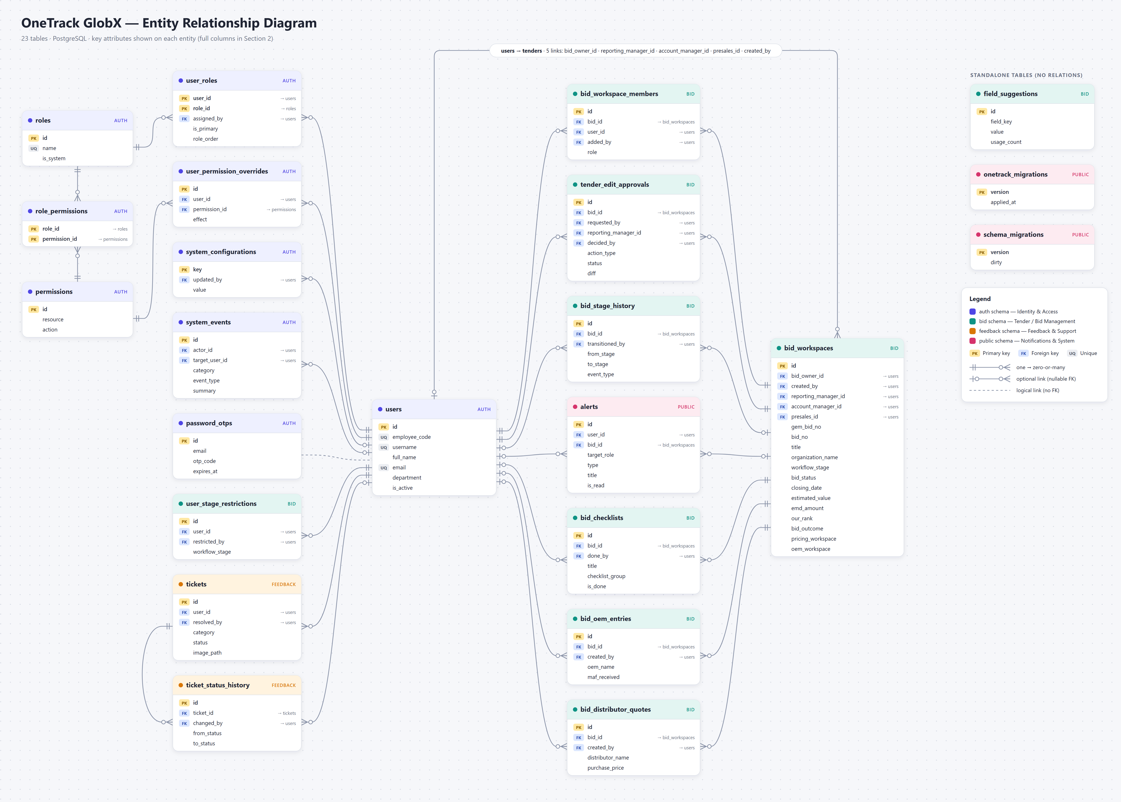
Figure 1 — Entity Relationship Diagram (key attributes per entity; all columns are listed in Section 2).

4. Database Diagram
Physical view of the database: every table with every column and its PostgreSQL data type, grouped by schema. Split into two figures for readability.
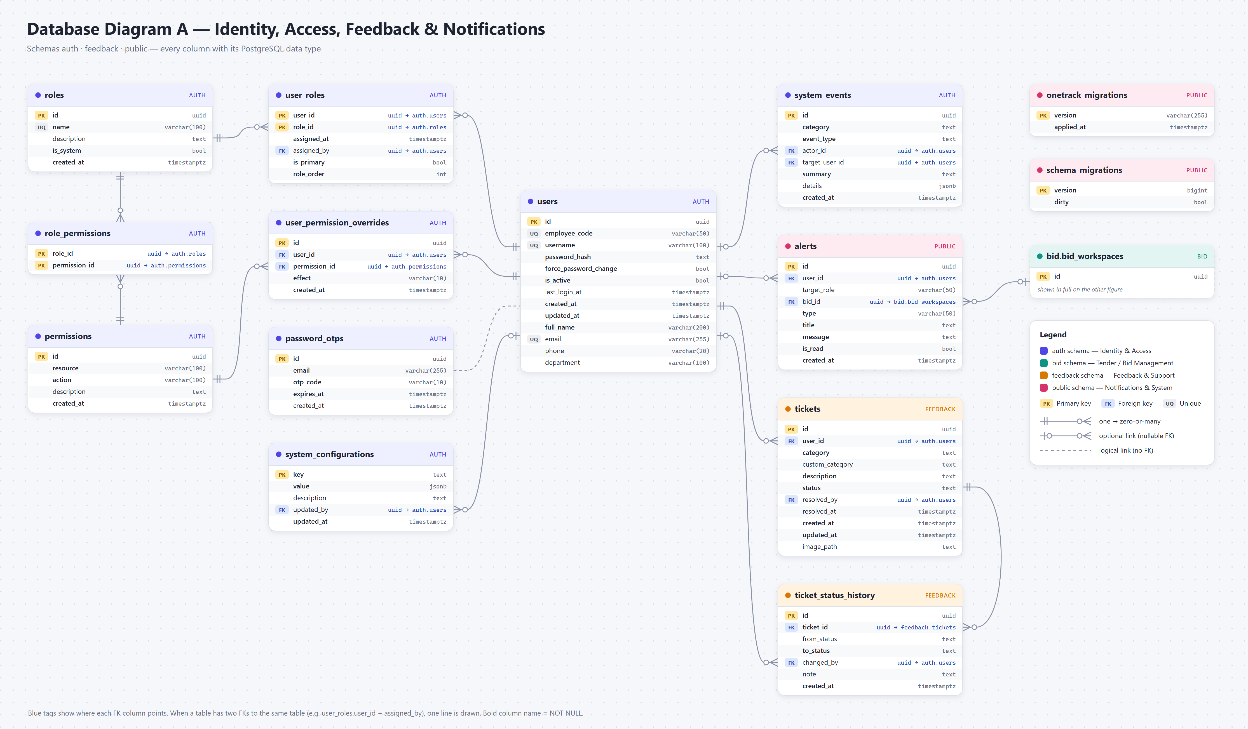
Figure 2A — auth, feedback and public schemas.

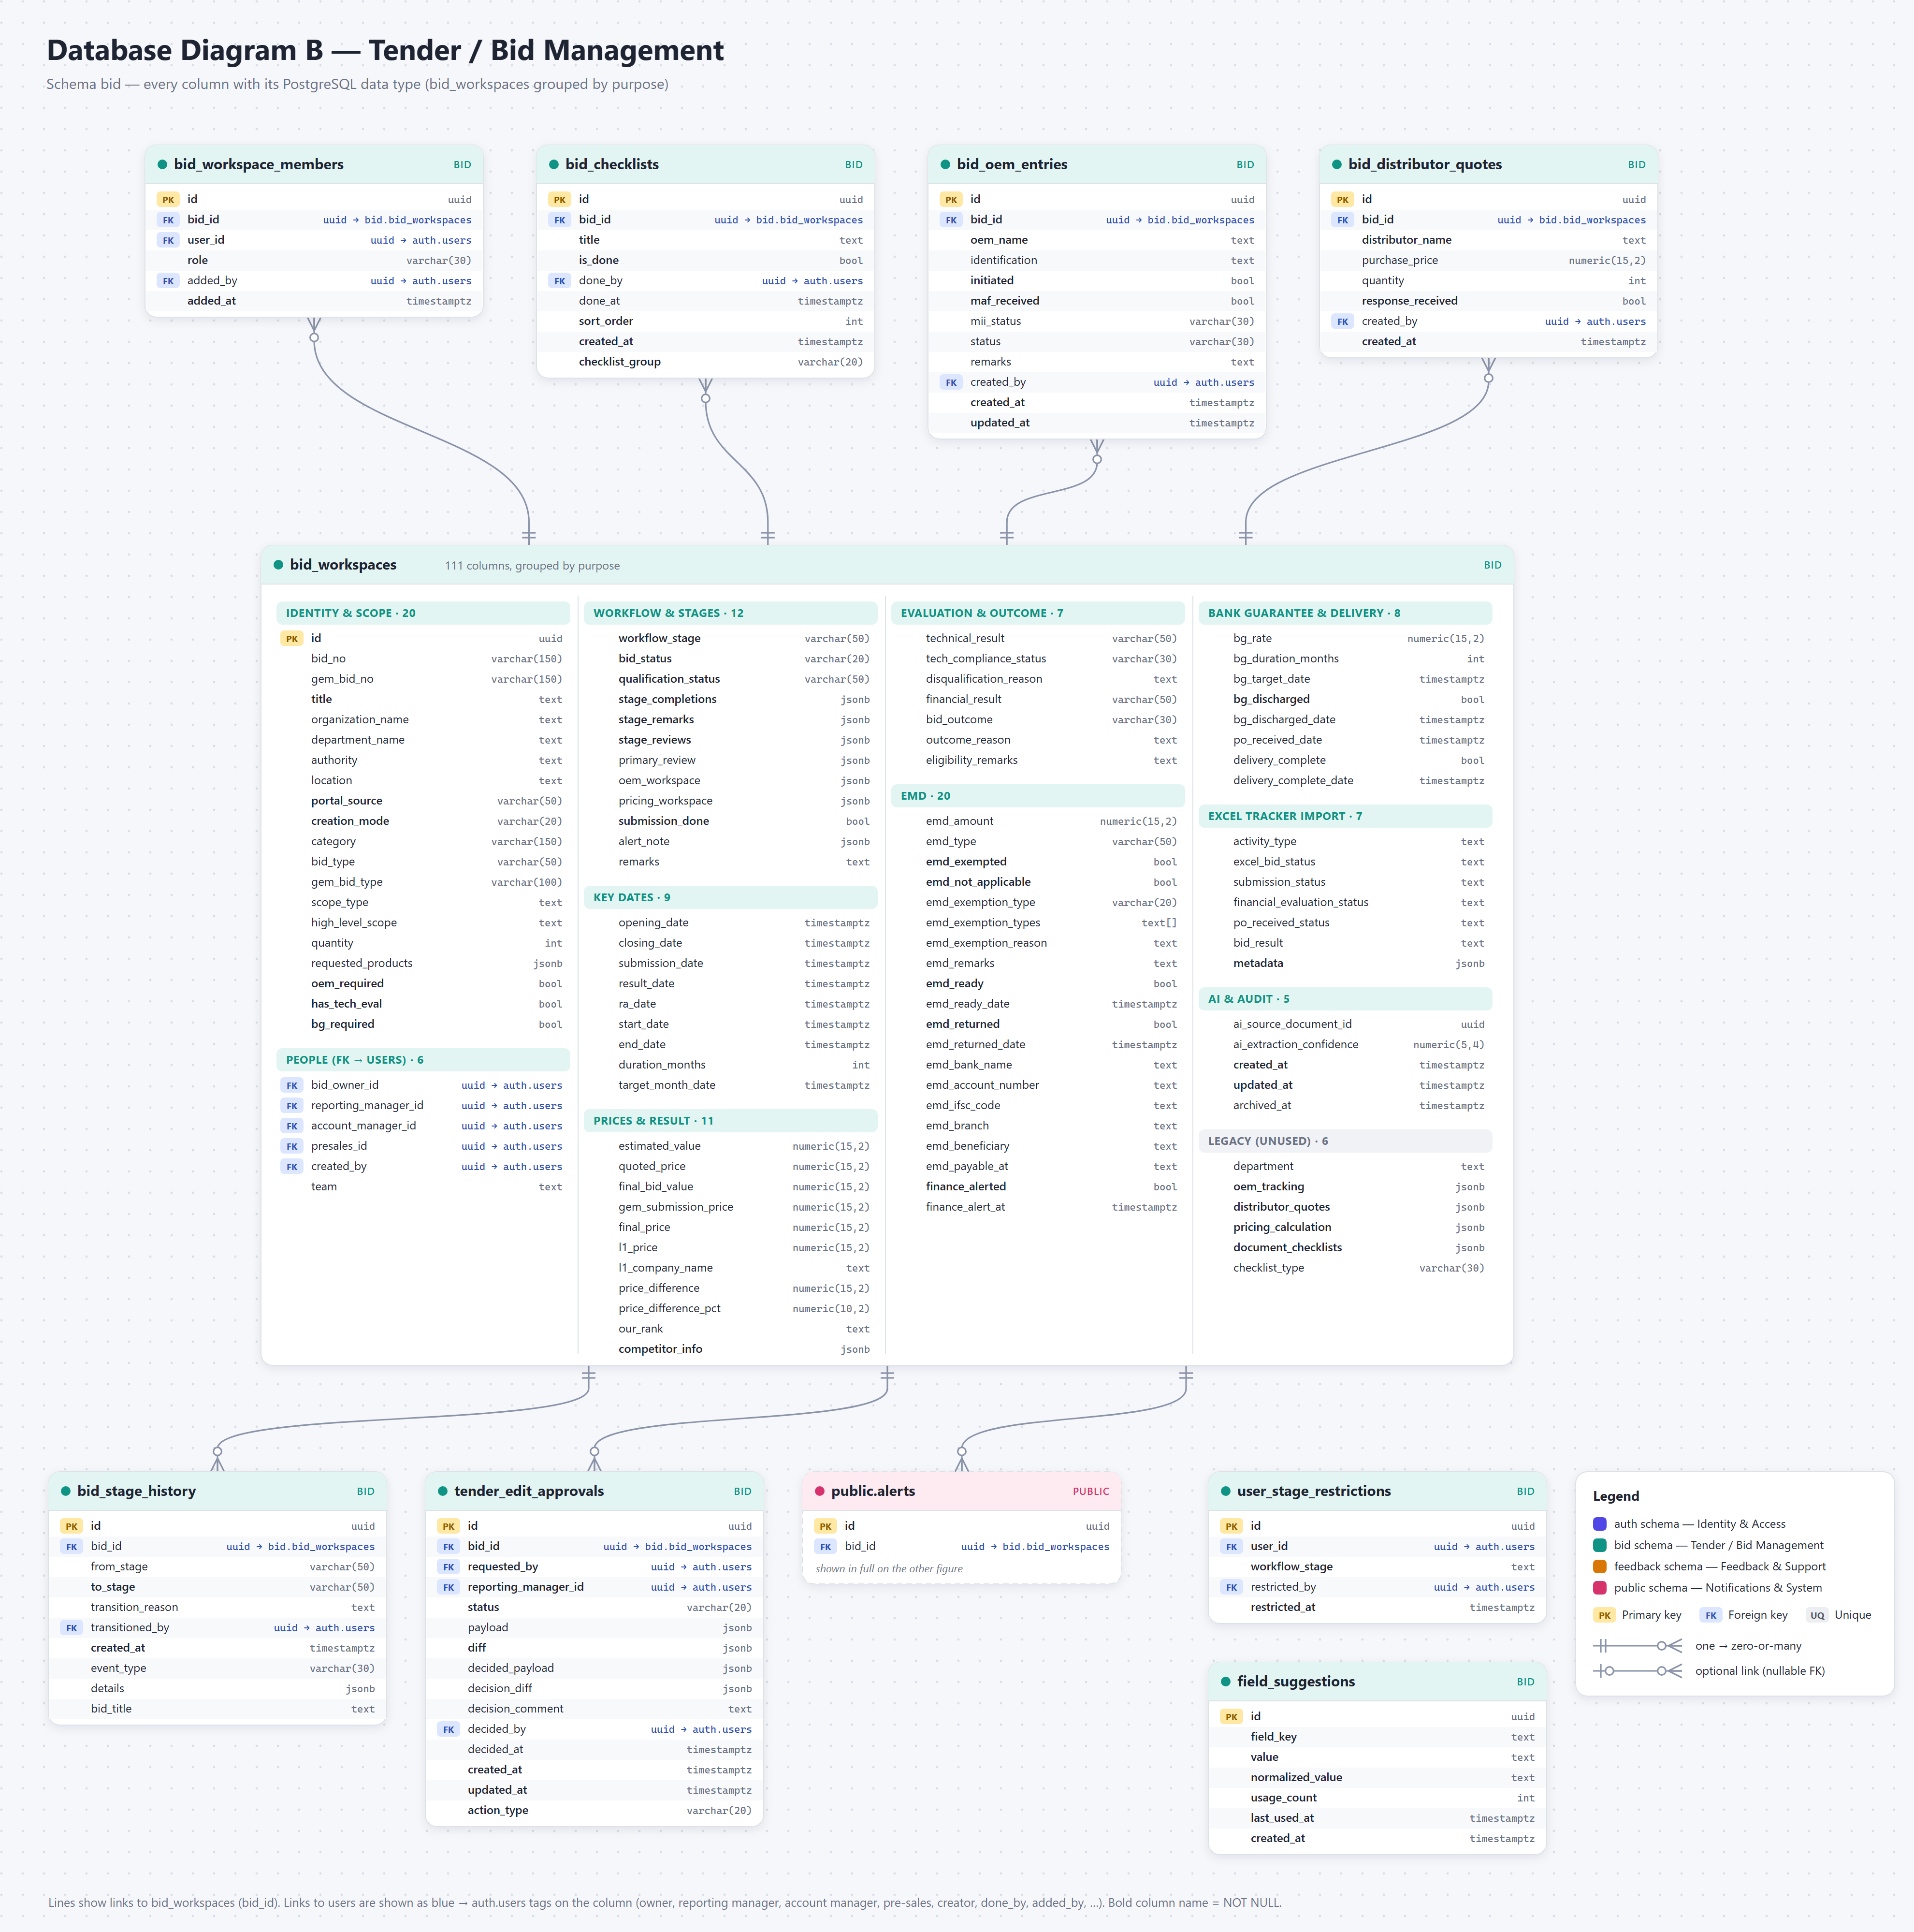
Figure 2B — bid schema (bid_workspaces columns grouped by purpose).

