1.Strongly agree

2.Agree

3.Agree

4.Agree

5.Neutral

6.Agree

7.Neutral

8.Agree

9.Neutral

10.Strongly agree.

My name is Biswadeep Bhattacharjee. I have 4 years of experience and my primary skill sets are Java and backend development. I am associated with since Citiustech since last 1 year. I like to travel and also follow :

Pointers:

No myself-----My name is/ I am

Rate of speech

Mention designation.

Speak out about achievements------excellent with so and so skill, mention goals met.

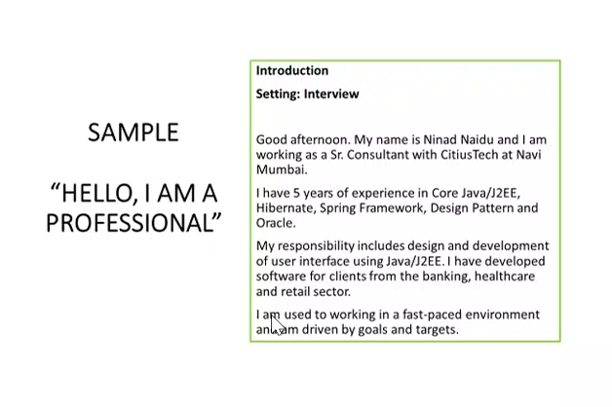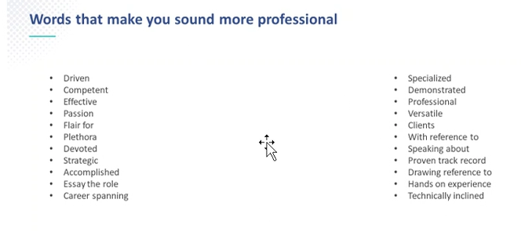

Good afternoon. My name is Biswadeep Bhattacharjee and I am working as a Senior Software Engineer with Citiustech at Bangalore.

I have 4 years of experience in Java, Spring Boot, Spring, Oracle SQL developer, microservices.

My responsibilities include design and development of backend services using the aforementioned technologies. I have developed software for clients from banking and healthcare sector.

I am used to working in agile mode with a proven track record of delivering quality products in the specified timeframe. I am a team player and easily approachable and also reach out to people as and when needed.Thank you

Inclined to learn new technologies like angular, docker, etc.

Strength----goal oriented, disciplined, motivated

Weakness----FOMO, also what are we doing to overcome this.

Achievements-----During covid, we developed applications in a very constrained time period, which had a huge impact during the covid period.

