#### **CURRICULAM VITAE**

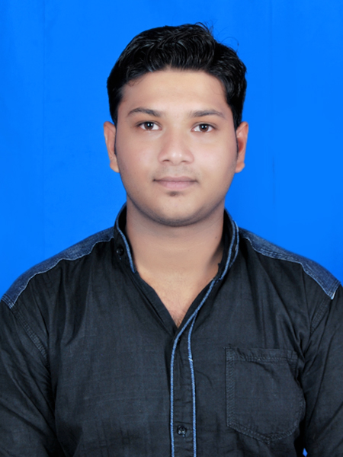

##### RASHMI RANJAN PATRA

S/O. Nrushinghanath Patra

At- D.N.K Colony, Qr No-H/7

Post- Koraput

Dist.- Koraput Email: nilu.patra1995@gmail.com

State- ODISHA Cell: 08093919522 / 7978105143

________________________________________________________________________________

**CAREER OBJECTIVE / VALUE PROFILE:**

* By associating with such progressive organizations and offices I shall have the scope to apply my knowledge and will be a part of the team that will enhance my skill as well as it helps for growing of that organization.

**EDUCATION PROFILE:**

|  |  |  |  |  |  |  |  |  |
| --- | --- | --- | --- | --- | --- | --- | --- | --- |
| **SL. NO** | **Name of the course** | **Specification of the course** | **year** | **Name of the  Board/ University** | **Total  Marks** | **Marks Secured** | **Percentage** | **Division** |
| **1** | Diploma  In Civil Engg. | Diploma | 2013 | SCTE&VT | 3700 | 2645 | 71.5 | 1st |
| **2** | HSE | 10th | 2010 | BSE, ORISSA | 600 | 324 | 54 | 2nd |

**WORK EXPERIENCE:**

**(Site Supervisor TPL (2015 -2016))**

Worked as Site Supervisor under Engineer and Contractors to manage the construction activities in TPL(Tata Power Limited) .

My responsibility was to build good class labour power to complete the construction activities on time with proper work distribution and on-time delivery.

Got good appreciation from our reporting manager for my dedication towards work.

**CO-CURRICULAR AND EXTRA CURRICULAR ACTIVITIES:**

**Year** **Technique / Experience**

2018- 2019 Post Graduate Diploma in Computer Application, (PGDCA)

**AREA OF INTEREST:**

* Work in a challenging environment where my skill will value to my employer.

**PERSONAL TRAIT:**

* Ability to manage people to complete task on-time with optimized cost-based approach.

**PERSONEL PROFILE:**

* **Date of Birth : 25th May 1995**
* **Religion : Hindu**
* **Nationality : Indian**
* **Gender : Male**
* **Marital Status : Un-Married**
* **Languages Known : Eng., Hindi, Oriya**

**TEMPORARY ADDRESS Rashmi Ranjan Patra**

**S/o: Nrushinghnath Patra (Govt. servant)**

**At: D.N.K Colony, Qr. No-H/7**

**Post: Koraput**

**Dist: Koraput**

**Pin: 764020**

**State: Odisha**

**Mob: 08093919522 / 7978105143**

**DECLARATION:**

I do here by declare that the above written particulars are correct and true to the best of my knowledge and belief.

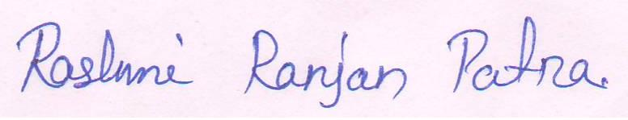

Place : Koraput (Rashmi Ranjan Patra)

Date : 05.06.2018 Signature of the Candidate