LOGO SPACE — TOP LEFT
ANTARAGANGE RURAL HOSPITAL AND RESEARCH INSTITUTE

ADVANCED HOSPITAL AMBULANCE
Standalone CSR Sponsorship Proposal | Mobile Emergency & Critical Care Unit | Kolar District, Karnataka
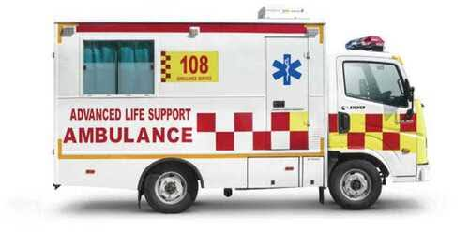
Illustrative emergency ambulance vehicle; final vehicle to be procured through quotation.

Source-Stated Budget: ₹25,00,000
A fully equipped emergency ambulance would support patient stabilisation, monitored transfers and access to time-critical hospital care. The proposed vehicle connects rural communities to emergency, surgical, diagnostic and intensive-care services.
IMPORTANT FINANCIAL DISCLOSURE: The original source states a ₹25 lakh ambulance total, but its eleven listed item costs add to ₹27 lakh. This proposal transparently preserves both amounts. Final funding should be approved only after this ₹2 lakh discrepancy is reconciled.

Why the Ambulance Matters

Rural emergency access
Supports prompt transport for serious illness, injury and complications where timely medical care matters.

Continuity of monitoring
Portable monitoring, oxygen, suction and defibrillation capabilities support appropriately staffed transfers.

Safe patient movement
A suitable stretcher and secure interior can improve loading, positioning and travel safety.

Referral coordination
Communications and GPS can support handover and coordination with receiving facilities.
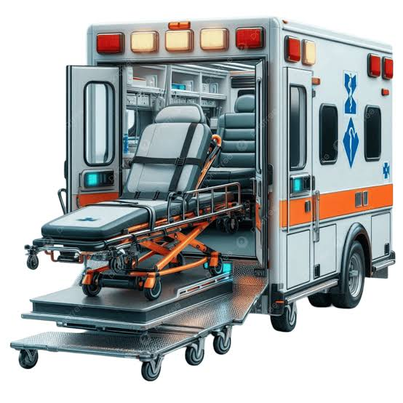
Illustrative ambulance patient compartment and stretcher arrangement.

Exact Source Item-Wise Cost Estimate
Equipment / Component | Original Estimate
1. Ambulance Vehicle Chassis (Force Traveller / Equivalent) | ₹1,400,000
2. Medical Interior Fabrication & Insulation | ₹250,000
3. Electrical, AC & Power Backup Systems | ₹150,000
4. Portable Ventilator | ₹250,000
5. Multipara Monitor | ₹120,000
6. Defibrillator | ₹180,000
7. Oxygen Support System & Suction Unit | ₹100,000
8. Syringe Pumps & Emergency Equipment | ₹75,000
9. Hydraulic Stretcher & Patient Transfer Systems | ₹80,000
10. GPS, Siren, Communication & Safety Systems | ₹45,000
11. Storage Cabinets, Seating & Utility Fixtures | ₹50,000
SUM OF ORIGINAL LINE ITEMS | ₹27,00,000
SOURCE-STATED AMBULANCE TOTAL | ₹25,00,000
UNRECONCILED DIFFERENCE | ₹2,00,000
The original hospital project summary includes ₹25,00,000 for the ambulance. The eleven detailed source entries total ₹27,00,000. Neither total nor line items have been silently changed. The ₹2 lakh variance requires clarification, revised vendor quotes, negotiated savings or a formally approved budget increase. It is not legitimate to claim the current item list sums to ₹25 lakh.

Equipment and Clinical Use

Ventilator and oxygen
May support respiratory assistance during indicated transfers with trained personnel and appropriate protocols.

Monitor and defibrillator
Support surveillance of vital signs and emergency cardiac response under clinical protocols.

Syringe pumps and emergency supplies
Facilitate controlled medication delivery and essential emergency care.

Stretcher and transfer system
Enable secure patient loading and transport; confirm vehicle compatibility and load ratings.

Vehicle electrical and communications
Support powered equipment, cabin cooling, emergency alerts, location tracking and reliable communication.
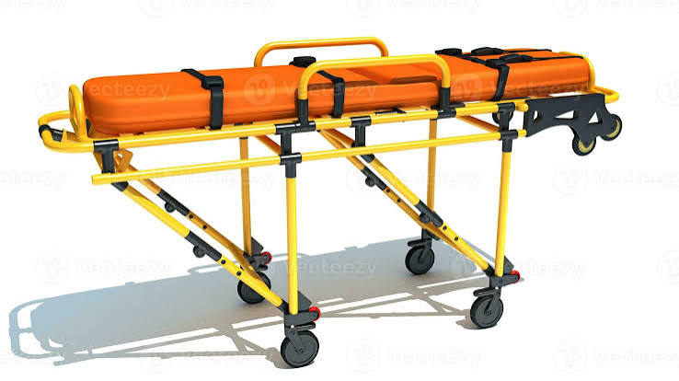
Illustrative hydraulic ambulance stretcher; not a confirmed supplier model.

Procurement, Compliance and Launch Plan

1. Finalise ambulance specification
Define ambulance class, clinical scope, equipment interoperability, cabin ergonomics, infection prevention and transport safety.

2. Reconcile the financial estimate
Request itemised vehicle and fit-out quotations; document the ₹2 lakh source discrepancy and approve a revised, internally consistent budget.

3. Verify compliance
Check applicable Indian vehicle/ambulance regulations, registration, permits, insurance, oxygen safety, equipment certifications and emergency medical staffing requirements.

4. Commission and train
Perform vehicle and device acceptance checks, electrical and oxygen-system tests, equipment training and emergency drills.

5. Measure CSR impact
Track emergency trips, patient transfers, response and turnaround times, equipment uptime and referral outcomes while protecting patient privacy.
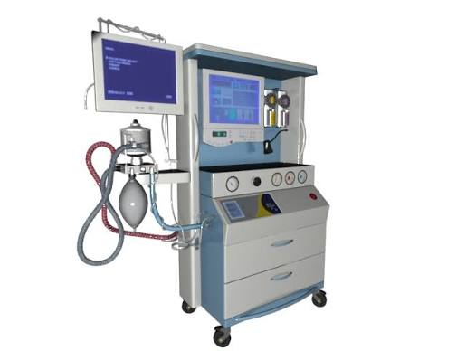
Illustrative portable ventilator equipment for critical-care transport.

CSR Sponsorship and Reporting
The ambulance is an independently sponsorable line within the original ₹5,50,15,000 hospital capital plan. The source-stated ₹25 lakh ceiling should not be represented as sufficient for the listed ₹27 lakh equipment package until quotations reconcile the variance. The hospital can provide donor recognition, asset registration, commissioning records and periodic service reports.

Source Integrity Note
Based on the user-provided 12-page CSR hospital equipment estimate, “Advanced Hospital Ambulance Cost Estimate,” page 11: eleven original amounts, source-stated total ₹25,00,000. The ₹27,00,000 arithmetic sum and ₹2,00,000 variance are independently calculated. Photographs are illustrative references from the user-provided equipment image set.

