LOGO SPACE — TOP LEFT
ANTARAGANGE RURAL HOSPITAL AND RESEARCH INSTITUTE

C-ARM IMAGING SYSTEM
Standalone CSR Proposal | Image-Guided Surgery & Orthopaedic Care
“Precision during surgery can make a lasting difference in recovery.”
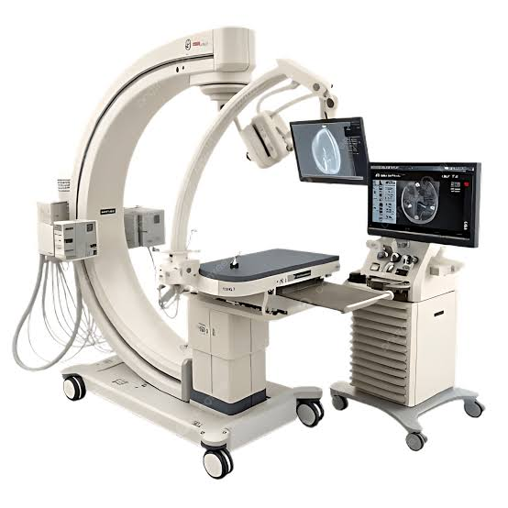
Illustrative C-Arm system; model and configuration to be selected through procurement.

Project Allocation: ₹15,00,000
This proposal presents the C-Arm imaging system as an independently sponsorable equipment component for Antaragange Rural Hospital and Research Institute. The original hospital estimate allocates ₹15 lakh to the C-Arm within its ₹86.80 lakh Operation Theatre budget. Sponsoring this unit separately does not increase the original overall hospital budget.
The C-Arm will provide real-time fluoroscopic images during selected orthopaedic, trauma and other image-guided procedures, supporting intra-operative decisions and reducing dependence on external imaging facilities.

Clinical Need and Rationale
Fracture fixation and certain surgical procedures require clinicians to confirm alignment, placement and movement of instruments while the procedure is underway. A mobile C-Arm allows image acquisition in the surgical environment without routinely moving the patient to a separate diagnostic imaging room.

Orthopaedic and trauma procedures
Supports imaging during fracture reduction, fixation and selected implant-positioning procedures, subject to the operating team’s training and approved protocols.

Image-guided surgical decisions
Provides live fluoroscopic views that may help clinicians verify anatomy and equipment placement during appropriately indicated interventions.

Continuity of care
Connects the hospital’s emergency assessment, operation theatre, postoperative monitoring and inpatient recovery services.

Rural access
May reduce the need to refer otherwise manageable surgical cases solely because intra-operative imaging is unavailable.
The system uses ionising radiation. Its clinical use requires radiation protection, authorised personnel and regulatory compliance; it is not a replacement for CT, ultrasound or standard radiography.

Equipment Scope and Economics
Component | Specification / Quantity Status | Source / Cost Treatment
Mobile C-Arm fluoroscopy system | 1 system identified in OT estimate | ₹15,00,000
Imaging monitor / display | Configuration to be confirmed | Included only if quoted within system package
Image storage / transfer capability | DICOM / PACS compatibility to be assessed | Not individually priced in source
Radiation protection accessories | Aprons, thyroid shields and monitoring as required | Not individually priced in source
Delivery, commissioning and training | OEM scope to be confirmed | Not individually priced in source

Core source allocation: ₹15,00,000
The source PDF specifies one C-Arm line item valued at ₹15 lakh under Operation Theatre Equipment; it does not break the price into generator, detector, monitors, software or accessories. The additional rows above are procurement checks, not claims that these items are funded or included in the original ₹15 lakh figure.
Budget reconciliation: OT total ₹86,80,000 includes C-Arm ₹15,00,000. Remaining OT items therefore total ₹71,80,000. If a sponsor funds this C-Arm independently, deduct ₹15 lakh from the unsponsored OT requirement; do not count the same C-Arm twice.

Technical Procurement Considerations

Imaging performance
Assess image quality, fluoroscopy modes, dose-management features, geometry, manoeuvrability and suitable detector technology against expected case mix.

Operating theatre compatibility
Confirm footprint, movement around the table, electrical supply, cable management and sterile-field workflow.

Digital integration
Seek clear specification for image export, storage, DICOM compatibility, reporting and hospital IT integration.

Radiation protection
Obtain a site-specific radiation safety assessment and confirm protective equipment, personnel monitoring and applicable AERB authorisations.

Service and sustainability
Compare OEM warranty, preventive maintenance, service response, spare parts, staff training and total lifecycle cost.
The original ₹15 lakh is a planning allocation, not a validated contemporary market quote. Final price and technical suitability must be confirmed through competing OEM / authorised supplier quotations. Any building modifications, licensing, radiation protection or software charges excluded by suppliers must be identified separately.

Implementation Plan
Stage | Action
1. Clinical specification | Confirm orthopaedic and surgical indications, expected workload and technical requirements.
2. Site readiness | Check OT access, electrical supply, equipment circulation, shielding and safety procedures.
3. Competitive procurement | Compare itemised quotations, compliance, warranty and lifecycle support.
4. Delivery and commissioning | Complete installation, acceptance tests, image-quality checks and regulatory requirements.
5. Training and reporting | Train users, establish image records, safety monitoring and asset utilisation reporting.

Expected CSR Impact
Track procedures supported by fluoroscopy, number of orthopaedic/trauma cases served, imaging uptime, referral patterns, staff training and preventive maintenance compliance. Targets should be set after the hospital confirms staffing, service volumes and opening schedule.

Sponsorship and Accountability
A single sponsor may support the ₹15 lakh C-Arm allocation as a ring-fenced component of the Operation Theatre project. Sponsor recognition may include an equipment plaque, commissioning record, asset register, utilisation reporting and periodic outcome summaries, subject to hospital policy and privacy safeguards.
“Your CSR contribution can help bring image-guided surgical capability to rural patients closer to home.”

Source Note
Source: hospital equipment PDF, Operation Theatre Equipment section, C-Arm Imaging System ₹15,00,000 and total OT allocation ₹86,80,000. Clinical and procurement descriptions are explanatory planning content; additional component prices are not stated in the source.

