LOGO SPACE — TOP LEFT
ANTARAGANGE RURAL HOSPITAL AND RESEARCH INSTITUTE

64-SLICE CT SCAN FACILITY
Standalone Corporate Social Responsibility Proposal | Rural Kolar, Karnataka
“Bring time-critical diagnostic clarity closer to rural patients.”
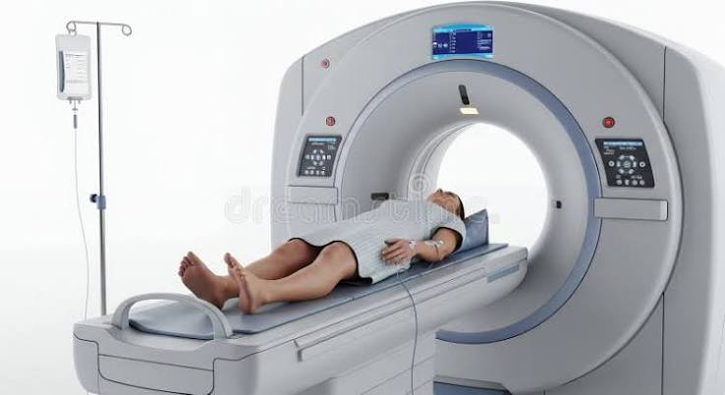
Illustrative CT scanner image. Final model and procurement specifications require OEM quotations.

Proposed Capital Allocation — ₹1,50,00,000
Antaragange Rural Hospital and Research Institute proposes a 64-slice CT scan facility to strengthen emergency, trauma, neurological, chest, abdominal and vascular imaging services. This document is a standalone sponsor proposal, independent of X-Ray, ultrasound and C-Arm funding.
The hospital’s equipment summary allocates ₹1.50 crore to the CT scanner; its detailed CT section describes a ₹1–1.5 crore range. This proposal uses the upper figure as the planning allocation, not a confirmed supplier quotation.

Clinical Need and Community Value
A local CT facility can reduce delays when clinicians require cross-sectional imaging to evaluate serious illness or injury. The proposed unit is especially relevant to rural patients who may otherwise need transfer to distant imaging centres.

Emergency and trauma
CT can help evaluate suspected head injury, internal bleeding and selected traumatic injuries when clinically indicated.

Neurological conditions
Non-contrast CT is commonly used in initial assessment of suspected acute stroke and other neurological emergencies, with additional imaging protocols selected by clinicians.

Chest, abdomen and vascular imaging
CT supports assessment of selected lung, abdominal and vascular conditions. Contrast-enhanced studies require appropriate screening, trained personnel and emergency preparedness.

Pre-operative and postoperative care
CT may assist surgical planning and assessment of complications when required.
Clinical scope depends on installed hardware, protocols, specialist staffing, contrast availability and patient safety procedures. A CT scanner is not a substitute for clinical assessment or every other imaging modality.

Equipment and Economics
Source-listed component | Purpose | Item allocation
GE CT Machine (64-slice) | Cross-sectional image acquisition | Not itemised in source
Control Console | Examination planning, scanning and operator control | Not itemised in source
Patient Table | Positioning and controlled movement through scanner | Not itemised in source
Radiology Workstation | Reconstruction, viewing and reporting | Not itemised in source
UPS & Power Stabilisation | Electrical protection and service continuity | Not itemised in source

Total planning allocation: ₹1,50,00,000
Source reconciliation: the hospital summary gives ₹1,50,00,000; the detailed CT page says ₹1–1.5 crore. No separate component prices or quantities are supplied beyond the proposed 64-slice scanner. The source specifies “GE CT Machine,” but model, detector configuration and commercial package have not been confirmed.
Do not assume the planning allocation includes shielding, room preparation, cooling, contrast injector, PACS, licences, annual maintenance, consumables, taxes or commissioning unless these are expressly included in a vendor quotation.

Implementation and Safety Requirements

1. Clinical specification
Agree the clinical case mix, required scan protocols, throughput, reporting workflow and technical configuration.

2. Site and engineering survey
Confirm room dimensions, access route, floor loading, power, earthing, HVAC, UPS, networking and patient circulation.

3. Radiation protection and regulatory approval
Arrange qualified shielding design, AERB compliance, applicable authorisations, quality assurance and personnel protection.

4. Vendor selection
Compare authorised OEM quotations, detector and software features, service coverage, installation, training, warranty and total cost of ownership.

5. Installation and commissioning
Complete acceptance testing, radiation-safety verification, image quality assessment and clinical user training.

6. Operational readiness
Ensure radiologist reporting, trained radiographers, contrast safety protocols, emergency equipment and preventive maintenance.
Because a CT facility is capital- and infrastructure-intensive, the hospital should obtain a site-specific turnkey quote and a separately itemised list of exclusions before a CSR partner approves the final grant.

CSR Outcomes and Sponsorship
Outcome area | Suggested reporting indicator
Access | Number of CT examinations completed locally
Emergency response | Time from clinical request to CT examination / report
Referral reduction | Transfers avoided solely for CT access, where verifiable
Service equity | Rural and economically vulnerable patients served
Equipment reliability | Uptime, preventive maintenance and quality assurance
Clinical governance | Radiation safety, contrast reactions and reporting compliance

Sponsorship Structure
A corporate donor may sponsor the complete CT facility at the ₹1.50 crore planning ceiling, subject to a final approved quotation. Alternatively, sponsors can support separately quoted equipment, shielding, installation or digital reporting components. Component-specific amounts must be established from vendor bids, not invented allocations.

Donor Accountability
The hospital can maintain an asset register, procurement documentation, commissioning certificate, utilisation records and periodic CSR impact reports. Recognition may include departmental signage and acknowledgement, subject to institutional policy and patient confidentiality.
“A CT scanner can be more than a machine: it can be a vital link between an emergency and a timely clinical decision.”

Source and Financial Integrity
Based on the uploaded hospital equipment PDF: “CT Scan Machine (64 Slice)” ₹1,50,00,000 in the project summary; “A 64-slice CT Scan” detailed section with budget ₹1–1.5 crore and five listed equipment components. All other explanatory and procurement considerations are planning guidance, not source-listed costs.

