SPACE RESERVED FOR HOSPITAL LOGO — TOP LEFT
ANTARAGANGE RURAL HOSPITAL AND RESEARCH INSTITUTE

3-BEDDED DIALYSIS UNIT
Standalone CSR Sponsorship Proposal | Kolar District, Karnataka
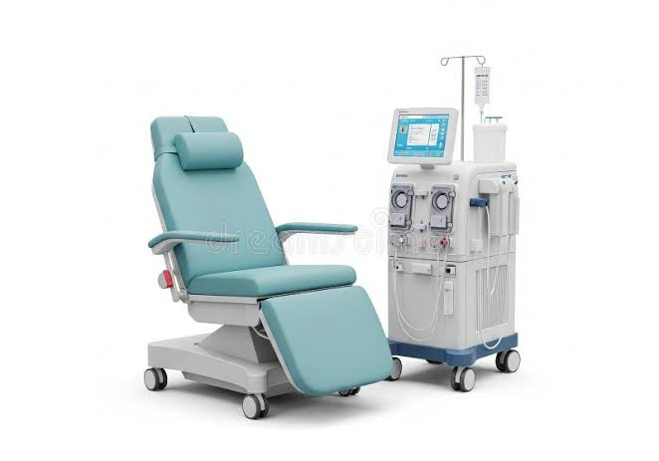
Illustrative haemodialysis treatment chair and dialysis machine; image for reference only.

Total Estimated Capital Cost: ₹12,50,000
The hospital proposes a three-station haemodialysis unit for patients requiring kidney replacement therapy. This is an independently sponsorable component already included in the original ₹5,50,15,000 hospital project estimate; it is not an additional cost.

Why a Rural Dialysis Unit Matters
Patients with kidney failure may need regular, time-consuming haemodialysis sessions. A locally accessible unit can help reduce repeated travel for eligible patients, subject to clinical oversight, infection prevention, reliable water treatment and continuity of consumable supplies.

Patients and clinical pathway
The service will require nephrologist oversight or an appropriate specialist-led protocol, trained dialysis nurses/technicians, referral arrangements, vascular access assessment and escalation pathways for emergencies.

Service readiness
The planned three treatment stations require dependable electricity, treated water, infection-control zoning, biomedical waste management, dialysis disposables and routine microbiological/chemical water checks.

Exact Item-wise Budget from Uploaded Hospital Estimate
Equipment / Infrastructure | Source quantity | Original estimate
Haemodialysis Machines | 3 Nos | ₹600,000
Dialysis Beds / Recliner Chairs | 3 Nos | ₹150,000
RO Water Treatment System | 1 system (quantity not stated) | ₹200,000
Multipara Patient Monitor | Quantity not stated | ₹75,000
Suction Apparatus & Emergency Support Equipment | Package | ₹50,000
Dialysis Unit Furniture & Storage Cabinets | Package | ₹50,000
Air Conditioning & Electrical Works | Package | ₹75,000
UPS / Power Backup System | Package | ₹50,000
TOTAL PROJECT COST |  | ₹12,50,000
Source: uploaded 12-page hospital equipment estimate, “3-BEDDED DIALYSIS UNIT COST ESTIMATE” (page 10). All eight allocations are reproduced unchanged. Quantities are only specified where the source provides them.

Equipment and Facility Scope

Three haemodialysis machines — ₹6,00,000
Primary treatment devices for extracorporeal blood purification, with safety monitoring and alarms. Procurement must verify required features, service support and suitability for the hospital’s intended clinical protocols.

Three dialysis beds/recliners — ₹1,50,000
Patient positioning and comfort during prolonged sessions, with access for clinical observation and emergency intervention.

RO water treatment — ₹2,00,000
Water purification infrastructure for dialysis use. Verify pretreatment, distribution loop, disinfection, testing requirements and compliance with applicable water-quality standards.

Patient monitor — ₹75,000
Vital-sign monitoring during treatment, supplemented by staff observations and clinical escalation procedures.

Emergency support — ₹50,000
Suction and other emergency-support equipment, with emergency-response processes established before patient care begins.

Furniture and storage — ₹50,000
Storage for supplies and documentation, designed to support clean workflows and stock management.

AC and electrical works — ₹75,000
Appropriate treatment-room conditions and electrical connections, subject to engineering assessment.

UPS / power backup — ₹50,000
Power continuity provisions; runtime and compatibility must be confirmed with equipment vendors.

Equipment Photo References
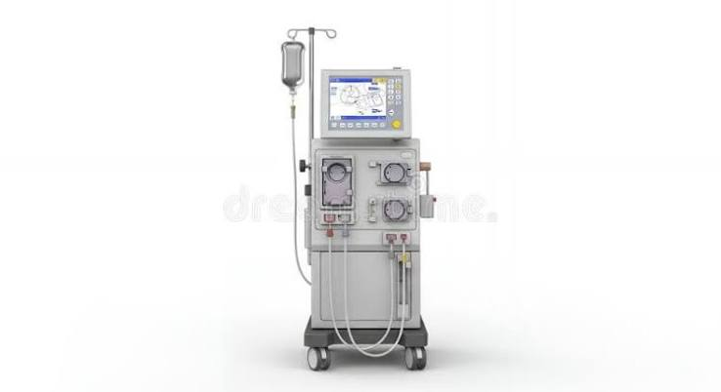
Illustrative haemodialysis machine — reference image, not a confirmed purchase model.
Illustrative dialysis station with patient recliner — reference image.

Implementation Plan
Stage | Activities
1. Planning | Confirm clinical demand, staffing, referral protocols and technical specifications.
2. Engineering | Verify treated-water capacity, plumbing, drainage, electrical, backup and infection-control layout.
3. Procurement | Obtain itemised quotations and compare warranty, consumables, service and maintenance.
4. Installation | Complete water-system qualification, equipment commissioning and acceptance checks.
5. Training | Train nurses and technicians in dialysis workflows, infection control and emergency procedures.
6. Launch & reporting | Begin service only after required approvals, testing and clinical governance are in place.

CSR Outcomes and Reporting
Suggested indicators include patients served, completed dialysis sessions, average patient travel distance avoided where measurable, equipment uptime, treatment interruptions, staff training, water-quality compliance and patient feedback. Baseline volumes and numeric targets should be approved before launch, not assumed.

CSR Sponsorship Opportunity
A donor may sponsor the full ₹12,50,000 dialysis unit or an identified line item from the table. Recognition can include unit signage, commissioning acknowledgment and periodic utilisation reports, subject to institutional policies and patient confidentiality.
Financial integrity: the ₹12,50,000 unit budget is already one line within the hospital’s original ₹5,50,15,000 capital estimate. No separate increase to the hospital total is proposed. Recurring costs such as dialysers, tubing, medicines, water testing, staffing and annual maintenance are not separately budgeted in the source and require an operating plan.

