HOSPITAL LOGO SPACE — TOP LEFT
ANTARAGANGE RURAL HOSPITAL AND RESEARCH INSTITUTE

EMERGENCY & CASUALTY UNIT
Standalone Corporate Social Responsibility Funding Proposal | Kolar District, Karnataka

₹9,00,000
Exact department allocation from the uploaded hospital cost estimate. This is a subcomponent of the ₹1,88,35,000 ICU / Emergency / OPD & Infrastructure budget, not an additional cost.
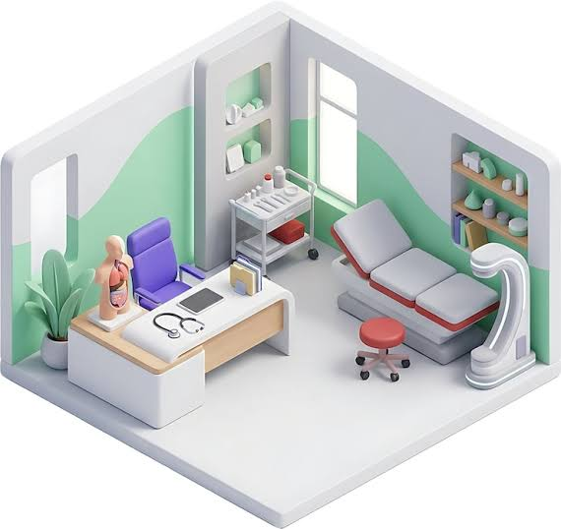
Illustrative emergency treatment room; visual reference, not a final floor plan.

Purpose and Clinical Need
The proposed six-bed emergency and casualty service will support initial assessment, stabilisation and transfer or admission decisions for patients presenting with injury, acute illness and other urgent conditions. It is designed to connect with the hospital’s ICU, operation theatre, laboratory, imaging and inpatient services.

Six emergency beds
Dedicated examination and observation spaces for immediate clinical assessment and short-term monitoring.

Portable monitors
Bedside observation of vital signs in patients who need closer monitoring.

Crash cart
Organised access to emergency supplies and resuscitation equipment, with routine readiness checks.

Wheelchairs and trolleys
Safer transfer of patients between triage, treatment, imaging and wards.

IV stands, curtains and chairs
Supports treatment workflow, patient privacy and accompanying carers.

Item-wise Budget — Source Figures
Equipment / Infrastructure | Source quantity | Estimated cost
Emergency Room Beds | 6 Nos | ₹3,50,000
Portable Monitors | Not specified | ₹2,00,000
Crash Cart | Not specified | ₹85,000
Emergency Wheelchairs & Trolleys | Not specified | ₹1,00,000
IV Stands, Curtains & Patient Chairs | Not specified | ₹1,65,000
TOTAL EMERGENCY & CASUALTY | — | ₹9,00,000
Arithmetic verification: ₹3,50,000 + ₹2,00,000 + ₹85,000 + ₹1,00,000 + ₹1,65,000 = ₹9,00,000. Quantities are shown only where stated in the uploaded estimate. No additional costs or assumed quantities have been inserted.
Budget reconciliation: ₹9,00,000 is already within the parent ₹1,88,35,000 allocation and within the original overall ₹5,50,15,000 hospital estimate. Sponsor recognition for this unit should not result in a second addition to the project total.

Equipment Image References
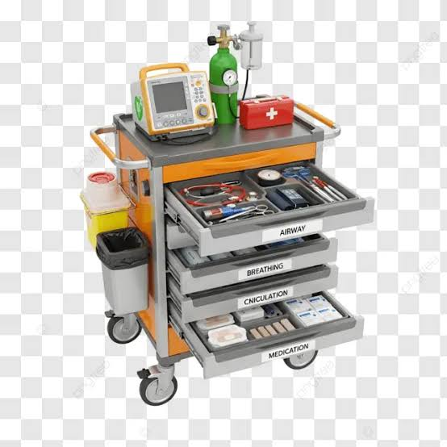
Illustrative emergency crash cart; original allocation ₹85,000.
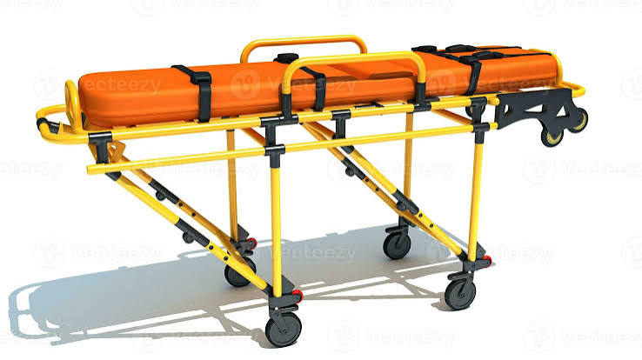
Illustrative patient-transfer stretcher; wheelchairs and trolleys allocation ₹1,00,000.

Equipment Image References — Continued
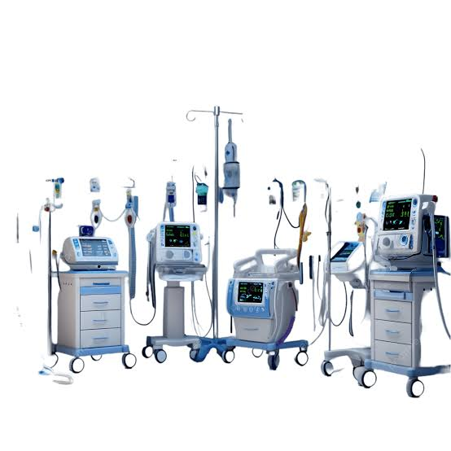
Illustrative acute-care equipment group; final monitor and accessory models subject to purchase specifications.

Implementation Plan

1. Finalise specifications
Confirm bed dimensions, monitor capabilities, crash-cart contents, trolley design and infection-control compatibility.

2. Verify site readiness
Confirm six-bed layout, electrical sockets, oxygen access, patient circulation and storage.

3. Procure transparently
Obtain itemised supplier quotations aligned with the five source allocations and document any exclusions.

4. Commission and train
Complete inspection, acceptance checks, equipment labelling and staff orientation.

5. Track outcomes
Record emergency attendances, equipment uptime, staff readiness checks and patient transfer patterns.

CSR Partnership and Accountability
A CSR partner may fund the complete ₹9,00,000 Emergency & Casualty package or a named line item from the source estimate. Reporting can include procurement invoices, an asset register, installation photographs, commissioning confirmation and periodic service indicators. All funding remains ring-fenced within the original hospital estimate.

Source Note
Uploaded document “CSR Proposal — Anthargange Rural Hospital & Research Center”, page 4, “2. Emergency & Casualty — ₹9,00,000”, five item allocations. Hospital naming in this standalone proposal follows the requested “Antaragange Rural Hospital and Research Institute”. Photographs are illustrative references from materials supplied for the project, not verified vendor catalogue images.

