[ LOGO SPACE ]

ANTARAGANGE RURAL HOSPITAL
AND RESEARCH INSTITUTE
INTENSIVE CARE UNIT (ICU)
EQUIPMENT & CRITICAL-CARE INFRASTRUCTURE
Standalone CSR Partnership Proposal
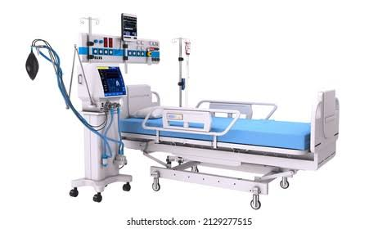 | 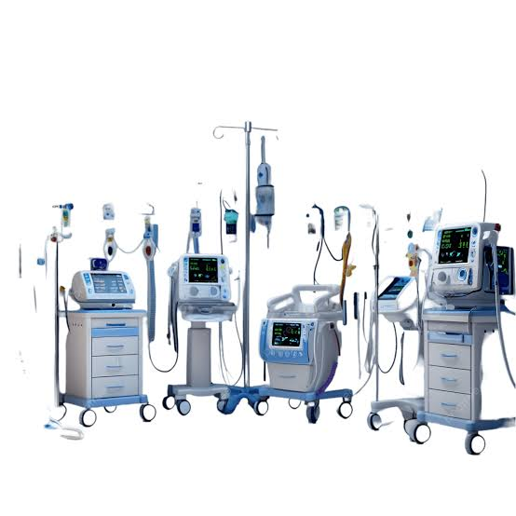
Illustrative ICU bed, ventilator and monitoring configuration | Illustrative critical-care equipment configuration
SOURCE-DEFINED ICU EQUIPMENT BUDGET  This document isolates only the ICU component from the hospital’s combined ICU / Emergency / OPD estimate. Emergency, OPD, wards, reception, disability support and IT are excluded. | ₹1,02,50,000
“Critical care close to home can turn delayed referral into timely stabilisation and treatment.”

PROJECT OVERVIEW
A six-bed intensive-care platform for respiratory support, continuous monitoring, resuscitation and high-dependency treatment.
About the Hospital
Antaragange Rural Hospital and Research Institute is being developed as a comprehensive secondary-care healthcare facility for rural and underserved communities of the Kolar region of Karnataka. The planned facility integrates 50 inpatient beds, 6 ICU beds, 6 emergency beds and 3 dialysis beds, supported by outpatient services, surgery, laboratory and imaging diagnostics, rehabilitation, disability support and digital-health connectivity.
Why the ICU Matters
A functional ICU allows critically ill patients to be stabilised, monitored and treated locally when their condition requires continuous observation, respiratory support, controlled drug delivery or immediate resuscitation. In a rural secondary-care hospital, this capability is especially important because referral delays can occur when patients must travel to distant urban centres.
Provides continuous physiological monitoring for unstable patients.
Supports invasive and non-invasive respiratory care through ventilators and BiPAP.
Enables precise administration of critical medications and fluids through infusion systems.
Supports rapid response to cardiac arrest, rhythm disturbance and acute deterioration.
Provides immediate blood-gas assessment for respiratory and metabolic emergencies.
Creates a monitored bridge between emergency stabilisation, surgery, inpatient recovery and referral when higher-level care is required.
Clinical Position in the Hospital
Stage | Role in the Critical-Care Pathway
Emergency / Casualty | Initial triage and stabilisation
ICU Admission | Continuous monitoring and organ support
Diagnostics | Laboratory, ECG, ABG and imaging support
Definitive Treatment | Medical management / surgery / procedure
Step-Down or Referral | Transfer to ward when stable, or higher-centre referral when indicated

DETAILED ICU EQUIPMENT & ECONOMICS
Exact item-level allocations preserved from the hospital equipment estimate.
Equipment / Component | Quantity / Basis | Allocation | Purpose & Value
ICU Ventilators | 4 Nos | ₹30,00,000 | Controlled respiratory support for severe respiratory failure, postoperative complications and other critical conditions.
Multipara Monitors | 15 Nos | ₹18,00,000 | Continuous ECG, heart rate, blood pressure, oxygen saturation and respiratory monitoring.
Central Monitoring System | 1 No | ₹8,00,000 | Centralised surveillance of multiple monitored patients for faster recognition of deterioration.
Syringe & Infusion Pumps | 20 Nos | ₹8,00,000 | Accurate delivery of critical medications, fluids, antibiotics, sedatives and vasoactive infusions.
Oxygen Support & Pipeline System | System | ₹10,00,000 | Reliable medical oxygen distribution to ICU and other high-dependency clinical points.
ICU Electronic Self-Operating Beds | 6 Nos | ₹12,00,000 | Motorised positioning for respiratory care, procedures, pressure relief and nursing.
BiPAP Machines | 2 Nos | ₹2,50,000 | Non-invasive ventilatory support for selected patients with acute breathing difficulty.
Minor Procedure Spot Light | 1 provision | ₹1,00,000 | Focused illumination for bedside procedures and minor interventions.
ABG Analyser | 1 No | ₹2,50,000 | Rapid assessment of oxygenation, ventilation and acid-base status.
Defibrillator | 1 No | ₹3,00,000 | Electrical therapy and resuscitation support for cardiac arrest and life-threatening arrhythmias.
12-Lead ECG Machine with Trolley | 1 No | ₹1,50,000 | Bedside cardiac electrical assessment for chest pain, rhythm disturbance and critical-care evaluation.
Bedside Lockers & Overbed Tables | Package | ₹3,50,000 | Bedside organisation and functional support for medicines, meals, records and patient needs.
IV Stands, Curtains & Patient Chairs | Package | ₹2,50,000 | Treatment support, privacy and patient / attendant comfort within the ICU environment.

TOTAL ICU EQUIPMENT BUDGET  The individual allocations above reconcile exactly to the source-defined ICU subtotal. | ₹1,02,50,000
Budget Integrity
No OPD, emergency, inpatient ward, reception, disability-support or hospital IT cost is included in this standalone ICU proposal. Where the source estimate gives a package rather than a unit quantity, the package basis is preserved rather than inventing a quantity or unit rate.

RESPIRATORY SUPPORT & CONTINUOUS MONITORING
The core technology required to recognise deterioration early and support failing respiration.
ICU Ventilators - 4 Nos | ₹30,00,000
Mechanical ventilators provide controlled respiratory support when a patient cannot maintain adequate ventilation or oxygenation independently. They are central to the management of severe respiratory failure, postoperative instability and selected critical emergencies. In procurement, emphasis should be placed on adult ventilation modes, alarm systems, ease of disinfection, battery backup, service support and availability of consumables.
Multipara Monitors - 15 Nos | ₹18,00,000
Multipara monitors continuously display key physiological parameters such as ECG, heart rate, non-invasive blood pressure, oxygen saturation and respiratory rate. Their value is not only measurement but early recognition of deterioration, allowing staff to intervene before instability progresses.
Central Monitoring System - 1 No | ₹8,00,000
The central station consolidates patient-monitor data at a nursing or clinical observation point. This supports simultaneous surveillance of multiple monitored patients and helps improve situational awareness, alarm recognition and response time.
BiPAP Machines - 2 Nos | ₹2,50,000
BiPAP provides non-invasive positive-pressure respiratory support for appropriately selected patients. It can support ventilation without immediate intubation in certain clinical situations, subject to physician assessment and standard critical-care protocols.
Oxygen Support & Pipeline System | ₹10,00,000
A reliable oxygen pipeline and distribution system is basic critical-care infrastructure. The final engineering design should be coordinated with the hospital medical-gas plan, source capacity, pressure regulation, alarm systems, outlet locations and applicable safety requirements.
Recommended Technical Procurement Focus
OEM-authorised installation and commissioning
Clinical user training at handover
Preventive-maintenance and breakdown-support commitments
Battery / UPS continuity where relevant
Standardised accessories and consumables to simplify inventory
Compatibility between bedside monitors and central monitoring where technically planned

MEDICATION DELIVERY, ICU BEDS & POINT-OF-CARE DIAGNOSTICS
Equipment that supports safe treatment, nursing care and time-sensitive bedside decisions.
Syringe & Infusion Pumps - 20 Nos | ₹8,00,000
These pumps deliver drugs and fluids at precise, controlled rates. They are particularly important for sedatives, vasoactive medicines, antibiotics and other infusions where accuracy and consistency directly affect patient safety.
ICU Electronic Self-Operating Beds - 6 Nos | ₹12,00,000
Motorised ICU beds allow controlled adjustment of patient position for respiratory care, nursing procedures, pressure relief and mobilisation. Side rails, braking systems, mattress compatibility and ease of cleaning should be considered in final technical specifications.
ABG Analyser - 1 No | ₹2,50,000
Arterial blood-gas testing provides rapid information on oxygenation, carbon dioxide, pH and acid-base status. This is valuable in respiratory failure, shock, severe metabolic disturbance and ventilator management, where decisions may need to be made quickly.
12-Lead ECG Machine with Trolley - 1 No | ₹1,50,000
The ECG machine provides a standard 12-lead recording for evaluation of chest pain, arrhythmias, ischemic changes and other cardiac abnormalities. A mobile trolley supports bedside use across ICU and adjacent high-dependency areas.
Minor Procedure Spot Light | ₹1,00,000
Focused procedure lighting supports bedside interventions such as wound care, line placement, catheterisation and other minor procedures where clear visualisation is necessary.
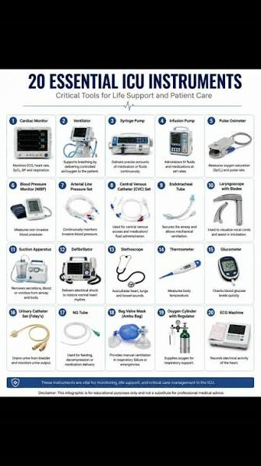
Illustrative critical-care equipment reference chart | Illustrative ICU treatment environment

RESUSCITATION & BEDSIDE SUPPORT
Completing the ICU environment with immediate emergency response and practical patient-care infrastructure.
Defibrillator - 1 No | ₹3,00,000
A defibrillator is essential for management of cardiac arrest and selected life-threatening arrhythmias. The device should be readily accessible, clearly assigned for emergency response and integrated into staff resuscitation protocols and regular readiness checks.
Bedside Lockers & Overbed Tables | ₹3,50,000
Bedside furniture supports orderly storage of essential patient items and provides a practical surface for meals, documents and care activities. Selection should prioritise stability, cleanability, rounded surfaces and suitability for hospital disinfection procedures.
IV Stands, Curtains & Patient Chairs | ₹2,50,000
These elements appear simple but are fundamental to day-to-day ICU functioning. IV stands support infusion therapy; curtains support privacy and dignity; and chairs provide safe seating for patients during recovery or for limited attendant use in accordance with ICU policy.
Safety & Readiness Principles
Daily equipment readiness and alarm checks
Clearly defined emergency equipment location
Preventive-maintenance schedule and service records
Biomedical engineering oversight for critical devices
Consumables and accessories stock planning
Infection-control cleaning protocols for reusable equipment
Electrical safety, earthing and protected power supply for sensitive critical-care devices
“An ICU is not a collection of machines; it is a coordinated system for observation, intervention and rescue.”

CLINICAL WORKFLOW & IMPLEMENTATION
A capital-equipment project must be commissioned as a working critical-care system, not as isolated purchases.
Implementation Sequence
Stage | Key Activity
1. ICU Room & Utility Review | Confirm six-bed layout, bed spacing, oxygen outlets, power points, nurse observation and equipment locations.
2. Final Technical Specifications | Prepare equipment specifications, accessories list, interoperability requirements and installation prerequisites.
3. Competitive OEM / Vendor Quotations | Obtain comparable quotations with warranty, service, installation, training and consumable details.
4. Technical & Commercial Evaluation | Assess clinical functionality, lifecycle support, service presence, uptime commitments and total cost of ownership.
5. Site Preparation | Complete medical gases, electrical protection, networking where required, HVAC coordination and furniture placement.
6. Delivery & Commissioning | Install, test, calibrate and formally accept devices with documentation.
7. User Training & Readiness | Train clinical and biomedical teams; establish checklists, emergency protocols and preventive-maintenance plans.
8. CSR Asset & Impact Reporting | Tag funded assets, retain procurement records and report utilisation / service indicators to the sponsoring partner.
Operational Dependencies
Trained critical-care doctors and nursing staff
24/7 oxygen and protected electrical supply
Access to laboratory, imaging and blood-gas testing
Emergency drug and consumable availability
Biomedical engineering / maintenance support
Infection prevention, waste management and cleaning systems
Escalation and referral protocols for cases beyond hospital capability

CSR IMPACT & PARTNERSHIP
A defined, auditable capital project with direct clinical value to critically ill rural patients.
What a CSR Partner Enables
A six-bed critical-care platform with respiratory, monitoring and resuscitation capability.
Local stabilisation of patients who would otherwise require immediate transfer for basic critical-care support.
Faster recognition of deterioration through bedside and central monitoring.
Accurate medication delivery and point-of-care assessment for time-sensitive treatment decisions.
Durable medical assets with multi-year service potential when properly maintained.
Suggested Monitoring Indicators
ICU admissions after commissioning.
Number of patients requiring ventilatory or non-invasive respiratory support.
Number of monitored critical-care bed-days.
Number of emergency resuscitation events supported by ICU equipment.
Equipment uptime, preventive-maintenance completion and service-response records.
CSR-funded assets commissioned, tagged and included in utilisation reporting.
CSR Partnership Options
Partnership | Indicative Support | Scope
Complete ICU Equipment Partner | ₹1,02,50,000 | Supports the entire source-defined ICU package.
Respiratory Support Partner | ₹42,50,000 | Ventilators + oxygen pipeline + BiPAP systems.
Monitoring Partner | ₹26,00,000 | Multipara monitors + central monitoring system.
ICU Bed & Bedside Infrastructure Partner | ₹18,00,000 | ICU beds + bedside lockers / overbed tables + IV stands / curtains / chairs.
Medication & Diagnostic Support Partner | ₹10,00,000 | Infusion / syringe pumps + ABG analyser + ECG machine.
Resuscitation & Procedure Partner | ₹4,00,000 | Defibrillator + minor procedure spot light.
“Support critical care today. Build rural life-saving capacity for years to come.”

ANTARAGANGE RURAL HOSPITAL AND RESEARCH INSTITUTE

