LOGO SPACE — TOP LEFT
ANTARAGANGE RURAL HOSPITAL AND RESEARCH INSTITUTE

HOSPITAL IT SYSTEMS
Standalone Corporate Social Responsibility Proposal | Kolar District, Karnataka

Original budget allocation: ₹12,00,000
This proposal funds digital infrastructure for a proposed rural hospital: hospital management, electronic medical records, registration, billing, laboratory and pharmacy workflows, secure connectivity and data backup. The ₹12 lakh is the exact Hospital IT Systems allocation in the uploaded hospital cost estimate, under the larger ICU / Emergency / OPD equipment and infrastructure category.

Illustrative telemedicine and digital-care workflow from the supplied hospital reference images.

Why Hospital IT Matters

Continuity of care
An electronic record can help authorised clinicians retrieve previous encounters, tests, medicines and treatment notes.

Operational coordination
Registration, pharmacy, laboratory and billing modules reduce fragmented paper processes when correctly implemented.

Safety and accountability
Role-based access, audit trails, routine backups and cybersecurity policies help protect patient information.

Rural access
Digital records and suitable connectivity can support future referral coordination and teleconsultation workflows; telemedicine is not separately costed in the source.

Source-Based Equipment and Software Scope
Source-listed component | Quantity stated | Cost stated
Central Server | 1 | Not individually specified
Desktop Systems | 10–15 | Not individually specified
Networking Rack | Not specified | Not individually specified
Structured LAN | Not specified | Not individually specified
UPS Backup | Not specified | Not individually specified
Cloud-Enabled HMS | Not specified | Not individually specified
Pharmacy & Lab Modules | Not specified | Not individually specified
Billing & EMR System | Not specified | Not individually specified
CCTV Integration | Not specified | Not individually specified
Daily Backup System | Not specified | Not individually specified
The source provides a single department total, not ten individual component costs. No artificial item prices or unsupported quantities have been added.

Illustrative Digital Infrastructure
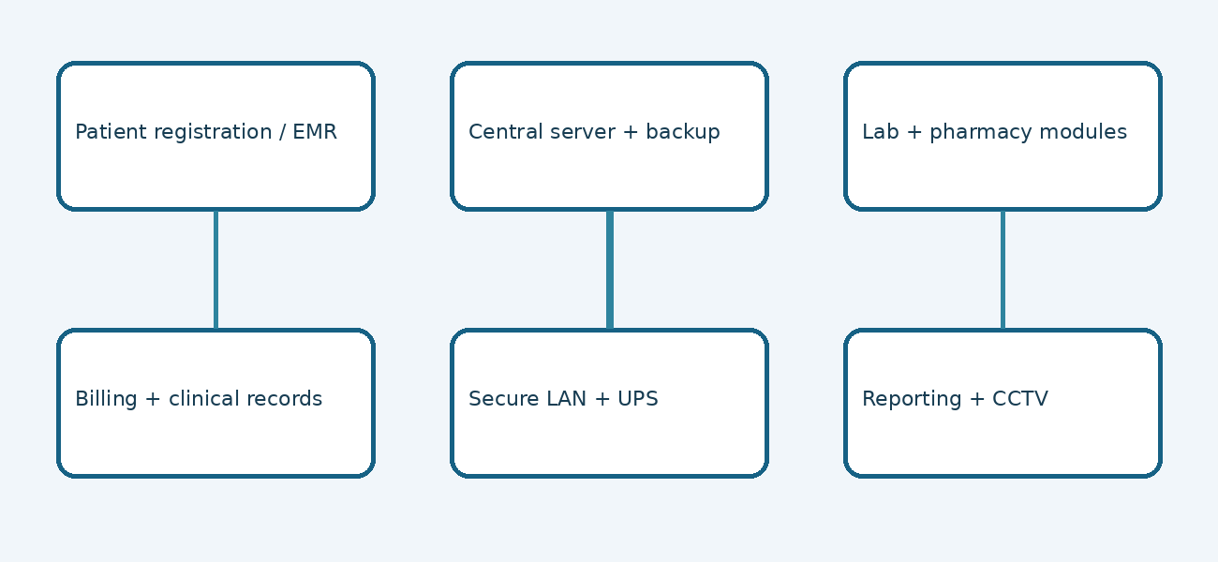
Conceptual architecture diagram illustrating relationships between the source-listed IT components. Not a supplier product photograph.

Procurement and Technical Considerations

Hospital Management System
Confirm clinical modules, user permissions, billing workflows, reporting, vendor support, licensing and data export rights.

Network and devices
Survey desktop placement, cable runs, switch capacity, rack space, Wi-Fi needs, power quality and UPS sizing.

Information security
Require encrypted data transfer, role-based permissions, audit logging, reliable backup recovery testing and incident procedures.

Integration
Clarify how lab, pharmacy, billing and EMR modules exchange data, and whether existing equipment can interface with the system.

Implementation and CSR Accountability

1. Workflow mapping
Identify outpatient, inpatient, emergency, pharmacy, laboratory and finance workflows and staffing.

2. Technical site assessment
Confirm power, network routes, server space, connectivity, device locations and backup arrangements.

3. Competitive quotations
Obtain itemised hardware, software, implementation, training, warranty, AMC and licence quotations.

4. Deployment and testing
Install equipment, configure modules, test permissions and backups, and pilot registration-to-billing workflows.

5. Training and support
Train clinical and administrative users, establish helpdesk escalation and monitor system uptime.

Measurable Results
Suggested indicators: staff trained, departments live on the HMS, proportion of registrations entered electronically, successful daily backups, system uptime, billing reconciliation, and turnaround time for laboratory result availability. Baselines and targets will be established once the hospital is operational.

Financial Reconciliation
Hospital IT Systems: ₹12,00,000 (source total). This is an existing subcomponent of the ₹1,88,35,000 ICU / Emergency / OPD infrastructure group and is already included in the overall hospital estimate of ₹5,50,15,000. It must not be added again when sponsors fund individual departments.
Vendor quotations must determine the distribution of ₹12 lakh across hardware, software, networking, commissioning, training and service. If the final scope cannot be supplied within ₹12 lakh, any gap requires explicit revision and sponsor approval.

CSR Sponsorship Opportunity
A corporate sponsor can support the complete ₹12 lakh digital infrastructure allocation, subject to final quotations, procurement controls, commissioning documentation and periodic utilisation reports. Recognition can be provided through institutional acknowledgement consistent with patient confidentiality.
Source: uploaded hospital equipment estimate, page 5–6, “8. HOSPITAL IT SYSTEMS – ₹12,00,000” and its ten included components. All technical recommendations and illustrations are supplementary planning guidance, not source-priced products.

