LOGO SPACE | ANTARAGANGE RURAL HOSPITAL  AND RESEARCH INSTITUTE

DIAGNOSTIC LABORATORY SETUP
Standalone Corporate Social Responsibility (CSR) Funding Proposal | Kolar District, Karnataka
PROPOSED CAPITAL REQUIREMENT | ₹20,00,000
“Every timely treatment decision begins with a reliable diagnosis.”

Project Rationale
Antaragange Rural Hospital and Research Institute is being developed to bring dependable secondary healthcare closer to underserved rural communities. An in-house diagnostic laboratory will support outpatient care, emergency assessment, inpatient monitoring, intensive care, and pre-operative evaluation, reducing avoidable delays associated with off-site testing.

What This Project Will Enable
• Emergency blood investigations to guide early treatment decisions
• Haematology and infection-related assessments
• Diabetes, renal, liver and metabolic monitoring
• Pre-operative investigations and post-operative follow-up
• Routine ICU and inpatient laboratory investigations
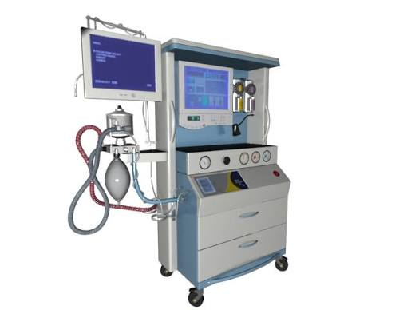
Illustrative laboratory equipment photograph — for presentation purposes only.

LOGO SPACE | ANTARAGANGE RURAL HOSPITAL  AND RESEARCH INSTITUTE

PROPOSED EQUIPMENT & CLINICAL APPLICATIONS
Equipment / Component | Purpose and Clinical Value
Fully Automated Biochemistry Analyser | Clinical chemistry investigations supporting renal, liver and metabolic assessments.
5-Part Haematology Analyser | Complete blood counts and white-cell differential for anaemia and infection evaluation.
Electrolyte Analyser | Sodium, potassium and related testing in emergency, renal and critical-care settings.
Semi-Automated Analyser | Supplementary routine biochemical testing and flexible laboratory workflow.
ELISA Reader & Washer | Selected immunoassays for infectious and other indicated investigations.
Microscopes | Direct examination of blood, urine and other appropriate samples.
Centrifuges | Sample preparation through separation of blood and other specimens.
Blood Storage Refrigerator | Controlled-temperature storage, subject to applicable licensing and blood-storage requirements.
Incubators | Controlled-temperature incubation for appropriate laboratory procedures.
Water Bath | Temperature-controlled processing for selected test protocols.
Laboratory Workstations | Hygienic benches and organised spaces for processing, reporting and quality control.
Scope and equipment names are taken from the supplied hospital equipment estimate. Individual quantities and line-item prices were not specified in that source.

LOGO SPACE | ANTARAGANGE RURAL HOSPITAL  AND RESEARCH INSTITUTE

FUNDING REQUIREMENT & IMPLEMENTATION

Capital Funding Summary
Diagnostic Laboratory — overall estimated budget | ₹20,00,000
Equipment-level prices / quantities | To be established through vendor quotations
Budget integrity: ₹20,00,000 is the departmental total stated in the supplied source. No unsupported item-wise cost split has been invented. Final procurement will require a detailed bill of quantities, comparative quotations, taxes, installation, consumables and maintenance provisions.

Operational Readiness

Site preparation
Laboratory layout, benches, ventilation, electrical supply, water and biomedical waste arrangements.

Procurement
Finalise test menu, instrument specifications, quantities, warranty, reagent supply and service support.

Commissioning
Install equipment, validate performance, establish calibration and quality-control procedures.

Staffing and governance
Deploy trained laboratory personnel, documented SOPs, biosafety practices and reporting workflows.

Integration
Connect laboratory reporting with patient records, OPD, emergency, wards and ICU.

Illustrative Sponsor Impact Indicators
• Number of diagnostic tests performed and turnaround times
• Number of emergency and inpatient investigations supported
• Equipment uptime and quality-control compliance
• Patients avoiding off-site travel for routine investigations

CSR Partnership Invitation
CSR support for the diagnostic laboratory will help establish the clinical information backbone of the hospital. Sponsorship can cover the complete laboratory or defined equipment packages once supplier quotations are finalised. Donor reporting can document procurement, installation, utilisation and patient-service outcomes.
“Fund the diagnosis. Empower the treatment. Strengthen rural healthcare.”

