LOGO SPACE — TOP LEFT
ANTARAGANGE RURAL HOSPITAL AND RESEARCH INSTITUTE

DISABILITY SUPPORT EQUIPMENT
Standalone CSR Sponsorship Proposal | Kolar District, Karnataka

Total source budget: ₹3,00,000
This proposal funds mobility, daily-living and transfer aids for patients with disabilities, elderly patients and people recovering from surgery or illness. It is a separately sponsorable portion of the original hospital equipment budget, not an additional cost.
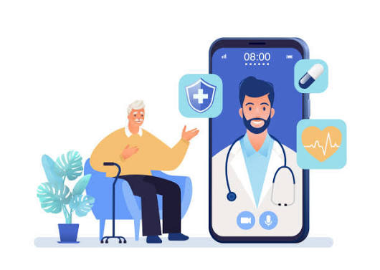
Illustrative accessible healthcare and mobility-support image (not a product quotation).

Why this investment matters
Accessible equipment supports safe movement within the hospital, preserves dignity and assists caregivers. Appropriate aids may support access to consultations, inpatient services, rehabilitation, toilets and discharge planning.

Wheelchairs
For patients unable to walk long distances or requiring seated mobility within hospital premises.

Walkers and commode chairs
To support selected patients with balance limitations and safe toileting access, after clinical assessment.

Transfer aids
To help trained staff and caregivers move patients between beds, chairs and clinical areas with reduced manual handling risks.

Original source: exact item-wise budget
Equipment category | Allocation from PDF
Wheelchairs | ₹1,50,000
Walkers & Commode Chairs | ₹1,00,000
Transfer Aids | ₹50,000
TOTAL | ₹3,00,000
The source PDF does not specify unit quantities, makes, models or per-unit rates for these categories. Final quantities will be determined from approved supplier quotations without exceeding the authorised category allocations.

Equipment visuals and procurement categories
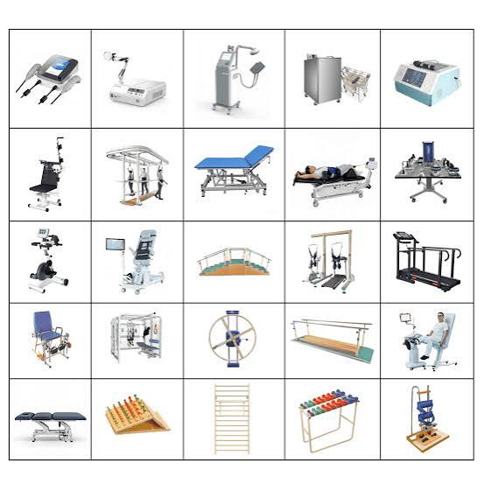
Illustrative hospital equipment catalogue. Relevant wheelchair, mobility and patient-transfer models must be selected by the hospital; the catalogue is not a confirmed procurement list.
Selection criteria: wheelchair seat width and load capacity; accessible braking and footrests; walker stability and height adjustment; commode-chair hygiene and safe support; transfer-aid compatibility with beds and staff handling procedures. Obtain manufacturer warranty, spare-parts availability and cleaning instructions.

Implementation and monitoring

1. Assessment
Identify mobility needs across OPD, emergency, inpatient wards and rehabilitation services.

2. Procurement
Collect comparable supplier quotations; approve quantities, specifications and category-wise totals.

3. Commissioning
Inspect safety, train staff in fitting and transfer techniques, and maintain an asset register.

4. CSR reporting
Report number of aids procured, patient utilisation, staff training, equipment availability and maintenance status.

CSR sponsorship opportunity
A sponsor can fund the complete ₹3 lakh disability-support package or one of its three budgeted categories. Acknowledgement and periodic utilisation reports can be provided in accordance with hospital policies and patient privacy.
Financial reconciliation: ₹1,50,000 + ₹1,00,000 + ₹50,000 = ₹3,00,000. This amount is already included in the PDF’s ₹1,88,35,000 ICU / Emergency / OPD equipment and infrastructure grouping and in the stated hospital-wide estimate. Do not add it again.
Source: user-uploaded hospital CSR cost-estimate PDF, “7. DISABILITY SUPPORT EQUIPMENT — ₹3,00,000”, page 5. Product descriptions and implementation guidance are explanatory, not additional source-listed budget items.

