[ LOGO SPACE ]

ANTARAGANGE RURAL HOSPITAL
AND RESEARCH INSTITUTE
OUTPATIENT DEPARTMENT (OPD)
EQUIPMENT & CONSULTATION INFRASTRUCTURE
Standalone CSR Partnership Proposal

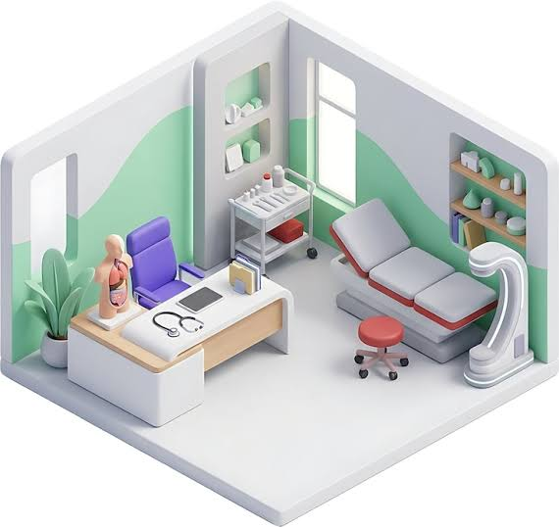 | 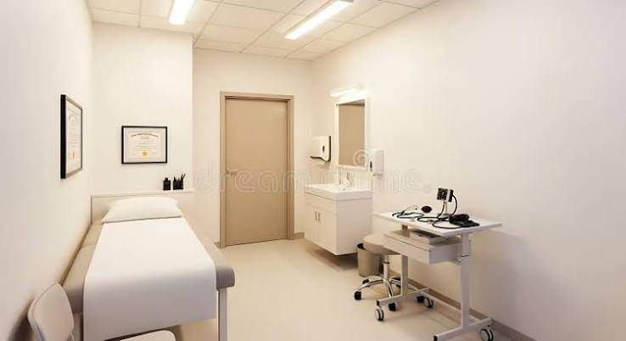
Illustrative OPD consultation environment | Illustrative clinical examination room
PROPOSED OPD EQUIPMENT ALLOCATION  As per the current hospital equipment estimate. Quantities are not specified in the source estimate and should be finalised through the room-wise BOQ and vendor quotation process. | ₹10,00,000
“A well-designed OPD is where access becomes diagnosis, reassurance, referral and continuity of care.”

PROJECT OVERVIEW
A dedicated outpatient platform for accessible first-contact care, clinical assessment and coordinated referral.
About the Hospital
Antaragange Rural Hospital and Research Institute is being developed as a comprehensive secondary-care healthcare facility for rural and underserved communities of the Kolar region of Karnataka. The planned hospital brings outpatient care, emergency services, inpatient treatment, critical care, diagnostics, surgery, dialysis, rehabilitation and disability support into one integrated rural healthcare ecosystem.
Why the OPD Matters
For most patients, the Outpatient Department is the first clinical point of contact with the hospital. A functional OPD must do more than provide a consultation room: it must support safe examination, clinical documentation, privacy, efficient patient flow and referral into diagnostics, pharmacy, procedures, emergency care or admission when required.
Provides a structured first point of care for routine illness, chronic disease review and follow-up.
Enables early clinical assessment and identification of patients who require urgent escalation.
Reduces unnecessary travel by making dependable consultation and basic assessment available locally.
Creates a professional environment for physician-patient communication, examination and continuity of care.
Connects directly with the hospital laboratory, imaging, emergency, inpatient and rehabilitation services.
Scope of This Standalone Proposal
Examination tables and clinical examination lights
Doctor and patient seating
Clinical cabinets and writing tables
SOURCE-DERIVED PROJECT VALUE  This amount is the standalone OPD allocation in the hospital equipment estimate and is separate from Reception & Administration, Emergency & Casualty, ICU and Inpatient Ward budgets. | ₹10,00,000

THE NEED & THE CSR SOLUTION
Translating a consultation room into a functional, patient-ready outpatient care platform.
The Rural Access Challenge
Patients may delay consultation when dependable medical assessment is not available close to home.
Without suitable examination infrastructure, clinical assessment becomes less efficient and may lead to avoidable referral or repeat visits.
Crowded or poorly organised consultation spaces can compromise privacy, documentation and patient experience.
Rural hospitals need OPDs that can act as gateways to diagnostics, treatment, chronic-disease follow-up and specialist referral.
The Proposed CSR Solution
Equip the OPD consultation areas of Antaragange Rural Hospital and Research Institute with essential examination, lighting, seating and clinical-workspace infrastructure so that doctors can examine patients safely, document care efficiently and coordinate onward treatment within the hospital.
“The OPD is not simply the front door of a hospital - it is the point where timely care begins.”
Patient Care Pathway
Stage | Function
1. Registration / Arrival | Patient enters the outpatient pathway and is directed to the appropriate consultation area.
2. Consultation | Doctor obtains history, evaluates symptoms and reviews previous medical information.
3. Examination | Examination table and dedicated lighting support safe and systematic clinical assessment.
4. Clinical Decision | Patient may be treated, investigated, referred to another department or admitted when appropriate.
5. Follow-Up | Records and counselling support continuity of care, chronic-disease review and treatment monitoring.

DETAILED EQUIPMENT & ECONOMICS
The current OPD allocation is distributed across three essential infrastructure categories.
Equipment / Component | Quantity / Basis | Budget Allocation | Clinical / Operational Value | Procurement Note
Examination Tables & Lights | Quantity not specified in source estimate | ₹5,00,000 | Provides appropriate patient positioning and focused illumination for physical examination, minor clinical procedures and routine outpatient assessment. | Room-wise quantity to be finalised based on number and specialty of consultation rooms.
Doctor & Patient Seating | Quantity not specified in source estimate | ₹2,50,000 | Creates a professional, accessible and comfortable environment for consultation, counselling and caregiver interaction. | Final mix should consider doctors, patients, attendants and accessibility needs.
Cabinets & Writing Tables | Quantity not specified in source estimate | ₹2,50,000 | Supports clinical documentation, storage of basic examination materials and organised outpatient workflow. | Final specification should consider infection-control surfaces, storage capacity and room dimensions.

TOTAL OPD EQUIPMENT BUDGET  ₹5,00,000 + ₹2,50,000 + ₹2,50,000 = ₹10,00,000 | ₹10,00,000
Budget Integrity Note
The current source estimate gives category-level allocations but does not provide item-by-item quantities or unit rates within the OPD package. This proposal therefore preserves the exact source allocation without inventing quantities. A room-wise Bill of Quantities should be prepared before procurement, followed by competitive vendor quotations and technical evaluation.
Recommended Procurement Principles
Durable, hospital-grade construction suitable for frequent cleaning and disinfectant use.
Ergonomic design for clinicians, patients and attendants.
Accessibility considerations for elderly persons and persons with mobility limitations.
Easy-to-maintain furniture and examination surfaces with readily available spare parts where relevant.
Uniform specifications across consultation rooms to simplify maintenance and future replacement.
Competitive procurement based on final BOQ, warranty, after-sales support and delivery / installation terms.
COMPONENT REQUIREMENTS
What each budget category enables in day-to-day outpatient care.
Examination Tables & Examination Lights
Examination tables provide a stable, appropriate surface for physical examination and selected minor outpatient procedures. Dedicated examination lighting improves visibility during inspection of wounds, skin, oral cavity, joints and other clinical areas. The final model mix should be selected according to specialty requirements, patient accessibility and ease of cleaning.
Stable patient support and safe positioning
Easy-clean upholstery and clinical surfaces
Appropriate step / access solution where required
Focused examination lighting with flexible positioning
Durability for high-volume outpatient use
Doctor & Patient Seating
Seating forms an important part of consultation quality. Appropriate chairs allow doctors to work ergonomically while patients and caregivers can participate in discussion, counselling and treatment planning with dignity and comfort.
Clinician seating suitable for repeated daily use
Patient seating with stable support
Provision for accompanying caregiver / attendant where room size allows
Accessible seating arrangement for elderly and mobility-impaired patients
Easy-clean finishes suited to healthcare environments
Cabinets & Writing Tables
Clinical cabinets and work tables organise consultation rooms and support documentation, basic examination materials and day-to-day clinical workflow. Good storage reduces clutter and helps maintain a professional, efficient consultation environment.
Secure and organised storage
Dedicated work surface for documentation and digital systems
Easy-clean construction
Layout that avoids obstructing patient movement
Provision for specialty-specific storage where required

OPD OPERATING MODEL & INTEGRATION
Designed as the gateway into the hospital’s wider continuum of care.
Clinical Integration
Linked Service | How the OPD Connects
Laboratory | Patients requiring blood or other diagnostic testing can be referred directly for investigation and review.
Imaging | Patients requiring X-ray, ultrasound or advanced imaging can move into the hospital diagnostic pathway.
Emergency & Casualty | Patients showing red-flag symptoms or clinical deterioration can be escalated for urgent stabilisation.
Inpatient Services | Patients requiring observation or admission can transition directly into ward-based care.
Operation Theatre | Patients identified for surgical evaluation can enter the pre-operative and surgical pathway.
Rehabilitation | Patients needing physiotherapy, disability support or post-operative rehabilitation can be referred internally.
Telemedicine | Where clinically appropriate, specialist consultation can be supported through digital connectivity and remote review.
Operational Considerations for Final Layout
Clear separation of patient movement and staff work zones where space permits.
Privacy for consultation and examination.
Accessible circulation for wheelchair users and patients with limited mobility.
Logical placement of examination table, doctor workstation and seating to reduce unnecessary movement.
Provision for hand hygiene and infection-control workflow in accordance with final architectural and clinical planning.
Digital readiness for electronic medical records, prescriptions and referral documentation.

CSR IMPACT, PARTNERSHIP & IMPLEMENTATION
A focused capital project with visible, measurable value to everyday patient care.
What a CSR Partner Enables
A functional outpatient clinical environment that can be used every working day.
Improved quality and consistency of physical examination and consultation.
Greater patient comfort, privacy and dignity during first-contact care.
Better coordination between outpatient consultation and diagnostics, emergency, admission and follow-up.
A durable capital asset that continues to support patients beyond the initial CSR grant period.
Suggested Monitoring Indicators
Number of outpatient consultations delivered after commissioning.
Number of patients referred internally for laboratory, imaging, emergency or inpatient care.
Number of follow-up consultations and chronic-disease reviews.
Patient feedback on accessibility, waiting and consultation experience.
Equipment / furniture uptime and maintenance status.
CSR-supported assets commissioned, tagged and reported through project documentation.
Implementation Sequence
Stage | Key Activity
1. Room Mapping | Confirm OPD consultation rooms, specialty mix and usable dimensions.
2. BOQ Finalisation | Convert the ₹10 lakh category allocation into a room-wise quantity and specification schedule.
3. Vendor Quotation | Obtain competitive quotations for hospital-grade furniture and examination equipment.
4. Technical Review | Evaluate quality, dimensions, cleanability, warranty, service support and suitability.
5. Procurement & Delivery | Place orders through institutional procurement procedure and inspect delivered goods.
6. Installation & Handover | Position equipment, tag CSR-supported assets and complete acceptance documentation.
7. Utilisation Reporting | Track outpatient utilisation and maintain CSR impact / asset documentation.
CSR Partnership Options
Partnership | Indicative Support | Scope
Complete OPD Equipment Partner | ₹10,00,000 | Supports the full source-defined OPD equipment allocation.
Examination Infrastructure Partner | ₹5,00,000 | Supports examination tables and clinical examination lighting.
Consultation Furniture Partner | ₹2,50,000 | Supports doctor and patient seating.
Clinical Workspace Partner | ₹2,50,000 | Supports cabinets and writing tables.
“Support the first point of care. Strengthen the entire patient journey.”

ANTARAGANGE RURAL HOSPITAL AND RESEARCH INSTITUTE
Bringing dependable outpatient care closer to rural families.
Planning note: Budget figures are based on the hospital equipment estimate supplied for this proposal. Final quantities, technical specifications and procurement values should be confirmed through a room-wise BOQ and competitive vendor quotations before purchase.

