LOGO | ANTARAGANGE RURAL HOSPITAL AND RESEARCH INSTITUTE

OPERATION THEATRE EQUIPMENT
A standalone CSR proposal for safe surgery, anaesthesia, image guidance and sterilisation

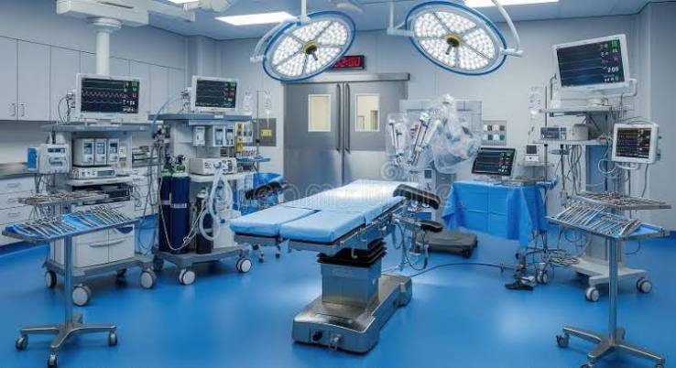
Illustrative modern operation theatre environment
Operation Theatre Equipment – Core Capital Requirement  Source-derived amount from the current hospital equipment estimate | ₹86,80,000

“Equip a safe operating theatre. Enable essential surgery closer to home.”

Project Overview
The proposed Operation Theatre at Antaragange Rural Hospital and Research Institute is intended to create a safe, dependable surgical platform for rural patients who would otherwise need to travel to larger urban centres for essential procedures. The planned equipment package brings together anaesthesia, patient positioning, surgical illumination, intra-operative monitoring, electrosurgery, suction, minimally invasive instruments, real-time imaging, surgical instrument sets and sterilisation.
This document covers only the Operation Theatre equipment requirement. ICU, OPD, inpatient wards, Emergency & Casualty, diagnostics and other departments are being presented separately so that each CSR opportunity can be evaluated and sponsored independently.

LOGO | ANTARAGANGE RURAL HOSPITAL AND RESEARCH INSTITUTE

THE CLINICAL NEED

A hospital cannot provide complete secondary care unless it can safely perform indicated surgical procedures. In rural settings, the absence of an equipped OT often converts treatable conditions into referrals, delays and additional cost for families.
• Trauma and fractures may require timely orthopaedic intervention.
• General surgical conditions may need planned or emergency procedures.
• Anaesthesia and continuous monitoring are essential for safe surgery.
• Image guidance improves accuracy in selected orthopaedic and trauma procedures.
• Laparoscopic capability can support selected minimally invasive procedures.
• Sterilisation infrastructure is fundamental to infection prevention and safe reuse of surgical instruments.
• Local surgical capability can reduce avoidable referral travel and improve continuity from diagnosis to recovery.

Proposed Surgical Care Pathway
Stage | OT Role | Patient Value
Pre-operative preparation | Assessment, monitoring preparation, anaesthesia planning | Safer entry into surgery
Anaesthesia & positioning | Workstation, OT table, monitoring | Controlled anaesthesia and secure surgical positioning
Procedure | Lights, cautery, suction, instruments, microscope / laparoscopy | Efficient and technically supported surgery
Image guidance | C-Arm where clinically indicated | Real-time support for orthopaedic / trauma procedures
Sterilisation | Autoclave / ETO processing | Infection-control support for reusable instruments
Recovery & transfer | Coordination with ICU / inpatient wards | Continuity after surgery

“The operation theatre is where diagnostics, anaesthesia, surgery, imaging and infection control must function as one system.”

LOGO | ANTARAGANGE RURAL HOSPITAL AND RESEARCH INSTITUTE

DETAILED CAPITAL BUDGET

Equipment / Component | Quantity | Source Allocation
Anaesthesia Workstations | 2 Units | ₹20,00,000
Electric OT Tables | 2 Units | ₹6,00,000
LED OT Lights | 2 Units | ₹5,00,000
Electrocautery Unit | 1 Unit | ₹3,00,000
Suction Machines | — | ₹1,00,000
Laparoscopic Instrument Sets | — | ₹9,60,000
Multipara Monitors | — | ₹7,20,000
C-Arm Imaging System | 1 Unit | ₹15,00,000
Orthopaedic & General Surgery Instruments | Sets | ₹10,00,000
Operating Microscope | 1 Unit | ₹5,00,000
Autoclave & ETO Sterilisation Unit | — | ₹5,00,000

TOTAL OPERATION THEATRE EQUIPMENT | ₹86,80,000

Budget Integrity
The allocations above are reproduced from the hospital's current equipment estimate and sum exactly to ₹86,80,000. No additional equipment cost has been merged into this core figure. Final procurement values should be established through technical specifications and competitive OEM / authorised-dealer quotations.

LOGO | ANTARAGANGE RURAL HOSPITAL AND RESEARCH INSTITUTE

ANAESTHESIA, POSITIONING & MONITORING

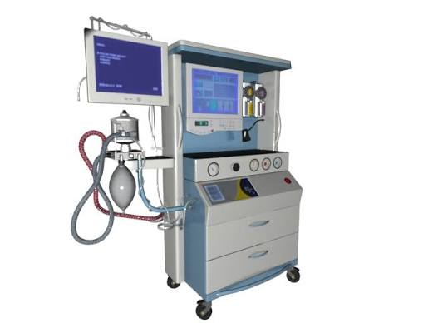
Illustrative anaesthesia workstation

Anaesthesia Workstations – 2 Units | ₹20,00,000
The anaesthesia workstation is the central platform for delivery of anaesthetic gases, assisted or controlled ventilation, and management of the patient's airway and respiratory status during surgery. Two units support parallel theatre capability or operational redundancy, subject to the final OT configuration.

Electric OT Tables – 2 Units | ₹6,00,000
Electric OT tables allow controlled adjustment of patient position for different procedures. Reliable positioning improves surgical access and assists the anaesthesia and nursing teams in maintaining patient safety.

Multipara Monitors | ₹7,20,000
Multipara monitors provide continuous physiological information such as ECG, heart rate, non-invasive blood pressure and oxygen saturation. They enable early recognition of deterioration throughout anaesthesia and surgery.

Recommended Technical Procurement Points
• Compatibility with the hospital's electrical and medical-gas infrastructure.
• Clearly defined monitored parameters and anaesthesia modules.
• Availability of local service support, preventive maintenance and spare parts.
• Battery backup and alarm performance appropriate to peri-operative use.
• User training for anaesthesia, nursing and biomedical personnel.

LOGO | ANTARAGANGE RURAL HOSPITAL AND RESEARCH INSTITUTE

SURGICAL FIELD & PROCEDURE SUPPORT

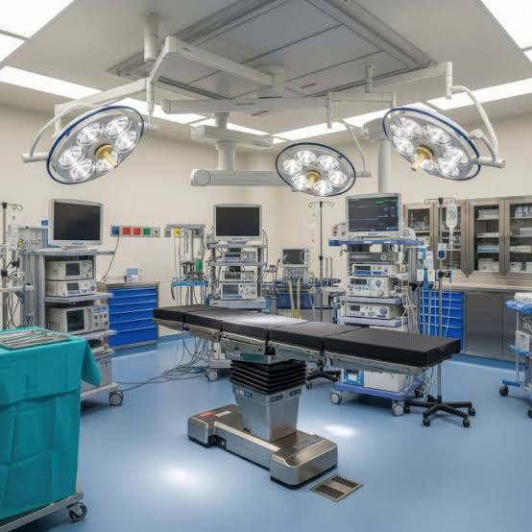
Illustrative operation theatre with surgical lights, table and supporting systems

LED OT Lights – 2 Units | ₹5,00,000
Modern LED surgical lights are designed to provide bright, consistent illumination with reduced shadowing over the operative field. Appropriate lighting is fundamental to surgical visibility and precision.

Electrocautery Unit | ₹3,00,000
Electrosurgical equipment assists tissue cutting and coagulation and is commonly used to control bleeding during surgery. Final specification should match the expected surgical case mix and applicable safety standards.

Suction Machines | ₹1,00,000
Suction systems remove blood and other fluids from the operative field and support selected airway and procedure requirements. Reliable suction contributes to visibility and procedural efficiency.

Laparoscopic Instrument Sets | ₹9,60,000
Laparoscopic instruments provide the access and working tools required for selected minimally invasive procedures. Where clinically appropriate, minimally invasive surgery may support smaller incisions and faster recovery compared with open approaches.

LOGO | ANTARAGANGE RURAL HOSPITAL AND RESEARCH INSTITUTE

IMAGE-GUIDED & PRECISION SURGERY

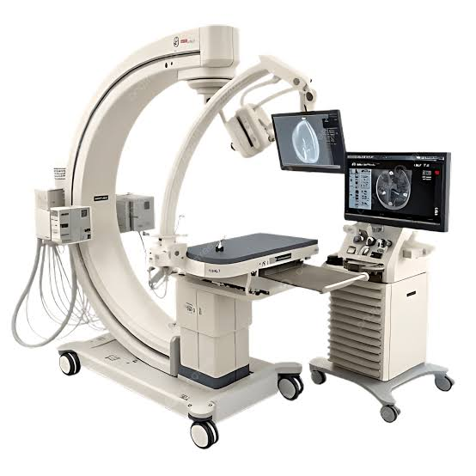
Illustrative mobile C-Arm imaging system

C-Arm Imaging System – 1 Unit | ₹15,00,000
The C-Arm provides real-time fluoroscopic imaging inside or adjacent to the operating theatre. It is particularly valuable for orthopaedic trauma, fracture fixation and other procedures where image guidance can assist positioning and decision-making.
• Orthopaedic fracture reduction and fixation support
• Trauma procedures requiring real-time imaging
• Selected image-guided interventions
• Improved intra-operative visual confirmation where clinically indicated

Operating Microscope – 1 Unit | ₹5,00,000
An operating microscope provides magnified and illuminated visualisation for procedures that require greater precision. The final specification should be matched to the intended specialties and case mix.

Radiation & Workflow Note
C-Arm use requires appropriate radiation-safety processes, trained operators, protective equipment and compliance with applicable regulatory requirements. These infrastructure and licensing requirements should be confirmed before commissioning.

LOGO | ANTARAGANGE RURAL HOSPITAL AND RESEARCH INSTITUTE

SURGICAL INSTRUMENTS & STERILISATION

Orthopaedic & General Surgery Instrument Sets | ₹10,00,000
Instrument sets provide the core reusable tools required for routine and emergency general and orthopaedic surgery. A well-planned inventory should reflect the hospital's initial case mix while allowing safe rotation between use, cleaning and sterilisation.

Autoclave & ETO Sterilisation Unit | ₹5,00,000
Sterilisation is a critical patient-safety function. Steam autoclaving is used for many reusable heat-tolerant instruments, while ethylene oxide (ETO) processing may be used for selected heat- or moisture-sensitive items where appropriate and where regulatory and occupational-safety requirements are met.

Essential Planning Considerations
• Define dirty-to-clean instrument flow and avoid cross-contamination.
• Separate decontamination, packing, sterilisation and sterile-storage steps where feasible.
• Document sterilisation cycles, validation and maintenance.
• Ensure staff training and occupational-safety procedures, particularly for ETO.
• Maintain instrument traceability and a preventive-maintenance schedule.
“Sterilisation is not an accessory to surgery; it is part of the surgery safety system.”

LOGO | ANTARAGANGE RURAL HOSPITAL AND RESEARCH INSTITUTE

EQUIPMENT-WISE CLINICAL VALUE

Equipment | Qty | Allocation | Clinical Use / Value
Anaesthesia Workstations | 2 Units | ₹20,00,000 | Controlled anaesthesia delivery, ventilation and intra-operative support.
Electric OT Tables | 2 Units | ₹6,00,000 | Safe and precise positioning for general, orthopaedic and other surgical procedures.
LED OT Lights | 2 Units | ₹5,00,000 | High-intensity, shadow-reduced illumination of the operative field.
Electrocautery Unit | 1 Unit | ₹3,00,000 | Tissue cutting and coagulation to support haemostasis during surgery.
Suction Machines | — | ₹1,00,000 | Removal of blood and fluids to maintain visibility and airway/procedure support.
Laparoscopic Instrument Sets | — | ₹9,60,000 | Instruments for selected minimally invasive procedures.
Multipara Monitors | — | ₹7,20,000 | Continuous ECG, SpO2, NIBP and other physiological monitoring during anaesthesia and surgery.
C-Arm Imaging System | 1 Unit | ₹15,00,000 | Real-time fluoroscopic imaging for orthopaedic, trauma and image-guided procedures.
Orthopaedic & General Surgery Instruments | Sets | ₹10,00,000 | Core instrument inventory for routine and emergency surgical procedures.
Operating Microscope | 1 Unit | ₹5,00,000 | Magnified visualisation where increased procedural precision is required.
Autoclave & ETO Sterilisation Unit | — | ₹5,00,000 | Sterilisation of reusable instruments and selected heat-sensitive items.

Procurement Principle
Brand selection should follow approved technical specifications rather than image or brand preference alone. Evaluation should include clinical suitability, compliance, service network, uptime commitment, warranty, consumables, training, spare-parts availability and total cost of ownership.

LOGO | ANTARAGANGE RURAL HOSPITAL AND RESEARCH INSTITUTE

IMPLEMENTATION & COMMISSIONING

Phase | Key Activities | Output
1. Clinical specification | Confirm specialties, case mix, theatre count and essential features. | Approved equipment specification
2. Infrastructure readiness | Review electrical load, earthing, medical gases, HVAC, radiation safety and sterilisation workflow. | Site-readiness checklist
3. Competitive procurement | Obtain OEM / authorised-dealer quotations and compare technical compliance, warranty and lifecycle support. | Procurement recommendation
4. Delivery & installation | Inspect, install, calibrate and test equipment. | Installed OT equipment
5. Training & commissioning | Train anaesthesia, surgical, nursing, biomedical and sterilisation teams. | Operational readiness
6. Asset & maintenance control | Tag assets, record serial numbers and establish preventive-maintenance schedule. | Traceable CSR assets

Infrastructure Outside the ₹86.80 Lakh Core Equipment Budget
The source estimate lists OT equipment separately from the hospital's broader air-conditioning allocation. Therefore, OT HVAC / air-conditioning, civil works, electrical upgrades, medical-gas extensions, radiation shielding, modular OT works and any bed/stretcher lift should not be silently added to the ₹86.80 lakh equipment figure. If any of these are required, they should be costed as separate infrastructure packages after site assessment and vendor quotation.

LOGO | ANTARAGANGE RURAL HOSPITAL AND RESEARCH INSTITUTE

CSR IMPACT & PARTNERSHIP OPTIONS

The proposed OT creates a permanent rural surgical asset rather than a one-time camp or consumable programme. Its impact can be tracked through service utilisation, procedures supported, emergency cases managed and referrals avoided.
Impact Area | Illustrative Indicator
Surgical access | Number of operations performed locally
Emergency capability | Trauma / urgent cases supported
Orthopaedic access | Procedures supported with C-Arm guidance
Continuity of care | Patients completing surgery and recovery within the hospital pathway
Referral reduction | Selected cases managed locally rather than transferred solely for OT capability
Safety | Equipment uptime, preventive maintenance and sterilisation compliance
Equity | Rural / underserved patients accessing subsidised or affordable surgery

Illustrative CSR Partnership Options
Partnership | Illustrative Support | Scope
Complete Operation Theatre Partner | ₹86,80,000 | Full source-defined OT equipment package
Anaesthesia & Monitoring Partner | ₹27,20,000 | 2 anaesthesia workstations + multipara monitoring
Image-Guided Surgery Partner | ₹15,00,000 | C-Arm imaging system
Minimally Invasive Surgery Partner | ₹9,60,000 | Laparoscopic instrument sets
Surgical Instrument Partner | ₹10,00,000 | Orthopaedic & general surgery instrument sets
Sterilisation Partner | ₹5,00,000 | Autoclave & ETO sterilisation unit
Precision Surgery Partner | ₹5,00,000 | Operating microscope

LOGO | ANTARAGANGE RURAL HOSPITAL AND RESEARCH INSTITUTE

PARTNERSHIP CASE

“A safe operating theatre turns a rural hospital from a place of referral into a place of treatment.”

Why This Project Is Suitable for CSR
• Creates durable, high-value clinical infrastructure with multi-year use.
• Supports emergency, orthopaedic and general surgical services under one platform.
• Can reduce treatment delay and travel burden for rural families.
• Allows modular sponsorship of clearly identifiable equipment groups.
• Provides measurable utilisation and asset-level reporting.
• Strengthens the full care pathway from diagnosis to surgery, critical care and recovery.

Recognition & Accountability
Subject to institutional policy and CSR guidelines, recognition may include donor acknowledgement, equipment / department plaques, inauguration communication, utilisation certificates, asset registers and periodic impact reporting. All patient stories or identifiable clinical information should be used only with appropriate consent and privacy safeguards.

Source Note
The ₹86,80,000 core budget and line-item allocations in this proposal are drawn from the hospital's current Operation Theatre equipment estimate. Clinical explanations and procurement framing are presented to make the CSR proposal easier to evaluate; they do not alter the source-defined capital budget.
ANTARAGANGE RURAL HOSPITAL AND RESEARCH INSTITUTE
Building Accessible Healthcare for Rural Karnataka

