SPACE FOR HOSPITAL LOGO — TOP LEFT
ANTARAGANGE RURAL HOSPITAL AND RESEARCH INSTITUTE

RECEPTION & ADMINISTRATION
Standalone CSR Sponsorship Proposal | Kolar District, Karnataka

Total allocation: ₹10,00,000
A welcoming, functional reception and administration area is essential for patient registration, wayfinding, waiting, records and coordination of care at the proposed rural hospital. This proposal isolates the Reception & Administration component already included in the original ICU / Emergency / OPD equipment and infrastructure allocation.
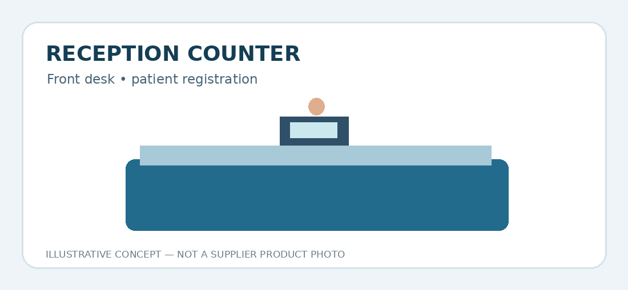

Source-Based Itemised Budget
Source item | Estimated allocation | Clinical / operational purpose
Reception Counter | ₹300,000 | Patient registration, enquiries and reception workflows
Waiting Area Chairs | ₹300,000 | Seating for patients, companions and elderly visitors
Office Furniture | ₹400,000 | Administrative desks, storage and office operations
TOTAL | ₹10,00,000 | Matches source PDF
Financial source: uploaded 12-page hospital cost estimate, page 5, “6. RECEPTION & ADMINISTRATION – ₹10,00,000”. The source provides these three lump-sum item costs but does not specify furniture quantities, brands or individual unit rates.

Equipment and Infrastructure Illustrations

Reception Counter
Original PDF allocation: ₹300,000. Front desk • patient registration. Illustration for planning only; not a photograph of a selected supplier product.

Waiting Area Chairs
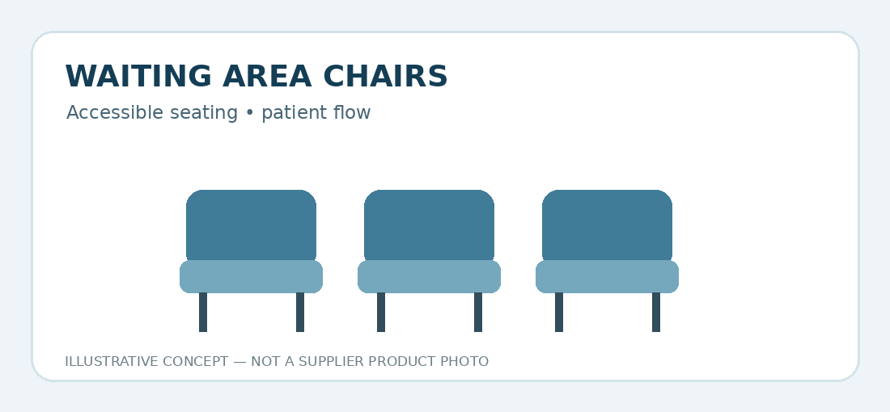
Original PDF allocation: ₹300,000. Accessible seating • patient flow. Illustration for planning only; not a photograph of a selected supplier product.

Office Furniture
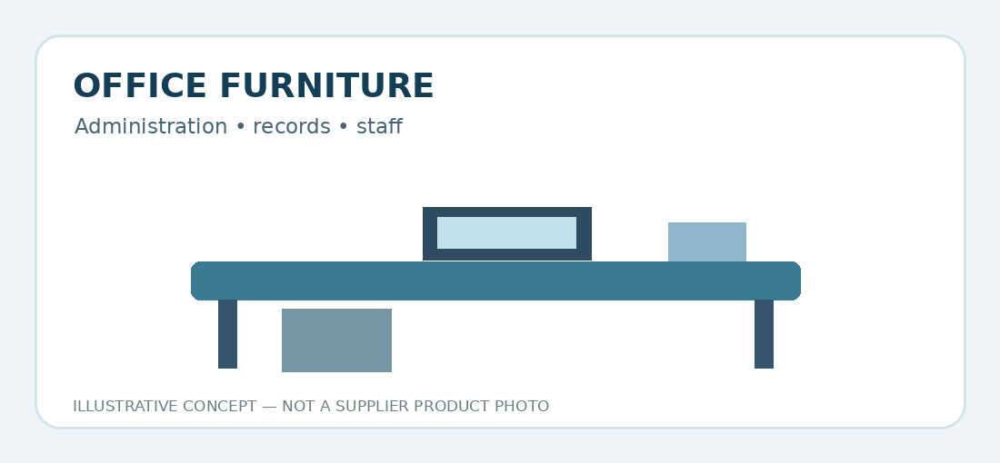
Original PDF allocation: ₹400,000. Administration • records • staff. Illustration for planning only; not a photograph of a selected supplier product.

Operational Scope and Accessibility

Patient-friendly entry and registration
Reception counters should support clear enquiries, queue management and registration with appropriate privacy safeguards.

Accessible waiting spaces
Select chairs and circulation layouts suited to older adults, wheelchair users and patients with limited mobility; keep access routes unobstructed.

Administration and records
Provide practical workstations, storage and furniture for hospital coordination. IT systems and software are budgeted separately under Hospital IT Systems (₹12 lakh), not here.

Durability and infection prevention
Prefer cleanable surfaces, robust furniture and maintainable fittings suitable for healthcare use.

Implementation Plan
- Validate floor plan, patient flow, reception layout and accessibility requirements.
- Prepare a bill of quantities for counters, seating and office furniture.
- Obtain comparable supplier quotations within the three source allocations.
- Install furniture and complete quality, safety and accessibility checks.
- Train reception and administrative personnel and begin routine asset tracking.

Expected CSR Outcomes
Measure registration waiting times, daily patient footfall, availability of accessible seating, patient feedback and furniture functionality. Baseline and targets should be set once hospital services begin.

CSR Sponsorship and Budget Reconciliation
The sponsor may fund the entire ₹10,00,000 reception and administration allocation or a quoted subcomponent. This ₹10 lakh is ALREADY included within the hospital PDF’s ₹1,88,35,000 ICU / Emergency / OPD infrastructure subtotal and therefore within its stated ₹5,50,15,000 project total. It must not be added again. The illustrations are conceptual; final purchases depend on approved specifications and quotations.
Sponsor acknowledgement may be provided through reception-area signage and periodic asset and impact reports, subject to hospital policy.

