LOGO SPACE — TOP LEFT
ANTARAGANGE RURAL HOSPITAL AND RESEARCH INSTITUTE

ADVANCED PHYSIOTHERAPY & REHABILITATION UNIT
Standalone CSR Sponsorship Proposal | Kolar Region, Karnataka
Restoring mobility, independence and participation in everyday life

Total Estimated Project Cost: ₹12,50,000
This standalone proposal follows the uploaded hospital equipment and infrastructure estimate, “Advanced Physiotherapy & Rehabilitation Unit”, page 9. The source allocates ₹12,50,000 for the complete department. Every component amount below is reproduced exactly from that estimate.
The proposed unit supports stroke rehabilitation, cerebral palsy therapy, spine rehabilitation, post-surgical recovery, gait and mobility rehabilitation, and musculoskeletal physiotherapy.

Why This Department Matters
People recovering from stroke, injury, surgery or chronic mobility problems often require repeated therapy sessions, assistive devices and supervised exercise. A hospital-based rehabilitation service can provide a local pathway from acute treatment through functional recovery, reducing avoidable travel for rural families.

Neurological rehabilitation
Structured exercise and mobility training for stroke-related weakness and movement limitations, according to individual clinical assessment.

Cerebral palsy and disability support
Functional movement, positioning, balance and caregiver education for appropriate patients.

Orthopaedic and spine rehabilitation
Supervised strengthening, range-of-motion, balance and mobility work after injury or surgery, when medically cleared.

Gait and functional independence
Parallel bars, walking aids and balance trainers can support safe, graded practice in walking and daily activities.

Services in the Original Hospital Proposal
• Stroke Rehabilitation
• Cerebral Palsy Therapy
• Spine Rehabilitation
• Post-Surgery Recovery Programs
• Gait Training & Mobility Rehabilitation
• Musculoskeletal Physiotherapy

Source-Based Equipment and Cost Breakdown
No. | Equipment / Infrastructure (source wording) | Estimated allocation
1 | Electrotherapy Units (IFT, TENS & Ultrasound Therapy) | ₹2,50,000
2 | Laser Therapy Unit | ₹1,00,000
3 | Exercise Therapy & Rehabilitation Equipment | ₹2,00,000
4 | Balance & Proprioception Trainers | ₹1,00,000
5 | CP Rehabilitation Tools | ₹1,00,000
6 | Parallel Bars, Walkers & Gait Training Systems | ₹1,50,000
7 | Basic Orthotics & Prosthetics Fabrication Support Setup | ₹2,00,000
8 | Treatment Beds, Furniture & Therapy Accessories | ₹1,50,000
 | TOTAL PROJECT COST | ₹12,50,000
Arithmetic check: ₹2,50,000 + ₹1,00,000 + ₹2,00,000 + ₹1,00,000 + ₹1,00,000 + ₹1,50,000 + ₹2,00,000 + ₹1,50,000 = ₹12,50,000.
The uploaded source does not specify quantities, models or per-unit rates for these eight grouped categories. No additional equipment costs have been invented or added.

Equipment Roles and Clinical Applications

Electrotherapy (IFT, TENS and therapeutic ultrasound)
Potential adjuncts for symptom management in selected cases, applied only by qualified professionals with appropriate contraindication screening.

Laser therapy
A modality to be considered under evidence-informed clinical protocols, not a substitute for active rehabilitation.

Exercise therapy equipment
Supports graded strengthening, flexibility, endurance and movement retraining.

Balance and proprioception trainers
Supports fall-risk reduction and stability practice with suitable supervision.

Cerebral palsy rehabilitation tools
Supports positioning, motor practice and age-appropriate functional training.

Parallel bars, walkers and gait systems
Supports supported standing, transfer practice and progression of walking ability.

Basic orthotics and prosthetics fabrication support
Provides initial fitting, adjustments and rehabilitation support within trained staff capability; specialist fabrication needs may require referral.

Treatment beds, furniture and accessories
Provides safe treatment spaces, patient positioning and equipment organisation.
The source budget is a planning estimate. Clinical indications, procurement specifications and any applicable device registrations should be confirmed before purchase.

Implementation Roadmap
Phase | Key actions
1. Clinical planning | Confirm patient mix, referral pathways, staffing and therapy protocols.
2. Room preparation | Assess accessibility, circulation, electrical supply, storage and safe exercise zones.
3. Procurement | Obtain itemised quotations mapped to each of the eight approved budget categories.
4. Installation and training | Complete equipment acceptance, staff orientation and maintenance planning.
5. Service launch | Begin scheduled assessments, individualised treatment plans and follow-up reporting.

Outcome Measurement
• Patients assessed and rehabilitation sessions delivered
• Proportion of patients with documented functional goals and reassessments
• Changes in walking, balance, transfers or daily-function measures where appropriate
• Patients receiving gait aids or orthotic support
• Equipment utilisation, uptime and staff training completion

CSR Sponsorship and Accountability
A CSR partner can fund the complete ₹12,50,000 unit, or sponsor one or more source-listed equipment categories at their specified planning allocations. The hospital can provide purchase records, commissioning confirmation, an asset register, patient-volume summaries and periodic outcome reporting while safeguarding patient confidentiality.
Financial separation: This ₹12,50,000 is the same Physiotherapy & Rehabilitation line already included in the original hospital summary total of ₹5,50,15,000. It is not an additional cost and must not be added a second time.

Source and Scope
Source: user-supplied 12-page hospital CSR cost estimate, page 3 summary and page 9 “Advanced Physiotherapy & Rehabilitation Unit”. Clinical descriptions and implementation guidance expand on the source but do not modify its cost allocations. Photographs are omitted rather than misrepresent unrelated equipment as the proposed rehabilitation inventory.

Illustrative Rehabilitation Equipment — Photo Gallery
The photographs below illustrate rehabilitation equipment categories included in the hospital proposal. They are reference images, not confirmed makes, models or supplier quotations.
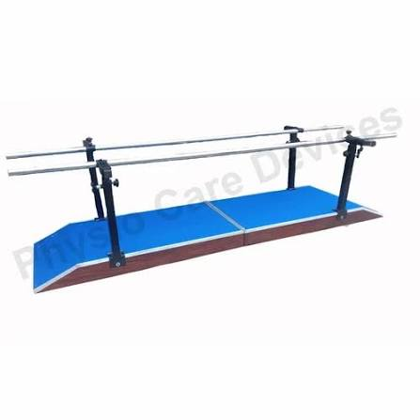
Parallel bars and supported gait training — relevant to the ₹1,50,000 gait training allocation.
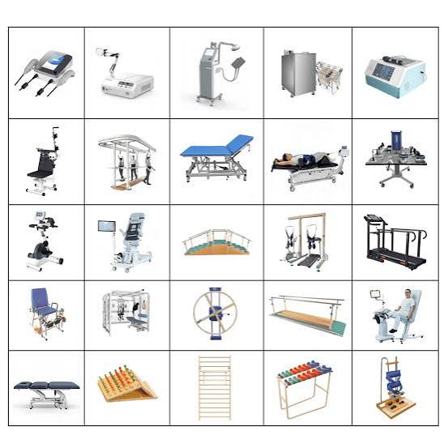
Rehabilitation aids and treatment accessories — examples relevant to exercise, balance and therapy equipment.
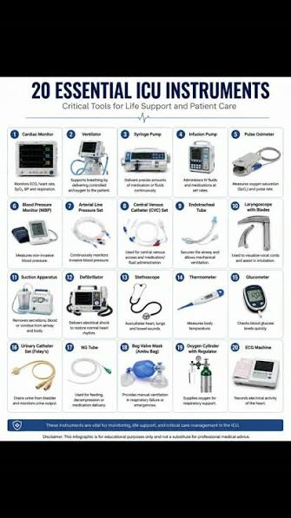
Illustrative therapy instruments and assistive equipment — exact purchase list to be finalised.

