LOGO SPACE
ANTARAGANGE RURAL HOSPITAL AND RESEARCH INSTITUTE

DIGITAL X-RAY IMAGING UNIT
Standalone CSR Funding Proposal | Kolar District, Karnataka
“Bring diagnostic clarity closer to every rural family.”
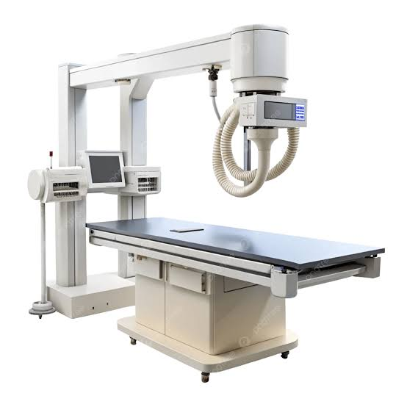
Illustrative equipment image — not a procurement specification.

Project Investment: ₹15,00,000
The hospital proposes a 500 mA digital X-ray facility to support timely imaging for trauma, orthopaedic evaluation, chest conditions and routine clinical diagnosis. This is a standalone proposal, distinct from the ultrasound, CT and C-Arm packages.
A digital radiography service will strengthen decision-making across OPD, emergency, inpatient and surgical departments while reducing the need for patients to travel solely for routine radiographs.

The Need and Proposed Solution
For patients with suspected fractures, chest disease and other conditions requiring plain radiography, a local X-ray service supports earlier assessment and appropriate referral or treatment. The proposed unit includes the image-acquisition system, digital detector, review workstation and essential radiation-protection infrastructure.

500 mA Digital X-Ray Machine
Produces diagnostic radiographs of the chest, limbs, spine and other anatomical regions, subject to approved protocols and clinical indication. The stated 500 mA rating is taken from the hospital equipment estimate.

Digital Radiography (DR) Panel
Captures digital images without conventional film processing, allowing prompt review and electronic transfer.

Radiology Workstation
Enables image review, reporting, storage and sharing with treating clinicians; interoperability and archive requirements should be finalised at procurement.

Lead Shielding and Safety Setup
Supports radiation protection of staff, patients and surrounding areas; final shielding design and approvals must be established by a qualified radiation-safety professional.

Installation and Calibration
Covers installation, acceptance checks, equipment testing and staff orientation prior to clinical use.

Detailed Equipment Scope and Economics
Component | Purpose | Budget status
Digital X-Ray Machine (500 mA) | Core radiographic image acquisition | Included in overall allocation; item price not specified
DR Panel System | Digital image capture | Included; item price not specified
Radiology Workstation | Image review and reporting | Included; item price not specified
Lead Shielding & Safety Setup | Radiation protection and compliant room readiness | Included; item price not specified
Installation & Calibration | Commissioning and quality checks | Included; item price not specified

Total Core Budget — ₹15,00,000
SOURCE RECONCILIATION: The hospital summary lists ₹15 lakh for Digital X-Ray. The detailed imaging section describes an approximate ₹12–15 lakh range. This CSR proposal uses the ₹15 lakh ceiling for consistency with the approved planning summary; it is not a vendor quotation.
The source does not give individual component costs, unit quantities beyond the stated machine type, or a vendor-approved bill of quantities. Accordingly, no invented line-item prices have been inserted. Obtain at least comparable technical and commercial quotations before funding approval.

Implementation and Regulatory Readiness

1. Room and electrical planning
Confirm room size, equipment positioning, electrical load, earthing, UPS requirements and accessibility.

2. Radiation-safety design
Commission shielding assessment and satisfy applicable AERB requirements for equipment, room layout, licensing and radiation protection.

3. Technical procurement
Seek quotations covering the generator, tube, detector, workstation, software licences, installation, warranty, AMC and service coverage.

4. Installation and acceptance
Complete delivery inspection, installation, calibration, quality assurance and documentation before first patient use.

5. Staff training
Train radiographers and clinical users on positioning, exposure protocols, infection prevention, image handling and safety.

Risk and Sustainability Controls
Budget confirmation should separately identify any civil modifications, power conditioning, network/PACS integration, ongoing quality checks, maintenance, regulatory fees and consumables if excluded from vendor quotations. The capital estimate must not be represented as covering unspecified works.

CSR Outcomes and Sponsorship
The proposed investment creates a durable diagnostic asset serving several hospital departments. Impact can be reported through examinations completed, turnaround time, equipment uptime, referral patterns and the proportion of patients accessing radiography locally.
Component | Purpose | Budget status
Complete Digital X-Ray Sponsorship | All five listed components | ₹15,00,000 planning allocation
Equipment Sponsorship | X-ray machine and DR detector | Amount to be determined from itemised quotation
Safety and Commissioning Sponsorship | Shielding, installation and calibration | Amount to be determined from itemised quotation

Sponsor Value
Corporate partners may support the full unit or a separately quoted component. Appropriate acknowledgement, asset registers, utilisation certificates and periodic impact summaries can demonstrate how the investment supports rural patients, subject to institutional policy and patient privacy.

Source and Financial Notes
Basis: uploaded hospital equipment estimate, “Digital X-Ray Imaging Unit”, including the five listed components, 500 mA specification and ₹12–15 lakh detailed estimate; hospital summary budget ₹15 lakh. Illustrative photograph provided by the user.
“One well-equipped diagnostic room can help shorten the distance between uncertainty and treatment.”

