IoT & Automation Lab Record

**Lab-1**

**Lab Exercise: Blinking the In-Built LED**

void setup() {

pinMode(LED_BUILTIN, OUTPUT);

}

void loop() {

digitalWrite(LED_BUILTIN, HIGH);

delay(1000);

digitalWrite(LED_BUILTIN, LOW);

delay(1000);

}

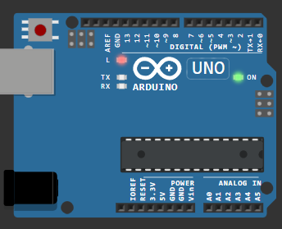

**[Wokwi Lab-1 @ project](https://wokwi.com/projects/410077373723539457)**

**Lab-2**

**Lab Exercise: Blinking an External Red LED**

#define vk 12

void setup() {

  pinMode(vk, OUTPUT);

}

void loop() {

  digitalWrite(vk, HIGH);

  delay(500);

  digitalWrite(light, LOW);

  delay(500);

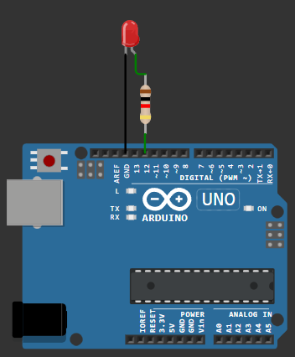  }

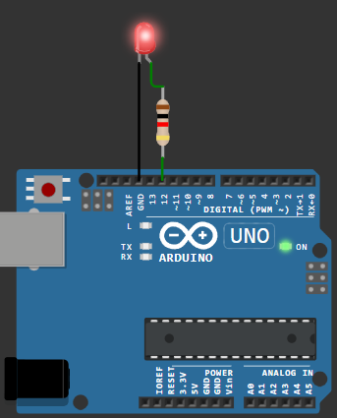

**[Wokwi Lab-2 @ Sketch](https://wokwi.com/projects/410077546199647233)**

**Lab-3**

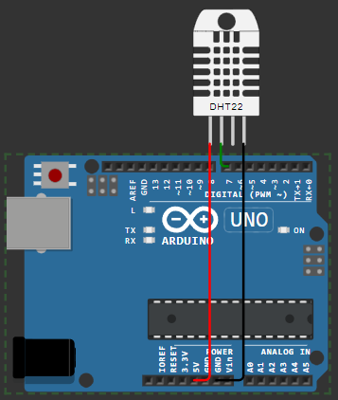**Lab Exercise: Reading and Displaying Humidity and Temperature Data**

#include <DHT.h>

#define vk 7

#define DHTTYPE DHT22

DHT dht(vk, DHTTYPE);

float humid, temp;

void setup() {

  Serial.begin(9600);

  dht.begin();

}

void loop() {

  delay(200);

  humid = dht.readHumidity();

  temp = dht.readTemperature();

  Serial.print("Humidity: ");

  Serial.print(humid);

  Serial.print(" %  Temperature: ");

  Serial.print(temp);

  Serial.println("°C");

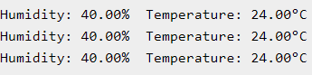  delay(1000);

}

**[wokwi Lab-3 @ Sketch](https://wokwi.com/projects/410078009353666561)**