IoT & Automation Lab. Record

**LAB 1 : Blinking the inBuilt LED**

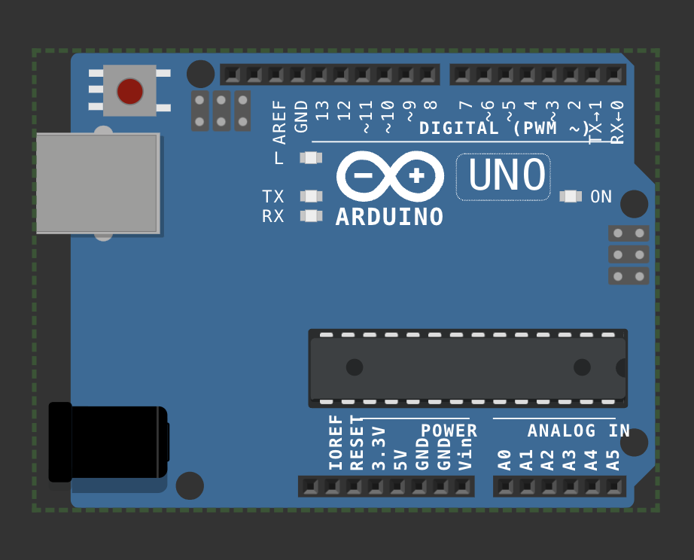

void setup() {

pinMode(LED_BUILTIN, OUTPUT);

}

void loop() {

digitalWrite(LED_BUILTIN, HIGH);

delay(1000);

digitalWrite(LED_BUILTIN,LOW);

delay(1000);

}

**[#](http://www.apple.com/uk) [Wokwi 1](https://wokwi.com/projects/410064097034032129)**

**LAB 2 : Blinking an external LED**

#define led_pin 11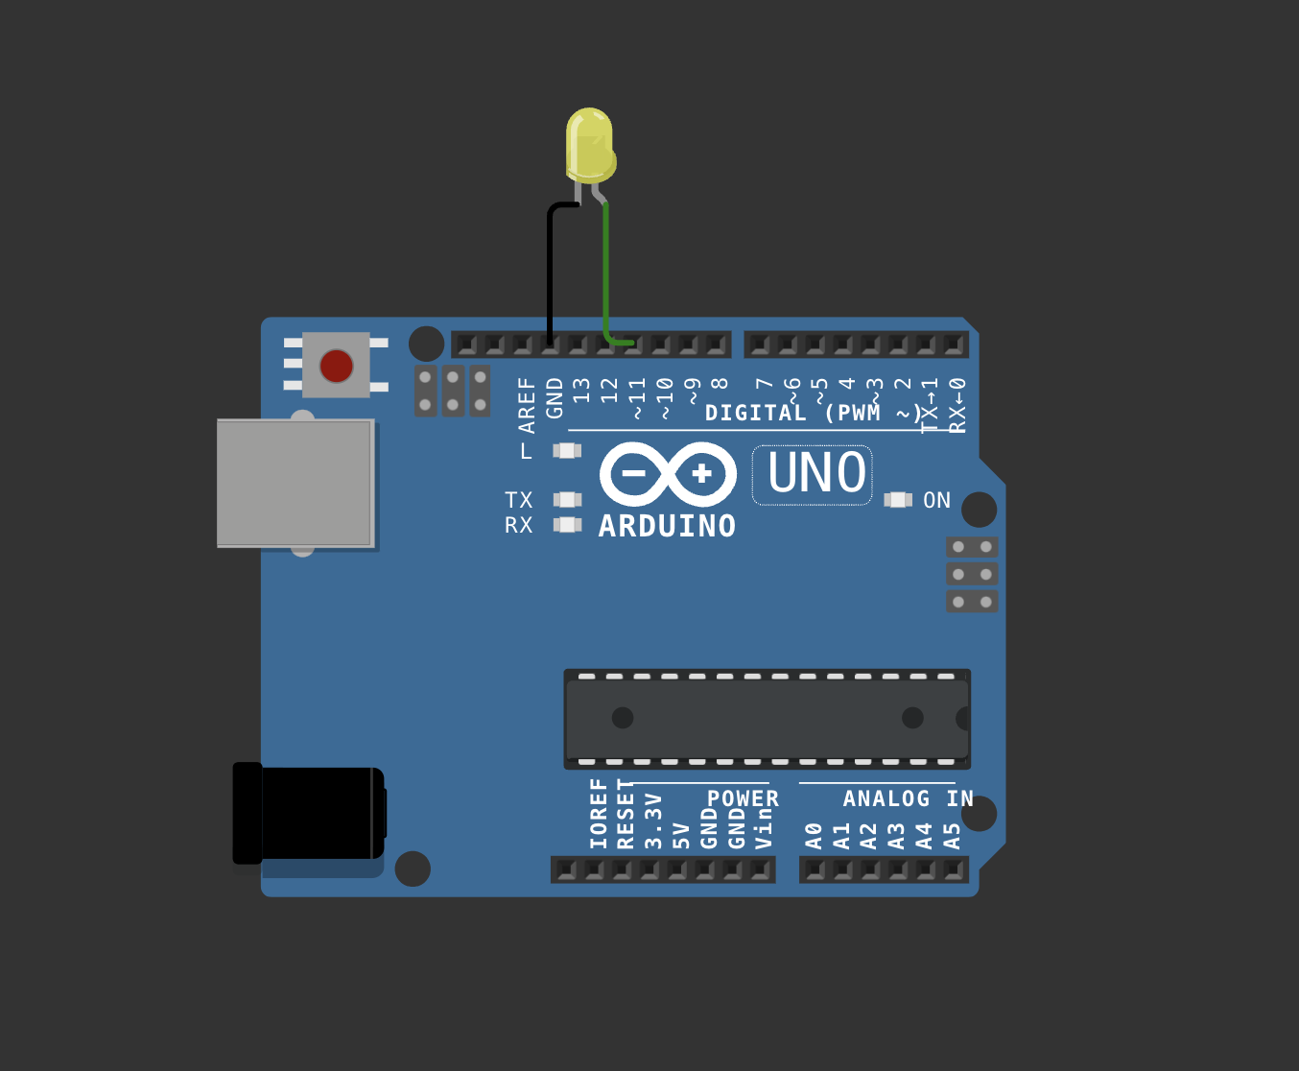

void setup() {

pinMode(led_pin, OUTPUT);

}

void loop() {

digitalWrite(led_pin, HIGH);

delay(1000);

digitalWrite(led_pin,LOW);

delay(1000);

}

[## wokwi 2](https://wokwi.com/projects/410063574396342273)

# Lab 3 : Using DHT sensor

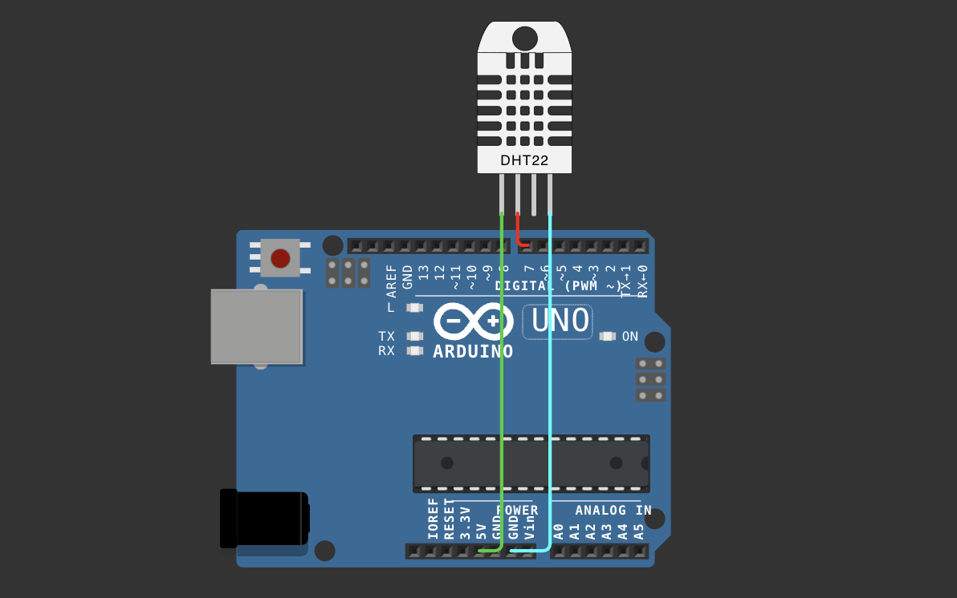

#include <DHT.h>

#define pin 7

#define DHTTYPE DHT22

DHT dht(pin, DHTTYPE);

float humid, temp;

void setup() {

**Serial**.begin(9600);

dht.begin();

}

void loop() {

delay(200);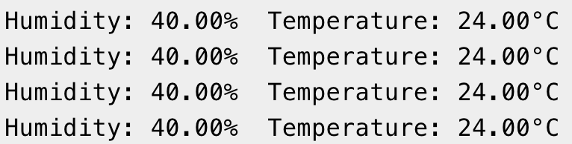

humid = dht.readHumidity();

temp = dht.readTemperature();

**Serial**.print("Humidity: ");

**Serial**.print(humid);

**Serial**.print("% Temperature: ");

**Serial**.print(temp);

**Serial**.println("°C");

delay(1000);

}

[#Wokwi 3](https://wokwi.com/projects/410064543004003329)