**Machine-to-Machine (M2M) communication**

1. **Introduction**

The technology, Machine to Machine (M2M) Communication, allows devices to communicate with each other and with other devices without human intervention, thereby achieving real time interactions that results in increased productivity as well as automation. It is M2M communication that supports the applications in various fields such as healthcare, transportation, manufacturing and utilities, where the devices can do the tasks autonomously.

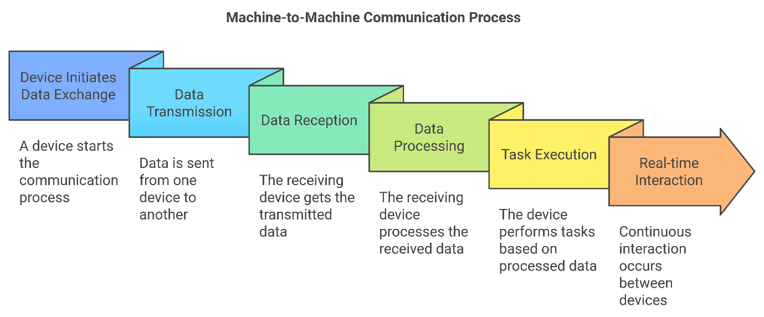

**Key Objectives:**

* Set the boundaries of M2M communication.
* A walk through M2M application spaces and technological components.
* Talk about the technical rules, concerns about the communication of M2M communication, and the current standardization work in M2M communication.

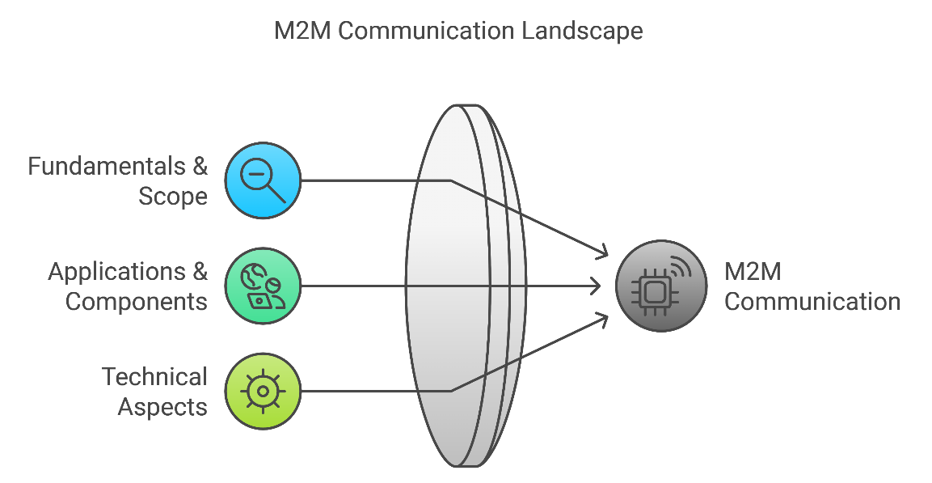

2. **Applications of M2M Communication**

*Unlocking Efficiency and Innovation with M2M Communication.*

Machine-to-machine (M2M) communication is creating new boundaries globally between the physical world and digital world leading to flawless, automatic, easy data flow in turn influencing the decision making, improving the functions, and thrilling user experience of these industries. M2M technology is ensuring that devices talk to each other while making systems smarter and responses swifter across numerous sectors.

* **Healthcare**: Continuous monitoring of vital signs, remote diagnostic, telemedicine and ultimately, better healthcare access and proactive care is enabled and made possible by M2M-driven solutions.
* **Transportation**: M2M helps with fleet management, navigation, traffic optimization through real time updates, asset tracking and route adjustments, in order to have efficient and safer travel.
* **Manufacturing**: M2M makes manufacturing more efficient by reducing downtime, processing automation and accelerating production through remote diagnostics.
* **Utilities**: M2M is also used by power, water, and gas companies to perform precision metering of resources and manage grids efficiently so as to minimize waste and respond rapidly to demand volatility.
* **Security**: M2M fortifies security frameworks and increase emergency response mechanisms from commercial building surveillance, alarm and access control systems.

But M2M applications beyond these industries are in security, payment systems, remote maintenance, metering, facility management, and beyond, leading to extraordinary innovation. With M2M technology, businesses can streamline processes, save money, and build a responsive, data driven infrastructure that will keep them competitive in an increasingly connected world.

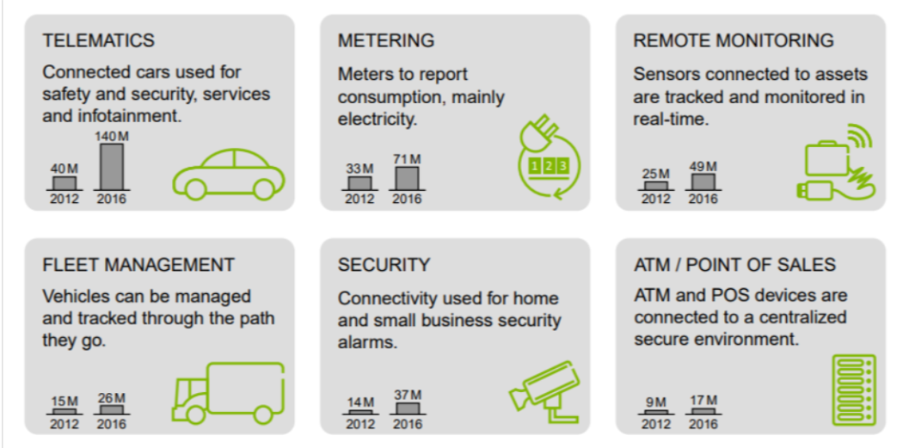

3. **Key Features of M2M Communication: Precision, Efficiency, and Reliability**

Machine to Machine (M2M) communications are engineered to deliver timely and efficient communication of precise data exchange designed for particular types of applications across industries. Here’s what sets M2M apart:

* **Time-Controlled Data Flow**: All designed for pre scheduled transmissions and reducing network load and congestion. Resources are used only as need be, and data is only sent at certain intervals.
* **Packet-Switched Communication**: M2M uses packet switched networks to maximize data transfer and network capacity for applications requiring repeated transfers of small amounts of data.
* **Location-Specific Triggering**: Based on geographic location, M2M devices can be activated and used to respond in real time, in use cases such as asset tracking and resource monitoring.
* **Low Mobility and Low Power Consumption**: They are comparatively stationary or confined to some limited area and have very good power efficiency, allowing extended deployment in remote or unmanned situations.
* **Event Monitoring**: M2M devices are not designed to do away with accidents directly, but to detect particular events and provide reputable data for imperative reactions.

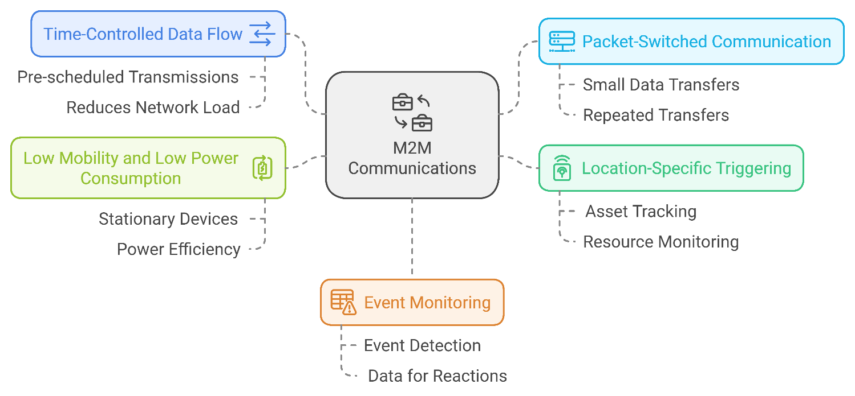

3. **M2M System Architecture:**

Machine-to-Machine (M2M) communications systems architecture is built with diverse essential components present that are designed to improve the connectivity, data flow and processing at any number of applications, such as industrial Automation or smart cities. Here’s a breakdown of the key elements:

**M2M Devices**: The M2M devices are endowed with sensors and actuators, and thus functioning as endpoints for data collection and transmission. It is allowed that these devices can be directly connected to the operator networks or via WPAN (e.g., Bluetooth, ZigBee) technologies to combine varying deployment options.

**M2M Area Networks (Device Domain)**: The local connectivity afforded by these networks is between M2M devices and gateways, utilizing personal area network (PAN) technologies for easy, short-range communication.

**M2M Gateway**: M2M gateways act as intermediaries, handling connection, data flow between M2M devices to communication networks. Essentially this takes care of fundamental work such as addressing, identification, and accounting that interface easily and a configurable control across capillary networks.

**Communication Network (Network Domain)**: It provides remote connectivity via fast networks such as 4G, LTE, WiMAX and WLAN; data transmission to M2M applications reliable, scalable.

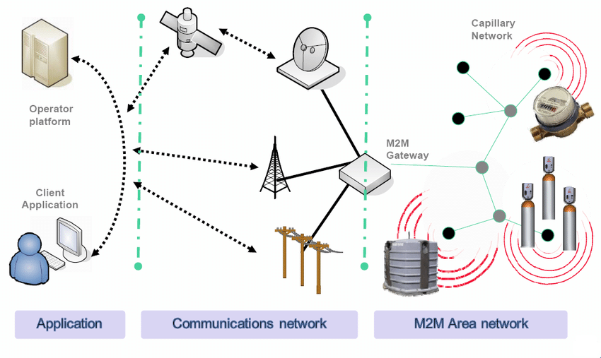

**M2M Applications**: M2M applications constitute the final layer which provides interfaces to process and use data by end users or other service providers. Providing advanced customer care, billing as well as business intelligence functionality based on real-time data, the middleware layer allows for decision making as well as automatic action towards data.

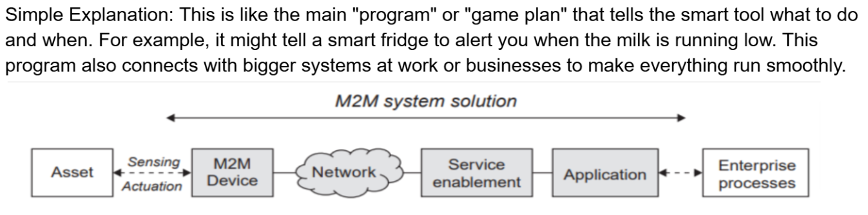

3. **Requirements for Effective M2M Communication:**

* **Seamless Device Integration**: It supports communication of device to gateways.
* **Message Delivery Modes**: It must also support unicast, multicast and broadcast modes for effective management of a network.
* **Scalability**: Makes it possible for the system to grow as more devices get added.
* **Security Protocols**: It is an implementation that allows to protect devices from cyber threats and unauthorized access.
* 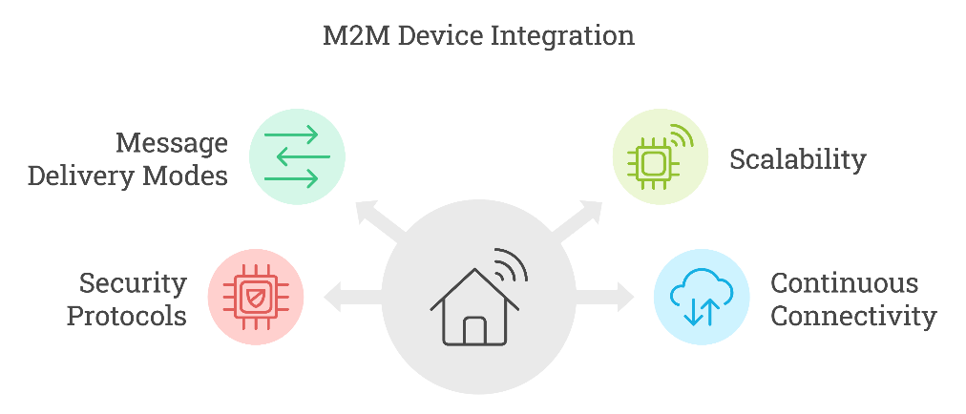**Continuous Connectivity**: Uninterrupted connectivity to applications that require application monitoring and control.

4. **Issues and Concerns in M2M Communication:**

Due to the vast and often unmanned nature of connected devices, M2M systems have critical challenges to address, security, and privacy of data. Key issues include:

**Security Risks**: Dispersed and unmonitored devices are susceptible to tracked, namely hacking and unauthorized monitoring and therefore require strong, immunity protected security measures, in particular for the remote management and firmware updates.

**Addressing and Identification**: This is complex: assigning unique identifiers to millions of devices. To accommodate a variety of device classes and environments, there had to be freedom in naming schemes (IP addresses, group multicast addresses, for example).

**Data Privacy and Management**: Fortunately, efficient privacy protocols are needed to protect unattended devices handling sensitive information, as they can misbehave and be used by unauthorized parties to perform various acts such as accessing and/or modifying the device contents.

**Interoperability**: This is not compatible across different manufacturers, and so we need standardized protocols.

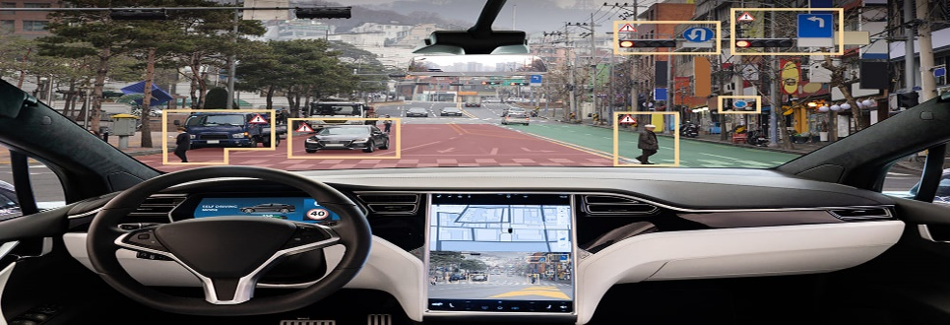**Tesla Example of M2M Communication**: A Tesla car automatically connects with a charging station to check for the next available slot. This communication happens directly between the car and the station, without any human involvement.

5. **Conclusion:**

M2M as an application holds the promise of bringing benefit to both telecom operators and vendors. For service providers it is an opportunity as low-bandwidth M2M services can be readily overlaid onto the current user services network. Vendors are expected to profit from selling both M2M-capable devices, and from the network expansion brought about by increased throughput. However, it comes with change in business model and value chain. There are questions regarding the role of operators in the value chain. Also, M2M services may have their own specific characteristics which might be different from services in which humans directly influence communication flow. The standardization in the direction of special handling or optimization of the network for M2M specific service will lead for better support of M2M communications.

6. **Glossary:**

* M2M (Machine-to-Machine): Direct communication between devices without human involvement.
* IoT (Internet of Things): A network of connected devices that communicate over the internet.
* ETSI: European Telecommunications Standards Institute, a body responsible for telecom standards.
* Packet-Switched Communication: A communication method that divides data into packets for efficient transmission.

6. **References’:**

[https://docs.google.com/document/d/18_I8IHcgBW-7ggGbFxM4gmVzff8Y_1nsgo64yzolfn4/](https://d.docs.live.net/0f2a337e6b9dac28/Documents/Machine.docx)

[https://www.researchgate.net/publication/277014621_Machine-to-Machine_Communication_-_A_Survey_and_Taxonomy](https://d.docs.live.net/0f2a337e6b9dac28/Documents/Machine.docx)

[https://www.sciencedirect.com/science/article/abs/pii/S1084804516000990](https://d.docs.live.net/0f2a337e6b9dac28/Documents/Machine.docx)