IoT & Automation Lab Record

Lab-1

Lab Activity: blinking the Integrated LED  
  
void setup() {  
 pinMode(LED_BUILTIN, OUTPUT);  
}  
  
void loop() {  
 digitalWrite(LED_BUILTIN, HIGH);  
 delay(1000);  
 digitalWrite(LED_BUILTIN, LOW);  
 delay(1000);  
}

void setup() {

pinMode(LED_BUILTIN, OUTPUT);

}

void loop() {

digitalWrite(LED_BUILTIN, HIGH);

delay(1000);

digitalWrite(LED_BUILTIN, LOW);

delay(1000);

}

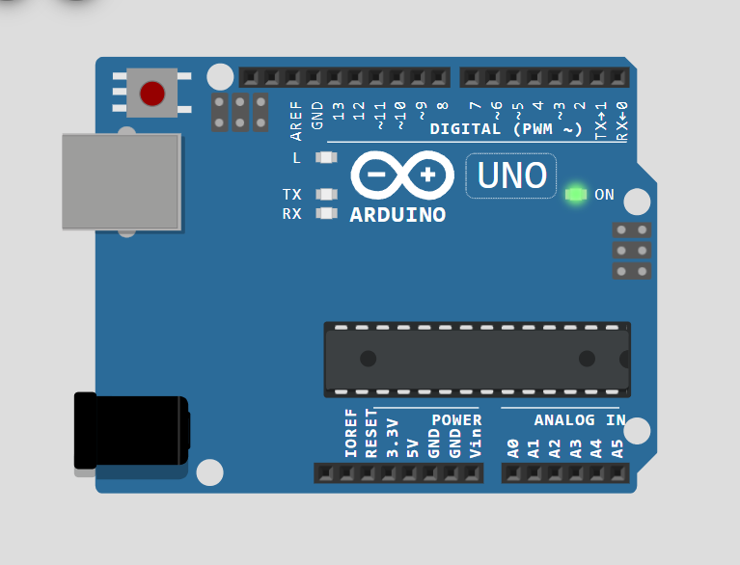

Lab-2

Lab Activity: Flashing an External LED  
  
#define ledPin 13  
  
void setup() {  
 pinMode(ledPin, OUTPUT);  
}  
  
void loop() {  
 digitalWrite(ledPin, HIGH);  
 delay(500);  
 digitalWrite(ledPin, LOW);  
 delay(500);  
}

#define vk 13

void setup() {

  pinMode(vk, OUTPUT);

}

void loop() {

  digitalWrite(vk, HIGH);

  delay(500);

  digitalWrite(light, LOW);

  delay(500);

  }

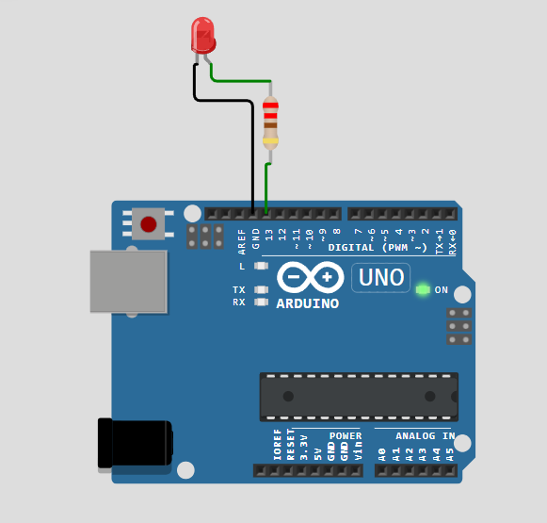 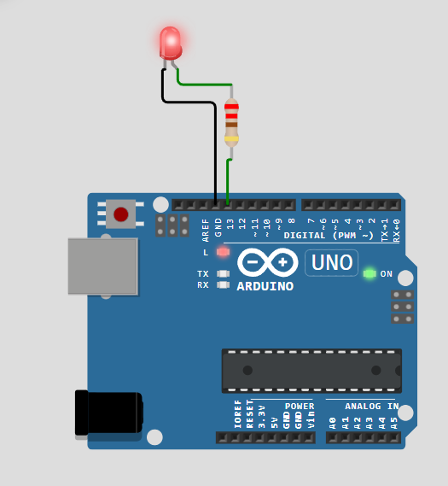

Lab-3

Lab Activity: Displaying Humidity and Temperature  
  
#include <DHT.h>  
#define sensorPin 7  
#define DHTTYPE DHT22  
DHT dht(sensorPin, DHTTYPE);  
  
float humidity, temperature;  
  
void setup() {  
 Serial.begin(9600);  
 dht.begin();  
}  
  
void loop() {  
 delay(200);  
 humidity = dht.readHumidity();  
 temperature = dht.readTemperature();  
 Serial.print("Humidity: ");  
 Serial.print(humidity);  
 Serial.print("% Temperature: ");  
 Serial.print(temperature);  
 Serial.println("°C");  
 delay(1000);  
}

#include <DHT.h>

#define vk 7

#define DHTTYPE DHT22

DHT dht(vk, DHTTYPE);

float humid, temp;

void setup() {

  Serial.begin(9600);

  dht.begin();

}

void loop() {

  delay(200);

  humid = dht.readHumidity();

  temp = dht.readTemperature();

  Serial.print("Humidity: ");

  Serial.print(humid);

  Serial.print(" %  Temperature: ");

  Serial.print(temp);

  Serial.println("°C");

  delay(1000);

}

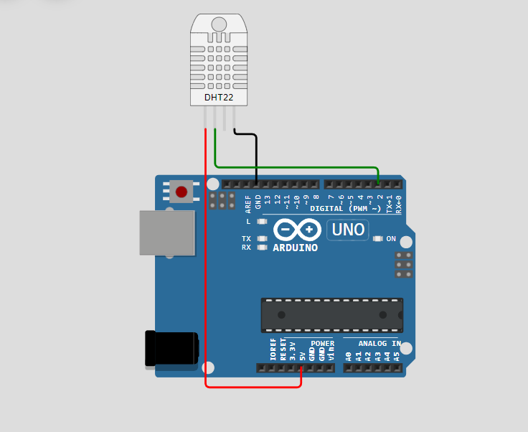 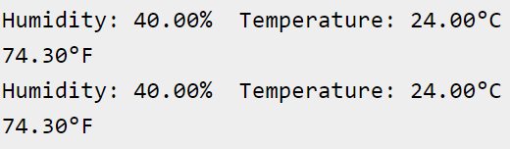

Lab#4

Configuring MQTT Service in my Machine

In SystemOS [ Windows11 ]:

- Installed Mosquitto as a Service from Official Eclipse Page [ ].

- This allows the MQTT Broker to run automatically in the background.

- Added mosquittio.exe to the System Environment Variables PATH [ ' C:\Program Files\mosquitto ' ], which allows us to use MQTT commands directly in the Command Prompt or, Terminal.

Starting @ boot byDefault:

net start mosquitto

Stopping:

In Elevated CMD > net stop mosquitto

For Transmission: Navigate to [ cd C:/Program Files/mosquitto ]

mosquitto.exe -v

Testing MQTT Services [ Message Transmission]

- Open 2 Terminals:

# 1st: mosquitto_sub.exe -h localhost -t test/topic

# 2nd: mosquitto_pub.exe -h localhost -t test/topic -m "Hello, Mosquitto!"

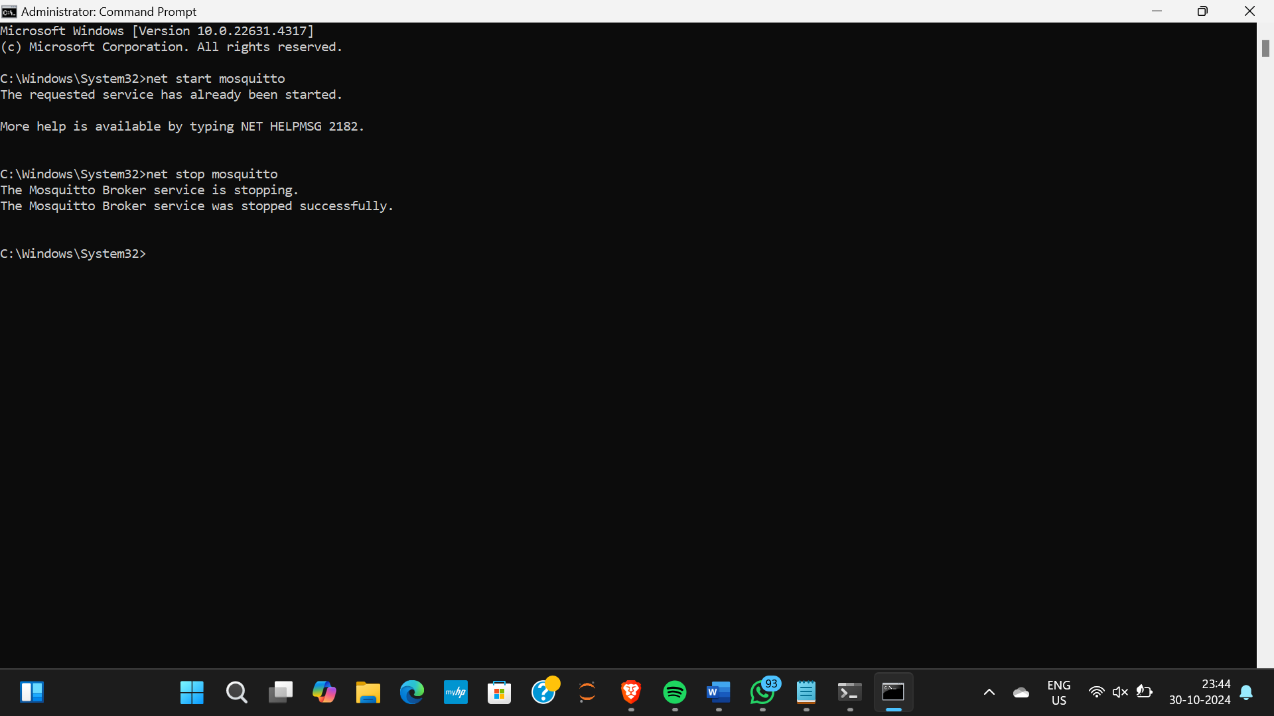 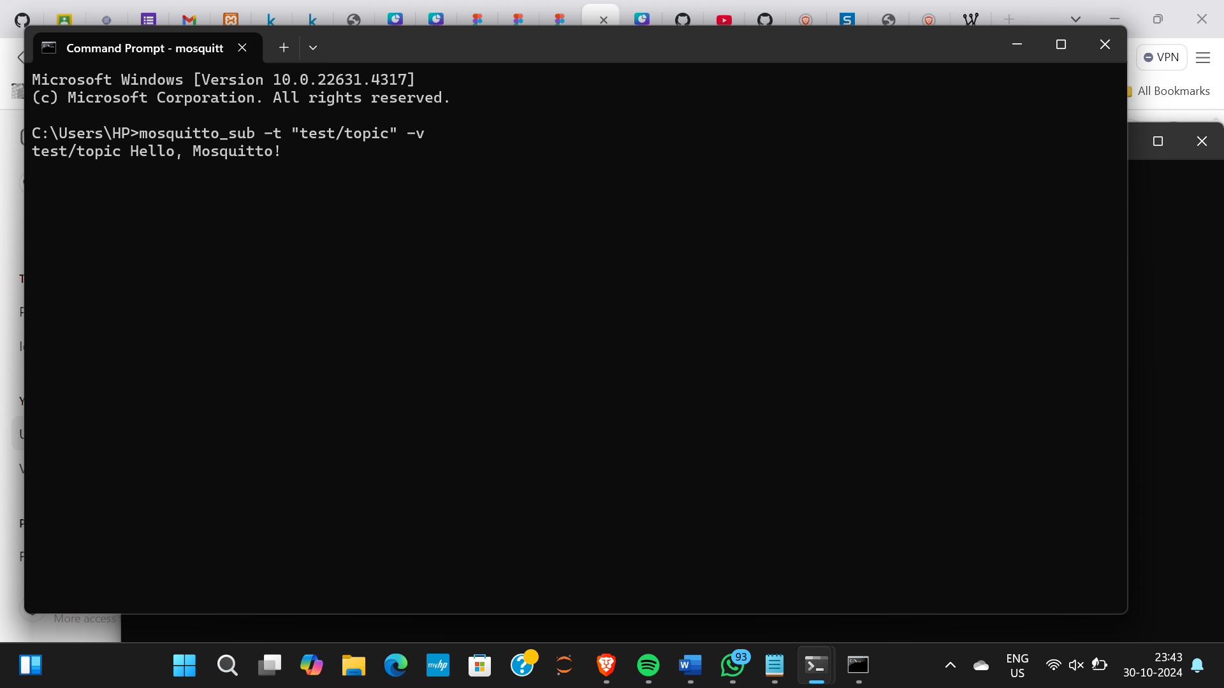 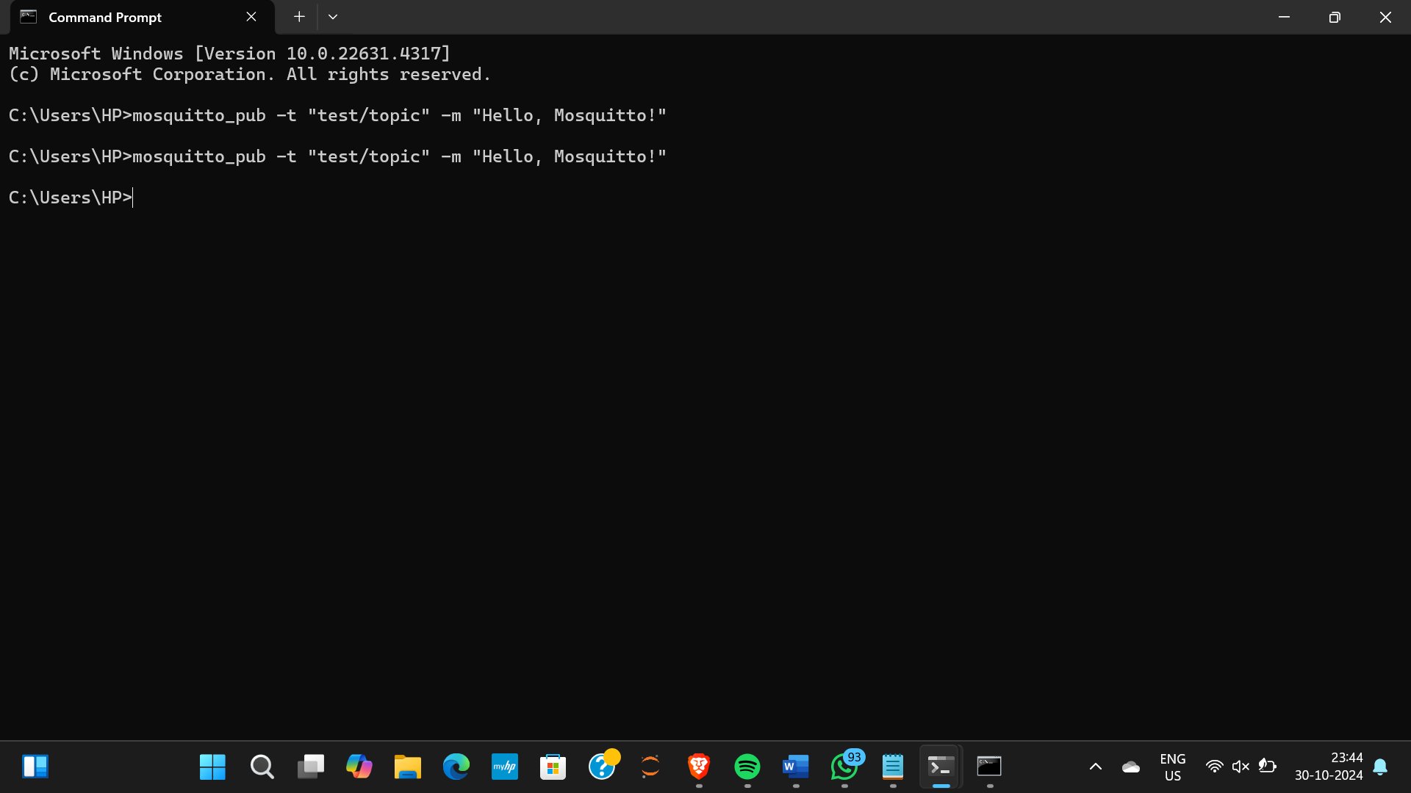

Lab#5

Realtime DHT Sensor Data on NodeRED 🀄

Install Node.js :

Installed NodeJS from Official Eclipse Page [ ].

Added node.js to the System Environment Variables which allows us to use npm commands directly in the Command Prompt or, Terminal.

Installing & Initialising NodeRED:

Open Node.js > npm install node-red-dashboard

[PostInstallation] > Elevated CMD: node-red

In Client Application, browsed http://127.0.0.1:1880/ [ Accessing NodeRED ]

Inside the NodeRED window, a flow was created w/ the nodes as:

            > SERIAL-IN ( Arduino Uno R3 Board )

            > DEBUGGER

            > DHT FUNCTION

            > 2 GAUGES ( Humidity & Temperature )

Serial In Node: Configured it to read from the correct serial port where my Arduino is connected (e.g., COM7) > Set the baud rate to 9600.

Configure the DHT Function as:

var m = msg.payload.split(',');

if (m.length === 2) {

var H = { payload: parseFloat(m[0]) };

            var T = { payload: parseFloat(m[1]) };

            return [H, T];

} else {

return null; }

Adjusting Gauge Nodes:

Humidity:

        - Title as “Humidity ”.

        - Value format as ‘ {{value}}% ’.

        - Range Value: 0 ~ 100 %.

Temperatue:

        - Title as ' Temperature '.

        - Value format as ‘ {{value}}°C ’.

**Ensure that Humidity & Temperature are in the same group.

Deployment:

Uploaded DHT11 /22 Sketch to the Arduino Board through its IDE:

#include <DHT.h>

#define DHTPIN 3

#define DHTTYPE DHT11

DHT dht(DHTPIN, DHTTYPE);

void setup() {

Serial.begin(9600);

dht.begin();

}

void loop()  {

float H = dht.readHumidity();

float T = dht.readTemperature();

if (isnan(H) || isnan(T)) {

Serial.println("Failed to read from DHT sensor!");

} else {

Serial.println(String(H) + "," + String(T));

}

delay(2000);

}

After uploading this sketch, close the IDE.

Deploy the flow in NodeRED.

Check the Dashboard in the upper-right corner, for the Humidity and Temperature Gauge.

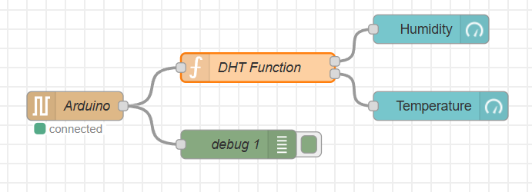

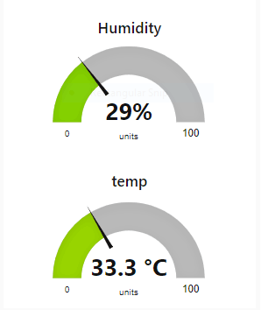

Lab#6

Arduino Project: Button, LED & Ultrasonic Sensor (HC-SR04)

Components Needed

Arduino UNO R3

Push Button

LED

Ultrasonic Sensor (HC-SR04)

Jumper Wires

Breadboard (optional)

Wiring Instructions

Button Connection

Connect two jumper wires diagonally to the button.

Wire 1: Connect one wire to Digital Pin 2.

Wire 2: Connect the other wire to GND.

LED Connection

Connect the LED to the board:

Anode (Longer leg, +ve): Connect to Digital Pin 13.

Cathode (Shorter leg, -ve): Connect to GND.

Ultrasonic Sensor Connection

Connect the HC-SR04 sensor:

VCC: Connect to 5V.

Trigger: Connect to Digital Pin 9.

Echo: Connect to Digital Pin 8.

GND: Connect to GND.

Sketches

Step 1: Button Functionality

Upload the following sketch to the Arduino IDE to test the button functionality.

const int buttonPin = 2; // Pin where the button is connected

void setup() {

Serial.begin(115200); // Initialize serial communication at 115200 baud

pinMode(buttonPin, INPUT_PULLUP); // Set the button pin as input with internal pull-up resistor

}

void loop() {

int buttonState = digitalRead(buttonPin); // Read the state of the button

if (buttonState == LOW) { // Check if the button is pressed

Serial.println("Button Held!"); // Print message to Serial Monitor

} else {

Serial.println("Button Released!"); // Print message to Serial Monitor

}

delay(500); // Add a small delay to debounce the button

}

Output: Displays "Button Held!" when pressed and "Button Released!" when released.

Step 2: Button + LED

To make the LED blink when the button is pressed, upload the following sketch.

const int buttonPin = 2; // Pin where the button is connected

const int ledPin = 13; // Pin where the LED is connected (built-in LED for most Arduino boards)

void setup() {

pinMode(buttonPin, INPUT_PULLUP); // Set the button pin as input with internal pull-up resistor

pinMode(ledPin, OUTPUT); // Set the LED pin as output

}

void loop() {

int buttonState = digitalRead(buttonPin); // Read the state of the button

if (buttonState == LOW) { // Check if the button is pressed

digitalWrite(ledPin, HIGH); // Turn the LED on

delay(500); // Wait for 500 milliseconds

digitalWrite(ledPin, LOW); // Turn the LED off

delay(500); // Wait for 500 milliseconds

} else {

digitalWrite(ledPin, LOW); // Ensure the LED stays off when the button is not pressed

}

}

Output: The external LED blinks every 500 ms while the button is held.

Step 3: Ultrasonic Sensor

To measure distance with the HC-SR04 sensor, upload the following sketch.

#define PIN_TRIG 9 // Define the pin for the trigger

#define PIN_ECHO 8 // Define the pin for the echo

void setup() {

Serial.begin(9600); // Initialize serial communication at 9600 baud

pinMode(PIN_TRIG, OUTPUT); // Set the trigger pin as output

pinMode(PIN_ECHO, INPUT); // Set the echo pin as input

}

void loop() {

// Start a new measurement:

digitalWrite(PIN_TRIG, HIGH); // Set the trigger pin high

delayMicroseconds(10); // Wait for 10 microseconds

digitalWrite(PIN_TRIG, LOW); // Set the trigger pin low

// Read the result:

int duration = pulseIn(PIN_ECHO, HIGH); // Read the duration of the pulse from the echo pin

// Calculate distance in centimeters:

Serial.print("Distance in CM: ");

Serial.println(duration / 58); // Print the distance in centimeters

// Calculate distance in inches:

Serial.print("Distance in inches: ");

Serial.println(duration / 148); // Print the distance in inches

delay(1000); // Wait for 1 second before taking the next measurement

}

Output: Displays distance in centimeters and inches.

Step 4: HC-SR04 + Button Integration

Finally, to integrate the ultrasonic sensor and button functionality, upload the following sketch.

#define PIN_TRIG 9 // Define the pin for the trigger

#define PIN_ECHO 8 // Define the pin for the echo

#define buttonPin 2 // Define the pin for the button

void setup() {

Serial.begin(9600); // Initialize serial communication at 9600 baud

pinMode(PIN_TRIG, OUTPUT); // Set the trigger pin as output

pinMode(PIN_ECHO, INPUT); // Set the echo pin as input

pinMode(buttonPin, INPUT_PULLUP); // Set the button pin as input with internal pull-up resistor

}

void loop() {

int buttonState = digitalRead(buttonPin); // Read the state of the button

if (buttonState == LOW) { // Check if the button is pressed

// Start a new measurement:

digitalWrite(PIN_TRIG, HIGH); // Set the trigger pin high

delayMicroseconds(10); // Wait for 10 microseconds

digitalWrite(PIN_TRIG, LOW); // Set the trigger pin low

// Read the result:

int duration = pulseIn(PIN_ECHO, HIGH); // Read the duration of the pulse from the echo pin

// Calculate distance in centimeters:

Serial.print("Distance in CM: ");

Serial.println(duration / 58); // Print the distance in centimeters

// Calculate distance in inches:

Serial.print("Distance in Inches: ");

Serial.println(duration / 148); // Print the distance in inches

} else {

Serial.println("Button Released!"); // Print message to Serial Monitor

}

delay(500); // Add a small delay to debounce the button

}

Output: Displays the distance in centimeters and inches when the button is pressed, and shows "Button Released!" when the button is not pressed.

Lab#7

Use of Breadboard

Objective

To understand the functionality and application of a breadboard for building and testing electronic circuits without soldering.

Materials Needed

Breadboard

Jumper wires

LEDs

Resistors (220Ω and 1kΩ)

Power supply (battery or DC power supply)

Arduino (optional, for more complex circuits)

Introduction

A breadboard is a reusable platform for prototyping electronic circuits. It allows components to be easily inserted and connected without soldering. The breadboard consists of a grid of holes, organized into rows and columns, where components can be placed and connected using jumper wires.

Step-by-Step Procedure

Step #1: Understand the Breadboard Layout

Power Rails: The outer rows (usually marked with red and blue) are used for power distribution. The red rail is typically for positive voltage, and the blue rail is for ground (GND).

Terminal Strips: The central area consists of vertical and horizontal strips where components are connected. Each vertical strip is connected internally, allowing components to be linked without jumper wires.

Step #2: Connect Power and Ground

Connect the positive terminal of the power supply to the red power rail.

Connect the negative terminal of the power supply to the blue power rail.

Step #3: Build a Simple LED Circuit

Insert the LED into the breadboard:

Place the long leg (anode) into a hole in the terminal strip.

Place the short leg (cathode) into another hole.

Connect a resistor (220Ω) to the cathode of the LED and then connect the other leg of the resistor to the ground rail (blue).

Connect a jumper wire from the anode of the LED to the positive rail (red).

Step #4: Power the Circuit

Turn on the power supply. The LED should light up, indicating that the circuit is complete and functioning.

Step #5: Experiment with Circuit Modifications

Replace the 220Ω resistor with a 1kΩ resistor and observe the changes in brightness of the LED.

Try adding multiple LEDs in series or parallel and adjust the resistor values accordingly.

Conclusion

Using a breadboard allows for rapid prototyping and testing of electronic circuits. Understanding how to properly use a breadboard is essential for building and experimenting with various electronic components and systems.

Safety Precautions

Ensure that the power supply voltage matches the requirements of the components being used.

Do not exceed the current rating of the breadboard to avoid damage.

Disconnect power before making changes to the circuit.

Lab#8

Setting Up ESP32

Step #1: Install ESP32 Board Package

Open Arduino IDE.

Navigate to File > Preferences.

In the Additional Boards Manager URLs field, paste:

https://dl.espressif.com/dl/package_esp32_index.json

Click OK.

Step #2: Install the ESP32 Board

Go to Tools > Board > Boards Manager.

Search for esp32 by Espressif Systems and click Install.

Step #3: Install CP210x USB-to-UART Driver

Download the CP210x USB-to-UART Bridge VCP Driver from the Silicon Labs website.

Follow installation instructions for your operating system.

Step #4: Configure Arduino IDE for ESP32

Reboot your computer after driver installation.

Connect your ESP32 to your computer via USB.

In Arduino IDE, select the correct COM port (e.g., COM12).

Choose ESP32 Dev Module under Tools > Board.

Note:

While uploading a sketch, press and hold the BOOT button during the upload process for 3-4 seconds after the "Connecting..." message.

Alternatively, hold the BOOT button, press the EN button for 1 second, then release the EN button followed by the BOOT button to enter bootloader mode.

Step #5: Blink the Internal LED

Use the following code in the IDE:

#define LED_PIN 2 // Onboard LED connected to GPIO 2

void setup() {

pinMode(LED_PIN, OUTPUT); // Initialize LED pin as output

}

void loop() {

digitalWrite(LED_PIN, HIGH); // Turn LED on

delay(1000); // Wait 1 second

digitalWrite(LED_PIN, LOW); // Turn LED off

delay(1000); // Wait 1 second

}

Click Upload to upload the code. The internal LED will blink on and off every second.