- Installing Node-RED
Step 1: Install Node.js first
→ Go to nodejs.org
→ Download LTS version
Step 2: Install Node-RED
Use command prompt
# Install Node-RED globally
npm install -g --unsafe-perm node-red
# Verify installation
Node -v
Step 3: Start Node-RED
npm install -g --unsafe-perm node-red
node-red
Step 4: Open in Browser
Open browser -> go to:
http://localhost:1880
5. Installing Node-RED Dashboard,Arduino node & serial port
The dashboard , arduino node and serial port is a separate package
# Method 1: Via Node-RED Editor (Recommended)
Step 1 → Open Node-RED (localhost:1880)
Step 2 → Click top-right menu (☰)
Step 3 → Select "Manage Palette"
Step 4 → Click "Install" tab
Step 5 → Search "node-red-dashboard" , ”Arduino node” , ”Serial port”
Step 6 → Click Install button

6. Components Required for This Lab
Hardware: Arduino uno r3 board , DHT 11/22 sensor , jumper wires , usb cable
Software: Arduino IDE, node.js , node red
- Arduino Code
#include <DHT.h> // Include the DHT sensor library
#define DHTPIN 3 // Pin where the DHT11 sensor is connected
#define DHTTYPE DHT11 // Define the type of DHT sensor (DHT11)
DHT dht(DHTPIN, DHTTYPE); // Initialize the DHT sensor with the specified pin and type
void setup()
{
Serial.begin(9600); // Start the serial communication to send data to the PC
dht.begin(); // Initialize the DHT sensor to start reading data
}
void loop() {
// Read humidity and temperature data from the sensor
float H = dht.readHumidity(); // Read humidity value
float T = dht.readTemperature(); // Read temperature in Celsius
// Check if the sensor readings are valid (not NaN = Not a Number)
if (isnan(H) || isnan(T)) {
Serial.println("Failed to read from DHT sensor!"); // If invalid, print an error message
} else {
// If valid, print the humidity and temperature in a comma-separated format
Serial.println(String(H) + "," + String(T)); // e.g., "45.6,24.3"
}
delay(2000); // Wait for 2 seconds before taking the next reading
}
Write this code in arduino check whether output is nproperly showing or not . after checking close the serial monitor .
9. Building Node-RED Flow – Step by Step
Step 1: Open Node-RED Editor
Browser → http://localhost:1880
Step 2: Add Serial Node
-> From left panel, drag "serialt in" node to canvas
-> Double-click to configure:
Serial port: same as shown in arduino
Bud rate:9600
Name:Arduino uno
→ Click Done
Step 3: Add Function Node (Data Processing)
-> Drag "function" node to canvas
-> Double-click and enter:
// Split the incoming serial data by comma
var m = msg.payload.split(',');
// Ensure the data is properly split and contains two values
if (m.length === 2) {
// Parse the humidity (first value) and temperature (second value)
var H = { payload: parseFloat(m[0]) }; // Humidity
var T = { payload: parseFloat(m[1]) }; // Temperature
// Return humidity and temperature as separate messages
return [H, T];
} else {
// If the data doesn't contain two values, return null to indicate a problem
return null;
}
Write this code in on message dsection and go to setup present atleftest side of on message and set the output to 2.
-> Name it: "Humidity & Temperature"
-> Click Done
Step 4: Add Dashboard Gauge Node
-> Drag "gauge" node (under dashboard section)
-> Double-click to configure:
Group : [Add New Group] “dht sensor”→[add new tab] "Sensor Data"
Label : Temperature
Units : °C
Range : Min 0, Max 100
-> Click Done
Add another gauge node ->
-> Double-click:
Group : [Add New Group] “dht sensor”→[add new tab] "Sensor Data"
Label : Humidity
Units : &
Range : Min 0, Max 100
-> Click Done
Step 6: Add Debug node
Step 7: Connect the Nodes
Serial->debug and function node
Function->gauge
Step 8: Deploy
-> Click red "Deploy" button (top right)
-> All nodes become active
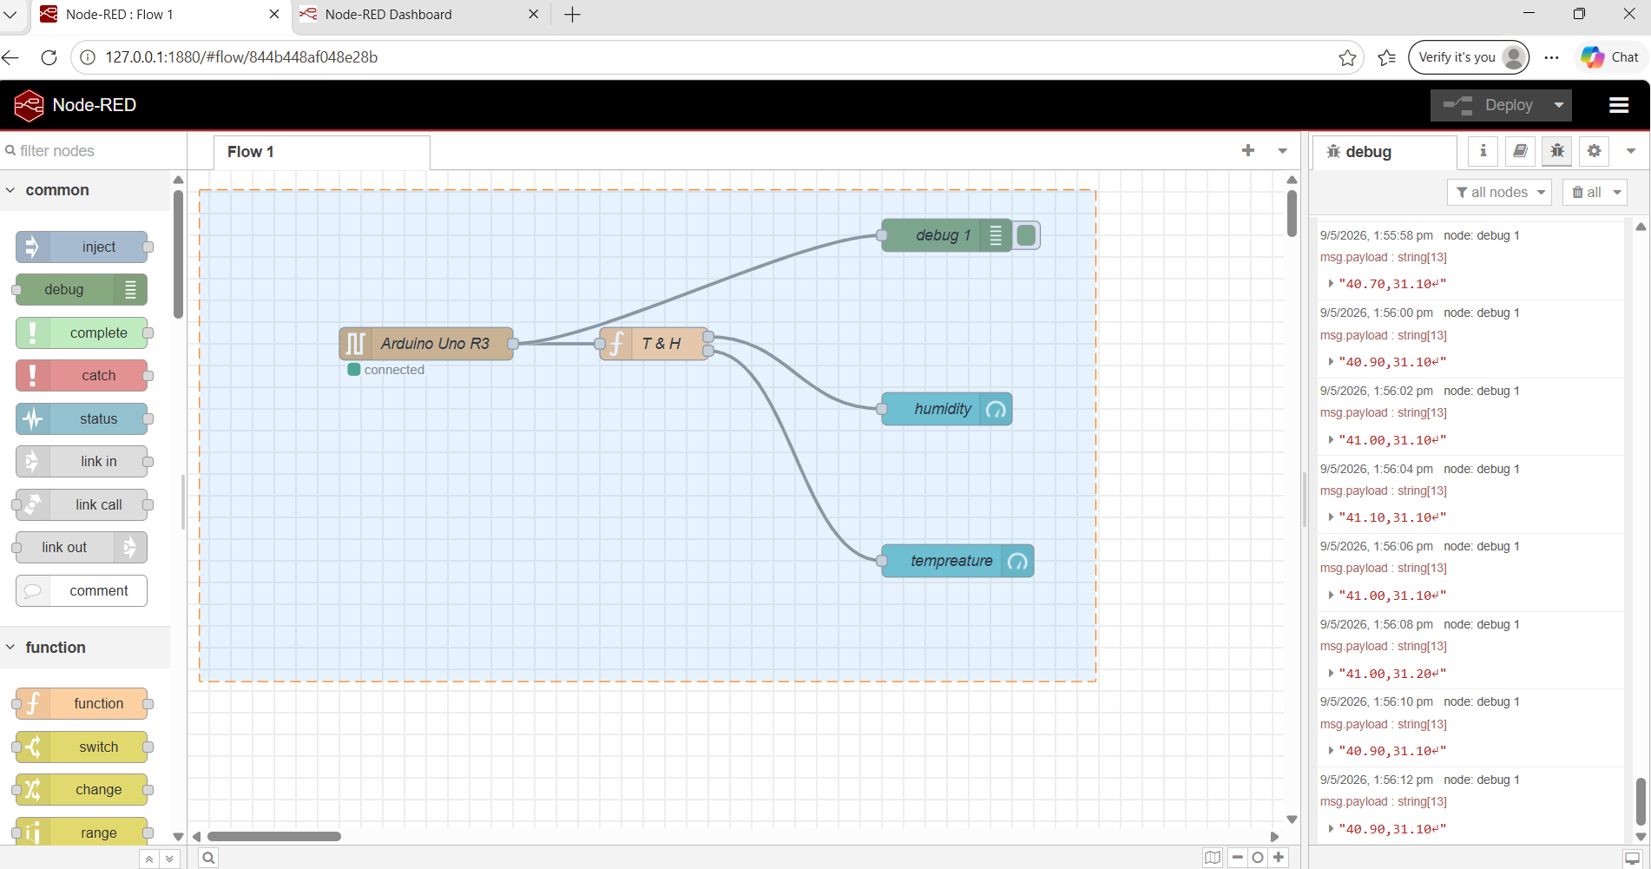

11. Viewing the Dashboard
Step 1 -> After deploying, open browser
Step 2 -> Go to: http://localhost:1880/ui
Step 3 -> You will see the dashboard with:
-> Temperature Gauge (circular dial)
-> 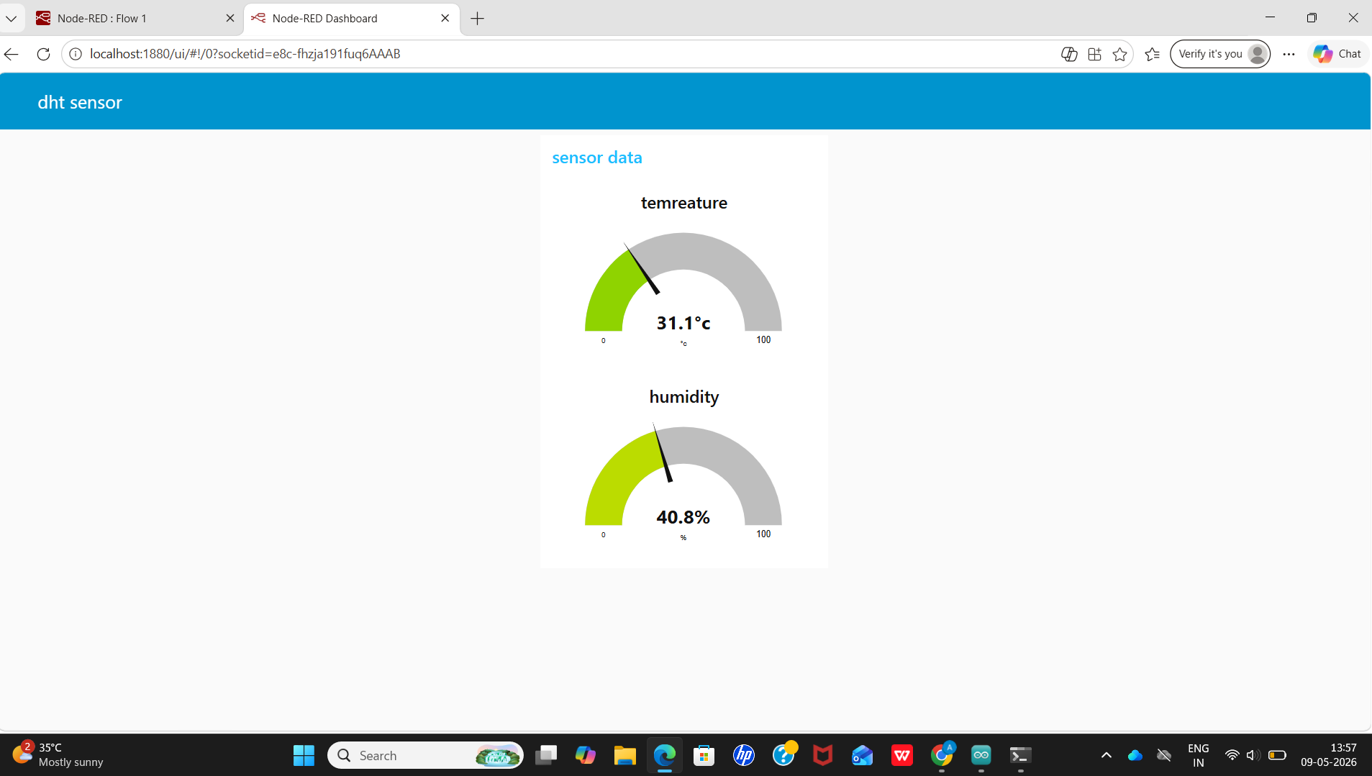Humidity Gauge (circular dial)

