ASSIGNMENT- 4

Arduino UNO R3 Pinout Explanation
The Arduino Uno R3 is one of the most popular microcontroller boards used for electronics and programming projects. Understanding its pinout helps you connect sensors, LEDs, motors, and other components correctly.

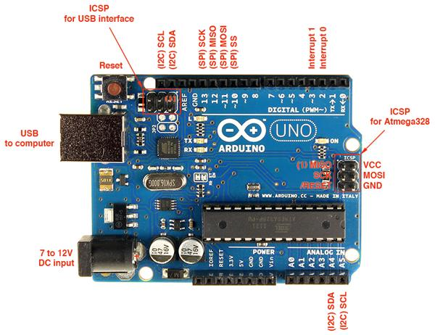 Microcontroller: ATmega328P
Operating Voltage: 5V
Input Voltage: 7–12V
Digital Pins: 14 (0–13)
Analog Pins: 6 (A0–A5)

1.Digital Pins (0–13) :-

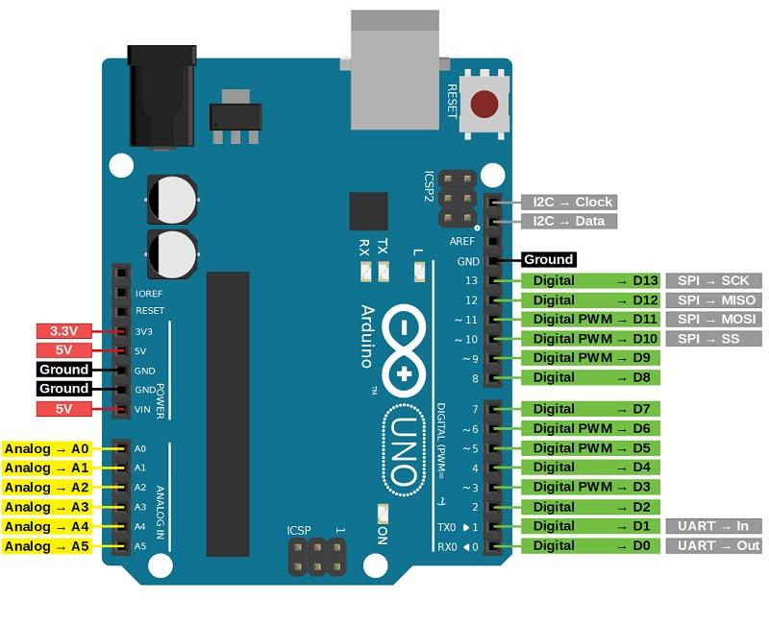
- Pins 0 (RX) & 1 (TX) → Serial communication
- PWM Pins (3, 5, 6, 9, 10, 11) → Used for analog-like output (e.g., LED brightness)
- Each pin can act as input or output

2. Analog Pins (A0–A5) :-

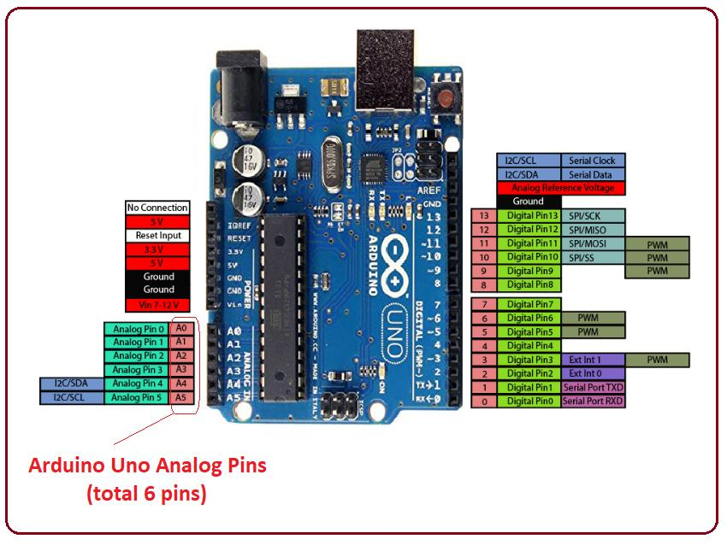

Used to read analog signals (range: 0–1023).

Example:
- Reading a sensor (temperature, light, etc.)
- Connecting a potentiometer
- 3. Power Pins :-

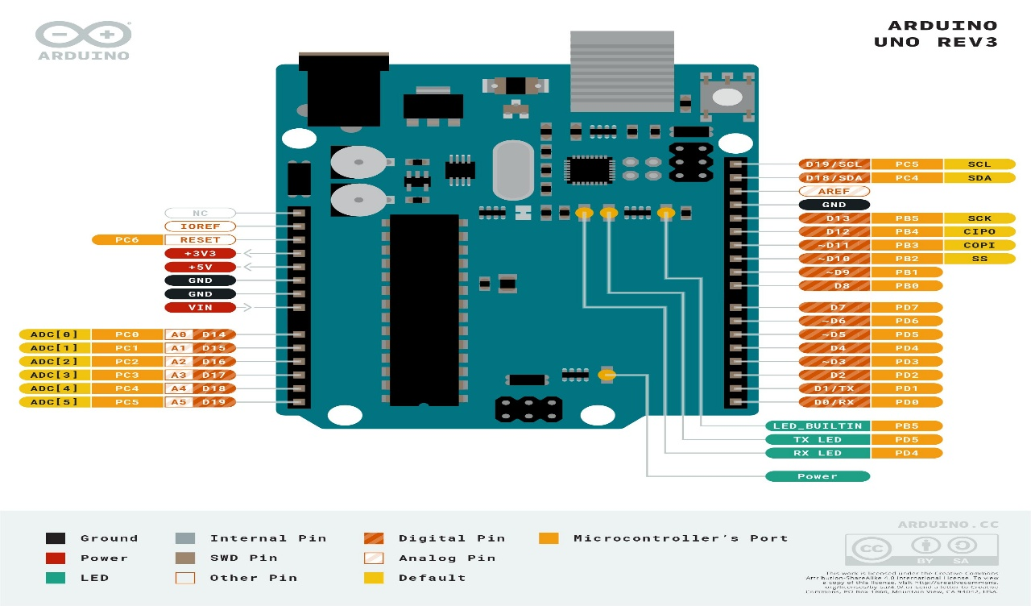
These pins provide power to the board and components.
Important Pins:
- 5V → Provides 5V output
- 3.3V → Provides 3.3V output
- GND → Ground (very important)
- VIN → External power input

4. Special Function Pins:-
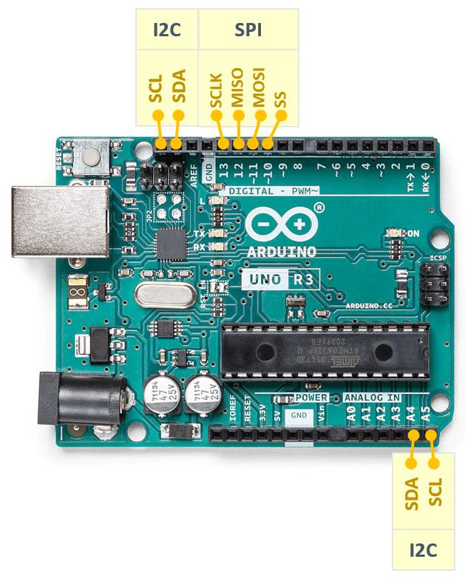

Communication Pins:
- I2C → A4 (SDA), A5 (SCL)
- SPI → Pins 10 (SS), 11 (MOSI), 12 (MISO), 13 (SCK)
Other:
- AREF → Analog reference voltage
- RESET → Restarts the board

5. Other Components on Board
- USB Port → For programming and power
- DC Power Jack → External power supply
- Reset Button → Restart program
- Crystal Oscillator → Provides clock (16 MHz)

