Assignment-1

Analyze the transition from Machine-to-Machine (M2M) communication to the Internet of Things (IoT).

I)Definition of M2M and IoT :-
a) Machine-to-Machine (M2M)
M2M means devices communicate directly with each other without human involvement.
It usually uses point-to-point communication (like sensors sending data to a central server).
Example: A vending machine sending stock data to a company server.
b) Internet of Things (IoT)
IoT is a network of connected devices (things) that collect, share, and analyze data using the internet.
It includes devices, cloud, software, and analytics.
Example: Smart home devices like smart lights, thermostats, etc.

II)Differences Between M2M and IoT :-
Feature | M2M | IoT
Connectivity | Direct (device-to-device) | Internet-based
Communication | Limited | Global & scalable
Data Usage | Basic data transfer | Advanced data analytics
Architecture | Closed systems | Open, flexible systems
Human Interaction | Minimal | High (apps, dashboards)
Example | ATM network | Smart home system

III)Vision of IoT and Global Context
The vision of IoT is to create a fully connected world where:
->Devices, people, and systems are interlinked
->Data is used to automatically improve life

Used in:
Healthcare (remote monitoring)
Transport (smart traffic systems)
Industry (automation, Industry 4.0)
Environment (climate monitoring)
Goal:
Make systems smarter, efficient, and automated at a global scale.

IV) Key Characteristics of IoT Systems
- Connectivity
Devices connect via internet (Wi-Fi, 5G, etc.)
- Sensing & Data Collection
Sensors gather real-world data (temperature, motion, etc.)
- Intelligence
Data is analyzed to make smart decisions
- Automation
Systems act without human intervention
- Scalability
Can support millions of devices
- Interoperability
Different devices work together

V) Real-World Use Case: Smart Agriculture
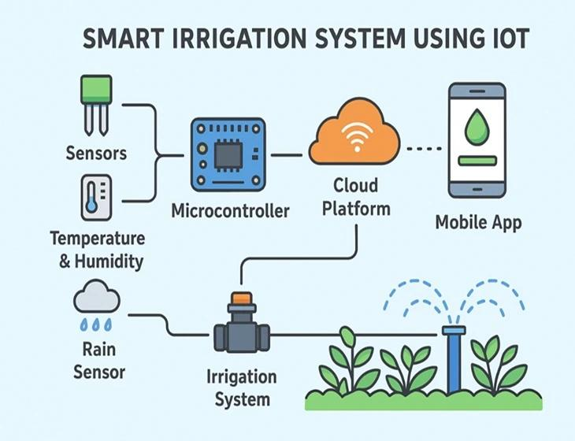

How IoT is Used:
a) Sensors measure:
->Soil moisture
-> Temperature
->Humidity
b) Data is sent to cloud platforms
c) Farmers monitor fields using mobile apps
Benefits:
Automatic irrigation (water only when needed)
Better crop yield
Reduced water waste
Real-time monitoring

