ASSIGNMENT-2

Biometric Face Recognition Attendance System (Real-Time Experience) :-

What is a Biometric Face Recognition Attendance System?
A Biometric Face Recognition Attendance System is a system that uses a person’s face as identity to automatically mark attendance.
Instead of:
- Signing a register
- Using ID cards
- Entering passwords
The system detects and recognizes your face and marks you present.

How the System Works (Step-by-Step)

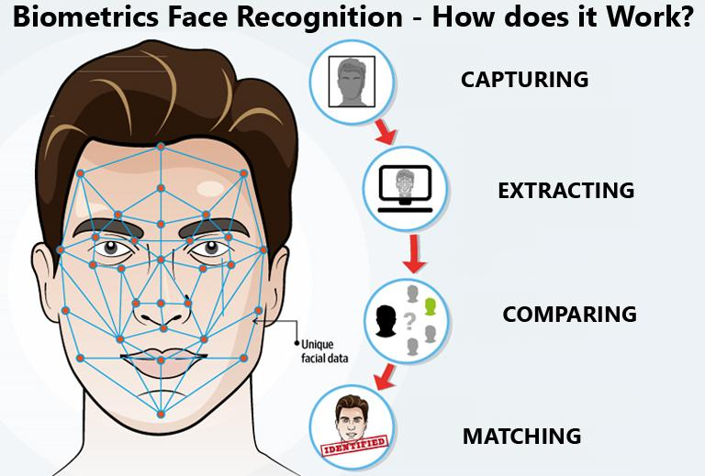

- Face Enrollment (Registration Phase)

The user’s face is captured using a camera
Multiple images are stored
The system converts face into digital features (face encoding)
These are saved in a database with name/ID

2.Real-Time Face Detection
- A camera continuously captures video
- The system detects faces in each frame
- It draws a box around detected faces

3.Face Recognition
- The detected face is compared with stored data
- If a match is found → identity is confirmed
- If not → marked as unknown
4. Attendance Marking
- The system records:
  - Name
  - Date
  - Time
- Attendance is stored in:
  - Database
  - Excel/CSV file
Technologies Used
- Computer Vision → Detect faces (OpenCV)
- Machine Learning / AI → Recognize faces
- Deep Learning models → High accuracy
- Database → Store user data
- Camera/Webcam → Capture real-time input

Example (Real-Time Flow)
- Student enters classroom
- Camera scans face instantly
- System matches with stored data
- Attendance marked automatically
- Duplicate entries are avoided

Advantages
- Fast and automatic
- No proxy attendance (hard to cheat)
- Contactless (hygienic)
- Real-time tracking
- Saves time and effort

Limitations
- Needs good lighting
- Accuracy may drop with masks or changes in appearance
- Privacy concerns
- Requires proper setup (camera + system)

