ABOUT THE APPLICATION:

The Load Balancer Decision System is a sophisticated application designed to optimize the distribution of tasks across multiple load balancers using advanced Q-Learning algorithms. This system aims to enhance decision-making processes in load balancing by employing reinforcement learning techniques, ensuring that tasks are allocated efficiently and effectively. The application offers a user-friendly graphical interface built with PyQt5, providing a seamless experience for users to input task parameters, make predictions, and visualize performance metrics such as accuracy, precision, and ROC curves.

Key features of the application include model training, real-time prediction capabilities, and comprehensive visualization tools that help users understand the system's performance. Additionally, the application supports batch processing of data, allowing users to process large datasets efficiently. It also includes a comparison feature that enables users to evaluate different load balancing algorithms, helping them choose the most effective strategy for their specific needs.

The ultimate goal of the Load Balancer Decision System is to provide an intelligent and adaptive solution for resource allocation, ensuring optimal performance and reliability in distributed systems. By leveraging the power of Q-Learning, the application can dynamically adjust to changing conditions, making it a valuable tool for managing complex load balancing scenarios.

GITHUB REPOSITORY :
https://github.com/DebmalyaRay9989/Load_Balancer_Decision_System_mlops --- GITHUB REPOSITORY

APPLICATION GUI :

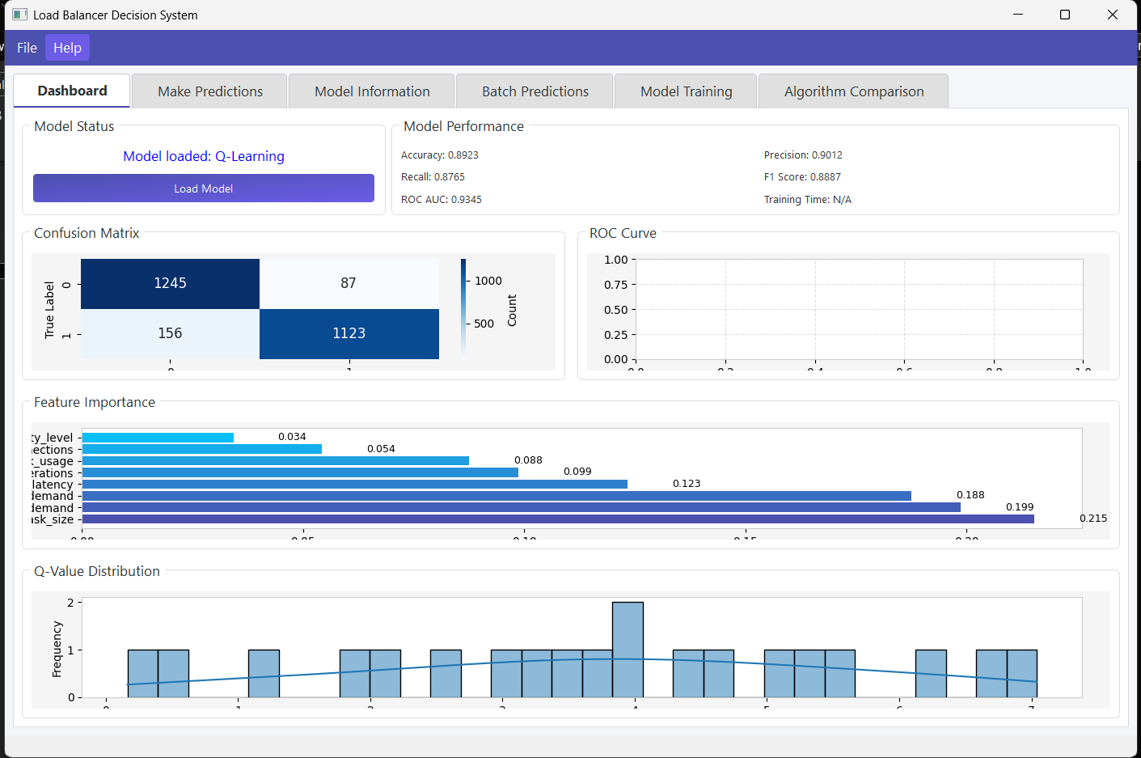
TREE STRUCTURE:

