Revolutionizing Wireless Communication: AComprehensive ReviewofFractalAntennas

Kunal Routh^{1*}, Jishnu Ray¹, Sutapa Ray¹, Aparna Biswas¹

¹Department of Electronics & Communication Engineering, Institute of Engineering & Management
Kolkata, India

*Corresponding author email:kunalrouth714@gmail.com

Abstract: Antennas are an integral component of contemporary wireless communication systems and are essential for sending and receiving electromagnetic signals. Antennas play a crucial role in a wide array of applications, including various communication systems such as cellular and satellite communications. Advancing antenna research is essential for enhancing Mobile Communication, improving wireless Local Area Networks (WLAN), increasing communication range, and enabling new applications. In recent decades, Fractal antennas have revolutionized the field of antenna design, marking a transformative breakthrough in engineering, offering unique solutions to modern challenges. This review delves into the fascinating properties of space-filling and self-similarity, which make fractal antennas highly effective for reducing antenna size and enabling operation across multiple frequency bands. It provides a comprehensive overview of fractal antennas, focusing on their underlying principles, design strategies, performance metrics, and diverse applications.

Keywords: Fractal antenna, FSS, Miniaturization, IOT Communication, 5G Communication, Satellite Communication,

INTRODUCTION

In today's interconnected world, the need for efficient and adaptable wireless communication systems is more critical than ever. Whether it's smart phones, satellites, IoT communication, the smooth exchange of data across expansive networks forms the foundation of modern life. Central to this digital transformation is the antenna—a vital component that facilitates the propagation of electromagnetic waves, driving the seamless connectivity we rely on daily. Among all the antenna designs that have emerged over the years, one stands out for its remarkable properties and versatility the Fractal antenna [1] [2][3].

Fractal antennas have their foundations in the revolutionary research of mathematicians Waclaw Sierpinski and Benoît B. Mandelbrot in the second half of the 20th century. Their insights into the self-similar, recursive structures led to the development to fractal geometry, which subsequently found its way into their antenna design [4].

Each antenna has a unique structure that is necessary for it to function. Here, antenna elements are subjected to fractal geometries of compact size and multi band behavior. The use of Fractal antenna arrays allows improving multi beam and multiband features due to their cursive nature of fractals [11][12][13].The Fractal antenna represent the optimum solution for the problem that an antenna need to be designed for a particular operating frequency [5][6][7].In the last decade, growth in the development of flexible devices and sensors, which can monitor and transmit vital signals in various body-worn applications such as health monitoring and geo-positioning of rescue or military personnel, etc., has led the foundation of wireless body area network (WBAN) [1]. Numerous frequency bands have been developed for exploration and commercialization of WBAN communication systems, such as the ultra-wideband 3.1–10.76 GHz, the Industrial, Scientific, and Medical (ISM) band 2.4–2.48 GHz, the Medical Implant Communication Services band 402–405 MHz [15].On increasing the range of wireless and satellite communication system, the technology antenna were require with wider bandwidth and compact length antenna than traditional antenna [1]. Researchers have long pursued advancements to meet evolving requirements in antenna technology. Dr. Nathan Cohen pioneered the development of the first fractal antenna in 1988, dedicating his efforts to refining this innovative technology. In 1995, he established Fractal Antenna Systems to expand his research into commercial and military applications [2], marking a significant milestone in the field. He has a renowned designer in the fractal antenna sector. It met all of the user's needs in terms of small size, increased bandwidth, affordability, and simplicity of fabrication. Two drawbacks of conventional antennas are addressed by fractal antennas [3]. 1. The electrical size of the antenna, including its parameter, gain, input impedance, and radiating pattern, affects its performance. It decreases the size of the antenna by extending the fractal antenna's effective length. Numerous applications, including wireless communication and the military, have made use of it [17].

I. Design of absorptive/transmissive frequency-selective surface based on parallel resonance.

One type of fractal antenna arrangement is called FSS (Frequency Selective Surface). Wideband and band transmission are crucial FSS features. The various forms of frequency wideband are referred to as FSS in this research. To provide multi-band band pass filtering responses, the parallel LC resonator-based FSS structure element is suggested. The simulated and measured results are rather close and align with the transmission. There are some errors of measured and simulated result due to fabrication or soldering [8].

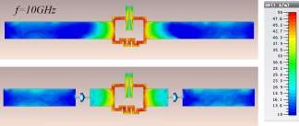
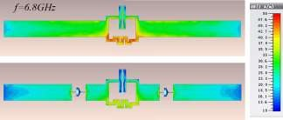

( a ) ( b )

Fig.1: Surface current distribution on dipole elements with PLC lumped resistors at two resonance frequencies (a)10 GHz and (b) 6.8 GHz

II. A frequency-selective surface Rabsorber based on four functional layers.



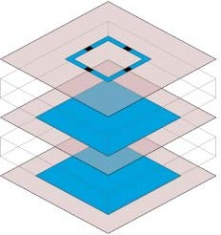




Fig.2: Element of the TA R absorber (The dimensions: p1=20mm, R1=80ohm. W11=0.8mm, l11=6.4mm, p2=20mm, l21=13mm, h1=6mm, h2=8mm).

The structure of the Fractal Antenna FSS (Frequency Selective Surface) consists of four layers. Two of these serve as transmission layers, while the other two function as absorption layers .The layers can be used to generate low pass and band pass transmission in frequency selective surface R absorber the measured result and simulated result closely maintain reasonable agreement [14]. The prototype was also constructed and tested to validate the design. The functional four layers are very good choice to be the measured transmission and absorption is nearly closed with simulation result [12][15].

Active Frequency Selective Surface with wide reconfigurable pass band
The Active Frequency Selective Surface (AFSS) is also defined with the wide reconfigurable pass band. The reissued varacator diode to tune the pass band and stop band of RFSS. Varactor diode allows to tune the two band applying voltage [16][17]. In the measured results, the pass band decreases, and as the voltage and varacator diode increase, the simulation results show a corresponding decrease in the pass band. Then the measure result and simulation result will agree well to each other and also maintain reasonable agreement [9] [10].

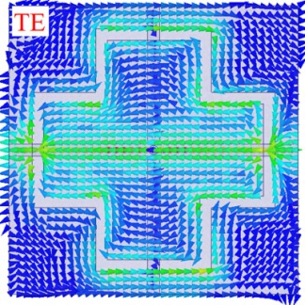
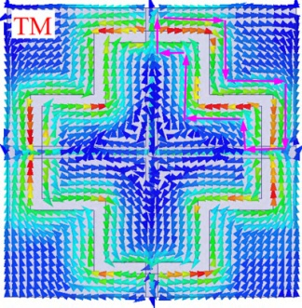

( a )
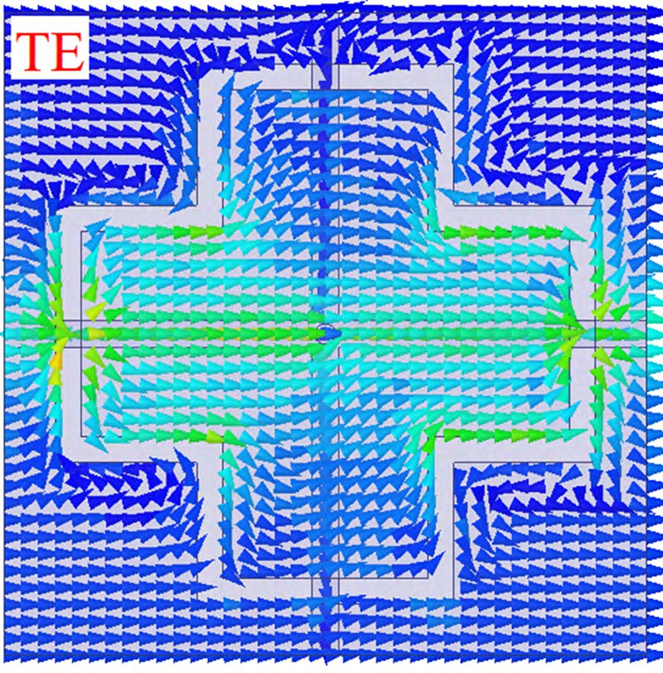


Fig.3: Current distribution under oblique incidence at 30deg. (a) 6.4 GHz. (b) 8 GHz

IV. A Surface Based Reconfigurable R absorber (Frequency selective) With Switchable Transmission Band.

Fractal antennas come in various configurations, including frequency selective surfaces (FSS) and resistive surfaces (FRS), both of which are widely utilized in advanced electromagnetic applications. The working principle of these configurations is fundamentally Depending on the configuration of repeating layers and the specific type of surface employed. Among these, an innovative design combining both types of selective surfaces has been developed—a frequency-selective surface (FSS) and a resistive surface-based reconfigurable absorber capable of switchable transmission and reflection. This dual-functionality design highlights the versatility and adaptability of the system for diverse applications.
The uniqueness of the proposed design resides in its adaptable reflection band, which enables dynamic control over electromagnetic wave behaviour. By strategically adjusting the periodic layers and integrating advanced switching mechanisms, the absorber transitions between different operational states, allowing it to selectively reflect or transmit electromagnetic waves based on the requirements. This makes the proposed reconfigurable absorber an ideal candidate for a wide range of applications, particularly in radar cross-section (RCS) reduction, where controlling wave reflections is critical to achieving stealth and reducing detect ability.
To verify the concept, a single prototype was constructed and experimentally evaluated. The prototype demonstrated reliable and consistent performance in achieving the desired reconfigurable reflection properties. The experimental results showed strong agreement with simulated data, confirming the robustness and practicality of the design. This reconfigurable absorber offers a high degree of adaptability, making it suitable for applications in radar systems, adaptive electromagnetic shielding, and stealth technology.
Overall, the proposed design represents a significant step forward in the field of frequency selective surfaces. Its ability to dynamically reconfigure its reflection band, combined with its proven performance in RCS reduction, highlights its potential for integration into next-generation radar and communication systems.
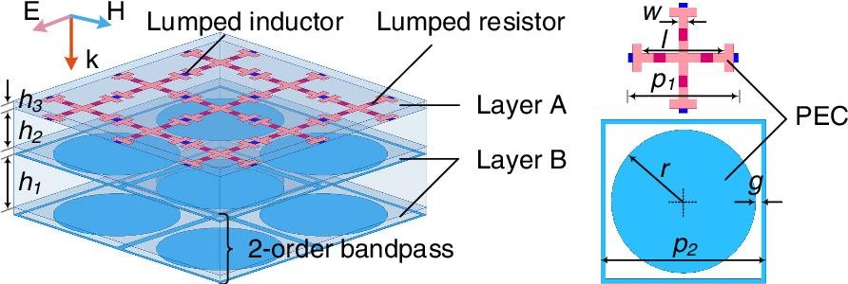

Fig.4: Frequency selective absorber with switchable transmission band.

V. Frequency-Selective R asorber Based on Centro symmetric Bended-Strip Resonator.

The proposed design focuses on frequency selective absorbers (FSRs) based on a Centro symmetric bended strip resonator, showcasing a unique structural approach to achieving precise absorption and transmission characteristics. To evaluate the performance and reliability of the design, two prototypes were fabricated and tested under controlled conditions. These prototypes, denoted as T-A FSR (Transmission-to-Absorption FSR) and A-T FSR (Absorption-to-Transmission FSR), were meticulously developed to demonstrate the dual functionalities of the proposed FSR system. By incorporating the Centro symmetric bended strip resonator into the design, the FSRs effectively manipulate electromagnetic waves, enabling tailored absorption or transmission responses. This adaptability is particularly advantageous for applications requiring dynamic control of electromagnetic energy, such as stealth technology, electromagnetic interference (EMI) mitigation, and advanced communication systems. The fabricated prototypes underwent extensive measurement and testing processes to analyze their performance characteristics. These tests were conducted in optimized conditions to ensure accuracy and reliability. The measured results closely matched the simulated outcomes, indicating strong alignment between theoretical predictions and experimental observations. Such agreement underscores the robustness and validity of the design, providing confidence in its practical applicability. The results clearly illustrate the FSRs’ ability to deliver reliable performance, affirming their potential in real-world scenarios. Furthermore, the Centro symmetric design offers structural symmetry, which contributes to consistent electromagnetic behavior across varying conditions. This structural advantage, combined with the excellent agreement between measured and simulated results, highlights the effectiveness of the proposed FSRs in achieving precise absorption and transmission control. Overall, the innovative design of these frequency selective absorbers represents a significant advancement in electromagnetic engineering, offering promising opportunities for applications in adaptive filtering, energy harvesting, and wave manipulation technologies.

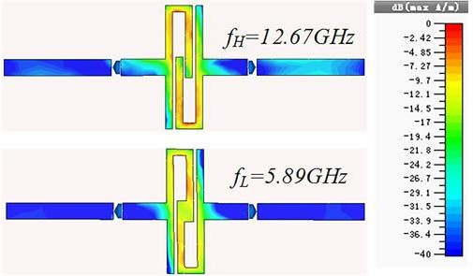

Fig.5: Distribution of surface current in the resistive sheet layers at 12.67 GHz and 5.89 GHz.

VI. Fully Reconfigurable absorber with Enhanced Absorption Bandwidth and Simplified Bias Network.

The proposed design revolves around a fully reconfigurable frequency selective absorber (R-absorber), an innovative approach aimed at achieving enhanced absorption bandwidth while maintaining a simplified and efficient bias network. This absorber is meticulously engineered to offer frequency configurability without compromising its performance, making it a versatile solution for modern electromagnetic applications. The emphasis on a streamlined biasing system ensures reduced complexity and potential fabrication challenges, all while preserving the high performance of the R-absorber across its operational frequency range.
The key feature of this design lies in the enhanced absorption bandwidth, which is crucial for ensuring the absorber’s effectiveness across a broader spectrum of frequencies. By carefully optimizing the structure and electrical configuration, the design achieves superior absorption characteristics that cater to dynamic and diverse operational requirements. The simplified bias network, a critical innovation in this design, ensures that the switching and configurability of the absorber can be managed efficiently without introducing additional losses or negatively impacting its electromagnetic properties.
To validate the performance of the R-absorber, a fully fabricated prototype was developed and subjected to experimental testing. These experimental assessments demonstrated a close alignment between the simulated and measured results, demonstrating the reliability and robustness of the design. The close agreement underscores the practical feasibility of the absorber, confirming that its theoretical performance translates effectively to real-world applications.
This design represents a significant advancement in frequency-selective absorbing materials, offering a combination of wideband absorption, reconfigurability, and simplified control systems. Such characteristics make it suitable for applications in electromagnetic interference (EMI) mitigation, radar cross-section (RCS) reduction, and adaptive shielding in communication systems. By addressing the challenges of complex biasing while achieving high performance, this R-absorber sets a benchmark for future developments in the field of reconfigurable electromagnetic materials.
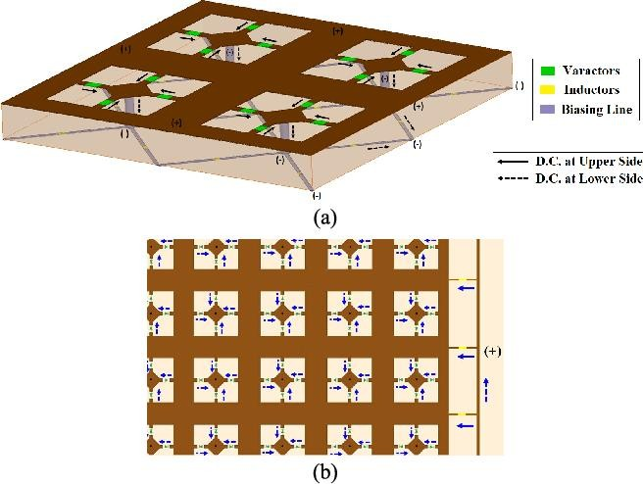

Fig.6: Arrangement of biasing (a)unit-cell,(b)array’s topside.

VII. Compact and Low Profile Antenna.

The proposed antenna design represents an innovative solution for flexible, body-worn devices, combining compactness, high performance, and adaptability. Central to the design is a reduction in structural stiffness to increase flexibility, achieved using a defected ground structure (DGS). By incorporating truncated corners and meandering slits into the ground plane, the DGS enhances impedance matching and broadens the bandwidth (BW), ensuring optimal performance. This makes the antenna suitable for dynamic environments, particularly in wearable technology.
The design process involved rigorous optimization to balance size and performance, resulting in a micro strip-based Koch fractal antenna integrated with a DGS. Operating within the 2.40–2.48 GHz ISM band, the antenna delivers the desired BW cantered at 2.45 GHz, with a reliable radiation pattern and satisfactory front-to-back ratio (FBR). This ensures stable operation for wireless communication in wearable applications.
The top layer of the antenna features a modified equilateral triangular copper patch incorporating Koch fractal geometry up to the second iteration. This geometry enhances miniaturization and performance. Additionally, four meandering slits further optimize flexibility and radiation efficiency. The patch is fed through a 50 Ω impedance inset feed line, ensuring effective energy transfer.
The bottom layer includes a copper defected ground plane, with six meandering slits and truncated corners reducing mutual coupling and enhancing BW. The antenna's overall dimensions are 39 × 39 × 0.508 mm³, corresponding to 0.318λ₀ × 0.318λ₀ × 0.004λ₀, making it highly compact and efficient.
This innovative combination of fractal geometry and DGS addresses the dual challenges of miniaturization and performance, making the antenna ideal for body-conformal applications. Its compact size, flexibility, and robust performance make it a standout choice for wearable wireless devices in the ISM band.

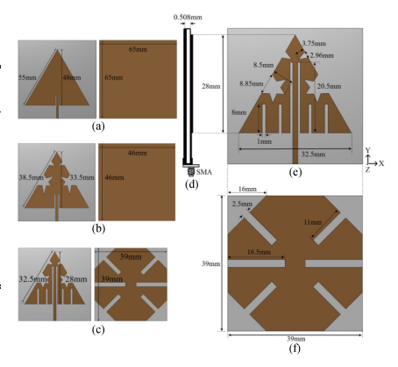

Fig.7 Initial and final antenna topology for the proposed design. (a) Simple MSA. (b) Koch modified MSA. (c) Final modified MSA. (d) Side view. (e) Top view. (f) Bottom view.

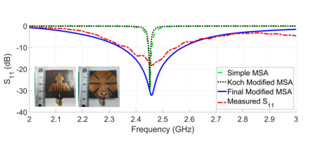
Fig.8 Simulated and measured return loss of the proposed design.

The mechanical structure under study has a crucial constant that directly influences its performance, primarily by affecting its stiffness and flexibility. A reduction in structural stiffness leads to an increase in flexibility, which has implications for its functional adaptability, particularly in dynamic or body-worn applications. The flexibility is achieved through specific design strategies, including the introduction of a defected ground structure (DGS). This design modification helps improve the bandwidth (BW) by engineering the ground plane with geometric adjustments such as truncated corners and the inclusion of meandering slits. These features enhance the performance of the structure by facilitating better impedance matching and widening the operational bandwidth, as highlighted in [27] and [28].
Design and Optimization Process
Figure 1 illustrates the transition from the initial to the finalized structure, achieved through a rigorous optimization process. This process involved a trade off analysis between minimizing the antenna's size and maximizing its bandwidth percentage. The outcome of this optimization is a micro strip-based Koch fractal antenna integrated with a defected ground structure, demonstrating superior characteristics.
The proposed design achieves an operational bandwidth of 2.40–2.48 GHz, precisely tailored to function within the 2.45 GHz Industrial, Scientific, and Medical (ISM) band. This bandwidth is critical for applications requiring consistent performance in wireless communication systems, particularly in flexible, body-worn devices. The design also ensures a good radiation pattern and satisfactory front-to-back ratio (FBR), making it highly suitable for wearable technology.

VIII. Shape wise Analysis of Fractal Antennas.

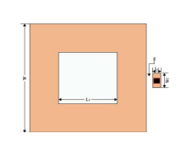
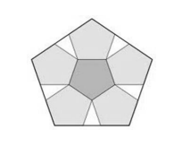


Fig. 9.Koch fractal geometry on Fig.10. Durer pentagon . Fig.11. Fractal slot on patch.
hexagon patch.

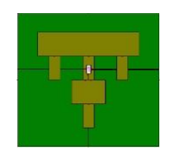
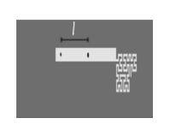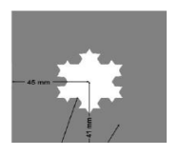
Fig.12. IFA using Hilbert geometry. Fig.13.T shape fractal patch. Fig.14. Koch curve fractal on ground.
Table 1: Comparative Analysis of Literature Review
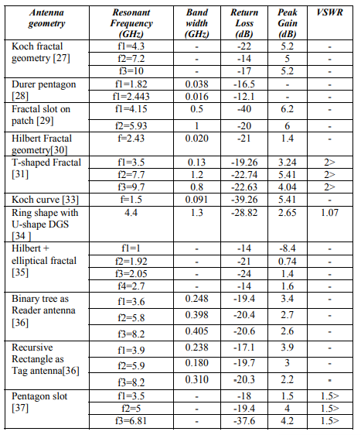

IX. Fractal antenna potential applications in Wireless Communication Systems.
The paper by Bhatt et al. [18] surveys ultra-wideband (UWB) fractal antenna designs, focusing on their potential applications in wireless communication systems. It explores the advantages of fractal geometries, such as compact size, multiband operation, and improved impedance matching, which enhance the efficiency and versatility of antennas in UWB systems. The study reviews various fractal designs, including Sierpinski and Koch geometries, and discusses their performance metrics, including bandwidth, gain, and radiation patterns. The authors emphasize the significance of UWB fractal antennas in emerging technologies like wireless sensing and broadband communication, highlighting their adaptability for modern wireless network requirements.
Zainud-Deen, Malhat, and Awadalla [19] present a study on fractal antenna designs tailored for passive Ultra-High Frequency (UHF) RFID applications. The paper highlights the advantages of fractal geometries, such as miniaturization, multiband operation, and improved impedance matching, which are critical for compact and efficient RFID systems. The authors propose a novel fractal antenna design optimized for RFID tags, focusing on performance metrics like gain, radiation patterns, and polarization. Simulation and experimental results demonstrate the antenna's suitability for passive UHF RFID, with enhanced read range and flexibility. The study underscores fractal antennas as a promising solution for advanced RFID applications.
Sadie et al. [20] propose an innovative epsilon-shaped fractal antenna for Ultra-Wideband (UWB) Multiple-Input Multiple-Output (MIMO) applications, emphasizing its compactness and high performance. The antenna design leverages fractal geometry to achieve enhanced bandwidth, gain, and radiation efficiency, catering to the requirements of modern UWB systems. The authors address challenges like mutual coupling and interference in MIMO systems through strategic placement and decoupling structures. Simulation and experimental results confirm the antenna's capability for UWB operation with stable radiation patterns and low envelope correlation. The study highlights the epsilon-shaped fractal antenna as a robust and efficient solution for next-generation MIMO communication systems.
CONCLUSION
Fractal antennas represent an innovative and intriguing field of research with the potential to transform antenna design and RF engineering. By leveraging the unique properties of fractal geometries—such as self-similarity, scalability, and space-filling capabilities—these antennas offer exceptional benefits, including miniaturization, multi-band operation, and enhanced bandwidth performance. These features make fractal antennas particularly well-suited for addressing the growing demands of modern wireless communication systems, where compactness, versatility, and high efficiency are paramount. The field of fractal antennas is not just limited to theoretical advancements but is also paving the way for practical applications in diverse and emerging technologies. For instance, their integration into next-generation communication systems like 5G promises to support high data rates and low latency in compact devices. Similarly, their adoption in the Internet of Things (IOT) can enable efficient, multi-functional connectivity in devices ranging from smart sensors to wearable electronics. In space-based communication systems, the scalability and robustness of fractal antennas are highly advantageous for satellite applications, where compact and lightweight designs are critical.
Furthermore, advancements in materials science and fabrication techniques, such as 3D printing and flexible substrates, are unlocking new possibilities for creating fractal antennas with improved performance and adaptability. These developments, combined with the potential for seamless integration into hybrid systems, are expanding the scope of fractal antennas into fields like biomedical devices, smart grids, and autonomous vehicles.This paper, by analysing the core concepts, design principles, and recent advancements in fractal antennas, aims to provide researchers and engineers with valuable insights and perspectives. It encourages further exploration and experimentation in this fascinating domain, with the goal of overcoming current limitations and unlocking the full potential of fractal antenna technology to meet the needs of evolving and future communication systems.

References

- Chen, Q., Yang, S., Bai, J., & Fu, Y. (2017). Design of absorptive/transmissive frequency- selective surface based on parallel resonance. IEEE Transactions on Antennas and Propagation, 65(9), 4897-4902.

- Ye,H.,Wei,J.,Lin,L.,Liu,F.,Miao,L.,Bie,S.,&Jiang, J. (2020). A frequency-selective surface Rasorber based on four functional layers.IEEETransactionsonAntennasandPropagation,69(5),2768-2778.

- Guo, Q., Li, Z., Su, J., Song, J., & Yang, L. Y.(2019).Activefrequencyselectivesurfacewithwidereconfigurablepassband.IEEEAccess, 7,38348-38355.

- Bakshi, S. C., Mitra, D., & Ghosh, S. (2018). Afrequencyselectivesurfacebasedreconfigurablerasorberwithswitchable transmission/reflection band. IEEE Antennas andWirelessPropagationLetters,18(1),29-33.

- Guo, M., Sun, Z., Sang, D., Jia, X., & Fu, Y. (2019). Design of frequency-selective rasorbersbasedoncentrosymmetricbended-stripresonator. IEEEAccess,7, 24964-24970.

- Bakshi, S. C., Mitra, D., & Teixeira, F. L. (2020).FSS-based fully reconfigurable rasorber with enhancedabsorption bandwidth and simplified bias network. IEEETransactionsonAntennasandPropagation, 68(11),7370-7381.

- Bakshi, S. C., Mitra, D., & Teixeira, F. L. (2020).FSS-based fully reconfigurable rasorber with enhancedabsorption bandwidth and simplified bias network. IEEETransactionsonAntennasandPropagation, 68(11),7370-7381.

- Fan, J. A., Yeo, W. H., Su, Y., Hattori, Y., Lee, W., Jung, S. Y., ... & Rogers, J. A. (2014). Fractal design concepts for stretchable electronics. Nature communications, 5(1), 3266.

- Azari, A. (2011). A new super wideband fractal microstrip antenna. IEEE transactions on antennas and propagation, 59(5), 1724-1727.

- Darimireddy, N. K., Reddy, R. R., & Prasad, A. M. (2018). A miniaturized hexagonal-triangular fractal antenna for wide-band applications [antenna applications corner]. IEEE Antennas and Propagation Magazine, 60(2), 104-110.

- Ghali, H., &Moselhy, T. A. (2004). Miniaturized fractal rat-race, branch-line, and coupled-line hybrids. IEEE Transactions on Microwave Theory and Techniques, 52(11), 2513-2520.

- Madhav, B. T. P., Anilkumar, T., &Kotamraju, S. K. (2018). Transparent and conformal wheel-shaped fractal antenna for vehicular communication applications. AEU-International Journal of Electronics and Communications, 91, 1-10.

- Hwang, K. C. (2007). A modified Sierpinski fractal antenna for multiband application. IEEE antennas and wireless propagation letters, 6, 357-360.

- Rahim, A., & Malik, P. K. (2021). Analysis and design of fractal antenna for efficient communication network in vehicular model. Sustainable Computing: Informatics and Systems, 31, 100586.

- Arif, A., Zubair, M., Ali, M., Khan, M. U., &Mehmood, M. Q. (2019). A compact, low-profile fractal antenna for wearable on-body WBAN applications. IEEE Antennas and Wireless Propagation Letters, 18(5), 981-985.

- Chitra, R. J., &Nagarajan, V. (2016, April). Design and development of koch fractal antenna. In 2016 International Conference on Communication and Signal Processing (ICCSP) (pp. 2294-2298). IEEE.

- Khanna, G., & Sharma, N. (2016). Fractal antenna geometries: A review. International Journal of Computer Applications, 153(7), 29-32.

- Bhatt, S., Mankodi, P., Desai, A., & Patel, R. (2017, January). Analysis of ultra wideband fractal antenna designs and their applications for wireless communication: A survey. In 2017 International Conference on Inventive Systems and Control (ICISC) (pp. 1-6). IEEE.

- Zainud-Deen, S., Malhat, H. A. E. A., &Awadalla, K. (2009). Fractal antenna for passive UHF RFID applications. Progress In Electromagnetics Research B, 16, 209-228.

- Sediq, H. T., Nourinia, J., Ghobadi, C., &Mohammadi, B. (2022). An epsilon-shaped fractal antenna for UWB MIMO applications. Applied Physics A, 128(9), 845.

