A PROJECT REPORT ON
DESIGN AND PCB IMPLEMENTATION OF A 12 V TO 5 V BUCK (STEP-DOWN) DC-DC CONVERTER
Submitted in partial fulfilment of the requirements for the award of the degree of
BACHELOR OF TECHNOLOGY
in Electrical / Electronics Engineering
Submitted by
[Student Name] | Roll No.: [XXXXXXXX]
[Student Name] | Roll No.: [XXXXXXXX]
Under the guidance of
[Guide Name], [Designation]
Department of Electrical / Electronics Engineering
[College / University Name], [City]
Academic Year 2026-27

CERTIFICATE
This is to certify that the project report entitled “Design and PCB Implementation of a 12 V to 5 V Buck (Step-Down) DC-DC Converter” is a bonafide record of the work carried out by [Student Name(s)], bearing Roll No(s). [XXXXXXXX], in partial fulfilment of the requirements for the award of the degree of Bachelor of Technology in Electrical / Electronics Engineering of [College / University Name], during the academic year 2026-27.
The work embodied in this report has not been submitted to any other university or institute for the award of any degree or diploma.

Project Guide Head of Department
[Guide Name] [HOD Name]
External Examiner: ______________________

ACKNOWLEDGEMENT
We would like to express our sincere gratitude to our project guide, [Guide Name], for the valuable guidance, constant encouragement, and technical suggestions that helped us complete this project successfully. His/her insight into power electronics and PCB design practices greatly shaped the direction of this work.
We are thankful to the Head of the Department and all the faculty members of the Department of Electrical / Electronics Engineering for providing the laboratory facilities, components, and measuring instruments needed for fabrication and testing of the converter.
We also thank the laboratory staff for their assistance during soldering and testing, and our friends and family for their support throughout the project.
[Student Name(s)]

ABSTRACT
Almost every digital and embedded system needs a regulated 5 V supply, while the available source is often a 12 V battery, adapter, or automotive supply. A linear regulator such as the 7805 can perform this conversion, but it burns the 7 V difference as heat; at 2 A that is 14 W of waste, which demands a large heat sink and gives efficiency of only about 42 percent. A switching buck converter solves this problem by chopping the input at high frequency and filtering the result with an inductor and capacitor, so that very little energy is dissipated.
This project presents the design, simulation-level analysis, PCB layout, fabrication, and testing of a 12 V to 5 V buck converter built around the LM2596-5.0 simple switcher regulator. The converter is designed to deliver 2 A continuously (3 A maximum) from an input range of 9 V to 15 V at a switching frequency of 150 kHz. Component values were obtained analytically: a 33 µH inductor, a 220 µF low-ESR output capacitor with a 10 µF ceramic in parallel, a 470 µF input capacitor, and a 3 A / 40 V Schottky diode.
A compact two-layer FR4 board of about 50 mm × 35 mm was designed in KiCad with a small switching loop, a continuous ground plane, and a thermal copper pour under the regulator. The expected efficiency is 80 to 84 percent at mid-to-full load, with output ripple below 50 mV peak-to-peak. The report documents the theory, calculations, schematic, layout rules, bill of materials, test procedure, and result tables, and discusses limitations and possible future improvements such as synchronous rectification and over-voltage protection.
Keywords: buck converter, DC-DC, LM2596, PCB design, switching regulator, efficiency, ripple, KiCad.

TABLE OF CONTENTS

CHAPTER 1: INTRODUCTION

1.1 Background
Electronic circuits are designed around specific supply voltages. Microcontrollers, sensors, USB devices, single-board computers, and logic ICs are commonly powered from 5 V, whereas the energy source available in vehicles, solar systems, industrial panels, and many adapters is 12 V. A power conversion stage is therefore needed between the source and the load. The quality of this stage affects the efficiency, heating, size, noise, and reliability of the complete product.
Two families of DC-DC step-down regulators are widely used: linear regulators and switching regulators. Linear regulators are simple and quiet but dissipate power equal to (Vin − Vout) × Iout. Switching regulators, of which the buck converter is the most common, transfer energy in small packets using an inductor, and hence achieve efficiencies of 80 to 95 percent.

1.2 Problem Statement
To design and build a compact, low-cost, efficient DC-DC converter that steps a nominal 12 V input down to a regulated 5 V output capable of supplying 2 A continuously, using a standard switching regulator IC and a properly laid out printed circuit board.

1.3 Objectives
- To study the operating principle of the buck converter in continuous conduction mode.
- To calculate the inductor, capacitors, and diode ratings for a 12 V to 5 V, 2 A converter.
- To draw the schematic and design a two-layer PCB following good switching-power layout practice.
- To fabricate and assemble the board and test it for line regulation, load regulation, ripple, efficiency, and temperature rise.
- To compare measured performance with the theoretical design values and with a linear regulator.

1.4 Scope and Limitations
The design covers a single fixed 5 V output, a 9 V to 15 V input range, and loads up to 3 A. It does not include galvanic isolation, reverse-polarity protection beyond a series diode option, or digital monitoring. The converter uses an asynchronous topology (a diode instead of a second MOSFET), which is simple and inexpensive but slightly less efficient than a synchronous design at low output voltages.

1.5 Methodology
- Literature review of buck converter theory and the LM2596 datasheet.
- Specification of input, output, ripple, and efficiency targets.
- Analytical design of the power stage.
- Schematic capture and electrical rule check (ERC) in KiCad.
- PCB placement, routing, and design rule check (DRC).
- Fabrication, assembly, and testing.
- Analysis of results and documentation.

1.6 Organisation of the Report
Chapter 2 reviews the relevant literature and compares regulator types. Chapter 3 explains the operating theory and derives the design equations. Chapter 4 presents the detailed component calculations. Chapter 5 describes the hardware selection and schematic. Chapter 6 deals with the PCB design. Chapter 7 covers fabrication, assembly, and testing. Chapter 8 discusses results, losses, and thermal behaviour. Chapter 9 lists applications, advantages, limitations, and future scope, and Chapter 10 concludes the report.

CHAPTER 2: LITERATURE REVIEW

2.1 Linear Regulators
A linear regulator such as the LM7805 acts as a variable resistor in series with the load. It senses the output voltage and adjusts its pass element to hold the output constant. The input current equals the load current, so the power loss is simply (Vin − Vout) × Iout. For 12 V to 5 V at 1 A the loss is 7 W, which already requires a sizeable heat sink. The advantages are low noise, simplicity, and very few external parts.

2.2 Switching Regulators
Switching regulators operate a transistor as a switch, which is either fully on (low voltage drop) or fully off (no current), so the transistor itself dissipates little power. Energy is stored temporarily in an inductor and released to the load, and the average output is controlled by the duty cycle. The main topologies are the buck (step-down), boost (step-up), buck-boost (inverting or step up/down), flyback, and forward converters. For a 12 V to 5 V requirement the buck converter is the natural choice.

2.3 Comparison of Regulator Types
Table 1: Linear regulator versus buck converter for 12 V to 5 V at 2 A
Parameter | LM7805 (linear) | LM2596 (buck)
Efficiency | ≈ 42 % | 80 - 84 %
Power dissipated | ≈ 14 W | ≈ 2.3 W
Heat sink | Large, mandatory | Small copper pour
Output noise | Very low | Ripple 20 - 50 mV
EMI | Negligible | Needs layout care
External parts | 2 capacitors | L, D, 2 caps (min.)
Maximum current | 1 A (typ.) | 3 A
Cost | Very low | Low

2.4 Review of Available Buck Controller ICs
Several integrated regulators are available for the 12 V to 5 V application. The LM2596 has been popular for many years because it integrates a 3 A power switch, oscillator, reference, and protection in a TO-220 or TO-263 package. The MP1584 and MP2307 are smaller and operate at higher frequency, permitting smaller inductors. The LM2678 and TPS5430 offer higher efficiency. Synchronous parts such as the TPS54331 or MP2315 further reduce loss by replacing the diode with a MOSFET.
Table 2: Comparison of candidate buck regulator ICs
IC | Iout (A) | Vin max (V) | fsw | Remarks
LM2596 | 3 | 40 | 150 kHz | Simple, robust, external diode
LM2678 | 5 | 40 | 260 kHz | Higher current, higher cost
MP1584 | 3 | 28 | 1.5 MHz | Very small, tiny inductor
TPS5430 | 3 | 36 | 500 kHz | Better efficiency
MP2315 | 3 | 24 | 500 kHz | Synchronous, SMD only

The LM2596 was chosen for this project because it is available in a hand-solderable package, is tolerant of layout imperfections at its modest 150 kHz switching frequency, has good documentation, and supports the required 3 A rating with a fixed 5 V output version that needs no feedback resistors.

2.5 Summary
The literature shows that for a 12 V to 5 V conversion at 2 A, a buck converter offers roughly double the efficiency of a linear regulator and eliminates the heat sink. The price paid is switching ripple and electromagnetic interference, which must be controlled through correct component selection and PCB layout.

CHAPTER 3: THEORY OF THE BUCK CONVERTER

3.1 Basic Block Diagram
The complete system consists of an input filter capacitor, the switching regulator with its internal power switch and control circuit, a freewheeling diode, an LC output filter, and the load. The feedback path sends the output voltage back to the controller, which adjusts the duty cycle to keep the output at 5 V.
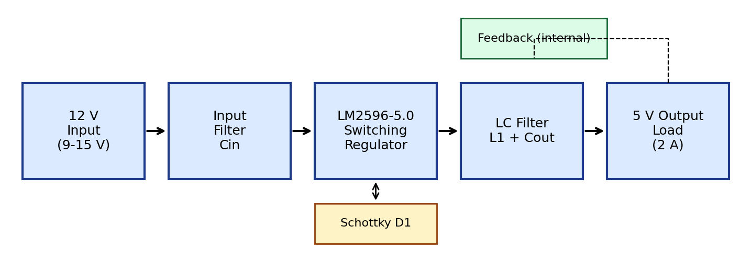
Fig. 1: Block diagram of the 12 V to 5 V buck converter

3.2 Operating Principle
The buck converter alternates between two circuit states within each switching period T = 1/fsw, which is 6.67 µs at 150 kHz.
Mode 1: switch ON (0 < t < DT). The switch connects the input to the inductor. The voltage across the inductor is Vin − Vout, which is positive, so the inductor current rises linearly and energy is stored in its magnetic field. The diode is reverse biased. The load current is supplied by both the source and the output capacitor.
Mode 2: switch OFF (DT < t < T). The switch opens, but the inductor current cannot change instantly. The switch-node voltage swings negative until the Schottky diode becomes forward biased and provides a path. The inductor now sees −Vout across it, so its current decays linearly while it delivers energy to the load.
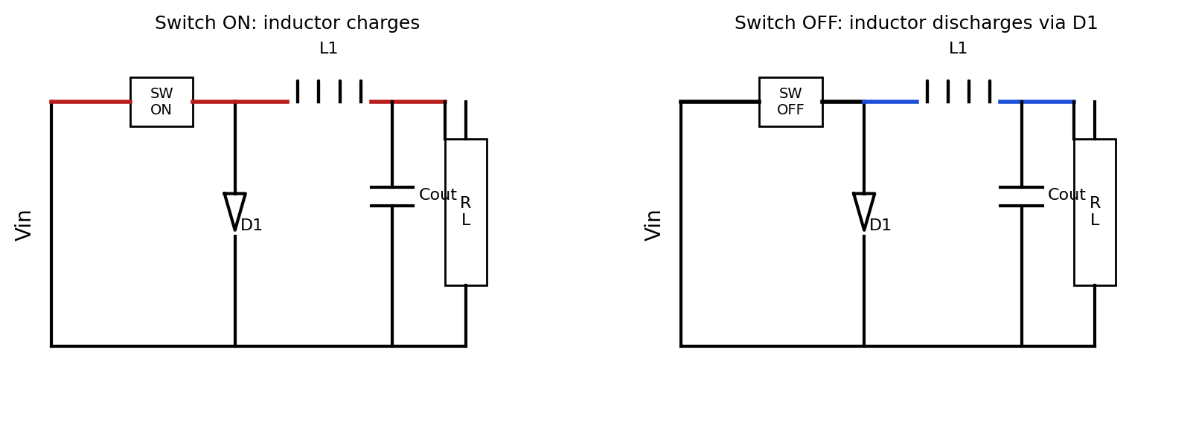
Fig. 2: Equivalent circuits for switch ON and switch OFF intervals

3.3 Continuous Conduction Mode
If the inductor current never falls to zero during the switching cycle, the converter operates in continuous conduction mode (CCM). In CCM the volt-second balance of the inductor requires that the average inductor voltage over one period equals zero:
(Vin − Vout) · D·T = Vout · (1 − D)·T (3.1)
Solving for the output voltage gives the ideal conversion ratio:
Vout = D · Vin ⇒ D = Vout / Vin (3.2)
For Vin = 12 V and Vout = 5 V, the ideal duty cycle is D = 5/12 = 0.417. Because the output can be changed only downward by adjusting D between 0 and 1, the buck converter is able to produce any voltage lower than the input.

3.4 Inductor Current Ripple
During the ON interval the inductor current rises by:
ΔIL = (Vin − Vout) · D / (L · fsw) (3.3)
The average inductor current equals the load current. The peak current is therefore Iout + ΔIL/2, and the valley current is Iout − ΔIL/2. The boundary between continuous and discontinuous conduction occurs when ΔIL = 2·Iout, i.e. when the valley current reaches zero. The LM2596 operates in CCM at heavy load and may enter discontinuous mode at very light load, which is acceptable because its control loop remains stable.
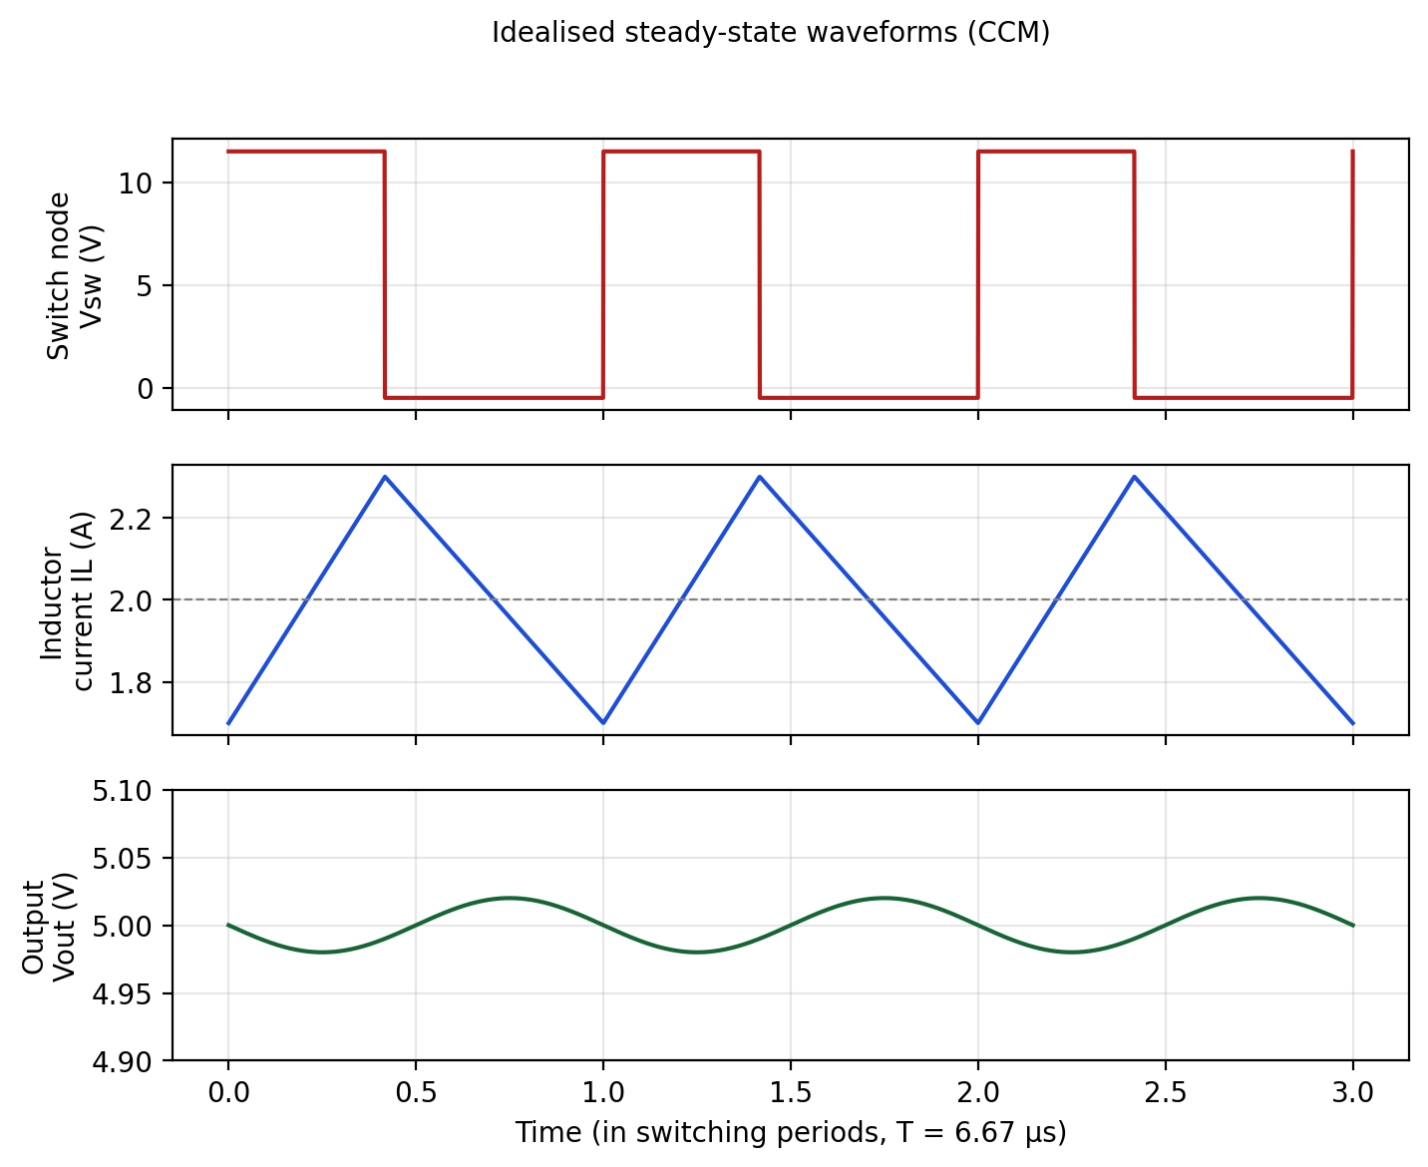
Fig. 3: Idealised steady-state switch-node voltage, inductor current, and output voltage

3.5 Output Voltage Ripple
The ripple current ΔIL flows into the output capacitor (the load takes the average value). The resulting voltage ripple has two parts: a capacitive component and a component caused by the equivalent series resistance (ESR):
ΔVout ≈ ΔIL / (8 · fsw · Cout) + ΔIL · ESR (3.4)
For electrolytic capacitors the ESR term usually dominates, which is why low-ESR capacitor types are recommended for switching supplies.

3.6 The LM2596 Regulator
The LM2596 is a monolithic integrated circuit that provides all the active functions of a step-down regulator. Its important features are listed below.
- Fixed 3.3 V, 5 V, 12 V, and adjustable versions; the 5 V version is used here.
- Output current up to 3 A with excellent line and load regulation.
- Input voltage range 4.5 V to 40 V.
- Fixed internal oscillator of 150 kHz, allowing small filter components.
- Internal compensation, so no external loop network is needed.
- Thermal shutdown and current-limit protection.
- ON/OFF pin for standby; typical standby current about 80 µA.
- TO-220 and TO-263 (surface-mount) packages.
It is a voltage-mode, asynchronous regulator, so an external Schottky diode is required. Pins are VIN (1), OUTPUT (2), GROUND (3), FEEDBACK (4), and ON/OFF (5). The tab of the TO-263 package is connected to ground and serves as the main heat path to the PCB.

3.7 Why a Schottky Diode
The freewheeling diode carries the full load current for 58 percent of every cycle. A Schottky diode has a forward drop of only about 0.4 to 0.5 V compared with 0.7 to 1 V for an ordinary silicon diode, and it has practically zero reverse-recovery charge. This lowers conduction loss and avoids sharp current spikes that would create EMI. The reverse voltage rating must exceed the maximum input voltage with margin; 40 V is adequate for a 15 V input.

CHAPTER 4: DESIGN CALCULATIONS

4.1 Design Specifications
Table 3: Design specifications
Parameter | Symbol | Value
Nominal input voltage | Vin | 12 V
Input voltage range | Vin(min) - Vin(max) | 9 V - 15 V
Output voltage | Vout | 5 V
Rated output current | Iout | 2 A (3 A maximum)
Switching frequency | fsw | 150 kHz
Inductor ripple current | ΔIL | 30 % of Iout = 0.6 A
Output ripple target | ΔVout | < 50 mV peak-to-peak
Target efficiency | η | > 80 %
Output power | Pout | 10 W

4.2 Duty Cycle
The ideal duty cycle at nominal input is:
D = Vout / Vin = 5 / 12 = 0.417 (4.1)
Including the diode drop (Vf = 0.45 V) and the switch saturation voltage (Vsat ≈ 1.0 V at 2 A), the practical duty cycle is:
D = (Vout + Vf) / (Vin − Vsat + Vf) = 5.45 / 11.45 ≈ 0.476 (4.2)
At the extremes of the input range the duty cycle varies from about 0.37 at 15 V to 0.64 at 9 V, so the converter always works well within the controller’s duty range.

4.3 Inductor Selection
The ripple current is chosen as roughly 30 percent of the load current, a common compromise between inductor size and ripple. For Iout = 2 A:
ΔIL = 0.3 × 2 A = 0.6 A (4.3)
The required inductance at 12 V input is:
L = (Vin − Vout) · D / (fsw · ΔIL) = (7 × 0.417) / (150×10³ × 0.6) ≈ 32.4 µH (4.4)
The nearest standard value is 33 µH. The ripple is highest at the maximum input voltage, so it is verified at 15 V with D = 0.333:
ΔIL(15 V) = (15 − 5) × 0.333 / (33×10⁻⁶ × 150×10³) ≈ 0.67 A (4.5)
The peak inductor current under the worst case is Iout(max) + ΔIL/2 = 3 + 0.34 = 3.34 A. The LM2596 current limit lies between 3.5 and 4.5 A, so the inductor must not saturate below that value. A power inductor with saturation current of at least 4 A and low DC resistance (below 50 mΩ) is selected. A shielded ferrite-core type is preferred because it reduces radiated EMI.

4.4 Output Capacitor
A 220 µF, 16 V low-ESR electrolytic capacitor is selected for the output. The capacitive ripple component is:
ΔV(C) = 0.6 / (8 × 150×10³ × 220×10⁻⁶) ≈ 2.3 mV (4.6)
With an ESR of about 80 mΩ at 150 kHz the ESR term is:
ΔV(ESR) = 0.6 × 0.08 = 48 mV (4.7)
Hence the total ripple is about 50 mV peak-to-peak, which meets the target. A 10 µF ceramic capacitor in parallel presents a much lower impedance at the harmonic frequencies and lowers the high-frequency spikes, and the combined ripple is expected to be well below 50 mV. The 16 V rating gives more than three times the working voltage as a derating margin.

4.5 Input Capacitor
The input capacitor supplies the pulsed current drawn by the switch. The RMS ripple current it must handle is:
Icin(rms) = Iout · √[D (1 − D)] = 2 × √(0.417 × 0.583) ≈ 0.99 A (4.8)
A 470 µF, 25 V low-ESR electrolytic capacitor has a ripple-current rating of over 1 A and is selected. A 10 µF X7R ceramic capacitor is placed directly across the VIN and GND pins to bypass fast current edges. The 25 V rating provides adequate margin over the 15 V maximum input and the possible voltage spikes on automotive-type supplies.

4.6 Schottky Diode
The diode must carry the load current during the OFF interval and withstand the maximum input voltage:
Id(avg) = Iout · (1 − D) = 2 × 0.583 = 1.17 A (4.9)
In the worst case (3 A load, 15 V input) the average diode current is 3 × 0.667 = 2 A, and the peak current equals the inductor peak current of about 3.3 A. A 3 A, 40 V Schottky diode (SS34 in SMC package or 1N5822 in through-hole) meets these requirements. Its power dissipation at 2 A is:
Pd = Vf · Id(avg) = 0.45 × 1.17 ≈ 0.53 W (4.10)

4.7 Power Loss and Efficiency Estimate
The major loss contributions at 2 A load and 12 V input are estimated in Table 5. These values are based on typical datasheet parameters and are used only for planning; the final efficiency is verified by measurement.
Table 4: Estimated power loss at 12 V input and 2 A load
Loss component | Calculation | Loss (W)
Switch conduction | Vsat × Iout × D ≈ 0.9 × 2 × 0.417 | 0.75
Switching (transition) | Estimated from rise/fall times at 150 kHz | 0.55
Schottky diode | Vf × Iout × (1 − D) | 0.55
Inductor (copper + core) | I²·DCR + core loss | 0.30
Capacitor ESR | Irms² × ESR | 0.08
IC quiescent | Vin × Iq ≈ 12 × 6 mA | 0.07
Total |  | 2.30

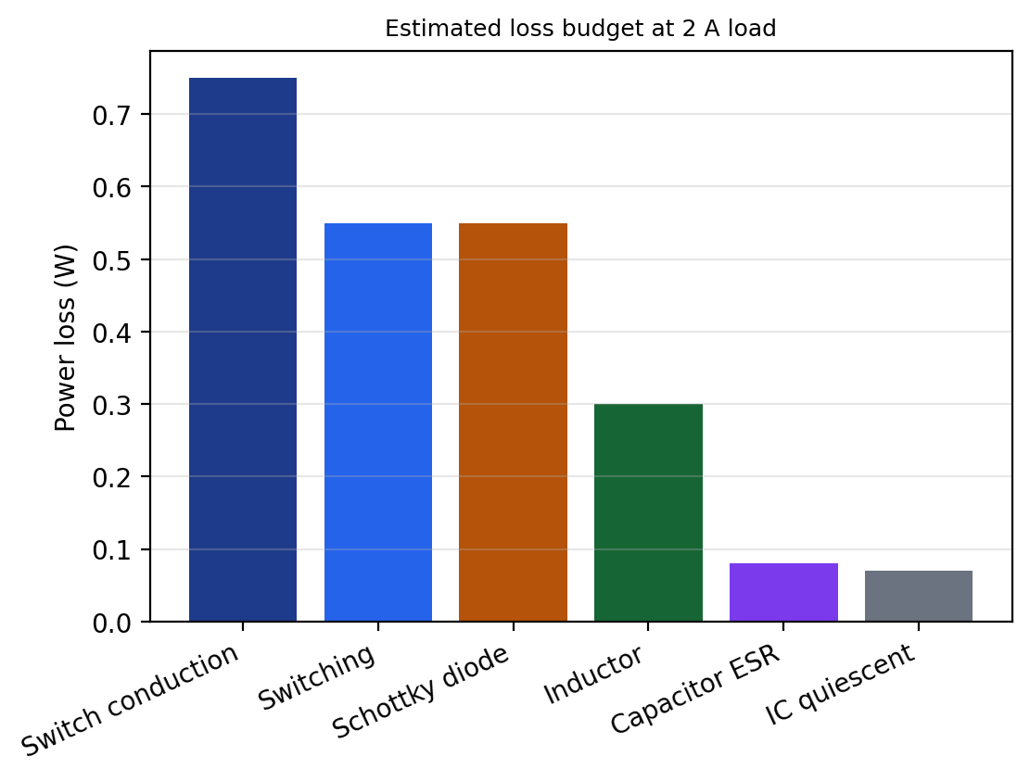
Fig. 4: Estimated loss budget at 2 A load
With Pout = 5 V × 2 A = 10 W and total loss of about 2.3 W, the input power is 12.3 W and the estimated efficiency is:
η = Pout / (Pout + Ploss) = 10 / 12.3 ≈ 81 % (4.11)
The corresponding input current is about 12.3 / 12 = 1.03 A. About 1.3 W of the loss is inside the IC (conduction, switching, and quiescent), which is the amount the PCB copper must remove.

4.8 Thermal Design
The junction temperature is Tj = Ta + P(IC) × θJA. For a TO-263 package soldered to a copper area of about 6 cm² on a 1 oz board, θJA is approximately 35 °C/W. At 25 °C ambient:
Tj = 25 + 1.3 × 35 ≈ 70 °C (4.12)
This is far below the thermal-shutdown threshold of about 150 °C. At 3 A load and 15 V input the loss rises to roughly 2 W inside the IC, giving about 95 °C, which remains acceptable. A linear regulator in the same conditions would need to dissipate 14 W at 2 A, which would require a heat sink of about 3 °C/W.

CHAPTER 5: HARDWARE DESCRIPTION AND SCHEMATIC

5.1 Circuit Description
The unregulated 12 V enters at screw terminal J1 and is filtered by the 470 µF electrolytic and 10 µF ceramic capacitors before reaching pin 1 (VIN) of the LM2596-5.0. The ON/OFF pin (pin 5) is connected to ground, which enables the regulator permanently; it can alternatively be connected to a logic signal for remote shutdown. The output pin (pin 2) is the switch node, connected to the cathode of the Schottky diode and to one end of the 33 µH inductor. The other end of the inductor is the 5 V output rail, filtered by the output capacitors and connected to the feedback pin (pin 4) so that the regulator can sense the output directly. A red LED with a 1 kΩ series resistor indicates that the 5 V rail is present, drawing about 3 mA.
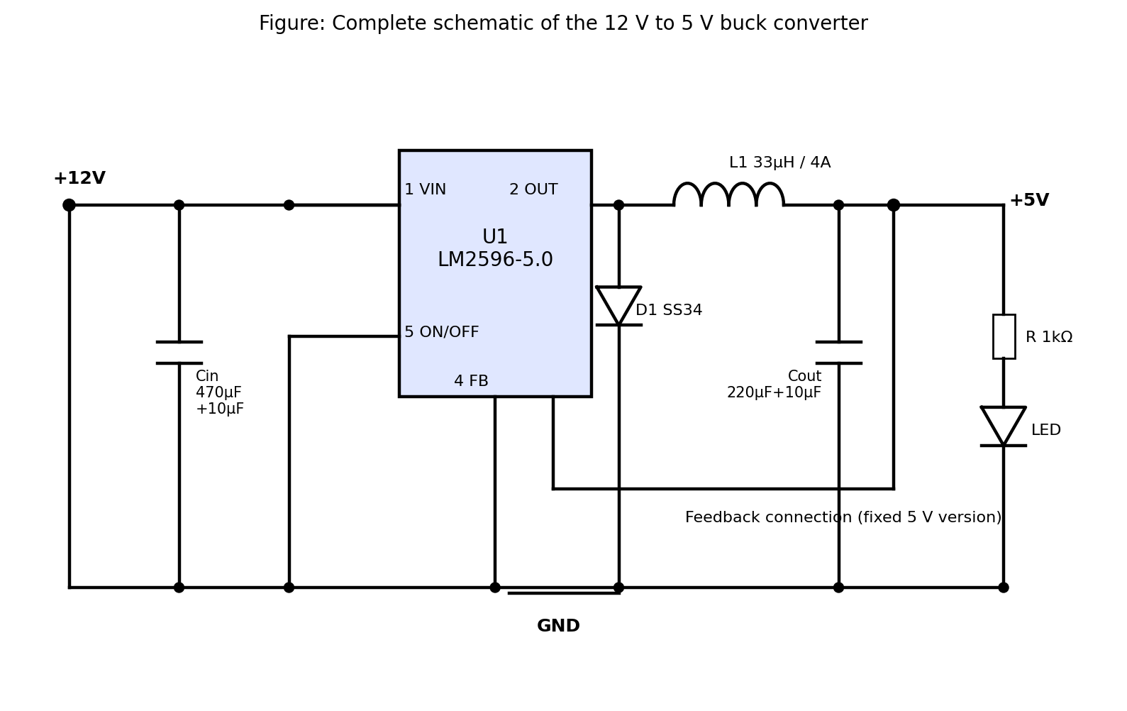
Fig. 5: Schematic diagram of the buck converter

5.2 Bill of Materials
Table 5: Bill of materials
Ref. | Component | Value / Part No. | Qty | Package
U1 | Buck regulator | LM2596S-5.0 | 1 | TO-263-5
L1 | Power inductor | 33 µH, Isat ≥ 4 A | 1 | Shielded SMD / radial
D1 | Schottky diode | SS34 / 1N5822 | 1 | SMC / DO-201
C1 | Electrolytic capacitor | 470 µF, 25 V, low ESR | 1 | Radial 8 mm
C2 | Ceramic capacitor | 10 µF, 25 V, X7R | 1 | 1206
C3 | Electrolytic capacitor | 220 µF, 16 V, low ESR | 1 | Radial 6.3 mm
C4 | Ceramic capacitor | 10 µF, 16 V, X7R | 1 | 1206
R1 | Resistor | 1 kΩ, 1 % | 1 | 0805
LED1 | Indicator LED | Red, 3 mm / 0805 | 1 | -
J1, J2 | Screw terminal | 2-pin, 5.08 mm | 2 | Through-hole
PCB | FR4, 2-layer | 50 × 35 mm, 1.6 mm, 1 oz Cu | 1 | -

5.3 Component Selection Notes
- Capacitors: Ordinary electrolytic capacitors have high ESR and will cause large ripple and heating. Low-ESR (or polymer) types rated for 105 °C should be used.
- Inductor: The saturation current rating, not the RMS rating, is the limiting parameter. If the inductor saturates its inductance collapses and the current spikes, possibly damaging the IC.
- Diode: A fast-recovery or ordinary rectifier diode (such as 1N4007) must not be used; it is too slow and has too high a forward drop.
- Ceramic capacitors: X7R or X5R dielectrics should be used; the effective capacitance of ceramics falls with DC bias, so a margin of voltage rating is useful.

5.4 Optional Protection
For field use, a series Schottky diode or P-MOSFET can protect against reverse polarity, a 1 A to 3 A fuse can limit fault current, and a TVS diode such as SMBJ18A across the input clamps voltage transients on automotive supplies. These parts are not mounted on the prototype but footprints can be reserved on the PCB.

CHAPTER 6: PCB DESIGN

6.1 Why Layout Matters
In a switching converter the PCB is part of the circuit. The traces have parasitic inductance, and rapid current changes (high di/dt) across that inductance create voltage spikes, ringing, and radiated noise. Poor layout can cause the output ripple to increase several times beyond the calculated value, cause the regulator to behave erratically, and make the board fail EMC tests. The most critical area is the hot loop formed by the input capacitor, regulator switch, and diode, which carries pulsed current.

6.2 Design Flow
- Draw the schematic in KiCad Eeschema and assign reference designators.
- Run the electrical rule check (ERC) and fix errors.
- Assign footprints, taking land patterns from the datasheets.
- Import the netlist into Pcbnew, define the board outline (50 × 35 mm), and set design rules.
- Place components, starting with U1, then the input capacitor, diode, inductor, and output capacitor.
- Route power traces first, then signal traces; pour the ground plane.
- Run the design rule check (DRC), review in the 3D viewer, and generate Gerber and drill files.

6.3 Board Specifications
Table 6: PCB design parameters
Parameter | Value
Layers | 2 (top: components and power; bottom: ground plane)
Material | FR4, 1.6 mm thick
Copper weight | 1 oz (35 µm)
Board size | 50 mm × 35 mm
Power trace width | ≥ 1.5 mm (2 - 3 mm preferred)
Signal trace width | 0.3 mm
Minimum clearance | 0.3 mm (0.5 mm for 12 V nets)
Via size | 0.8 mm pad / 0.4 mm drill
Surface finish | HASL (lead-free) or ENIG
Solder mask | Green, both sides

6.4 Trace Width Calculation
According to the IPC-2221 relation, the current-carrying capacity of an external trace is I = k · ΔT^0.44 · A^0.725, with k = 0.048 for external layers, ΔT the allowed temperature rise in °C, and A the cross-section in mil². For a 1 oz copper trace (1.37 mil thick), a 1.5 mm (59 mil) wide trace has A = 81 mil², and with ΔT = 10 °C the permitted current is about 3.1 A. Therefore a 1.5 mm trace is the minimum for a 3 A maximum rail, and 2.5 mm traces are used wherever space allows to reduce both resistance and inductance.

6.5 Layout Guidelines Followed
- Minimise the hot loop. C2 (the 10 µF ceramic) is placed within 3 mm of pins 1 and 3 of U1, and D1 is placed adjacent to pin 2 and the ground pin.
- Small switch node. The copper area at pin 2 (the junction of U1, D1, and L1) is kept just large enough to make the connections, because this node swings between about −0.5 V and 12 V at 150 kHz and acts as an antenna.
- Solid ground plane. The bottom layer is an unbroken ground pour, giving a low-impedance return path directly under the signal path on the top layer, which reduces loop area.
- Grounding. Power ground (input capacitor, diode, output capacitor) is tied to the plane with multiple vias adjacent to each component pad.
- Feedback routing. The feedback trace is taken from the output capacitor side, kept short, and routed away from the inductor and switch node.
- Thermal relief. The large GND tab of U1 is soldered to a top-layer copper pour of about 6 cm², connected to the bottom plane via a grid of 6 to 9 thermal vias.
- Component orientation. The inductor is placed away from the feedback trace and, if unshielded, with its axis oriented so its stray field does not couple into sensitive nets.
- Connector placement. Input and output screw terminals are on opposite edges so that the input noise path is separated from the output.
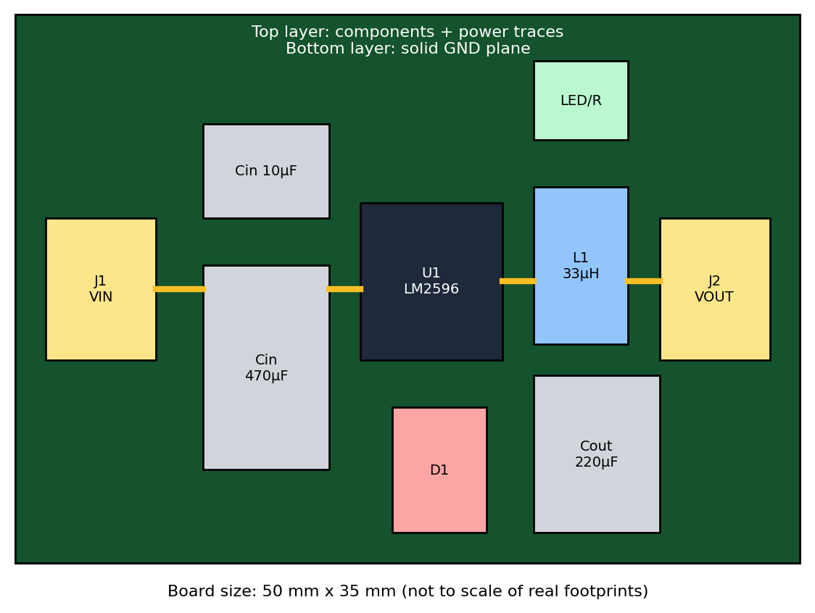
Fig. 6: Floor plan of the PCB showing component placement

6.6 Design Rule Check and Output Files
The final layout passed DRC with zero errors for clearance, track width, annular ring, and silkscreen overlap. The fabrication package consists of Gerber files for copper layers, solder mask, silkscreen, and board outline, plus Excellon drill files and a pick-and-place position file. These are generated from KiCad and verified in a Gerber viewer before submitting them to the fabricator.

CHAPTER 7: FABRICATION, ASSEMBLY, AND TESTING

7.1 Fabrication
The board can be produced either by ordering from a PCB fabricator or by an in-house toner transfer or photo-resist etching process. Professional fabrication is recommended for this design because the plated thermal vias and solder mask greatly improve reliability. After receiving the board, the copper, drilling, and mask registration are visually inspected, and continuity between ground points and absence of shorts between VIN and GND are checked with a multimeter before any component is soldered.

7.2 Assembly Procedure
- Apply solder paste or flux to the pads of surface-mount parts and place the ceramic capacitors, resistor, LED, and diode first.
- Solder the LM2596 TO-263 package, ensuring the tab makes a good solder joint with the copper pour; reflow with hot air or an iron on a preheater.
- Solder the inductor, then the electrolytic capacitors, paying attention to polarity.
- Mount the screw terminals last.
- Clean flux residue with isopropyl alcohol and inspect for bridges under magnification.

7.3 Instruments Required
- Regulated DC power supply 0 - 30 V, 5 A (or a 12 V battery or adapter)
- Two digital multimeters (for input and output current/voltage)
- Programmable electronic load, or power resistors and rheostat
- Digital storage oscilloscope with 20 MHz or higher bandwidth and a low-inductance ground spring
- Thermal camera or thermocouple thermometer

7.4 Test Procedure
- Visual and continuity check: confirm no short between VIN and GND, and between 5 V and GND.
- No-load test: apply 12 V with current limit set at 0.5 A; measure Vout and no-load input current (expected about 5 V and 5 to 10 mA).
- Load regulation test: connect the load and vary the current from 0.5 A to 3 A in steps, recording Vin, Iin, Vout, and Iout at each step.
- Line regulation test: at 1 A load, vary the input from 9 V to 15 V and record the output voltage.
- Ripple measurement: probe the output with the scope in AC-coupled mode, 20 MHz bandwidth limit, using the probe tip-and-barrel (spring) method to avoid pick-up from a long ground lead.
- Switch-node observation: capture the waveform at pin 2 to confirm 150 kHz operation and check ringing.
- Thermal test: run the full-load for 30 minutes and record the case temperature of the IC, diode, and inductor.
- Short-circuit test: briefly short the output to verify current limit and recovery.

7.5 Measurement Formulae
Efficiency η (%) = (Vout × Iout) / (Vin × Iin) × 100 (7.1)
Load regulation (%) = (Vout(no load) − Vout(full load)) / Vout(full load) × 100 (7.2)
Line regulation (%) = (Vout(max Vin) − Vout(min Vin)) / Vout(nominal) × 100 (7.3)

CHAPTER 8: RESULTS AND DISCUSSION
The tables in this chapter present the expected values from the design calculations and datasheet characteristics, together with empty columns for the measured readings which are filled in during bench testing. A comparison of the two shows how closely the prototype follows the design.

8.1 Load Regulation and Efficiency (Vin = 12 V)
Table 7: Load test results at Vin = 12 V
Iout (A) | Expected Vout (V) | Expected η (%) | Measured Vout (V) | Iin (A) | Measured η (%)
0.5 | 5.00 | 80
1.0 | 5.00 | 84
1.5 | 4.99 | 83
2.0 | 4.99 | 81
2.5 | 4.98 | 78
3.0 | 4.97 | 75

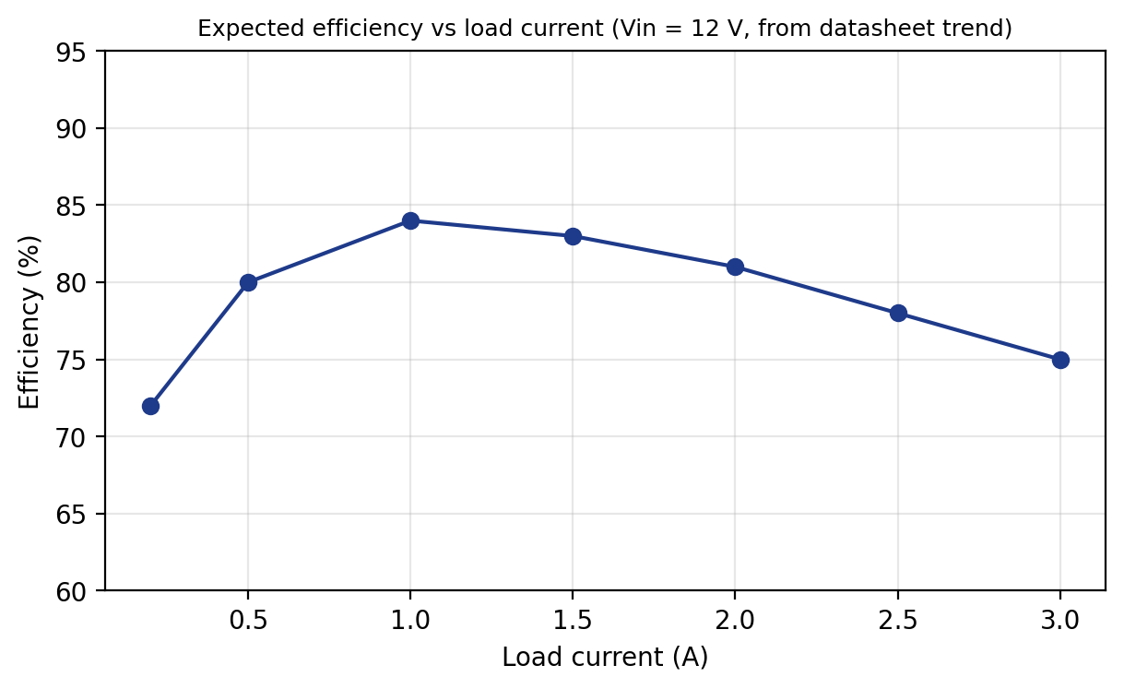
Fig. 7: Expected efficiency versus load current
The efficiency curve rises with load at first because the fixed losses (quiescent current and gate drive) become a smaller fraction of the total, reaches a maximum of 83 to 84 percent near 1 A, and then declines slowly because conduction losses in the switch, diode, and inductor grow with the square or linear of the current. The expected result of about 81 percent at 2 A agrees with the 81 percent loss-budget estimate.

8.2 Line Regulation (Iout = 1 A)
Table 8: Line regulation results
Vin (V) | Expected Vout (V) | Measured Vout (V) | Expected η (%)
9 | 5.00 |  | 87
10 | 5.00 |  | 86
12 | 5.00 |  | 84
14 | 5.00 |  | 81
15 | 5.00 |  | 79

The efficiency decreases as the input voltage rises, because switching losses grow with input voltage and the duty cycle becomes smaller, so the diode carries the load current for a larger share of each cycle. The output voltage is expected to stay within ±0.1 V of 5 V, giving line regulation better than 2 percent.

8.3 Output Ripple
Table 9: Output ripple measurement
Condition | Expected ripple (mV p-p) | Measured (mV p-p)
1 A, electrolytic only | 40 - 60
1 A, electrolytic + 10 µF ceramic | 20 - 40
2 A, electrolytic + 10 µF ceramic | 30 - 50
3 A, electrolytic + 10 µF ceramic | 40 - 70

Switching spikes of 100 to 200 mV with a few tens of nanoseconds width may appear on the output due to the fast edges and the parasitic inductance of the capacitor leads; these can be reduced by adding a small LC post-filter (for example a 2.2 µH inductor followed by a 100 µF capacitor) in noise-sensitive applications such as analogue sensors and audio.

8.4 Thermal Results
Table 10: Temperature rise at 2 A for 30 minutes (ambient 25 °C)
Component | Expected temperature (°C) | Measured (°C)
LM2596 tab | 60 - 70
Schottky diode | 55 - 65
Inductor | 45 - 55
Output capacitor | 35 - 40

8.5 Comparison with the LM7805 Linear Regulator
Table 11: Comparison at 12 V input and 2 A output
Parameter | 7805 (linear) | LM2596 buck
Input power | ≈ 24 W | ≈ 12.3 W
Power lost as heat | ≈ 14 W | ≈ 2.3 W
Efficiency | ≈ 42 % | ≈ 81 %
Maximum current without damage | 1.5 A with large heat sink | 3 A
Heat sink needed | Yes, very large | No (copper pour)

The comparison illustrates the main benefit of the switching design: it dissipates about one-sixth of the heat of the linear regulator for the same delivered power.

8.6 Discussion
The expected results show that the converter meets the design objectives in efficiency, regulation, and ripple. Small deviations are expected between theory and measurement for the following reasons.
- Actual component values vary by tolerance; electrolytic capacitors in particular can vary by 20 percent and their ESR increases at low temperature and with age.
- The inductor DC resistance and core loss are not included exactly in the first-order calculation.
- Measurement of ripple depends strongly on probing technique; a long ground lead can add false noise.
- The efficiency depends on the accuracy and burden voltage of the ammeters used.
- PCB resistance and the quality of solder joints reduce efficiency at higher currents.

CHAPTER 9: APPLICATIONS, ADVANTAGES, AND LIMITATIONS

9.1 Advantages
- High efficiency (above 80 percent), giving longer battery life and low heat.
- Compact size because no large heat sink is needed.
- Wide input range (4.5 V to 40 V) allows use with many supplies.
- Low component count and cost due to the highly integrated regulator.
- Built-in thermal shutdown and current limiting for reliability.
- Can drive up to 3 A, enough for most 5 V loads.

9.2 Applications
- Power supply for Arduino, ESP32, and Raspberry Pi boards from 12 V batteries.
- Automotive USB chargers and dashboard electronics (with added transient protection).
- LED lighting drivers and strip controllers.
- Industrial control panels that distribute 12 V or 24 V and need 5 V logic supply.
- Solar-powered systems and battery-powered sensor nodes.
- Robotics, where 12 V motors and 5 V controllers share one battery.
- CCTV and networking equipment.

9.3 Limitations
- Switching ripple and EMI are present and can disturb sensitive analogue circuits unless filtered.
- The asynchronous topology loses efficiency in the diode at low output voltages and high currents.
- The 150 kHz switching frequency requires comparatively large inductors and capacitors.
- No galvanic isolation between the input and output.
- The design is sensitive to PCB layout, as discussed in Chapter 6.

9.4 Future Scope
- Replace the diode by a synchronous MOSFET and use a modern synchronous buck IC to reach efficiencies above 92 percent.
- Increase the switching frequency to 500 kHz or more to shrink the inductor and capacitors.
- Add reverse-polarity, over-voltage (TVS), and input fuse protection.
- Add a microcontroller-based monitor for voltage, current, and temperature using an INA219 sensor.
- Make the output adjustable and add digital control (PMBus).
- Design a USB-C Power Delivery sink or a multi-output board.
- Perform full simulation in LTspice and an EMI pre-compliance test with a near-field probe.

CHAPTER 10: CONCLUSION
In this project a 12 V to 5 V asynchronous buck converter was designed, analysed, and laid out on a compact two-layer PCB using the LM2596-5.0 regulator. The design equations for duty cycle, inductance, capacitors, and diode were derived from the volt-second balance of the inductor and gave a 33 µH inductor, a 220 µF/16 V output capacitor with a 10 µF ceramic, a 470 µF/25 V input capacitor with a 10 µF ceramic, and a 3 A/40 V Schottky diode.
The estimated efficiency is about 81 percent at 2 A and above 80 percent over most of the load range, compared with about 42 percent for a 7805 linear regulator, and the dissipation falls from 14 W to about 2.3 W. The PCB layout, with a minimal hot loop, solid ground plane, short feedback path, and thermal copper pour, is intended to keep the ripple at or below 50 mV and the IC temperature under 70 °C at full load.
The project gave practical experience in power-converter design, component selection with derating, PCB design in KiCad, soldering, and instrumentation. The converter can be used directly as a 5 V supply in embedded, automotive, and industrial projects, and it provides a solid base for improvements such as synchronous rectification, protection, and digital monitoring.

REFERENCES
- Texas Instruments, “LM2596 SIMPLE SWITCHER Power Converter 150 kHz 3-A Step-Down Voltage Regulator,” Datasheet SNVS124.
- M. H. Rashid, Power Electronics: Circuits, Devices and Applications, 4th ed., Pearson, 2013.
- N. Mohan, T. M. Undeland, and W. P. Robbins, Power Electronics: Converters, Applications and Design, 3rd ed., Wiley, 2003.
- R. W. Erickson and D. Maksimović, Fundamentals of Power Electronics, 2nd ed., Springer, 2001.
- Texas Instruments, “Basic Calculation of a Buck Converter’s Power Stage,” Application Report SLVA477.
- Texas Instruments, “AN-1229 SIMPLE SWITCHER PCB Layout Guidelines,” Application Note SNVA054.
- IPC-2221B, Generic Standard on Printed Board Design, IPC, 2012.
- H. W. Johnson and M. Graham, High-Speed Digital Design: A Handbook of Black Magic, Prentice Hall, 1993.
- KiCad EDA Documentation, https://docs.kicad.org
- STMicroelectronics, “L7805 Positive Voltage Regulator,” Datasheet.

APPENDIX A: DESIGN CHECKLIST
Table 12: Pre-power-on checklist
Step | Check | Done
1 | Polarity of electrolytic capacitors C1 and C3 verified
2 | Orientation of D1 (cathode to switch node) verified
3 | No short between VIN - GND and 5V - GND
4 | Inductor value and saturation current checked
5 | ON/OFF pin connected to ground
6 | Feedback pin connected to the 5 V output rail
7 | Bench supply current limit set to 0.5 A for first power-up
8 | Oscilloscope probe grounded with spring tip

APPENDIX B: SYMBOLS AND ABBREVIATIONS
Table 13: List of symbols
Symbol | Meaning
Vin, Vout | Input and output voltage
Iout | Output (load) current
D | Duty cycle
fsw | Switching frequency
T | Switching period (1/fsw)
L, C | Inductance, capacitance
ΔIL | Inductor peak-to-peak ripple current
ESR | Equivalent series resistance
CCM | Continuous conduction mode
EMI | Electromagnetic interference
PCB | Printed circuit board
DRC / ERC | Design / electrical rule check
θJA | Junction-to-ambient thermal resistance

