**LAW FIRM APPLICATION** (**Bug report)**

**Date: 15/09/2023**

**Reporter: Biswalaxmi Nayak**

**Operating System: Windows 10**

**Environment: Chrome Browser**

**Bug ID** : ID_01

**Summary** : No any error message showing in username field in login page

**Description** : By entering invalid username, there is no error message showing

**Input Data** : Username: manoj1

**Steps** : 1. Open Browser  
 2. Enter URL: http://52.66.66.205:5069/#  
 3. Enter Username: manoj1

4. Click on Login button

5. Verify Login page error message

**Expected Behavior** : Username field should show an error message: “ENTER VALID USERNAME”

**Actual Behavior** : There is no error message showing

**Attachments** :

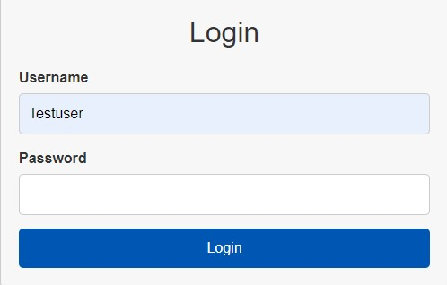

**Status** : New

**Priority** : P0

**Severity** : S0