**LAW FIRM APPLICATION** (**Bug report)**

**Date: 15/09/2023**

**Reporter: Biswalaxmi Nayak**

**Operating System: Windows 10**

**Environment: Chrome Browser**

**Bug ID** : ID_10

**Summary** : Search bottom of Document Detail page is not functioning

**Description** : Search bottom of Document Detail page is not functioning (with case id, date, document type)

**Input Data** : username: manoj

Password: 123

**Steps** : 1. Open Browser  
 2. Enter URL: http://52.66.66.205:5069/#  
 3. Enter username: manoj

4. Enter password: 123

4. Click on DOCUMENT BUTTON

5. Click on any Case id link

6. Click in search button

7. Enter case id/date/document type

8. Press enter key or button

8. Verify functionality

**Expected Behavior** : search button should show the result case id/date/document type

**Actual Behavior** : Search button is not functioning with case id/date/document type

**Attachments** :

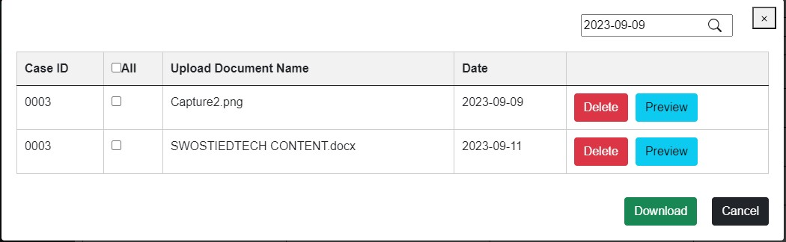

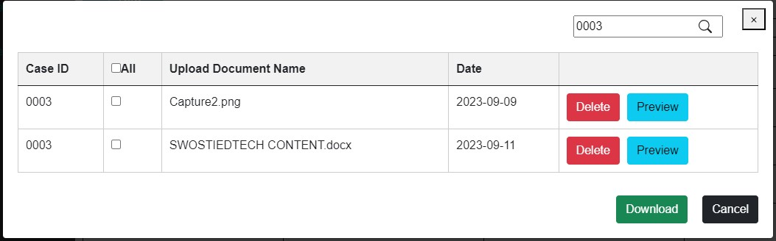

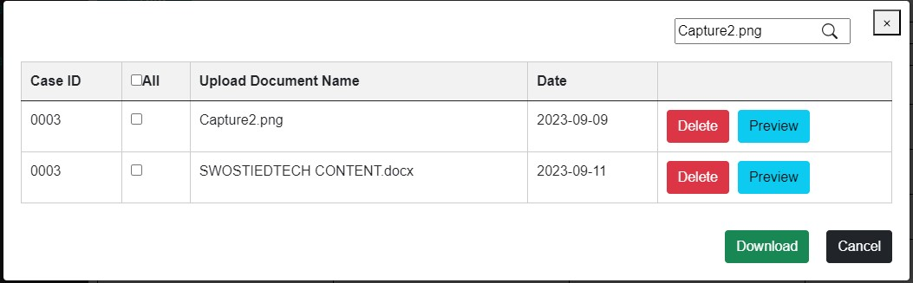

**Status** : New

**Priority** : P1

**Severity** : S1