**LAW FIRM APPLICATION** (**Bug report)**

**Date: 15/09/2023**

**Reporter: Biswalaxmi Nayak**

**Operating System: Windows 10**

**Environment: Chrome Browser**

**Bug ID** : ID_11

**Summary** : Update button is not functioning in Edit option

**Description** : No modification is happening with pressing update button of Edit option

**Input Data** : username: manoj

Password: 123

**Steps** : 1. Open Browser  
 2. Enter URL: http://52.66.66.205:5069/#  
 3. Enter username: manoj

4. Enter password: 123

4. Click on DOCUMENT BUTTON

5. Click on Edit button of any Case id

6. Modify case id/name/date/document type

7. Click on Update button

8. Verify functionality

**Expected Behavior** : By pressing update button modification should be done and show the success message “document updated successfully”

**Actual Behavior** : No update happening with a message “undefined”

**Attachments** :

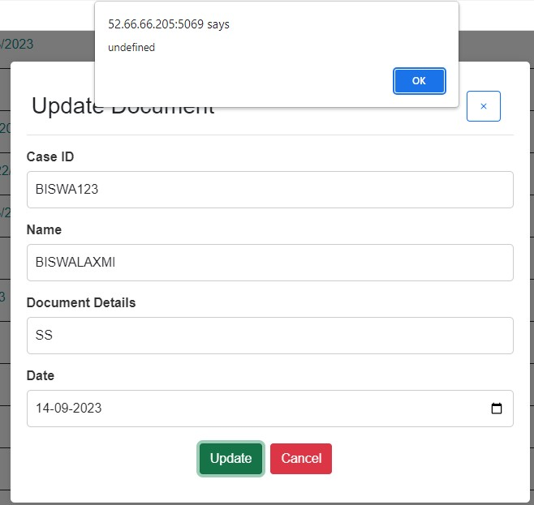

**Status** : New

**Priority** : P0

**Severity** : S0