**LAW FIRM APPLICATION** (**Bug report)**

**Date: 26/09/2023**

**Reporter: Biswalaxmi Nayak**

**Operating System: Windows 10**

**Environment: Chrome Browser**

**Bug ID** : ID_12

**Summary** : DOC file is not allowed to upload in document upload button

**Description** : In document upload functionality the error message is showing as “please upload a pdf or doc file “, but does not allowing doc file.

**Input Data** : username: manoj

Password: 123

**Steps** : 1. Open Browser  
 2. Enter URL: http://52.66.66.205:5069/#  
 3. Enter username: manoj

4. Enter password: 123

4. Click on DOCUMENT BUTTON

5. Click on Upload button of any Case id

6. Select doc file from folder and press open button

7. Verify functionality

**Expected Behavior** : A doc file should upload successfully and show a successful message

**Actual Behavior** : By uploading a doc file, an error msg is showing as: “please upload a pdf or doc file “

**Attachments** :

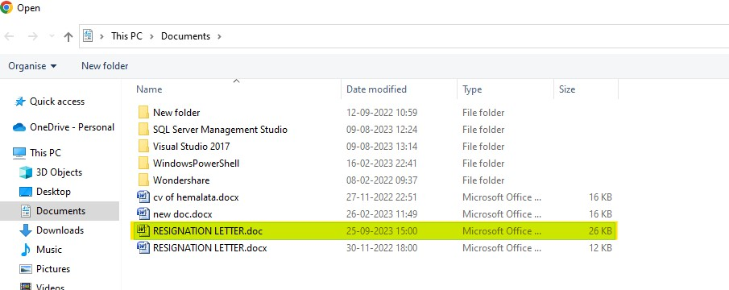

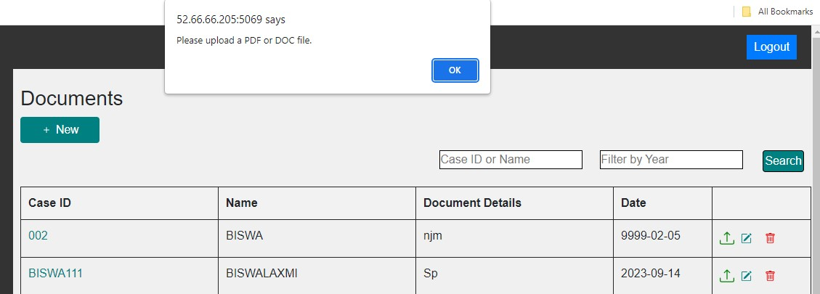

**Status** : New

**Priority** : P2

**Severity** : S0