**LAW FIRM APPLICATION** (**Bug report)**

**Date: 15/09/2023**

**Reporter: Biswalaxmi Nayak**

**Operating System: Windows 10**

**Environment: Chrome Browser**

**Bug ID** : ID_03

**Summary** : No password visibility icon in password field in login page

**Description** : In password field there is no visibility icon for view password

**Input Data** : password: 123

**Steps** : 1. Open Browser  
 2. Enter URL: http://52.66.66.205:5069/#  
 3. Enter Password: 123

4. Verify visibility of password

**Expected Behavior** : Password should have a visibility icon to view entered password

**Actual Behavior** : There is no visibility icon to view entered password

**Attachments** :

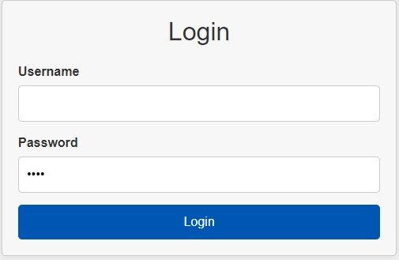

**Status** : New

**Priority** : P0

**Severity** : S0