**LAW FIRM APPLICATION** (**Bug report)**

**Date: 15/09/2023**

**Reporter: Biswalaxmi Nayak**

**Operating System: Windows 10**

**Environment: Chrome Browser**

**Bug ID** : ID_04

**Summary** : No any error message showing in username/password field in login page

**Description** : By login with blank space in username/password, there is no error message showing

**Input Data** : username: --------------

Password: ---------------

**Steps** : 1. Open Browser  
 2. Enter URL: http://52.66.66.205:5069/#  
 3. Enter username: ----------

4. Enter password: ----------

4. Click on Login button

5. Verify Login page error message

**Expected Behavior** : By clicking login button there should be show error message in username field as:“USERNAME IS REQUIRED” and “PASSWORD IS REQUIRED” in password field

**Actual Behavior** : There is no error message showing

**Attachments** :

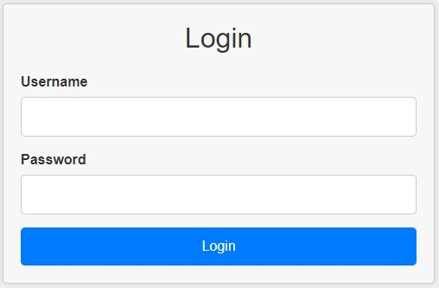

**Status** : New

**Priority** : P0

**Severity** : S0