**LAW FIRM APPLICATION** (**Bug report)**

**Date: 15/09/2023**

**Reporter: Biswalaxmi Nayak**

**Operating System: Windows 10**

**Environment: Chrome Browser**

**Bug ID** : ID_05

**Summary** : Allows invalid Year in date field of adding new document field without any error message

**Description** : Date field of adding new document page is allowing entering invalid year and saving the date without any error message

**Input Data** : username: manoj

Password: 123

**Steps** : 1. Open Browser  
 2. Enter URL: http://52.66.66.205:5069/#  
 3. Enter username: manoj

4. Enter password: 123

4. Click on DOCUMENT BUTTON

5. Click on NEW button

6. Enter Case id = 1234

7. Enter name= abcd

8. Enter document type=ss

9. Enter date= 15/09/0020

10. Verify document addition in document page

**Expected Behavior** : Date should not add in document page and should show an error message as: “ENTER A VALID DATE”

**Actual Behavior** : Invalid Date adding successfully and there is no error message showing as: “ENTER A VALID DATE”

**Attachments** :

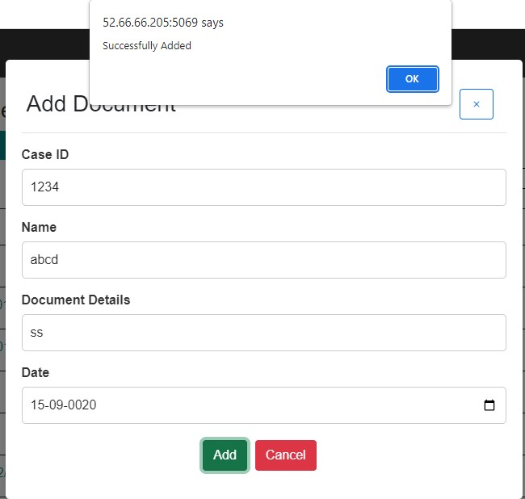

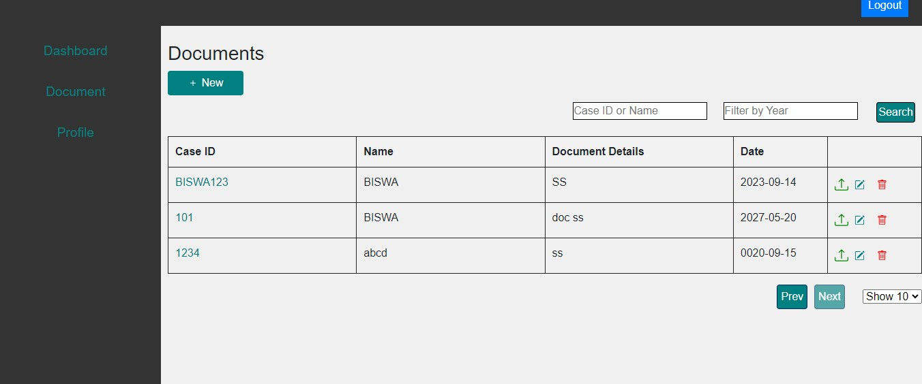

**Status** : New

**Priority** : P0

**Severity** : S0