**LAW FIRM APPLICATION** (**Bug report)**

**Date: 15/09/2023**

**Reporter: Biswalaxmi Nayak**

**Operating System: Windows 10**

**Environment: Chrome Browser**

**Bug ID** : ID_06

**Summary** : Document detail date is not matching with saved document date

**Descriptio** : By adding a new document, date is saving as entered date but it automatically showing current date as we open the same case id link

**Input Data** : username: manoj

Password: 123

**Steps** : 1. Open Browser  
 2. Enter URL: http://52.66.66.205:5069/#  
 3. Enter username: manoj

4. Enter password: 123

4. Click on DOCUMENT BUTTON

5. Click on NEW button

6. Enter Case id= 002

7. Enter name= mkl

8. Enter document type= njm

9. Enter date=02/05/9999

10. Click ADD button

11. Press OK BUTTON

12. Go to main page of document and click on Case id link -002

13. Verify document date in document page

**Expected Behavior** : Document date should be match with saved date in main document page

**Actual Behavior** : Saved Date is not matching with document date

**Attachments** :

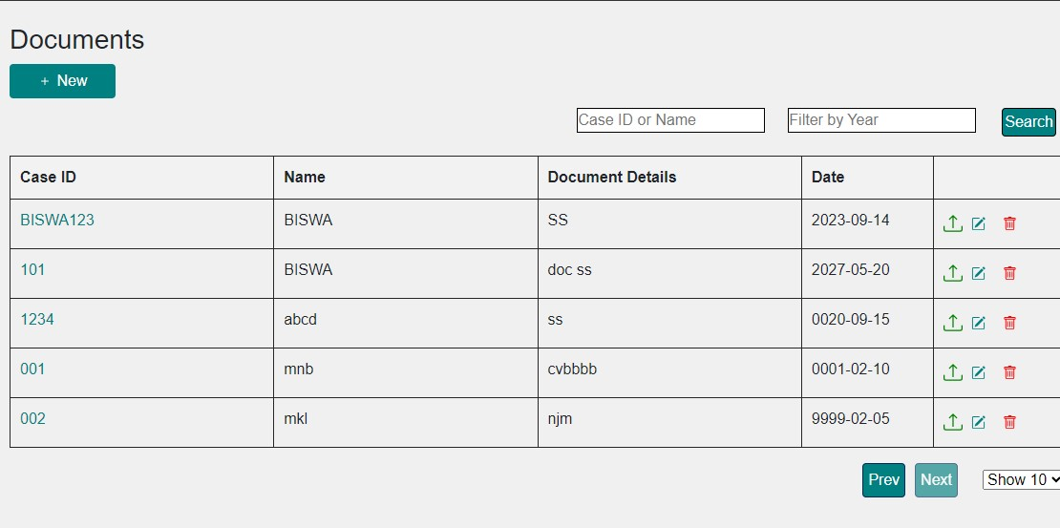

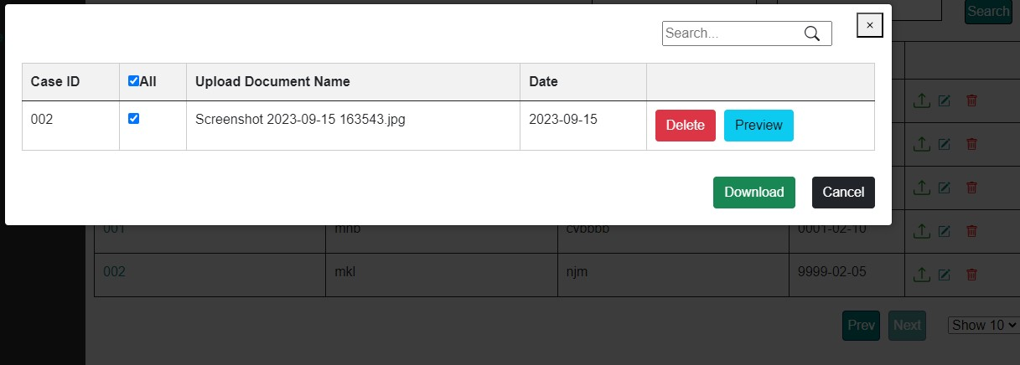

**Status** : New

**Priority** : P1

**Severity** : S1