**LAW FIRM APPLICATION** (**Bug report)**

**Date: 15/09/2023**

**Reporter: Biswalaxmi Nayak**

**Operating System: Windows 10**

**Environment: Chrome Browser**

**Bug ID** : ID_07

**Summary** : FILTER BY YEAR button is not searching result properly

**Description** : required date is present in document list but when we search the same date in FILTER BY YEAR filter button is not searching the result properly

**Input Data** : username: manoj

Password: 123

**Steps** : 1. Open Browser  
 2. Enter URL: http://52.66.66.205:5069/#  
 3. Enter username: manoj

4. Enter password: 123

4. Click on DOCUMENT BUTTON

5. Type 0001 in FILTER BY YEAR filter space

6. Click on search button

7. Verify document date in document page

**Expected Behavior** : Result should be shown as searched year

**Actual Behavior** : Result showing as “no data available”

**Attachments** :

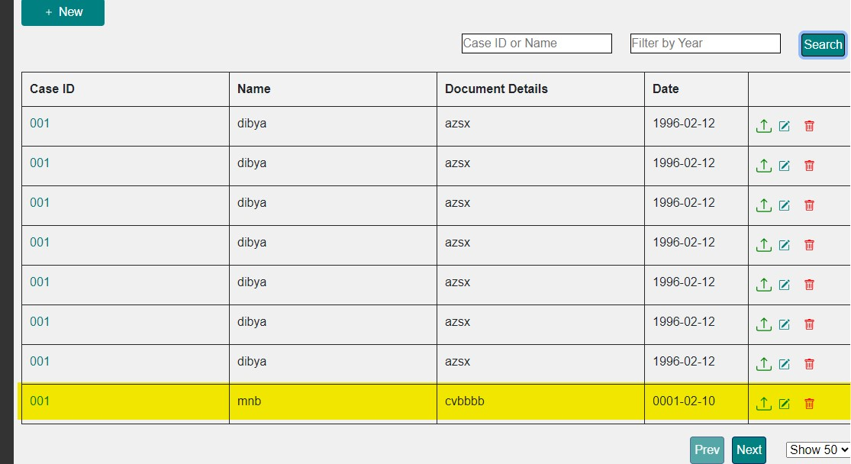

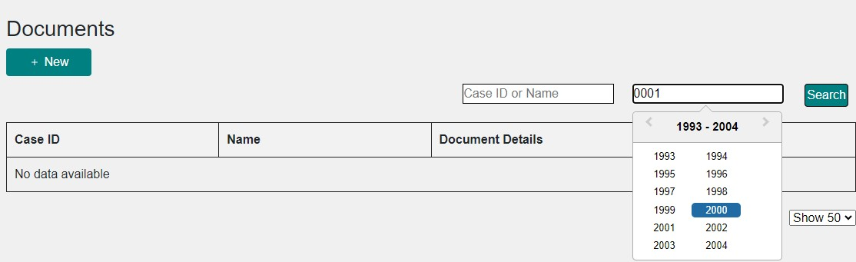

**Status** : New

**Priority** : P1

**Severity** : S1