**LAW FIRM APPLICATION** (**Bug report)**

**Date: 15/09/2023**

**Reporter: Biswalaxmi Nayak**

**Operating System: Windows 10**

**Environment: Chrome Browser**

**Bug ID** : ID_09

**Summary** : Downloading document format is zip file

**Description** : Downloaded document is not directly viewable.it is in zip file format for which it is necessary to extract every file again

**Input Data** : username: manoj

Password: 123

**Steps** : 1. Open Browser  
 2. Enter URL: http://52.66.66.205:5069/#  
 3. Enter username: manoj

4. Enter password: 123

4. Click on DOCUMENT BUTTON

5. Click on any Case id link

6. Check in a document

7. Click on download button

8. Verify downloaded document

**Expected Behavior** : Downloaded document should be in normal format and should not require extracting it again

**Actual Behavior** : Downloading document is in zip file

**Attachments** :

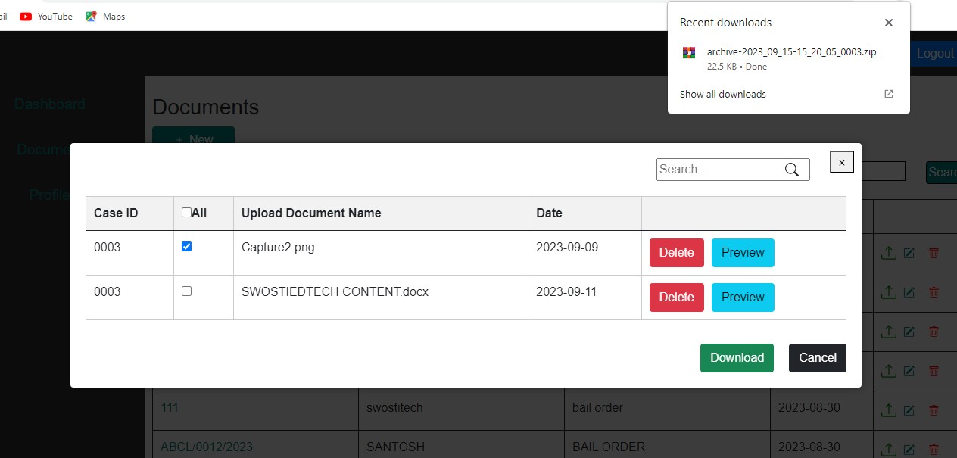

**Status** : New

**Priority** : P0

**Severity** : S0