**Index**

1. Introduction 02
2. Research Objectives 02
3. Research Importance 02
4. Source of data 02
5. Description of the data 03
6. Graphical representation of data (scatter plot) 04
7. Regression Analysis 07
8. Regression Diagnostics 08
   1. Detection of influential points 08
   2. Multicollinearity 10
   3. Heteroscedasticity 12
9. Test for significance of predictors 14
10. Regression fit 15
    1. Multiple correlation coefficients 15
    2. Partial correlation coefficients 16
11. Goodness of fit 16
12. Conclusion 17
13. Appendix of codes 17
14. References 17
15. Acknowledgement 18

# Introduction:

Crime, a social and legal construct, is a phenomenon that has been present in societies across the world and throughout history. It is an issue of significant concern due to its impact on victims, communities, and the overall society. The frequency and nature of criminal offences not only the mirror of the evolving socio-economic environment but also underscore the efficiency of governance and law enforcement measures. It is a complex task to understanding the patterns and causes of crime in India, a diverse country with population over a billion. This complexity arises from the myriad socio- economic factors and regional variations that influence crime rates.

The backbone of criminal justice system in India, The Indian Penal Code (IPC) and Special and Local Laws (SLL), serves as both a reflexion and a catalyst for the nation’s socio-economic development. While IPC establishes a uniform code of criminal laws applicable throughout the nation, SLL address specific legal provisions enacted by central or state governments for specialized or regional concerns, despite of the diverse tapestry of India’s legal landscape.

# Research Objectives:

This research endeavours to dissect the intricate relationship between crime rates, socio- economic factors throughout the whole nation, with the following objectives: -

* 1. Exploration of socio-Economic Determinants:

Study the impact of crucial socio-economic measures, including unemployment rates, GDP, inflation, and the economic performance at the state level, on the occurrence of IPC & SLL crimes in various states and territories.

* 1. Regional Disparities:

Assess variations in crime rates and police efficacy across diverse geographical regions of India, elucidating the underlying factors contributing to regional disparities in law enforcement and crime prevention strategies.

* 1. Identification of potential factors:

Employ rigorous statistical analyses to identify casual factors driving divergent trends in crime rates, thereby informing evidence-based policy interventions and pro- active crime prevention measures at both regional and national level.

# Research Importance:

The connection between crime rates and socio-economic factors can be better understood through certain theoretical frameworks. These are crucial in understanding the complicated aspects of criminal behaviours. Strain theory, Social disorganization theory, Routine activity theory represent seminal perspectives in criminology that offer insights into how socio-economic conditions shape patterns of criminal activity.

This part of study provides a critical analysis of these theories, outlining their significance in understanding the levels of crime and their regional differences.

# Source of data:

* Crimes in India,2021 (from national Crime Record Bureau)
* Handbook of statistics on Indian states,2021-22 (from Reserve Bank of India)

1. **Description of the data used:**

Here we have data on 36 states and territories of India for the year 2021 on variables namely proportion of IPC crimes, proportion of SLL crimes, Unemployment rate for rural areas, Unemployment rate for urban areas, GDP, state-wise average general inflation, state-wise average inflation of food & beverages and Net State Domestic Product (NSDP).

We restrict ourselves in some cases. For reference we don’t include some territories of India due to unavailability of the data required. Hence the total number of observation boils down to 33.

All the variables are renamed for further use and detailed description of them are given below:

* **Response variable:**
  + Rate of IPC crimes (Y1):

the data is given in the ratio scale where,

IPC crime rate is given due to crime per lakh population.

* + Rate of SLL crimes(Y2):

The data is given in the ration scale where,

IPC crime rate is given due to crime per lakh population

* **Predictors:**
  + Unemployment rate for rural areas(X1):

It denotes the rate of unemployment in the rural areas throughout the different states and territories of India for per thousand people.

* + Unemployment rate for urban areas(X2):

It denotes the rate of unemployment in the urban areas throughout the different states and territories of India for per thousand people.

* + GDP(X3):

Logarithmic value of GDP or Gross Domestic Product is given for different states and territories of India with respect to the year 2021-2022 taking base year as 2011-2012 in per lakh Indian rupees with respect to current prices.

* + NSDP(X4):

Logarithmic value of NSDP or Net State Domestic Product is given for different states and territories of India with respect to the year 2021-2022 taking base year as 2011-2012 in per lakh Indian rupees with respect to current prices.

* + State-wise average general inflation(X5):

Wages or State-wise average inflation for general i.e., Consumer Price Index (CPI) for general is given in percentage.

* + State-wise average inflation of food and beverages(X6):

Wages or State-wise average inflation for food and beverages i.e., Consumer Price Index (CPI) for food and beverages is given in percentage for India.

States and territories are divided into 3 categories according to their population Such that if population less than 500 lakh we assign 1, more than 1000 lakh we assign 3 and 2 for rest in-between.

* + Dummy variable1 (X7):

Assigned 1 to those where population lies below 500 lakhs and 0 to rest.

* + Dummy variable2 (X8):

Assigned 1 to those where population lies between 500 lakhs and 1000 lakhs and 0 to rest.

* 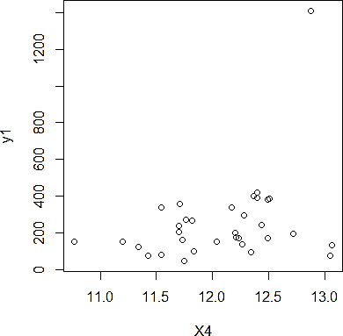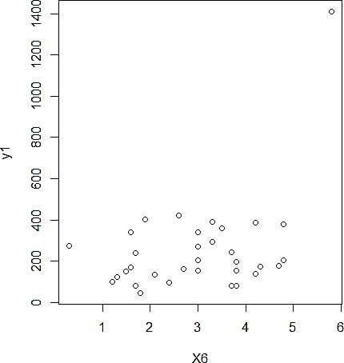**Cases:**
  + Case 1: we will regress Y1 jointly on X1,X2,X3,X4,X5,X6,X7,X8

Y1~ X1+X2+X3+X4+X5+X6+X7+X8 , for all observations

* + Case 2: we will regress Y2 jointly on X1,X2,X3,X4,X5,X6,X7,X8

Y2~ X1+X2+X3+X4+X5+X6+X7+X8 , for all observations

# graphical representation of data( scatter plot):

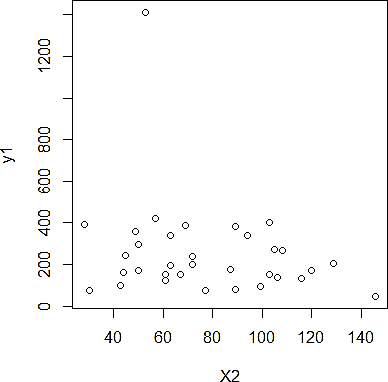**Case1:**

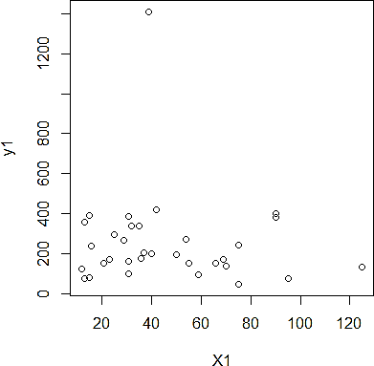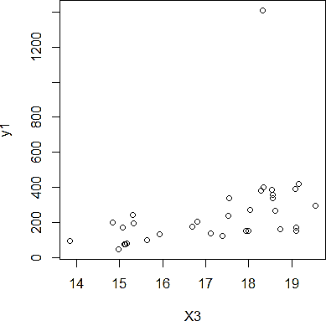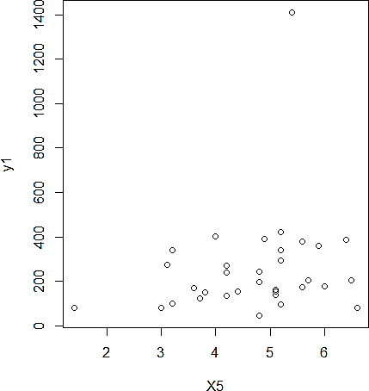

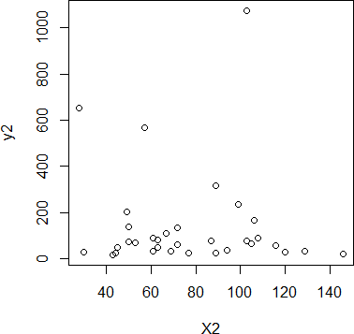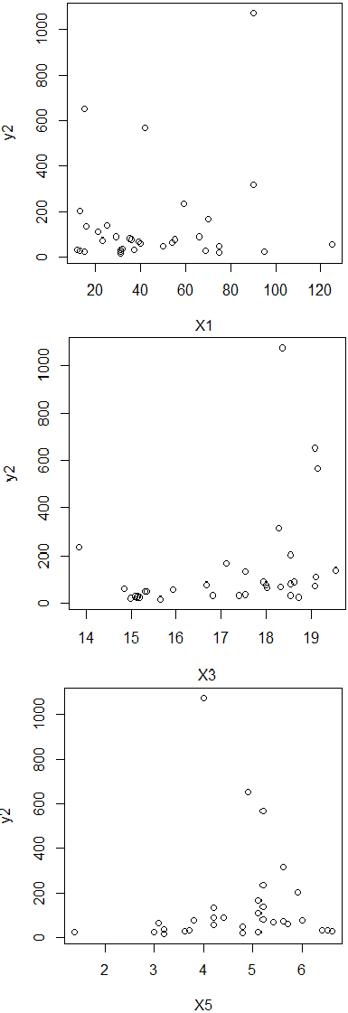**Case 2:**

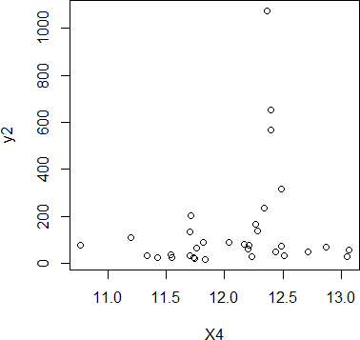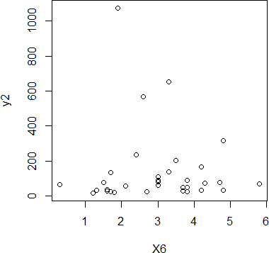

# Regression Analysis:

The term “Regression” was proposed by Sir Francis Galton, which literally means “ backward movement, return to an earlier stage of development.”.

The idea is to check how the predictor variables jointly influences the response variable though the linear relationship i.e., to describe and evaluate the relationship between the Y (explained/ dependent/response variable) with other Xk’s (explanatory/independent/predictor variables). When k=1, we called it simple regression and otherwise (k >0) multiple regression.

**Objective of the regression analysis:**

* Check if X is significant for Y or not.
* Effects on Y for changing value of X.
* Predict or forecast the value of Y for a given set of X.

**Model:**

Let Y be the response variable and X1,X2,X3,…..,Xp be p independent predictors and they can be modelled as follows,

*Yi* = *β0* + *β1x1i* + *β2x2i* +…+ *βpxpi* + *εi*

= *E* (*Y* | *x1i, x2i*, ……., *xpi*) + *εi*

Where, ***εi*** are the residuals(error terms associated with) of Yi for all values of i.

***β0*** is the intercept parameter and ***βj*** ‘s is the partial regression coefficient associated with ***Xj*** which can be interpreted as the change in the value of Y, for unit change in ***Xj***, keeping the other predictors fixed. j= 1(1)p

**Assumptions:**

Under classical linear model there are some assumptions as follows:

* The regression model must be linear in parameter. However it may or may not be linear in variables.
* Xi’s are non-stochastic i.e., data matrix X is non stochastic or non-probabilistic in nature.
* Errors are normally distributed with zero mean and constant variance. i.e., ***εi~*** N(0, σ2) Ɐ i.
* The errors are uncorrelated. i.e., cov (εi, εj)=0 Ɐ i ≠ j
* The number of observations must be greater than the number of parameters to be estimated.
* Variance of X must be positive and should not include any outliers.

**Estimation of coefficients:**

To estimate the regression coefficients we have to minimize the sum of the errors of predictors, in the method of ordinary least squares. i.e., we have to minimize the following,

∆ = n e2 = ∑n

∑

(Y − β

− β x

− β x

−..............β x )2

i=1 i

i=1 i

0 1 1i

2 2i

p pi

𝛽0 = 𝑦̅ - 𝛽1𝑥̅1- ..- 𝛽𝑝𝑥̅𝑝

β̂j

= - Ryj

Ryy

σy , j=1(1)p

σj

Where Ryy is the cofactor of (1,1)th element of R and Ryj is the cofactor of (1,j+1)th element of R.

**Fitted regression model:**

Yi = β̂0 + β̂1x1i + β̂2x2i +…+ β̂pxpi = E (Y | x1i, x2i, ……., xpi)

Where, β̂

0= 𝑦̅ - β̂

1𝑥̅1

- ..- β̂

p𝑥𝑝

and β̂j

= - Ryj

Ryy

σy , j=1(1)p

σj

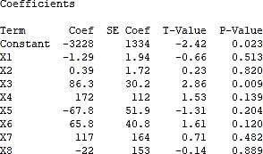Case1



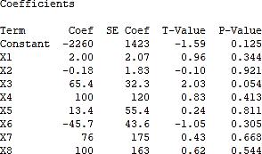**Comment:** as per adjusted r square, only 25.58 % of the total variation can be explained by the linear fit of Y1 jointly on X1,X2,X3,X4,X5,X6,X7 and X8. The fit is not seeming to be good. So, we will go for some test to remove unwanted values and refit the regression.

Case2



**Comment:** as per adjusted r square, only 4.97 % of the total variation can be explained by the linear fit of Y2 jointly on X1,X2,X3,X4,X5,X6,X7 and X8. The fit seems to be pretty bad. So, we will go for some test to remove unwanted values and refit the regression.

1. **Regression diagnostic:**

Often regression based on different subsets of the data sometimes produces various results which can lead to question the model stability. Reasons of that can be unusual circumstances like unknown error in data collection and collinearity can be also a potential cause of it.

## 8.1 Detection of influential points:

In general, an outlier is any unusual data point which is discordant with other points. There are two kinds of outliers: -

* 1. Outlier in y direction (called error outlier or outlier)
  2. Outlier in x direction (called high leverage point)

**Residuals:**

The residual is defined as the difference between the fitted and

observed value of the study variable. It can also be considered as the deviation between the data and the fit.

It can also be considered as the model error. So, it is expected that if there is any departure from the model it will be reflected by the residual. Thus, model inadequacies can be found by residual analysis.

We define residuals as **ui** and estimated residuals as

Then, **Standardized residuals**



:

where, = estimated residuals

= estimated standard errors

= leverage point for ith observation

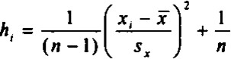Where leverage is calculated as,

**Rule for detection of outlier:** the ith observation is an  outlier if > 2

**Rule for detection of high leverage points:** the ith observation is a high leverage point if

 **>** 𝑙0 = 3*(p+1)/n; where p is the total number of prediction variables and n is the total number of observations.

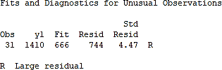

for **case1** , we get,

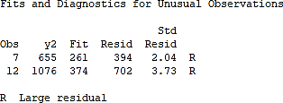

for **case2** , we get,

In both cases, 𝑙0 = 0.81818

For case1, we have point 31 as a potential outlier and for case2, we have points 7 and 12 as potential outliers but there is no potential leverage point found.

If a dataset is small, then deletion of values greatly affects the fit and statistical conclusions. So, in measurement of that if a point is an influential point or not, we should consider location of both in x and y space.

**Cook’s Distance:**

where is the fitted response value obtained when excluding i,  = MSE of regression model, where

And p: number of parameters in the model , n: number of observations

**Rule for detection of influential point:** a value more than 1 indicates that the point should be studied further and consider dropping.

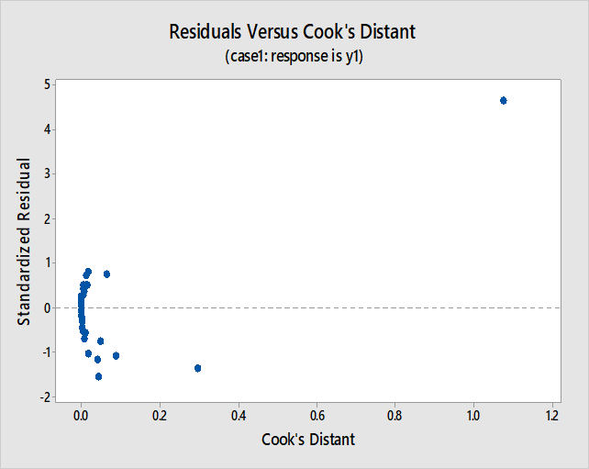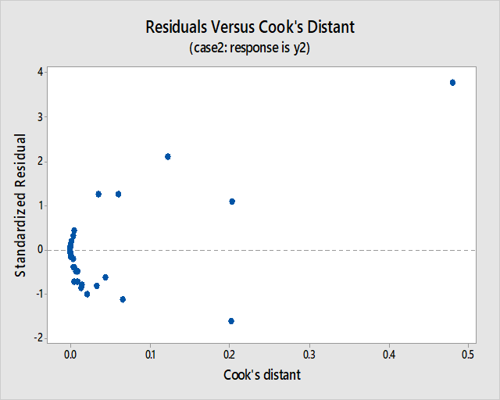

**Standard solution:** assessing the effect of the data point has on the regression by deleting the point and refitting the regression. If the quantities (i.e., estimated coefficients, fitted values, standard errors and so on.) changes markedly, the point is highly influential.

**Comment:**

In case1, the value of Cook’s distance for the 31th point is 1.07514 > 1, hence we can take this potentially outlier point as high influential point; thus, we delete that from out dataset before further analysis.

In case2, the value of Cook’s distance for both the potential outlier point 7th and 12th is less than 1, hence we can conclude that those two points are not high influential points, and we proceed without deleting them in further analysis.

## 8.2 Multicollinearity:

Before diving into modelling, a crucial initial inquiry arises: do we need all predictors for our study? It’s possible to exclude certain predictors if a subset proves adequate for predicting diabetes, or conversely, retain all predictors if they hold equal importance. So, we examine the concept of **Multicollinearity**.

The term "Multicollinearity" was initially introduced by Ragnar Frisch in statistics, referring to the presence of exact or "perfect" linear relationships among some or all predictors in a multiple regression model.

In such cases, the coefficient estimates of the regression model may exhibit irregular fluctuations in response to minor changes in the model or data. While multicollinearity might not diminish the overall reliability or predictive capacity of the model, it does impact the accuracy of calculations pertaining to individual predictors. Consequently, a multiple regression model with correlated predictors can accurately assess the collective predictive capability of the predictors for the outcome variable. However, it may not yield reliable insights into the significance of any individual predictor or identify which predictors are redundant in relation to others.

We have perfect multicollinearity if the correlation between explanatory variables is ±1 which in practice is rarely observed. The issue arises when there is an approximate linear relationship among two or more predictors.

Mathematically, this relationship represented as:

𝑏0 + 𝑏1𝑋1𝑖 + 𝑏2𝑋2𝑖 + ⋯ + 𝑏𝑘𝑋𝑘𝑖 = 0 ∀ 𝑖 = 1(1)𝑛

Where, 𝑏𝑗′𝑠 are constant and 𝑋𝑗𝑖 is the ith observation on kth covariate. ∀ 𝑗 = 1(1)𝑘

Even after eliminating redundancies, nearly multicollinear variables may persist due to inherent correlations within the studied system. In such instances, rather than adhering strictly to the previously mentioned equation, we adapt it into a modified form, incorporating an error term represented by 𝜀𝑖. We denote variables as nearly perfectly multicollinear when the variance of 𝜀𝑖's is minimal for certain values of the 𝑏𝑗 coefficients.

1. Visualization Method - using Correlation Plot:

Correlation plot is the graph plot of correlation matrix also called heatmap. In this plot, correlation coefficients are coloured according to the value. Higher the intensity of colour, higher the correlation.

1. Using Variance Inflation Factors(VIFs):

Existence of collinearity in data set can be checked by **Tolerance** which is **1**−𝑹𝟐 where

𝒌

𝑹𝟐 is the multiple correlation coefficient between 𝒙𝒌 and other independent variables. Also, one can consider **variance inflation factor (VIF)** which is nothing but the reciprocal of tolerance. VIF for the kth predictor is given as:

𝒌

**VIFk** = 1/(1-𝑹𝟐)

𝒌

Range of tolerance is from 0 to 1. A high value of tolerance & low value of VIF is acceptable. Tolerance value <0.2 i.e., VIF >5 is really concerning.

**Comments:**

**Correlation heatmap for case 1**

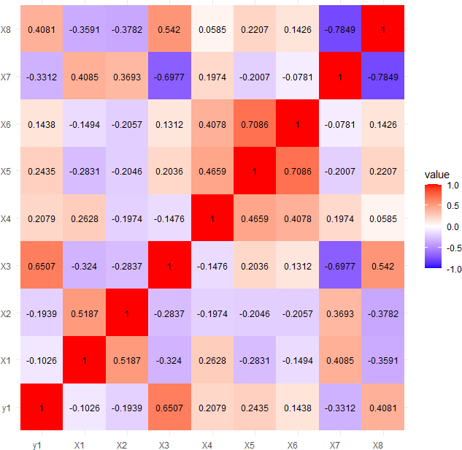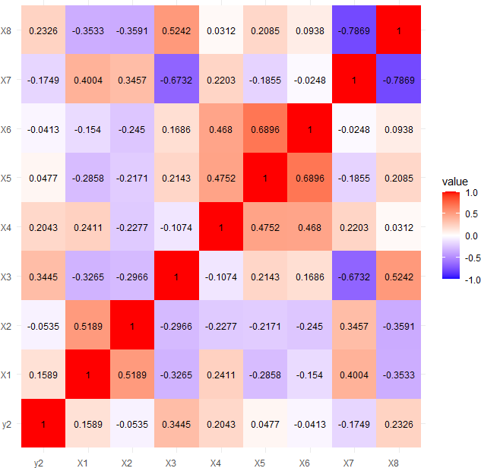

There is high negative correlation between the variables X3, X7 and X7,X8. Again, high positive correlation is noticed among Y1,X3 and X5,X6. Rest of the variables seems to be more or less correlated among themselves.

**Correlation heatmap for case 2**

There is high negative correlation between X3,X7 and X7,X8 where high

positive correlation is seen between X5,X6. rest of the variables are more or less correlated among themselves and some moderately correlated

**Values of Variance Inflation Factors:**



From the above snapshot we can observe that for all the predictor variables, the values of VIF are less than 5. Hence, all the independent variables can be considered as uncorrelated and should be included in our further study.

We can conclude same for case2 also as we said in case1.

## 8.3 Heteroscedasticity:

Heteroscedasticity is a phenomenon in regression analysis where the variability of the residuals changes across different levels of the predictor variables. It violates the assumption of homoscedasticity, potentially leading to biased estimates and incorrect inferences.

We plot residuals values against the fitted y values and check if it shows any systematic pattern or not. If the data shows any systematic pattern then we can assume that the data may be potentially heteroscedastic, and some tests will be done to confirm it.

We can make variable transformation to reduce the variability of the data i.e., to make the data homoscedastic.

100

Case1:

50

Residual values do not seem to

residual value of the model

have any pattern with the fitted value of ‘’’ Y1 variable. So it can be safe to say that the data may not have any presence of heteroscedasticity.

-100

-50

0

100 150 200 250 300 350

-150

fitted value of y1

Case 2:

600

Residual do not seem to have any

residual value of the model

400

Pattern with the fitted variable y2. As it shows no pattern, it is safe to say that the data may not have any presence of heteroscedasticity.

0

200

-100 0 100 200 300

-200

fitted value of y2

Hence we can perform two consecutive test’s for confirming the presence of heteroscedasticity as follows:

1. **Glejser’s Test:-**

This test is based on the assumption that 𝜎2 is influenced by only one variable which is influencing the heteroscedasticity.

for this the model chosen is, || = 𝛿0 + 𝛿1 𝑥𝑖𝛿2 + 𝑢∗ ∀ 𝑖 = 1(1)𝑛

𝑖

where 𝑢∗ is associated disturbance term.

𝑖

We are to test for,

ℎ0: 𝛿1 = 0 𝑣𝑠 ℎ1: 𝛿1 ≠ 0

We perform the test for, 𝛿2= -1,-1/2, ½,1

Test statistic, under h0

, T= 𝛿̂1 ~ t

𝑠𝑒(𝛿̂1)

n-2

The value is said to be significant under 5% level iff |Tobs| > 𝑡𝛼,𝑛−2

2

Alternatively, the value is said to be significant iff the p- value is less than 𝛼 where 𝛼 = 0.05

Note: among significant values of |Tobs| the highest one is taken and further that model is used in Goldfeldt_Quant test.

**Comment:** with Glejser’s test , we find that for each variable 𝛿2= 1 giving the highest significant value for both of the cases. To reconfirm our finding we will proceed for Goldfeldt- Quant test.

1. **Goldfeldt-Quant test:-**

The test is applicable if one assumes that the heteroscedastic variance 𝜎2 is positively related to one of the explanatory variables in the regression model.

For simplicity we assume the two variable model as,

𝑌𝑖= 𝛽0 + 𝛽1𝑋𝑖 + 𝑢𝑖 , where suppose that 𝜎2 = 𝜎2𝑋2 ,keeping in mind 𝜎2 is constant.

𝑖 𝑖

Here we divide the model into 2 equal group and find out the fitted regression for group one and two, while leaving c observations in the middle such that each part contains (n-c)/2 observations. In general c is preferred to be taken as n/3.

We have to test for,

ℎ0: 𝜎2 = 𝜎2 𝑣𝑠 ℎ1: 𝜎2𝛼 𝑋2 ∀ 𝑖 = 1(1)𝑛

𝑖 𝑖

𝑖

𝑅𝑆𝑆𝑖𝑖

Test statistic under ℎ0 is, F=

~ 𝐹 𝑛−𝑐 𝑛−𝑐

𝑅𝑆𝑆𝑖

( 2 −𝑘, 2 −𝑘)

Where k is the number of variables.

The assumption of homoscedasticity is rejected under 5% level of significance iff

|Fobs| > 𝐹 𝑛−𝑐 𝑛−𝑐

𝛼;( 2 −𝑘, 2 −𝑘)

**Comment:** for both cases, this test confirms that these is not present any heteroscedasticity for the variables we are testing for.

# Test for significance of predictors:

Our objective is to check which predictors are significant in determining the effect of crime.

Testing problem is given by:

Hoj: βo= 0 vs H1j : βo ≠ 0 ∀ j

The test statistic under Ho is then given by:

𝛽̂𝑖

T =

j 𝑠.𝑒(𝛽̂𝑖)

, where 𝛽̂ is the estimated coefficient of the ith predictor

Under 10% level of significance, we reject Ho iff |Tj obs| > tauα/2 and tauα/2 =1.64 As per the data shown in regression fit , decision table can be shown as follows:

𝜄

**Decision table :**

|  |  |  |  |  |  |  |  |
| --- | --- | --- | --- | --- | --- | --- | --- |
| Case 1 | | | | Case 2 | | | |
|  | parameters | Decision |  |  | parameters | Decision |  |
|  | X1 | Rejected | X1 | Rejected |  |
|  | X2 | Rejected | X2 | Rejected |  |
|  | X3 | Accepted | X3 | Accepted |  |
|  | X4 | Rejected | X4 | Rejected |  |
|  | X5 | Rejected | X5 | Rejected |  |
|  | X6 | Rejected | X6 | Rejected |  |
|  | X7 | Rejected | X7 | Rejected |  |
|  | X8 | Rejected | X8 | Rejected |  |

**Interpretation:**

In the light of the given data,

We can see at 10% level of significance in both cases only variable X3 found to be significant.

i.e., we can state that IPC crimes or SLL crimes significantly depends on GDP of that state or territory.

# Regression Fit:

After all the corrections made in the model like determining the influential points, multicollinearity check and the checking for heteroscedasticity and fixing them as per needed we get out fitted model with coefficients as,

**Case1 :**

𝑌1 = - 532.168 + 43.695 X3

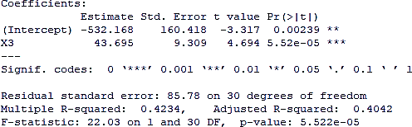

**Comment:** according to adjusted R square value, only 40.42% of the total observation can be explained by the fit of Y1 on X3.

**Case2:**

Y2= -655.88 + 46.5X3

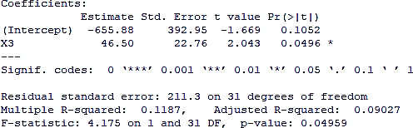

**Comment:** according to adjusted R square value, only 9.03% of the total observation can be explained by the fit of Y2 on X3.

* **10.1 Multiple Correlation coefficient:**

Here we consider the problem of measuring the degree to which one of the random variables

may be said to be dependent on the other variables jointly. i.e., let X1, X2, …..., Xp be p random variables then the joint influence of X2, X3, …... , Xp on X1 called to be multiple correlation coefficients and it is denoted as 𝜌1.23…𝑝.

𝜌1.23..𝑝

= (1 − |𝑅| )1/2

𝑅11

where R is the correlation matrix and R11 is the co-factor of it’s (1,1)th element.

**Comment:** in case 1, the value of multiple correlation is 0.6507 between Y1 and X3 i.e., they have moderate positive correlation among themselves.

In case 2, the value of multiple correlation is -0.0535 between Y1 and X3 i.e., they have moderate negative correlation among themselves.

* **10.2 Partial correlation coefficient:**

Here we consider the problem of measuring the degree to which two random variables said to be related when the influences of the other random variables are eliminated from each of them i.e., the marginal impact of Xj on X1 keeping the other predictors constant and it is denoted as 𝜌1j.23…𝑝.

𝜌1j.23…𝑝

= - 𝑅1j

√𝑅11 𝑅jj

Where Rij is the co-factor of (i,j)th element of correlation matrix R.

In similar fashion when the true regression of X1 as well as Xj on X2,X3, … ,Xp is linear then,

𝜌 = 𝐸[𝑐𝑜𝑣(𝑋1,𝑋𝑗|𝑋2𝑋3….𝑋𝑝)]

1j.23…𝑝

√𝐸[𝑣(𝑋1|𝑋2𝑋3….𝑋𝑝)] √𝐸[𝑣(𝑋𝑗|𝑋2𝑋3….𝑋𝑝)]

**Comment:** as there are only two variables, so partial correlation would be same as multiple correlation.

1. **Goodness of the fit:**

To understand the goodness of the fit graphically, we plot residual versus predicted response (in a linear combination of all predictors).

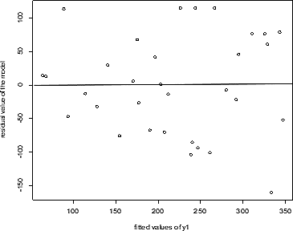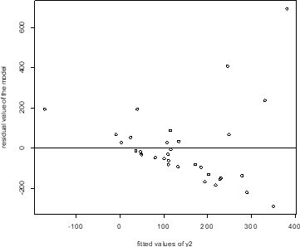

Case 1 Case 2

Residual standard error(RSE) = 𝑅𝑆𝑆

𝑛−𝑝

R squared = R2 = 1- 𝑅𝑆𝑆 = 𝜌

, where RSS is the residual sum of squares

2 = (1 − |𝑅| )

𝑇𝑆𝑆

1.23..𝑝

𝑅11

To get even more accurate result we use adjusted R squared, which is defined as follows,

Adjusted R2 = 1- 𝑛−1 (1 − 𝑅2) = 1- 𝑅𝑆𝑆/(𝑛−𝑝)

𝑛−𝑝

𝑇𝑆𝑆/(𝑛−1)

**Comment:** for case 1, R2 = 0.4234 and adjusted R2 = 0.4042 For case 2, R2 = 0.1187 and adjusted R2 = 0.09027

We can see that the fit is not good . i.e., the model doesn’t able to explain most of the variation of the data given.

# Conclusion:

we try to find that how used factors influences the crime of India (IPC and SLL). We at the end come to the conclusion that these factors are not sufficient to explain the crime rate. Only GDP of a place found be significant although not highly effective to explain crimes. So, the is further scope for work with this project if we have significant amount of predicting variables and sufficient amount of data.

# Appendix of codes:

Codes are uploaded in their original format at Github. The works done with help of Minitab software are not given.

Link: <https://github.com/Rup21/Dissertation-project.git>

# References:

* Fundamental of statistics, volume 1: [A.M. Goon, M.K.Gupta, B. Dasgupta](https://journals.sagepub.com/doi/10.1177/0008068319680206)
* Fundamental of statistics, volume 2: [A.M. Goon, M.K.Gupta, B. Dasgupta](https://journals.sagepub.com/doi/10.1177/0008068319680206)
* Crimes in India 2021, statistics volume 1: [docs](https://docs.google.com/document/d/1T8cvpoPAtmWfDz3diUrj7GrDp3dh-8TgSNvNbOkcDhk/edit?usp=sharing)
* Crimes in India 2021, statistics volume 2: [docs](https://docs.google.com/document/d/1lB3U77WNuU2nOT2PiaoKNPgzhUDN_jwfftRCOiWzSKE/edit?usp=sharing)
* Crimes in India 2021, statistics volume 3: [docs](https://docs.google.com/document/d/1qNf8yQJvzwcwrKyuJ4a1WmePVIfmEo4nFQtdYwpEThE/edit?usp=sharing)
* Handbook on statistics on Indian states: [docs](https://docs.google.com/document/d/1uwuQH58glPNNykNzvGCJMEJY_4TLdZC7VAofqgvPXfs/edit?usp=sharing)

**Reference folder** : [references](https://drive.google.com/drive/folders/1hW5hDv-MC_6kdaU6neMLZvep8HSeS005?usp=sharing)

# Acknowledgement:

I extend my heartfelt gratitude to St. Xavier’s College (Autonomous), Kolkata, for providing me with the opportunity to explore the subject of my dissertation. I am deeply thankful to my supervisor, Prof. Mausumi Bose , for her unwavering guidance, supervision, and encouragement throughout this journey. I am immensely grateful to my parents and friends for their invaluable help and support during the course of this project.

**---- Thank you ----**