**INTRODUCTION:**

**Description of weather app:**

In this project, we will be building a weather application. This application will show the temperature of a location. To fetch weather information we will need an API. An API(Application Programming Interface) is a function that allows applications to interact and share data using various components and microservices. For this project, we will be using WeatherBit API for fetching weather data. WeatherBit API provides a fast and elegant way to fetch weather data. Note that we are going to implement this project using the Kotlin language.

**Project Overview**

In this project, we will build an app that will find the device’s location coordinates(longitude and latitude). Then we will send this data to the API via an API key(which we will see later). The API will send us a JSON from which we will extract the required data that is the temperature and city of the location.

The Weather App is a simple project developed using JavaScript, CSS, and HTML. This project is an interesting project for simply weather forecasting. The user can check the condition of the present-day climate probability and predict whether the day is a cloudy or sunny day. The user can write down the name of any city across the world in the app.

**Making of the Project**

This App is simply in HTML, CSS, and JavaScript. Taking about the features of this system, the user can forecast the condition of the current-day climate probability and predict whether the day is a cloudy or sunny day. The user can write down the name of any city across the world in the app. Also, this project includes a lot of javascript for making the functioning of the project.

Weather forecasts are made by collecting as much data as possible about the current state of the atmosphere (particularly the temperature, humidity and wind) and using understanding of atmospheric processes (through meteorology) to determine how the atmosphere evolves in the future.

Weather Report project application is a web based application through which you will able to get all the reports related to weather forecasting of any locations. Its geographical locator which will be received through your browser setting and server configuration will automatically identify the location and able to present its weather details such as temperature, direction of wind, rains, humidity etc. To change the location you will just have to select the options provided below to get its details. Its new avatars and feed burner will also allow its users to get the weather reports directly to their mail, when they were not able to access this particular domain or even when the server is down.

Its weather watch gadgets in animated form will able to notify about weather for particular date and time also. It will also able to focus on critical weather condition for a particular gadgets through this gadgets. So with one weather solutions, its users can get weather reports by getting information directly from satellite and radar via proper communication medium using java servlet coding. Its calculations and details are so accurate, that you can even check and match it from news channel. Its user’s friendly tools are so simple to use, that even a child can handle it and get information on particular geographical area.

**LITERATURE SURVEY:**

**2.1 Existing System**

Previously built Weather Report project web based application was compatible with system and every time users start this application, they have to set their default location to get weather reports on it. Due to complex coding, system responding time was high and require more memory to get start up. The concept of graphics for geographical region was not implemented in older version. Dynamic concept was not implemented under the existing system, thus theme and color of web page was not changing as per the weather report.

**2.2 Proposed Weather Report project**

Under web based Weather Report project application, some exciting features has been added such as managing and handling exception error directly by the system which will be not visible by the user to make it bug free. Multiple choice provided to the user by which they can even select different weather channel as per their requirement and interest in it. Its pattern recognition system will able to notify abut bad weather condition previously before it begins with digital graphics is another added advantage of this system. Once location selected by the user for its system use, it will make it default location and remembered by the system so that users do not have to change every time they use this system.

**THEORITICAL ANALYSIS:**

**BLOCK DIAGARAM:**

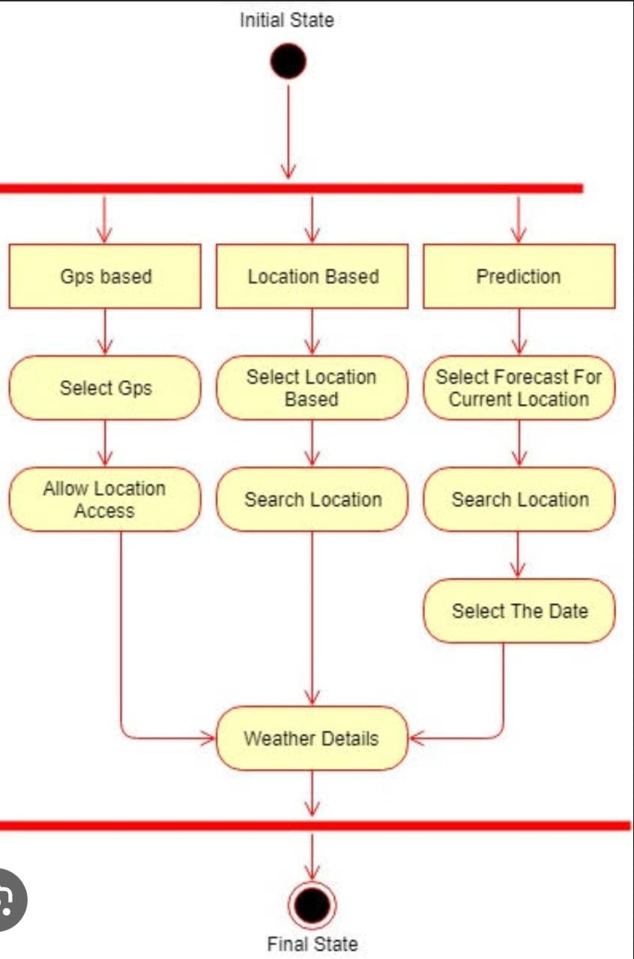

**Hardware Requirements :**

* **Processer –Intel**
* **Optical Mouse**
* **Key Board**
* **Ram -512mb**
* **Hard disk -1gb**

**Software Requirements:**

* **Operating system –windows10**
* **Interface –visual Studio.**

**OUTPUT:**

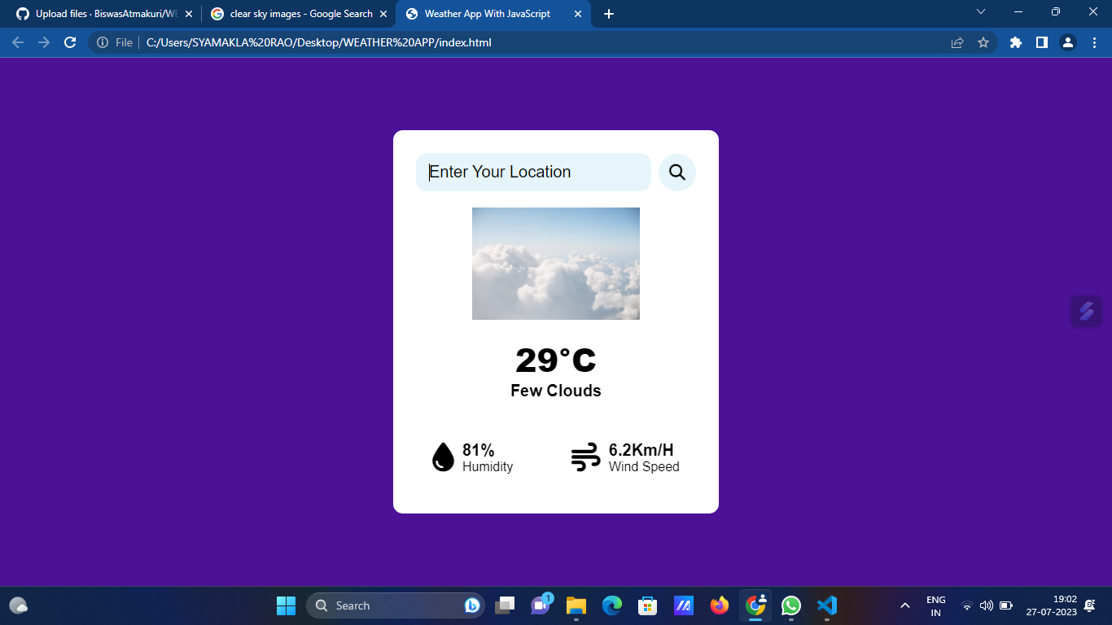

**Advantage and disadvantage**

**Advantages**

1. Farmers can known when to plant or harvest their crops
2. People cam choose where and when to take their holidays to take advantages of good weather
3. Surfers known when large waves are expected
4. Regions can be evacuated if hurricanes or floods are expected
5. Aircraft and shipping rely heavily on accurate weather forecasting

**Disadvantages**

1. Weather is extremely difficult to forecast correctly
2. It is expensive to monitor-so many variables from so many sources
3. The computers needed to perform the millions of calculations necessary are expensive
4. The weather forecasters get blamed if the weather is different from the forecast

**Applications**

* Accuweather
* Appy Weather
* Geometric Weather
* Google Feed
* MyRadar Weather Radar
* NOAA Weather
* Overdrop
* Today Weather
* WeatherBug
* The Weather Channel
* What The Forecast?!!
* Yahoo Weather
* YoWindow Weather
* WeatherUnderground

**Conclusion**

In the era of the global warming, research in weather measurement, monitoring and forecasting are become more and more relevant. This research demonstrates the design and implementation of an affordable mini weather monitoring system that ensures flexibility, portability, scability and user friendly operations which can provide data of some weather variables including temperature, humidity and pressure. With the advacement of technology weather forecasting has developed to its level best, but there is yet to develop, as far as a nature is so unpredictable. Weather forecasts are increasingly accurate and useful, and their benefits extend widely across the economy. While much has been accomplished in improving weather forecasts, there remains much room for improvement. Simultaneously, they are developing new technologies and observational netwoeks that can enchance forecaster skill and the value of their services to their users.

**Future scope**

**Features Weather Forecast Project:**

* Time to time update weather
* Tamprature Update
* Last 7 days data Predict
* change weather in every hours as according to weather changes.
* provide accurate data information about weather.
* user can search weather anytime and anywhere.
* any places data can be search and provide information as according to weather.
* help user to travel.
* help User to future plans for holidays.