1. KPI’s:
2. Total Revenue:

SQL Query: SELECT SUM(total_price) AS Total_Revenue from pizza_sales  
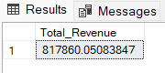

1. Average Order Value:

SQL Query: SELECT SUM(total_price) / COUNT(DISTINCT order_id) AS Avg_Oder_Value FROM pizza_sales

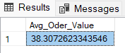

1. Total Pizza Sold

SQL Query: SELECT SUM(quantity) as Total_Pizza_Sold from pizza_sales

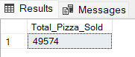

1. Total Orders:

SQL Query: SELECT COUNT(DISTINCT order_id) AS Total_Orders from pizza_sales  
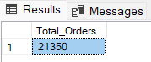

1. Avg Pizza Per Order:

SQL Query: SELECT CAST(CAST(SUM(quantity) AS DECIMAL(10,2)) /

CAST(COUNT(DISTINCT order_id) AS DECIMAL(10,2)) AS DECIMAL(10,2)) AS AVG_PIZZA_PER_ORDER from pizza_sales  
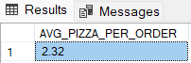

1. CHARTS:
2. Daily Trends:  
   SQL Query: SELECT DATENAME(DW, order_date) as order_day, COUNT(DISTINCT order_id) AS Total_Orders from pizza_sales GROUP BY DATENAME(DW, order_date)

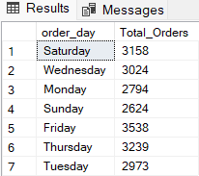

1. Monthly Trends:

SQL Query: SELECT DATENAME(MONTH, order_date) as Month_Name, COUNT(DISTINCT order_id) AS Total_Orders FROM pizza_sales GROUP BY DATENAME(MONTH, order_date) ORDER BY Total_Orders DESC

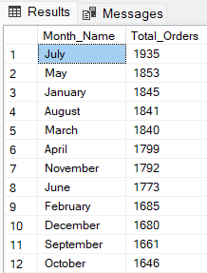

1. Category Trend:  
   SQL Query: SELECT pizza_category, SUM(total_price) * 100 / (SELECT SUM(total_price) from pizza_sales) AS PCT FROM pizza_sales GROUP BY pizza_category  
   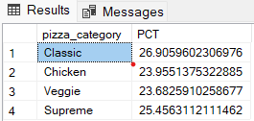
2. Size Trend:

SQL Query: SELECT pizza_size,

CAST( SUM(total_price) * 100 / (SELECT SUM(total_price) from pizza_sales) AS DECIMAL(10,2)) AS PCT

FROM pizza_sales GROUP BY pizza_size ORDER BY PCT DESC  
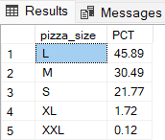

1. Top 5 Pizza’s By Revenue:

SQL Query: SELECT TOP 5 pizza_name, SUM(total_price) AS Total_Revenue FROM pizza_sales

GROUP BY pizza_name

ORDER BY Total_Revenue DESC

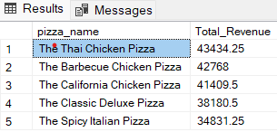

1. Bottom 5 Pizzas By Revenue:

SQL Query: SELECT TOP 5 pizza_name, SUM(total_price) AS Total_Revenue FROM pizza_sales

GROUP BY pizza_name

ORDER BY Total_Revenue ASC

